**Homework**

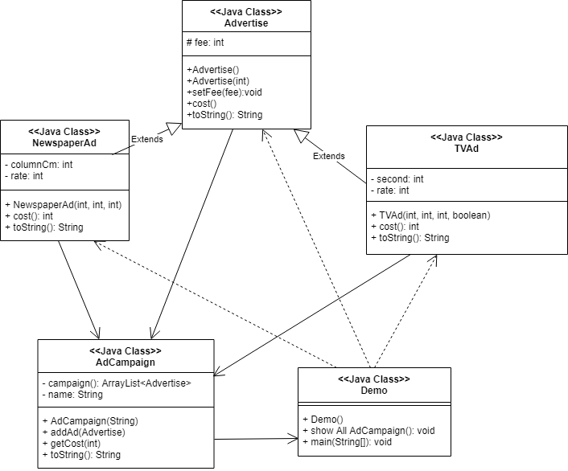

1. We need to create class Advertise.

We need to have following instance variable to store in the class

* fee as int:

The class also needs to implement the following instance methods:

* constructor: no argument
* constructor: has an argument: fee
* setFee(int): argument fee and set value to fee
* cost(): return fee
* toString(): display fee.

1. We need to create class NewspaperAd expend from class Advertise

We need to have following instance variable to store in the class

* column as int: column in newspaper
* rate as int:

The class also needs to implement the following instance methods:

* contructor: has fee, columnCm, ratePerCm
* cost(): return fee
* toString(): return toString() from class Advertise, columnCm, rate

1. create class TVAd extent from class Advertise

This class need to have following instance variable to store in the class

* second as int: second of advertise
* rate as int:
* peakTime as Boolean:

The class also needs to implement the following instance methods:

* constructor(): have arguments fee, rate, adLength, peakTime and instance variable from class Advertise
* cost(): return cost() from class Advertise and variable second has condition
* toString(): return toString() from class Advertise with second and rate

1. create class AdCampaign

This class need to have following instance variable to store in the class

* campaign as ArrayList of Advertise
* name as String: name of advertise

This class need to have following instance variable to store in the class

* constructor(): has an argument name
* addAd(): for add advertise into campaign
* getCost(): return total cost of advertise
* toString(): for return total cost

1. create class Demo to test advertise by 2 advertises

