Search and Self learning (Static keyword)

1. Definition

The static keyword in java is used for memory management mainly.

1. How to apply it

We can apply static keyword with:

1. Variable
2. Method
3. Block
4. Nested class.
5. Variable static

We declare variable static for save memory and retain value.

Example:

* save memory

If we have objects that have the same value so we can declare static value for save memory.

* Retain value

If we want to know how many objects in a class so can declare static variable for get number of objects.

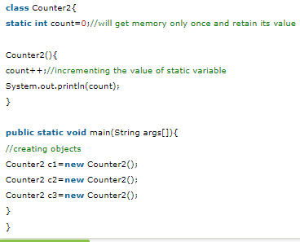

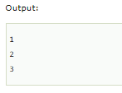

1. Method static

* A static method belongs to the class rather than object of a class.
* A static method can be invoked without the need to for creating an instance of a class.
* A static method can access static data member and can change the value of it.

Example:

Static method that performs a normal calculation

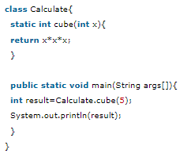



1. Block static

* Is used to initialize the static data member.
* It is executed before the main method at the time of class loading.

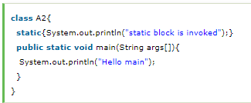Example:

1. Nested class

A static class i.e. created inside a class is called static nested class in java. It cannot access non-static data members and methods. It can be accessed by outer class name.

* It can access static data members of outer class including private.
* Static nested class cannot access non-static (instance) data member or method.

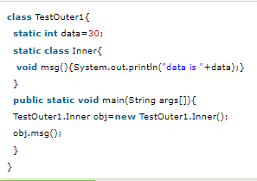Example:

**The end**