**Quiz**

**Name :…………………………..**

**100**

**Class :…………………………..**

1. **Choose the best answer for the following question(10 pts)**

*Some questions will have more than one answer*

1. What does MVC stand for?
   1. Modal View Controler
   2. Model View Controller
   3. Model View Collect
   4. Model Views Controller
2. What does MFC stand for?
   1. Microsoft Foundation Class
   2. Microsoft Foundation Community
   3. Micorsoft Foundation Class
   4. Microsoft Function Class
3. Nowadays, what does KDE stand for?
   1. Kool Develop Environment
   2. K Development Environment
   3. Kool Development Environment
   4. K Develop Environment
4. What does GUI stand for?
   1. Graphic User Interaction
   2. Graphic Using Interface
   3. Graphic User Interface
   4. Graphed Users Interface
5. Which one aren’t PHP framework?
   1. Laravel
   2. ASP.net
   3. CakePHP
   4. Spring MVC
   5. Yii
6. **Matching Question (10 pts)**

*Match the right definition or description to the following keywords or phrases.*

|  |  |  |
| --- | --- | --- |
| **Keyword** | **Description** | **Answer** |
| 1. Abstraction 2. MFC 3. KDE 4. GUI 5. QT | 1. It is the library that we use to create the view for each platform. 2. It is a cross-platform application framework that is use for developing application software that can be run on various software and hardware with little or no change in the underlying codebase, while still being a native application with native capabilities and speed. 3. It is an international free software community that develops Free and Open Source based software. 4. It is the process of hiding the working style of an object, and showing the information of an object in understandable manner. 5. It is a type of user interface that allows users to interact with electronic devices through graphical icons and visual indicators such as secondary notation, instead of text-based user interfaces, typed command labels or text navigation. | 1.___  2.___  3.___  4.___  5.___ |

1. **Complete the keyword in the box below into the blank space(30 pts)**

|  |
| --- |
| Request, Response, View, Controller, Data, Model, Data, User |

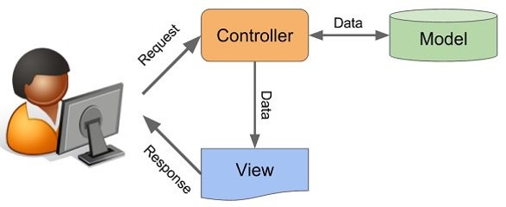

____________

----------------

____________

--------------

--------------

____________

------------

--------------

1. **Answer the question (50 pts)**
2. What is Model?
3. What is Controller?
4. What is View?
5. Explain the relationship among Model View and Controller, and give the example with your own understanding.