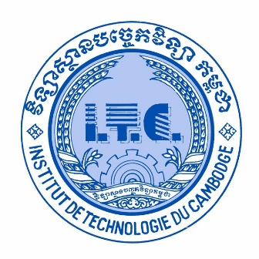

Institute of Technology of Cambodia

Department of Information and Communication Engineering

Assignment: TP0

Subject: **Software Engineering**

Lecturer Course: **TAL Tongsreng**

Lecturer TP: **Roeun Pacharoth**

Student: **Saren Sokmeak**

ID: **e20211376**

Year: **I4**

Academic year: 2024-2025