

Institute of Technology of Cambodia

Department of Information and Communication Engineering

Assignment: TP0

Subject: **Software Engineering**

Lecturer Course: **TAL Tongsreng**

Lecturer TP: **Roeun Pacharoth**

Student: **Saren Sokmeak**

ID: **e20211376**

Year: **I4**

Academic year: 2024-2025

# TP00.1. Reservation class

Create the Reservation class, which represents the room reservation at department. This class will contain information such as room number, person name who make reservation, date and time start and end of reservation, and other remarks as a string.

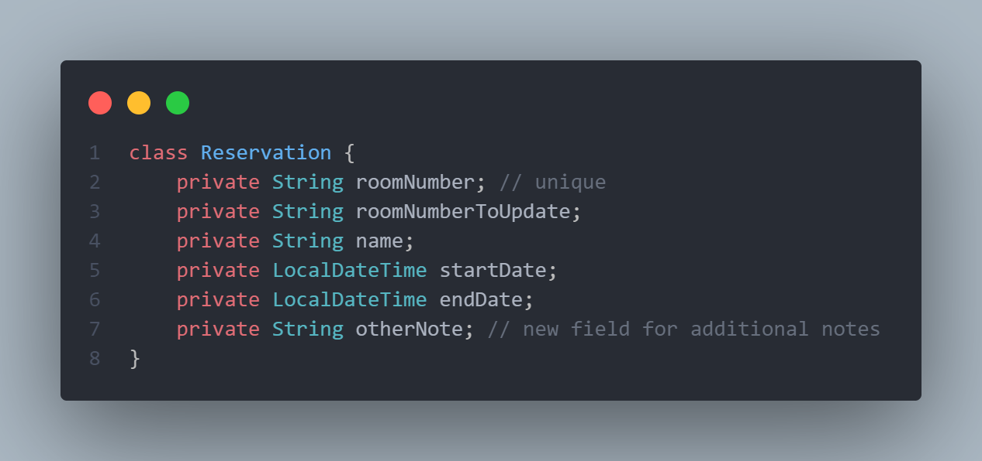

# TP00.2. Constructors

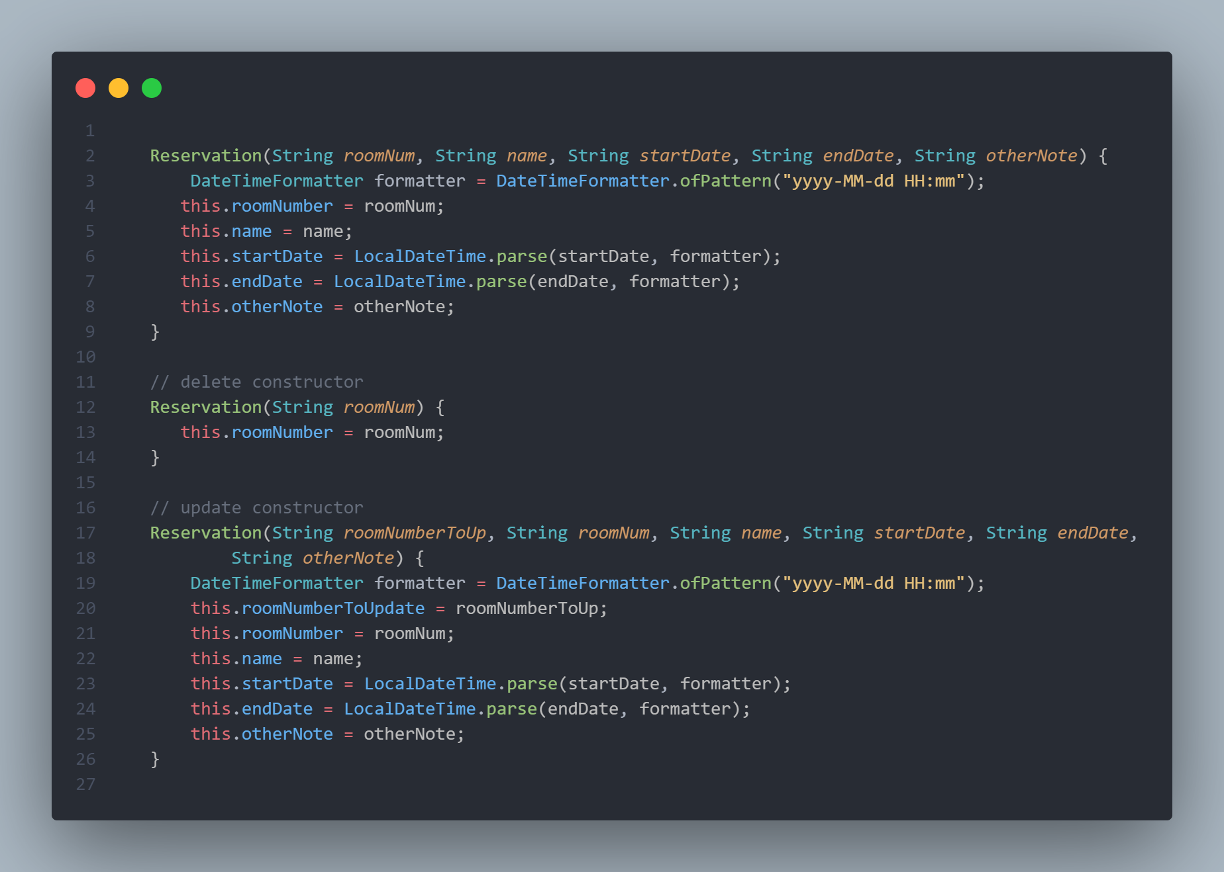

# TP00.3. Getters/Setters or Accessors/Mutators

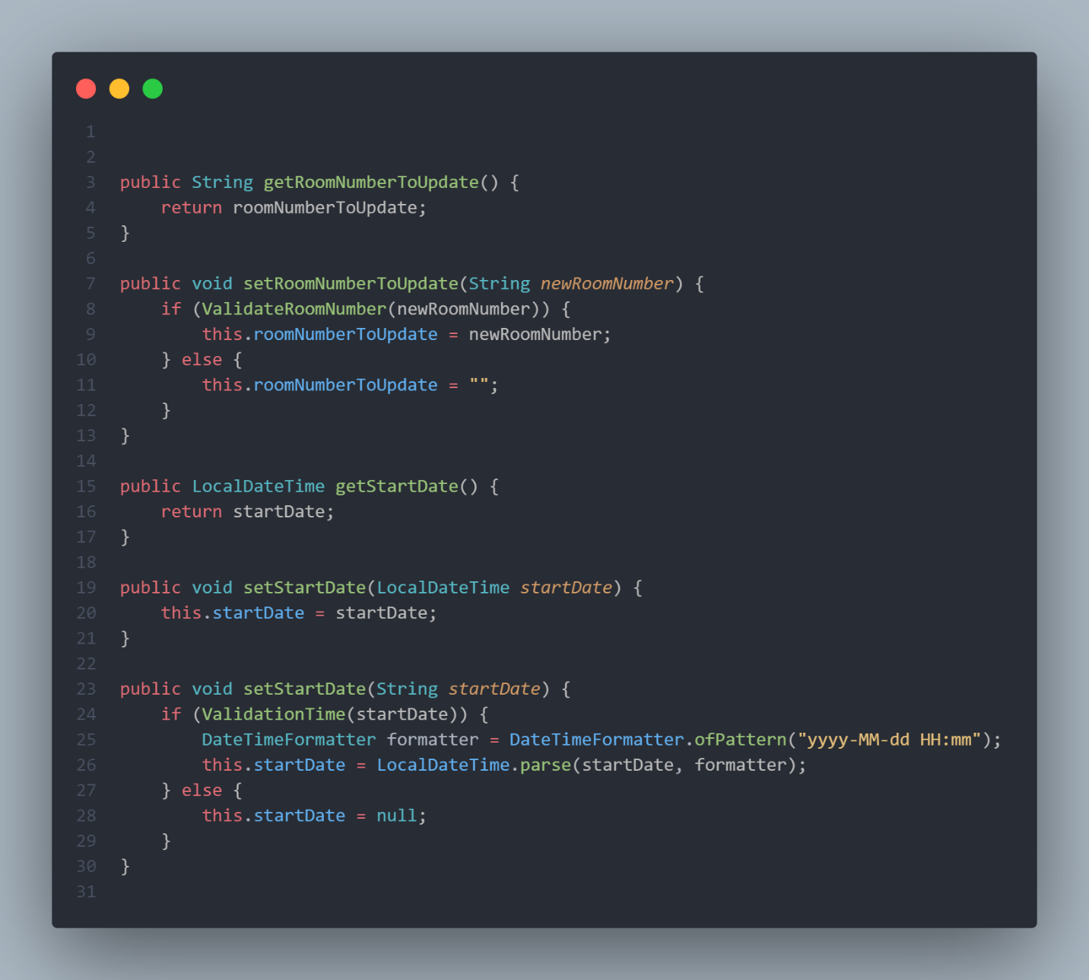

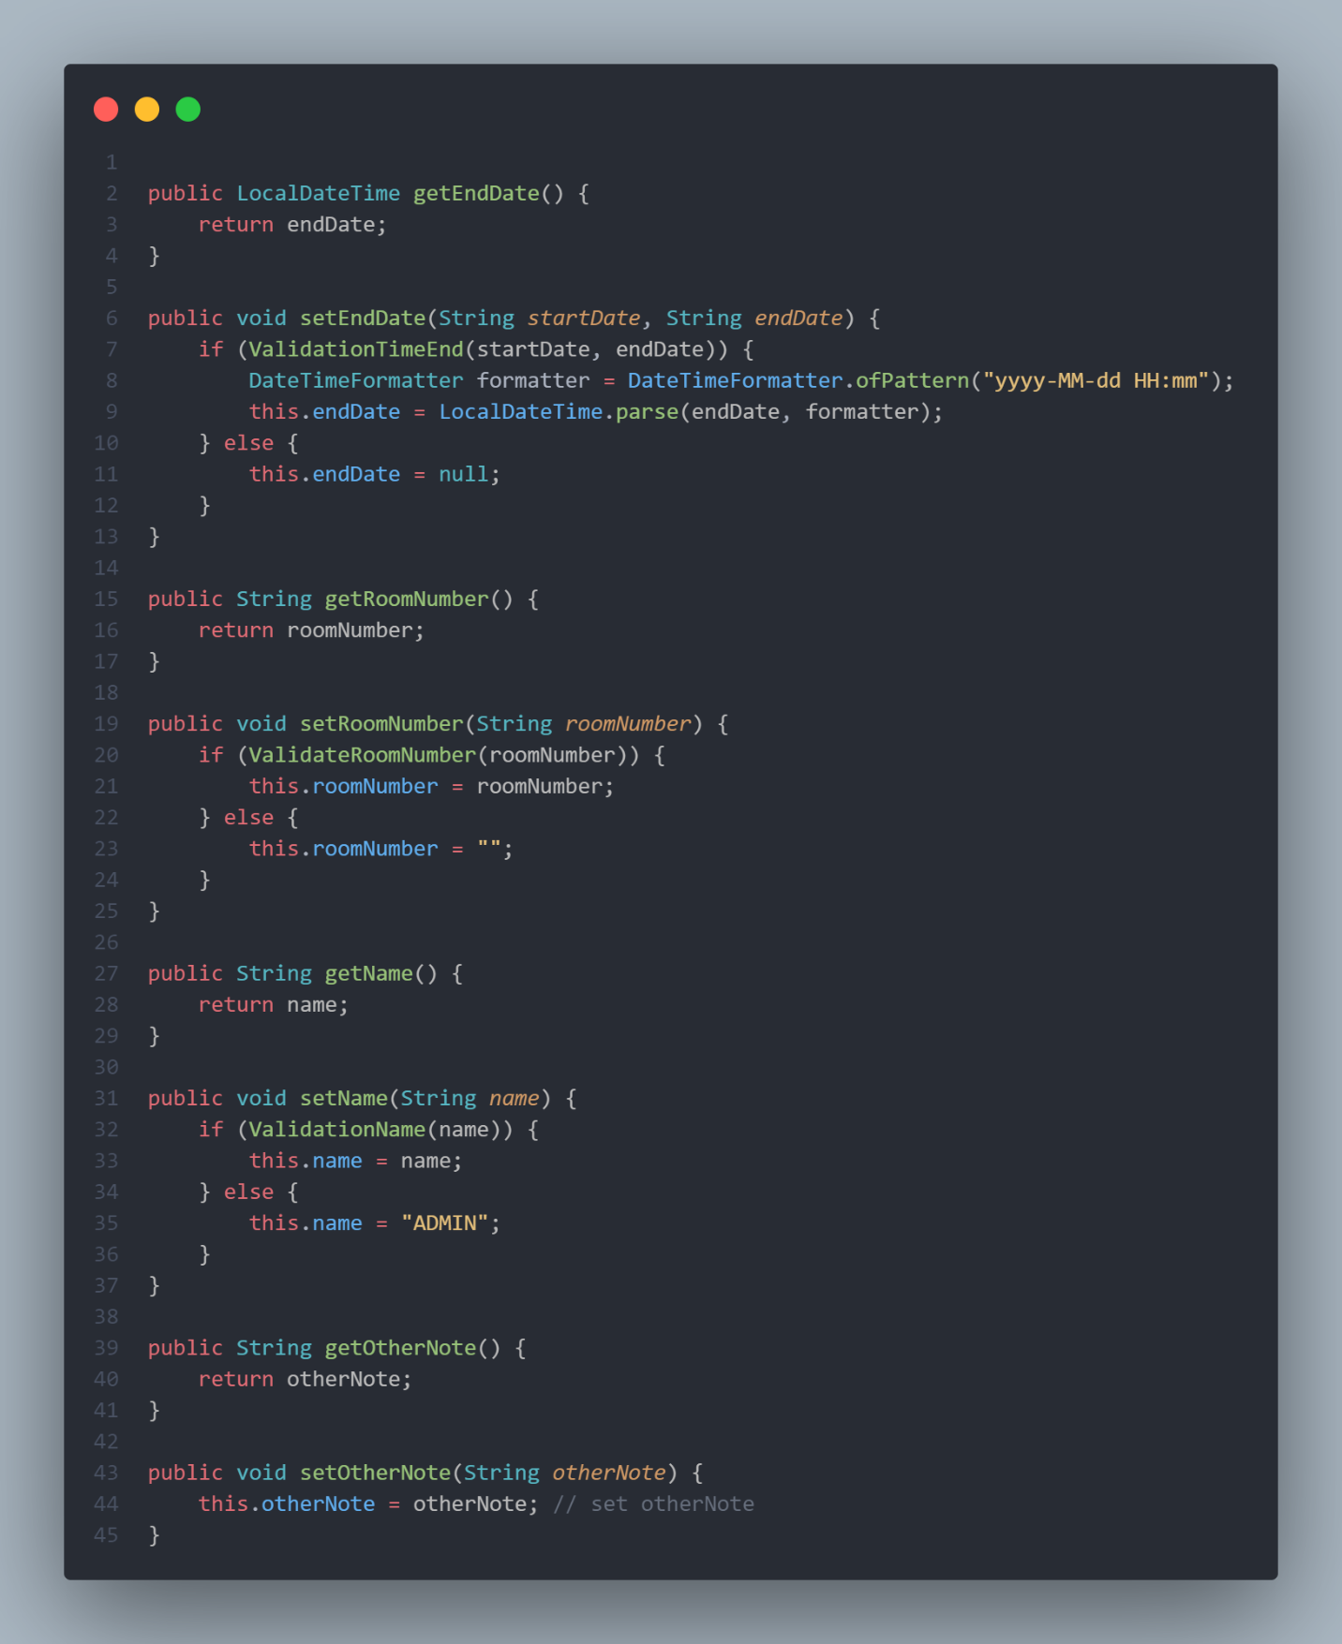

# TP00.4. Validations with Exception

* 1. Room number must not be empty and must start with a letter follows by dash and 3 numbers. Ex: F-209, J-704, …

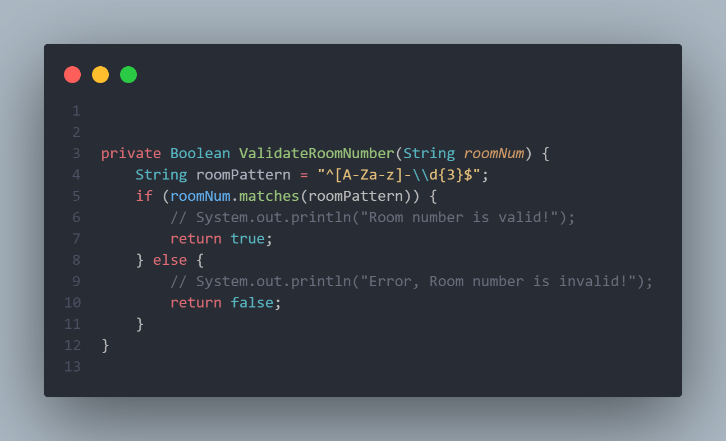

* 1. Reservation person’s name must not be empty and must contains vowels and consonants.

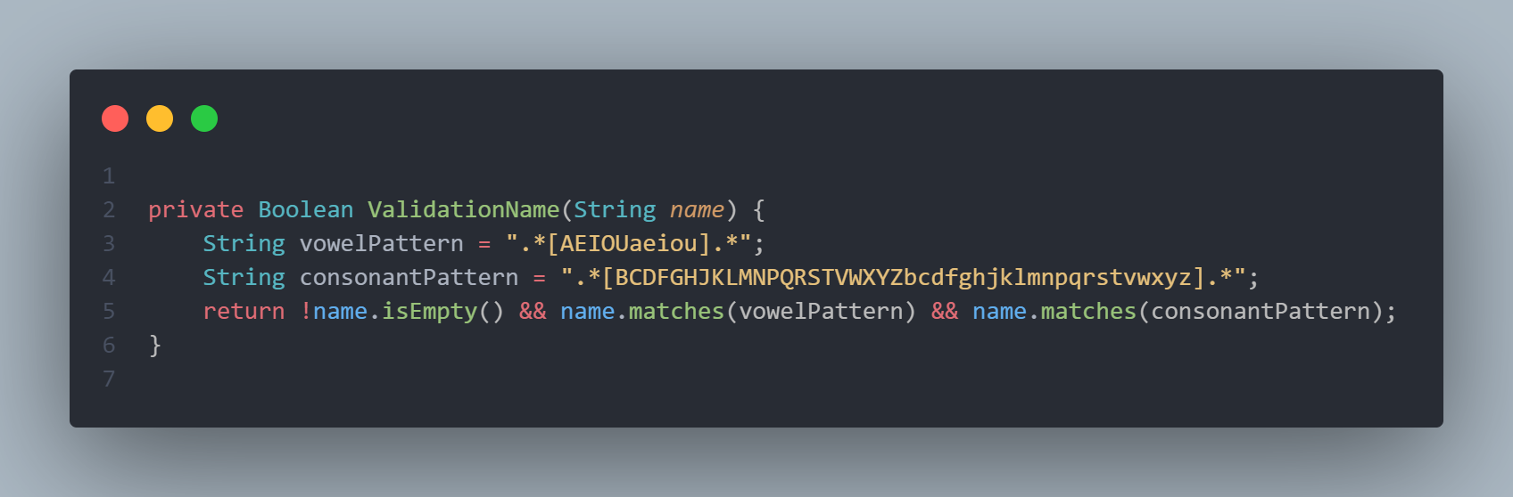

* 1. Reservation date time start must be in the future.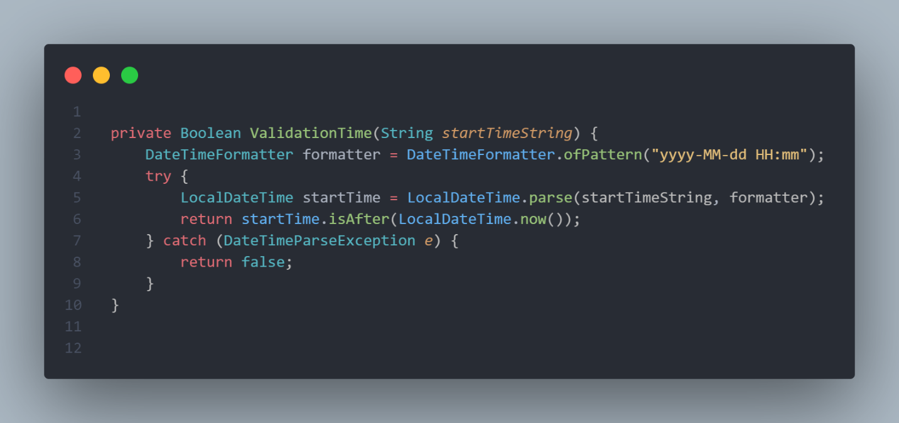
  2. 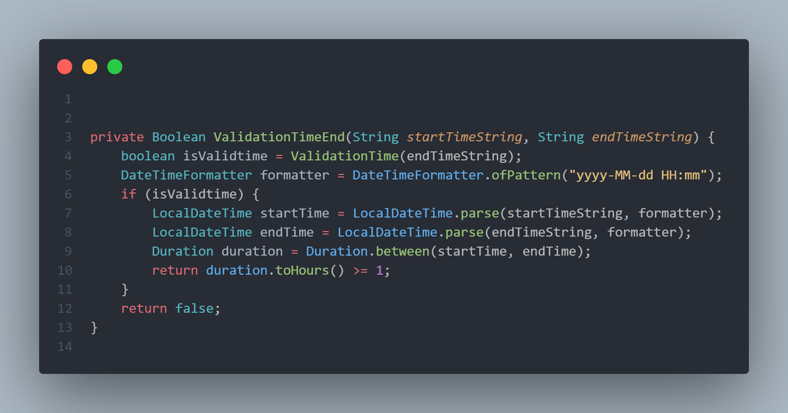Reservation date time end must be greater than date time start at least an hour.
  3. Update the constructors to use setters instead of this… = …;

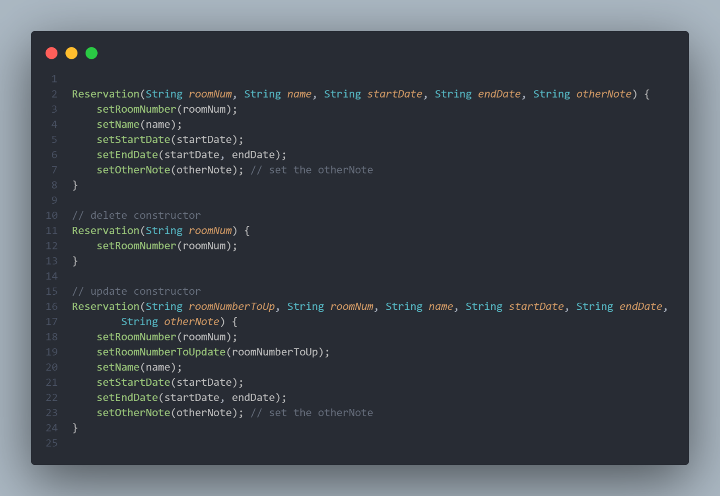

# TP00.5. **Va**

1. List all reservations.

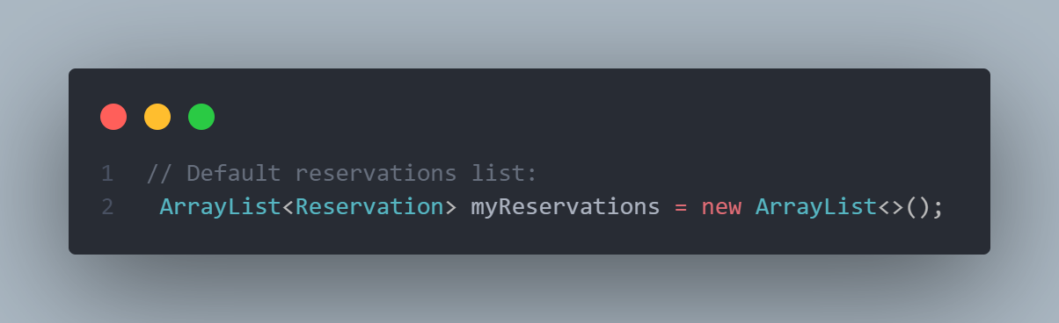

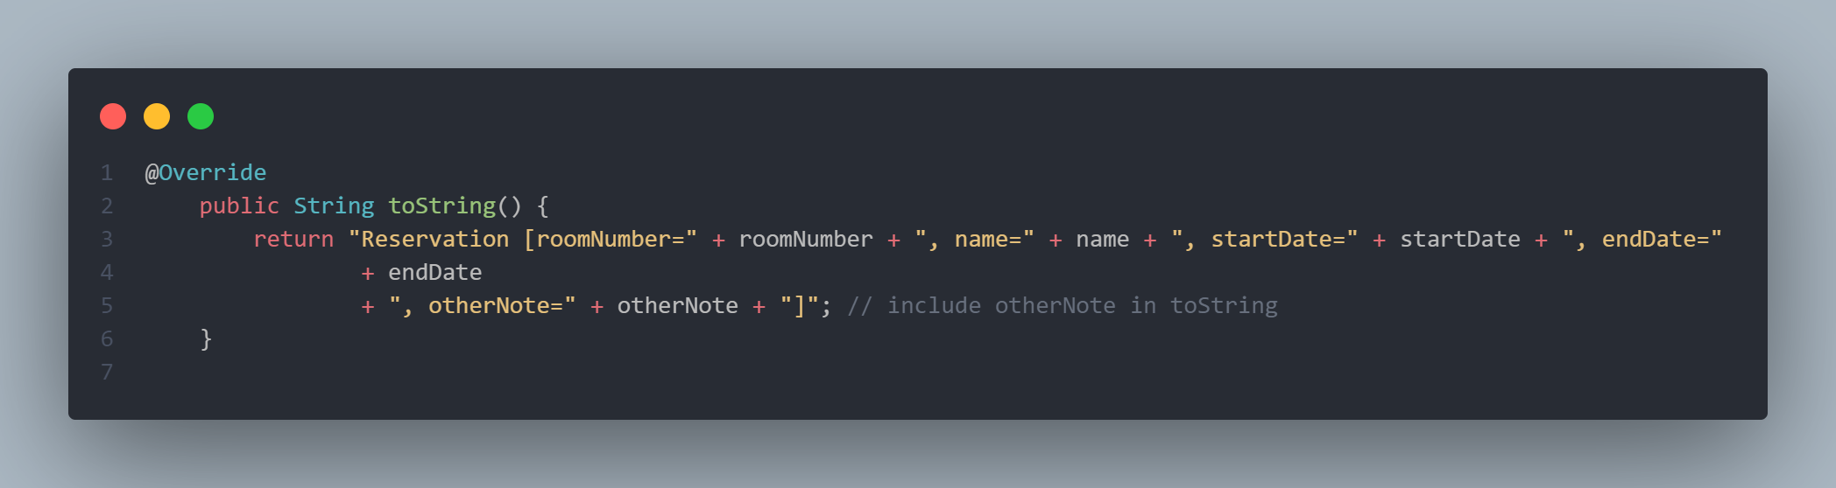

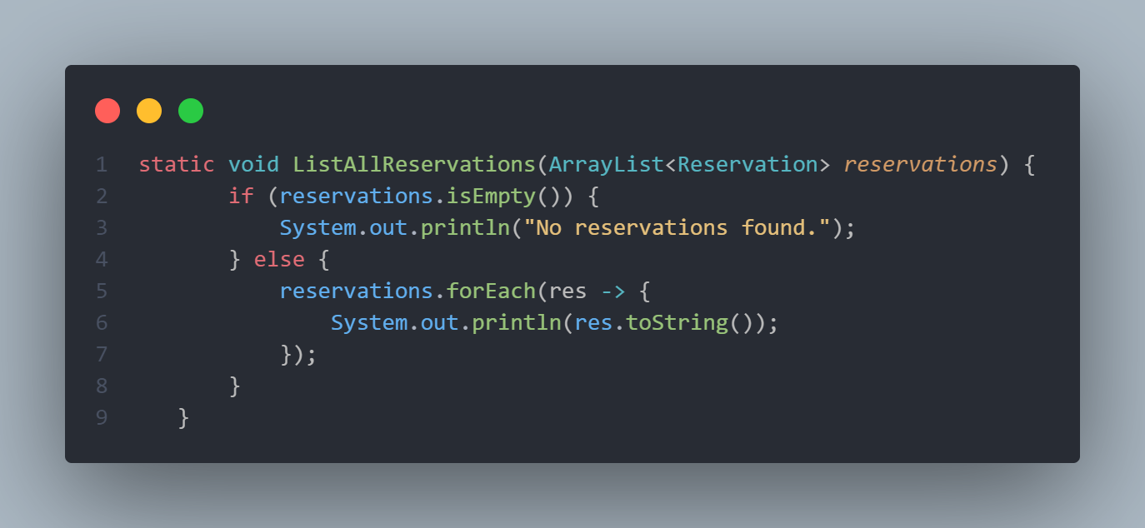

1. Add new reservation. Reservation date and time must be expressed as a future time.

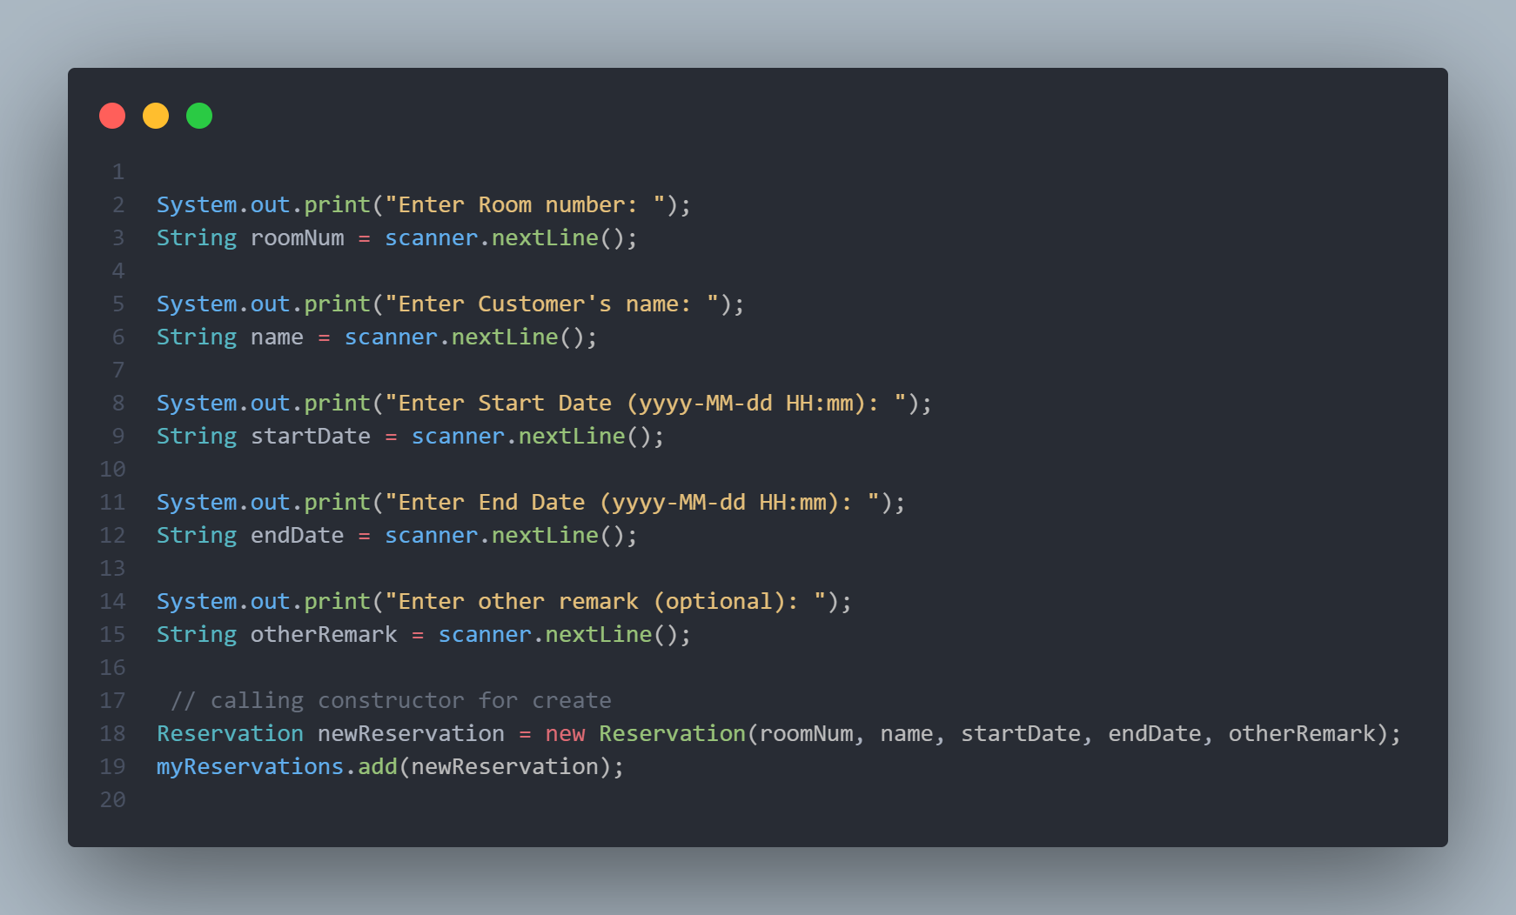

1. Cancel/remove reservation. A Reservation can be canceled/removed if and only if it is not yet started.

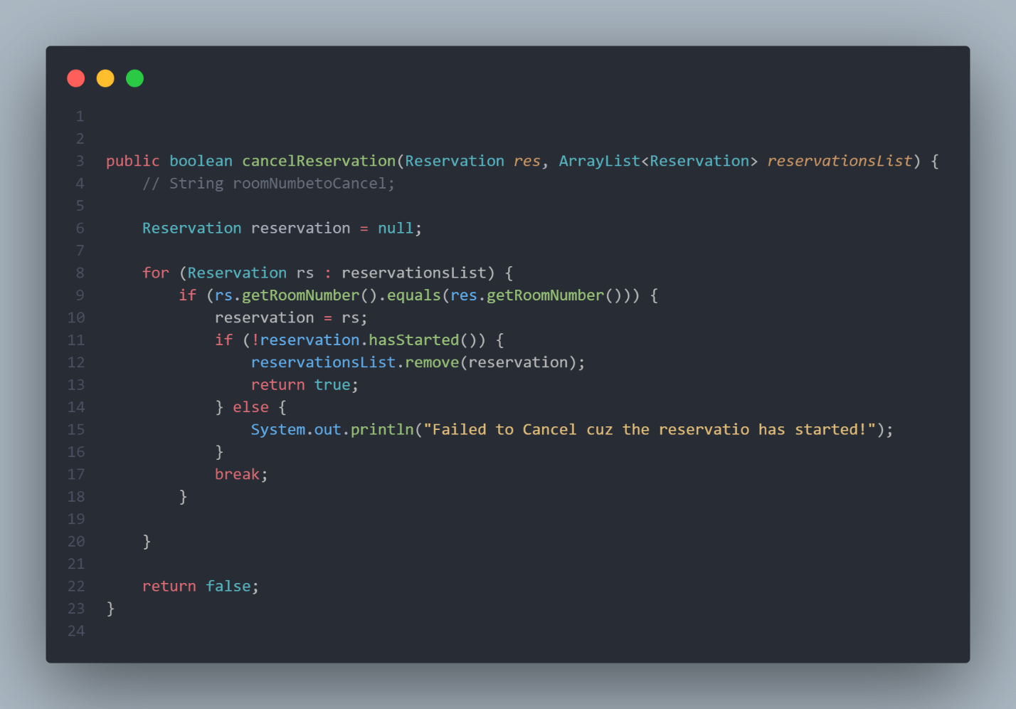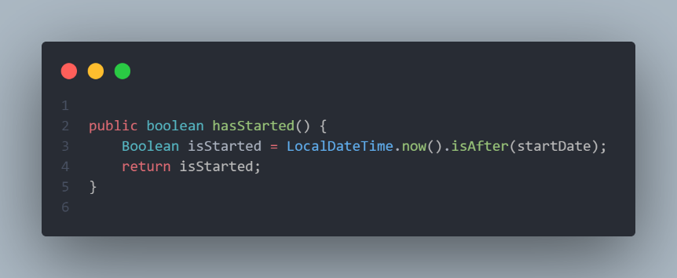

1. Update reservation if it is not yet started.

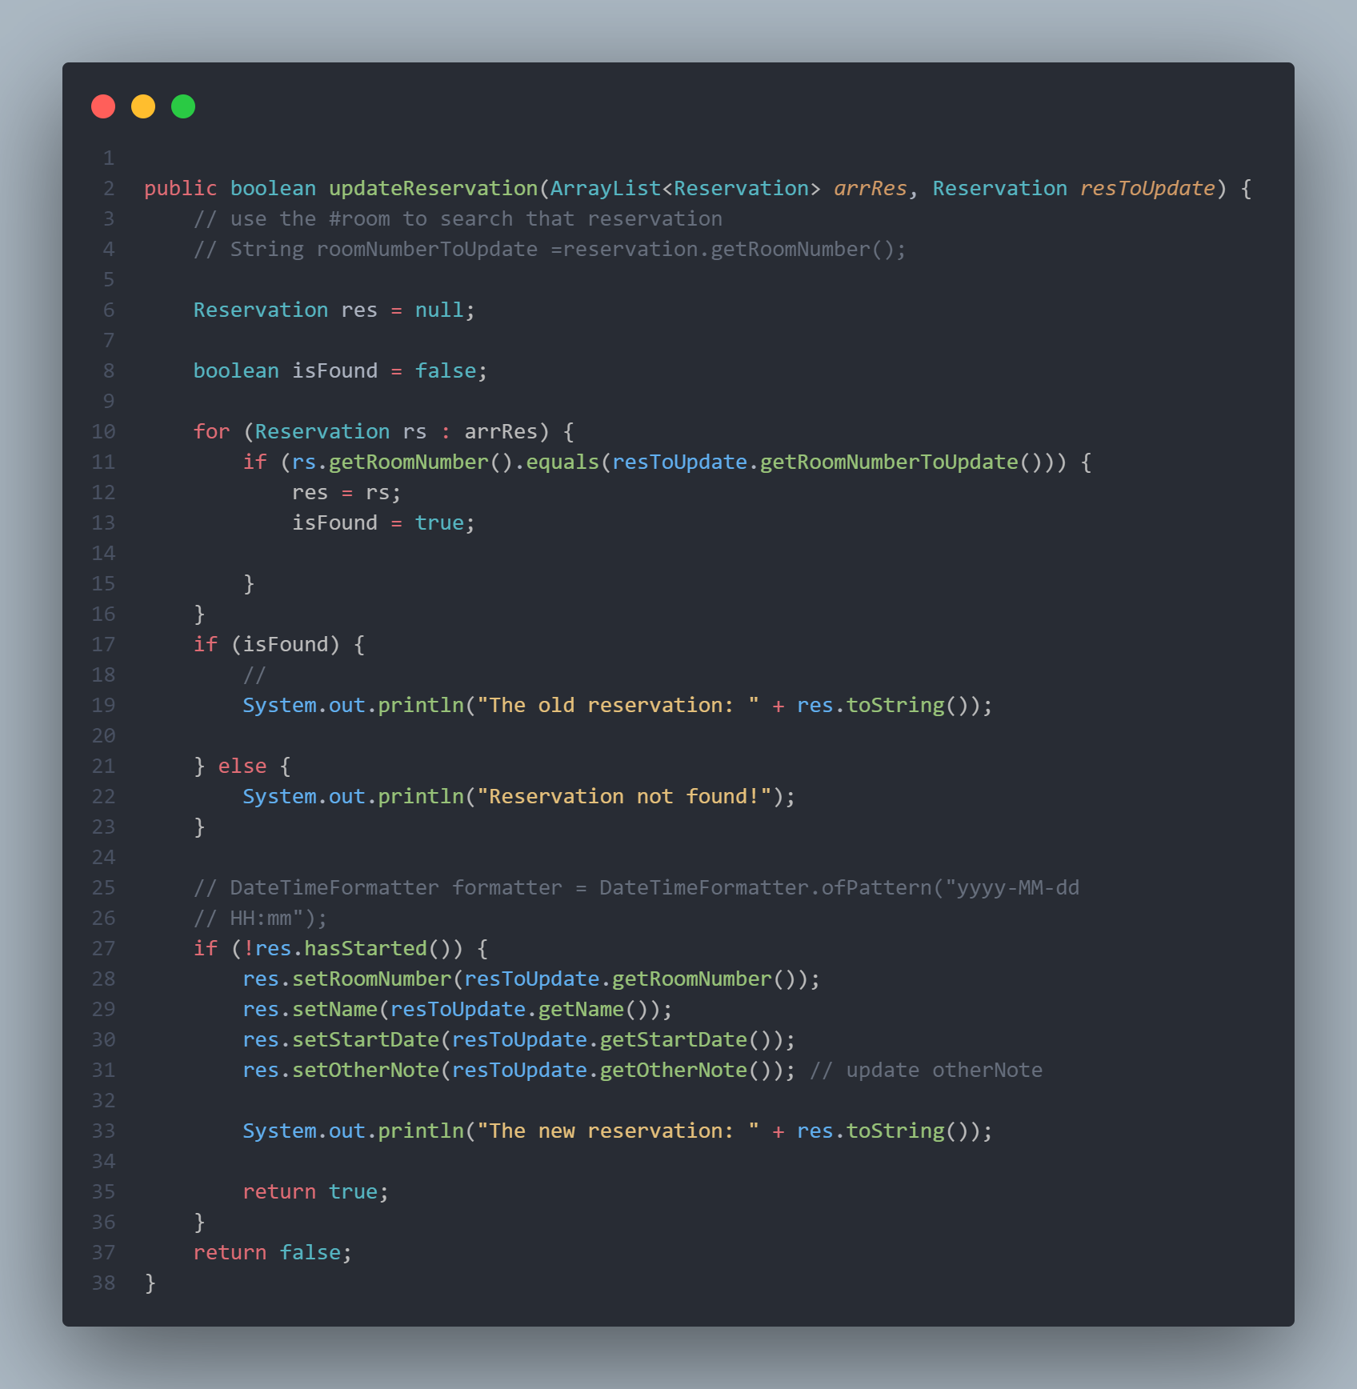

5. Swap room between 2 reservations of the same date and time reservation

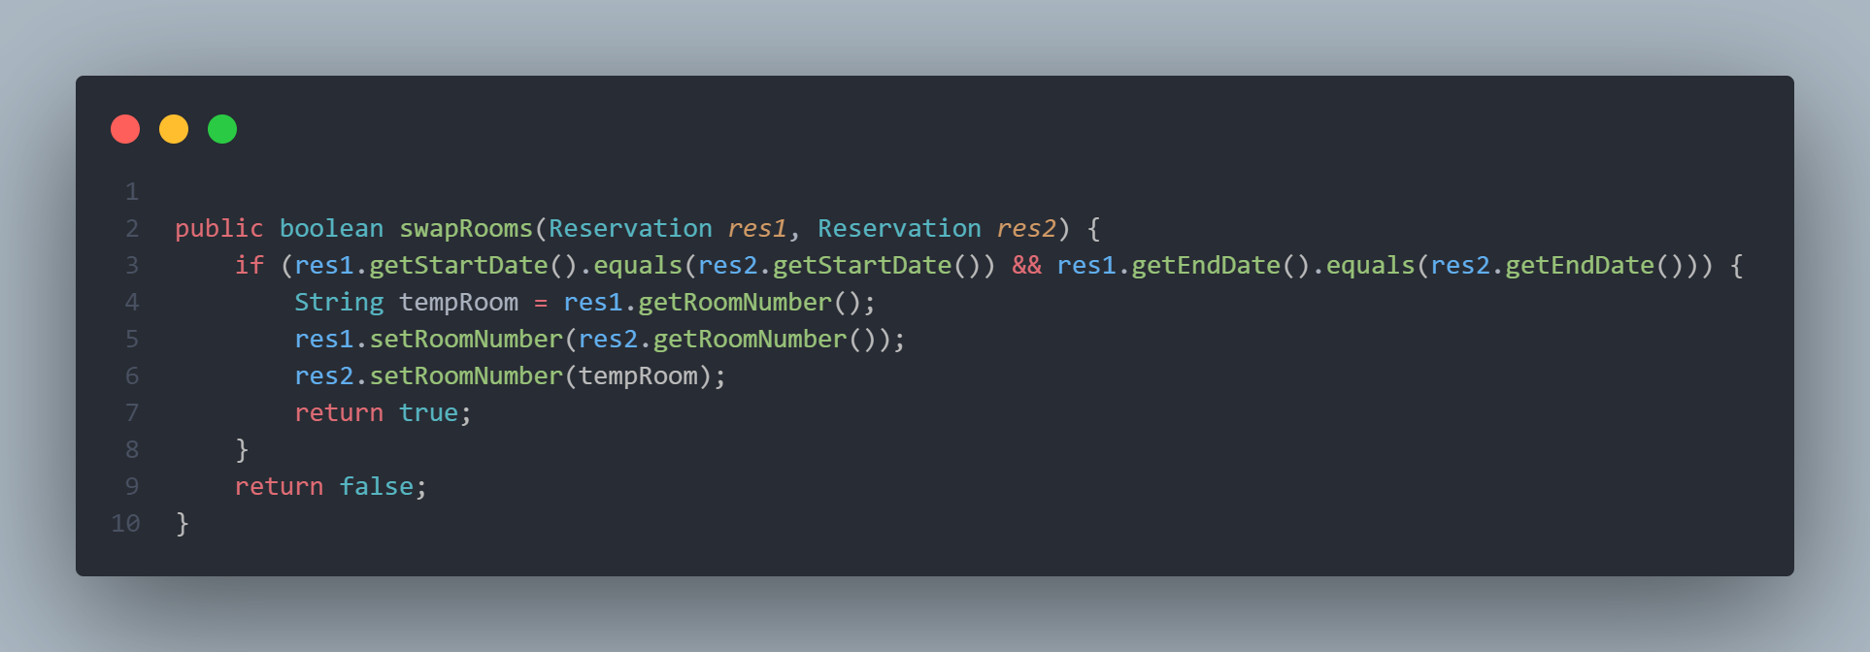

Thank you teacher <3