Card@Once Instant Issue Card Printing
Card Services | November 2025

OVERVIEW
This procedure covers instant issue card printing for consumer and business debit and credit cards using the Card@Once system. Staff must build cards in GOLD before printing. This guide includes login, card selection, PIN entry, activation, troubleshooting, and manager reporting functions.
RELATED: Policies: Debit Card Policy, Credit Card Policy | Procedures: FIS PaymentOne Activation | Forms: Card Issuance Log
Quick Reference
Card@Once URL | cardatonce.eftsource.com | Support Phone | 1-800-237-3387 (Opt 2)
Re-PIN Phone | 1-800-290-7893 | Manual Offset | 0000

Contents: Prerequisites • System Access • Print a Card • PIN Entry • Card Activation • Credit Card Printing • Troubleshooting • Manager Reports
Prerequisites
⛔ Card MUST be built in GOLD before printing. Verify card number and expiration date match GOLD exactly.
- Active Card@Once login credentials
- Card@Once printer connected and online
- Card stock loaded in printer
- Ribbon installed with sufficient remaining prints
- PIN pad device connected (for in-branch PIN entry)

Card Type Selection Reference
Card Type | Card@Once Selection
Consumer Debit | TONGASS FCU C@O EMV CONSUMER-411393
Business Debit | TONGASS FCU C@O EMV BUSINESS-426164
Consumer Credit | EMV CREDIT-412054
Business Credit | EMV BUSINESS CREDIT-474443

System Access
1. Navigate to https://cardatonce.eftsource.com/Home/Login and enter your username and password.  ℹ️ Forgot password? Select 'Forgot your password?' to receive reset instructions via email. You cannot reuse previous passwords. | 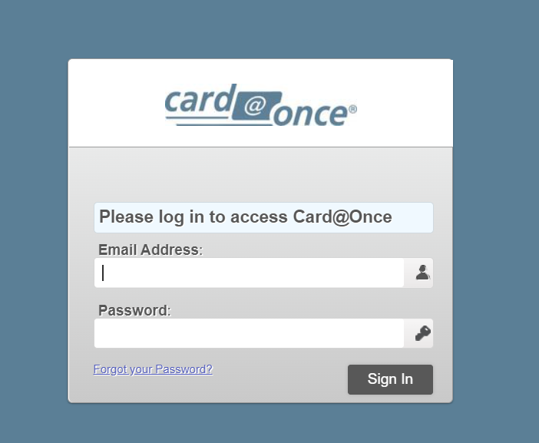
2. From the Home Dashboard, select 'Print a Card' tab or the +Print a Card icon in the upper right corner. | 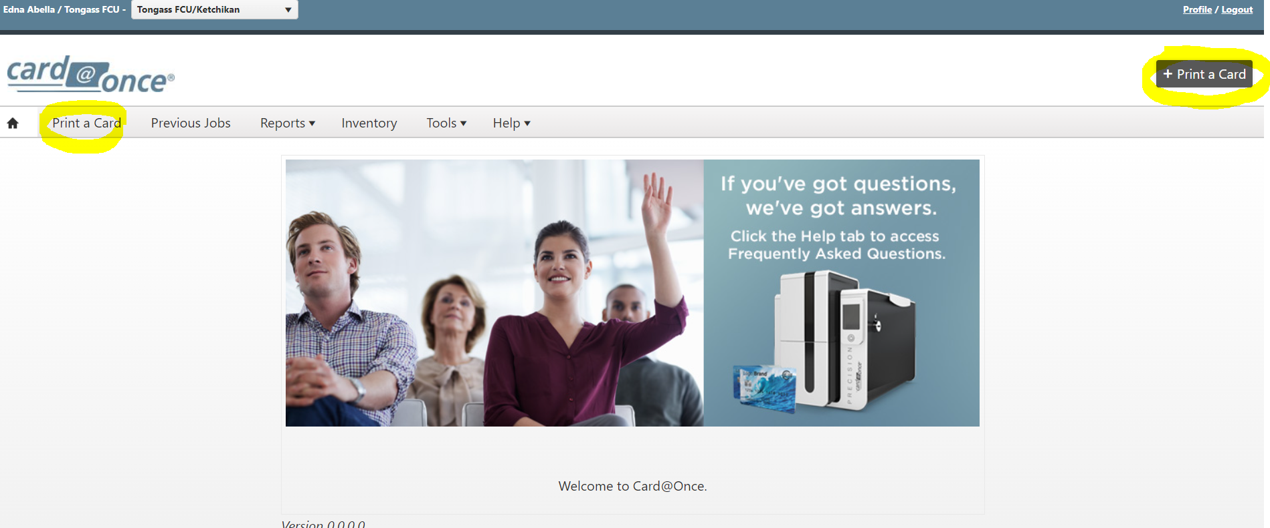
Print a Card
3. Select the correct card type from the dropdown. Reference the Card Type Selection table above for the correct selection.  a. Consumer Debit: TONGASS FCU C@O EMV CONSUMER-411393  b. Business Debit: TONGASS FCU C@O EMV BUSINESS-426164 | 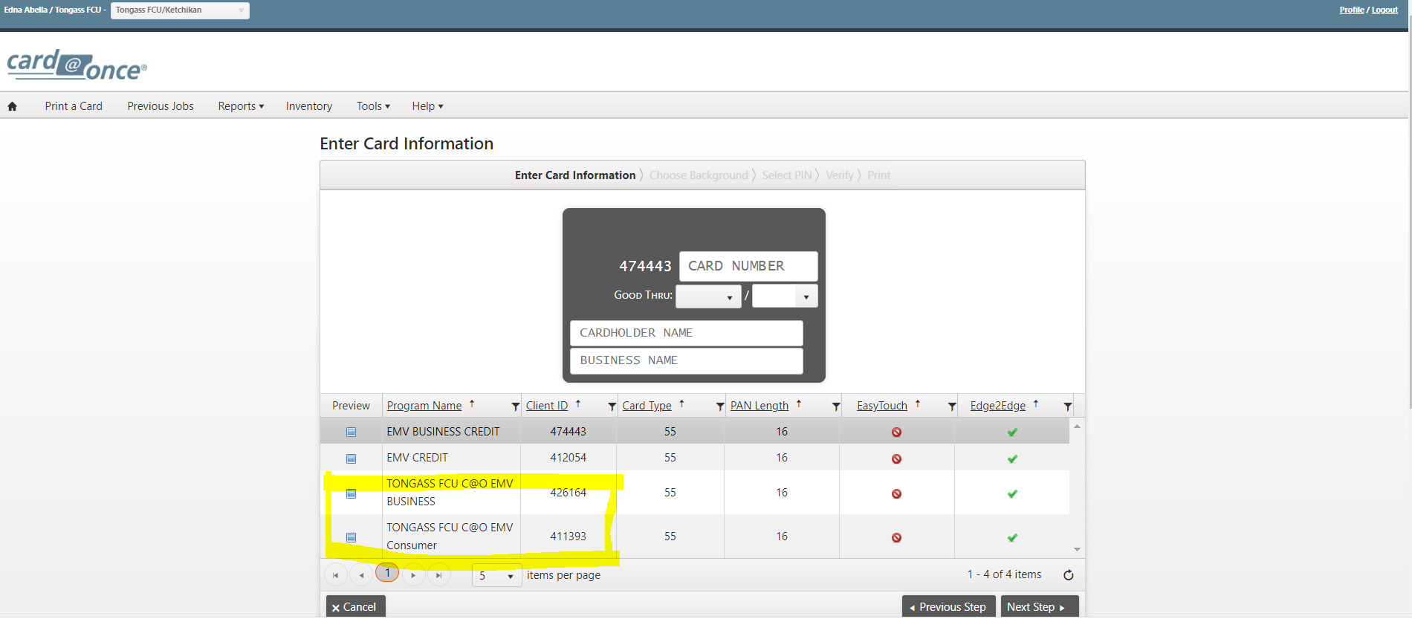
4. Enter the cardholder information exactly as it appears in GOLD.  ⚠️ Business cards: Cardholder name MUST match the business name exactly as shown in GOLD. | 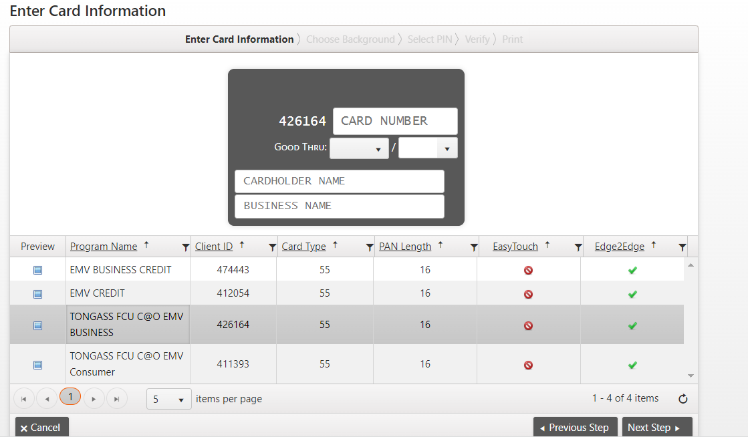
5. Select 'Next Step' to proceed to background selection. | 
6. Select the appropriate card background for the card type, then select 'Next Step'.  a. Consumer Debit: Multiple background options available  b. Business Debit: Single business-branded background  c. Consumer Credit: Standard credit card design  d. Business Credit: Business credit card design | 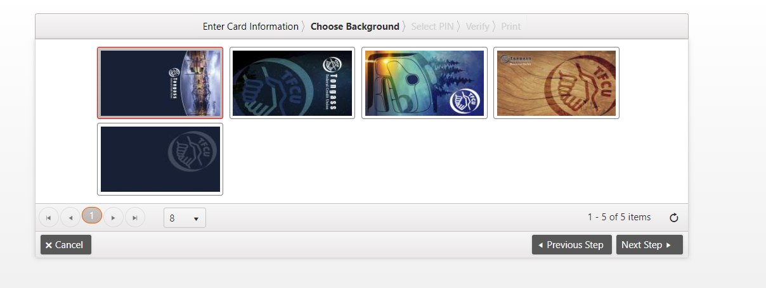
PIN Entry
7. Select 'PIN Pad Device' for in-branch PIN entry. The member enters their 4-digit PIN directly on the PIN pad and confirms by re-entering. | 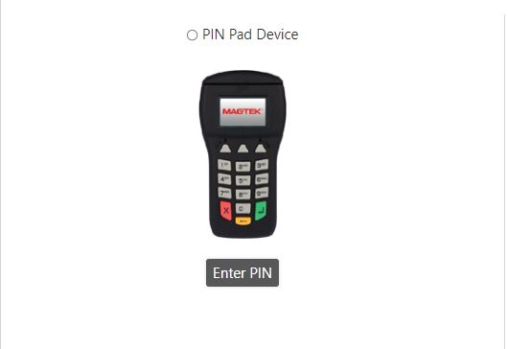
8. If PIN Pad is not working, select 'Manual OFFSET' and enter 0000 for both Offset and Re-Enter Offset fields, then select 'Next Step'.  ⛔ When using Manual Offset, provide the member with the Re-PIN phone number: 1-800-290-7893 | 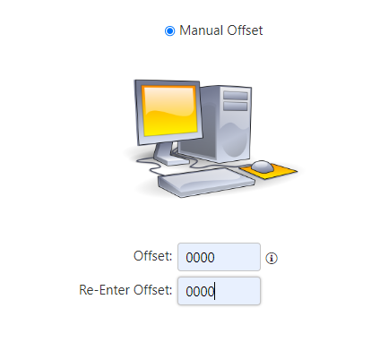
9. Verify all information on the confirmation screen:
a. Correct printer selected
b. Cardholder number matches GOLD
c. Expiration date matches GOLD
d. Cardholder/business name spelled correctly
✅ Select 'Previous Step' to correct any errors before printing.
10. Select 'Print' when all information is verified correct. The printing status indicator appears while the card prints. | 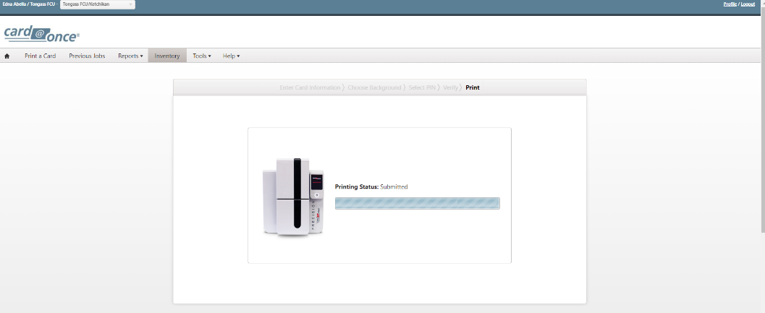
Debit Card Activation
11. When the Activate Card prompt appears, select 'OK' to proceed to activation. | 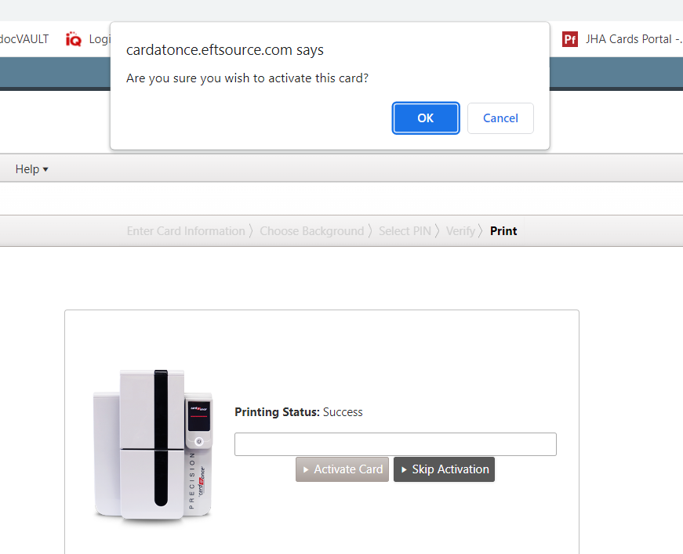
12. Enter the Funding/Account Number: Add leading zeros (0000) before the GOLD account number for a total of 10 digits.  a. Example: Account 206411 becomes 0000206411  b. Account Type: Select CHECKING for all debit cards  ⛔ DO NOT enter the MICR account number. Use the GOLD account number only. | 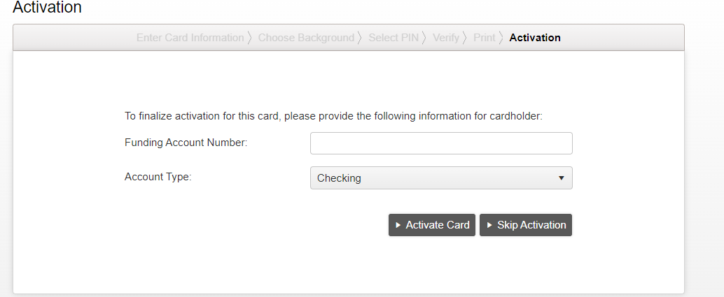
13. Select 'ACTIVATE CARD' to complete activation. The Activated field must show 'True' for successful debit card activation.  ⚠️ ALWAYS activate the card, even when reprinting the same card number. If Activated shows 'False', contact VSR/Card Services. | 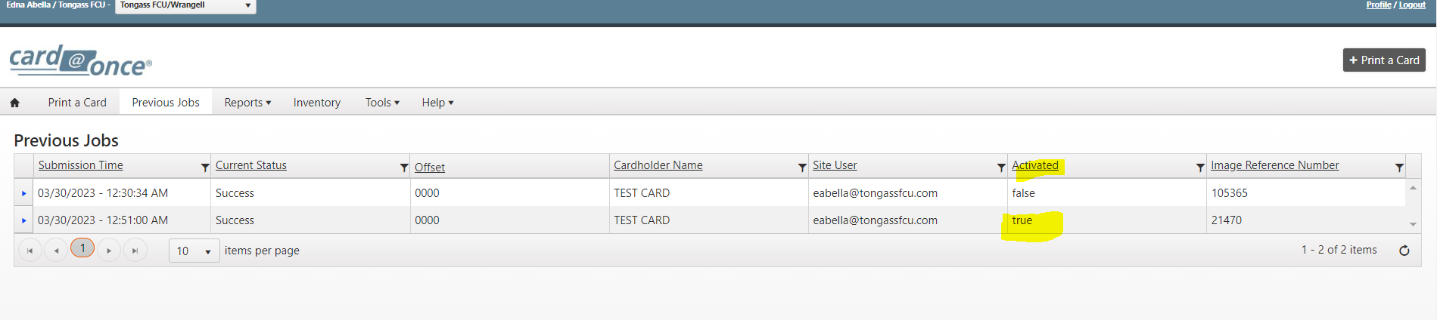
Credit Card Printing
14. Follow the same steps above for credit card printing. The key difference is activation:
a. Consumer Credit: EMV CREDIT-412054
b. Business Credit: EMV BUSINESS CREDIT-474443
15. After printing, credit cards will show 'Activated: False' in Card@Once. This is expected—credit cards must be activated in FIS PaymentOne.  ⛔ All credit cards MUST be activated in FIS PaymentOne. Card@Once activation does not apply to credit cards. | 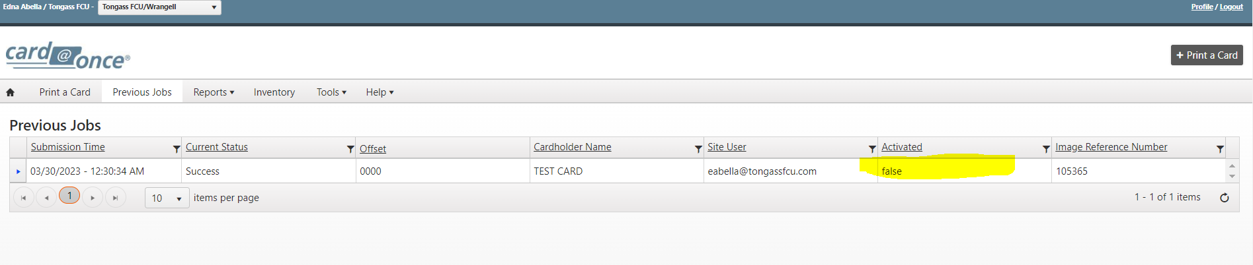
16. Select the 'Previous Jobs' tab to view print history for your branch. Verify debit cards show 'True' under Activated; credit cards will show 'False'. | 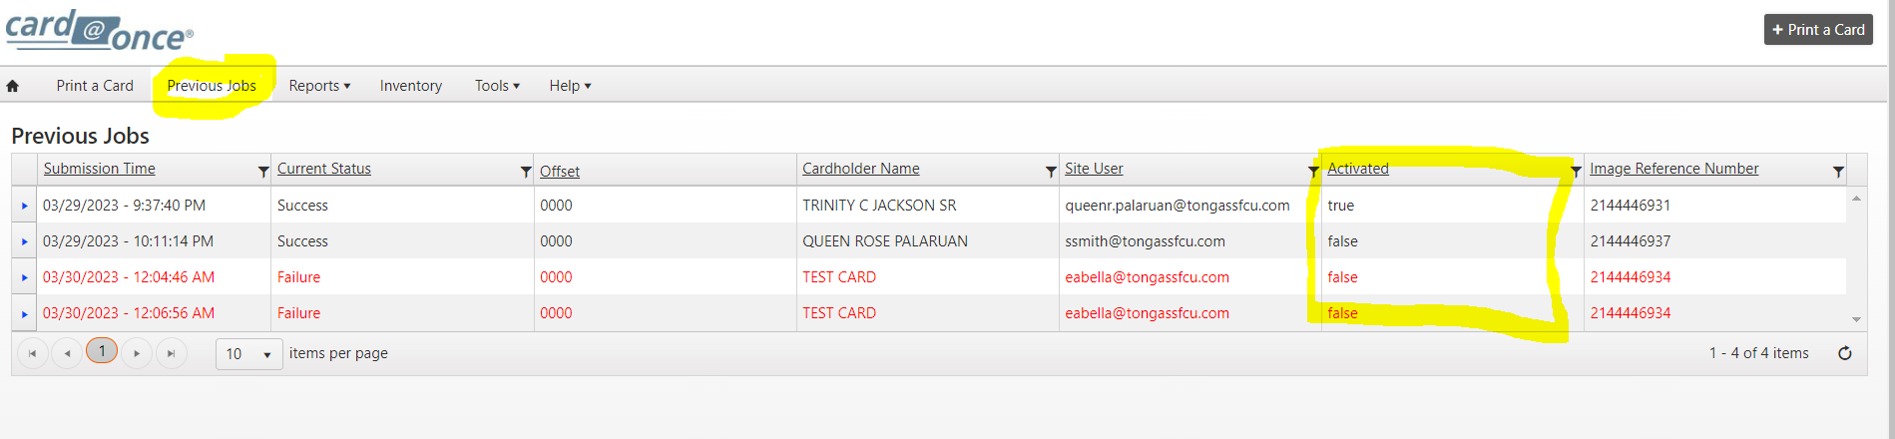
Troubleshooting
Issue | Cause | Resolution
Print error message (red) | Connection or hardware issue | Check: printer connected, no flashing lights, card stock loaded, ribbon installed, internet connected
Error persists after checks | System issue | Log out, restart browser, retry. If still failing, call Card@Once: 1-800-237-3387 (Option 2)
PIN pad not responding | Device disconnection | Use Manual Offset (0000), provide member Re-PIN phone: 1-800-290-7893
Debit card shows 'False' activation | Activation failed | Contact VSR/Card Services for assistance
Credit card shows 'False' activation | Normal behavior | Activate credit cards in FIS PaymentOne (not Card@Once)
Forgot password | N/A | Select 'Forgot your password?' on login page; reset email sent

Manager Reports (Manager Access Only)
17. Select the 'Reports' tab, then select 'Real Time Report' from the dropdown. | 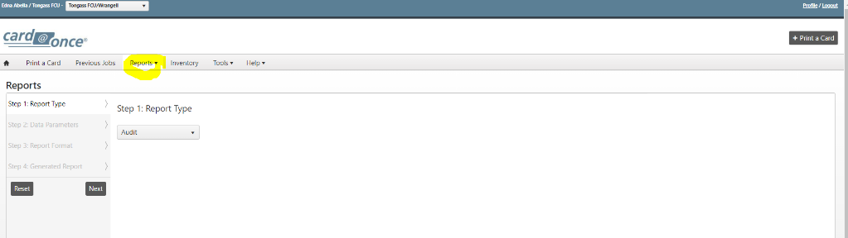
18. Configure the report parameters:
a. Step 1 - Report Type: Select 'Audit'
b. Step 2 - Data Parameters: Enter start and end dates
c. Step 3 - Report Format: Leave as 'Adobe Acrobat (.pdf)'
d. Step 4 - Generated Report: View real-time print job status and errors
19. Select 'Generate Report' to view audit data for the selected date range. This report shows all print jobs and any errors encountered. | 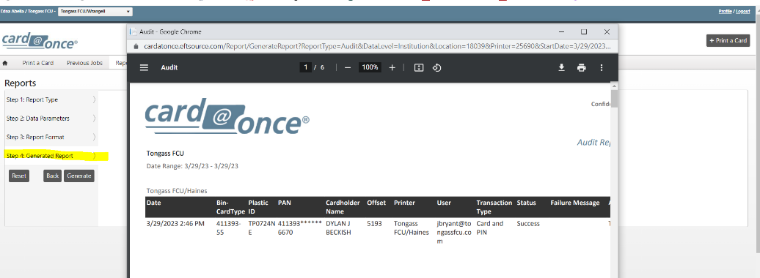
Revision History
Date Updated | Reviewed By | Changes Made
November 2025 | Card Services | Reformatted to TFCU procedure template; reorganized sections; added troubleshooting table

