<https://github.com/k3b/APhotoManager/>

<https://github.com/cgeo/cgeo>

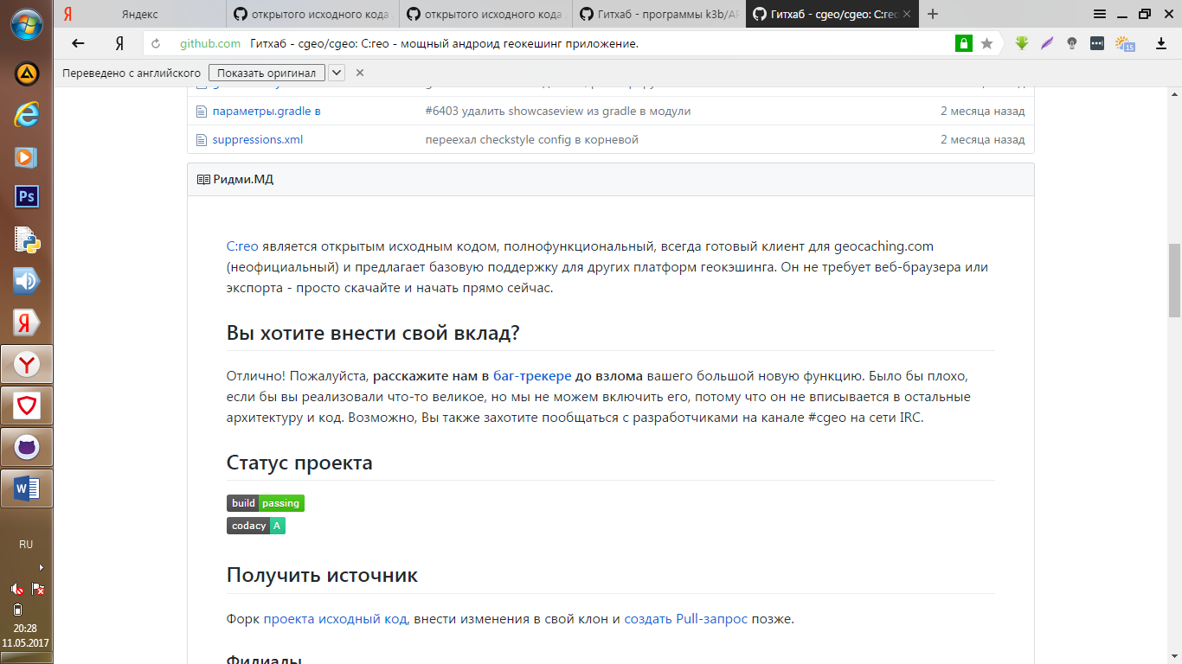

<https://github.com/mapsme/omim>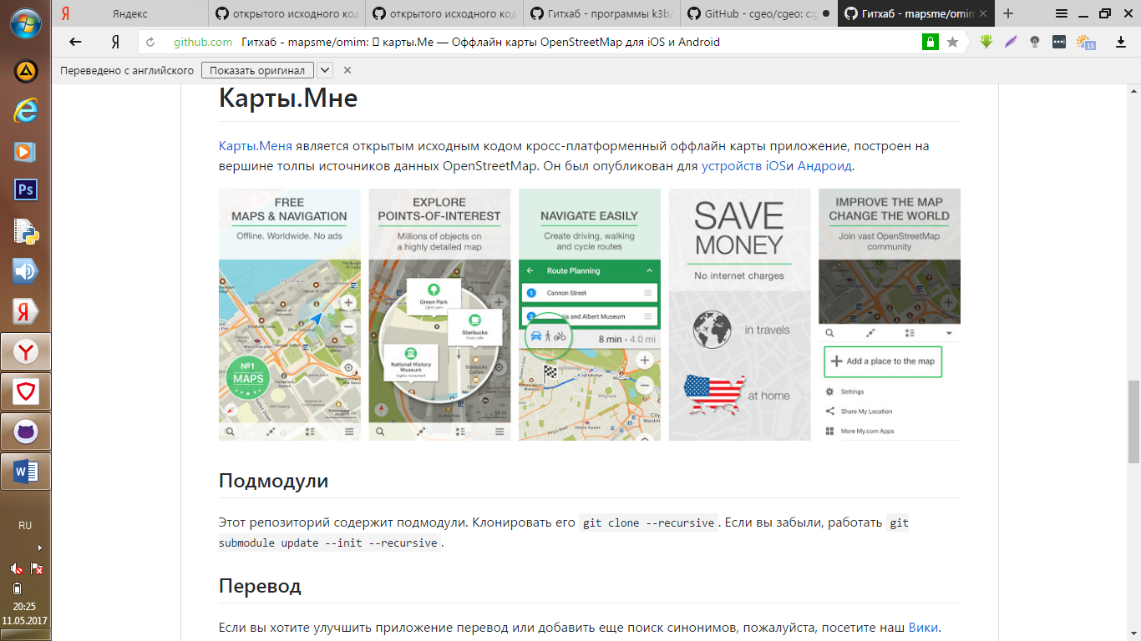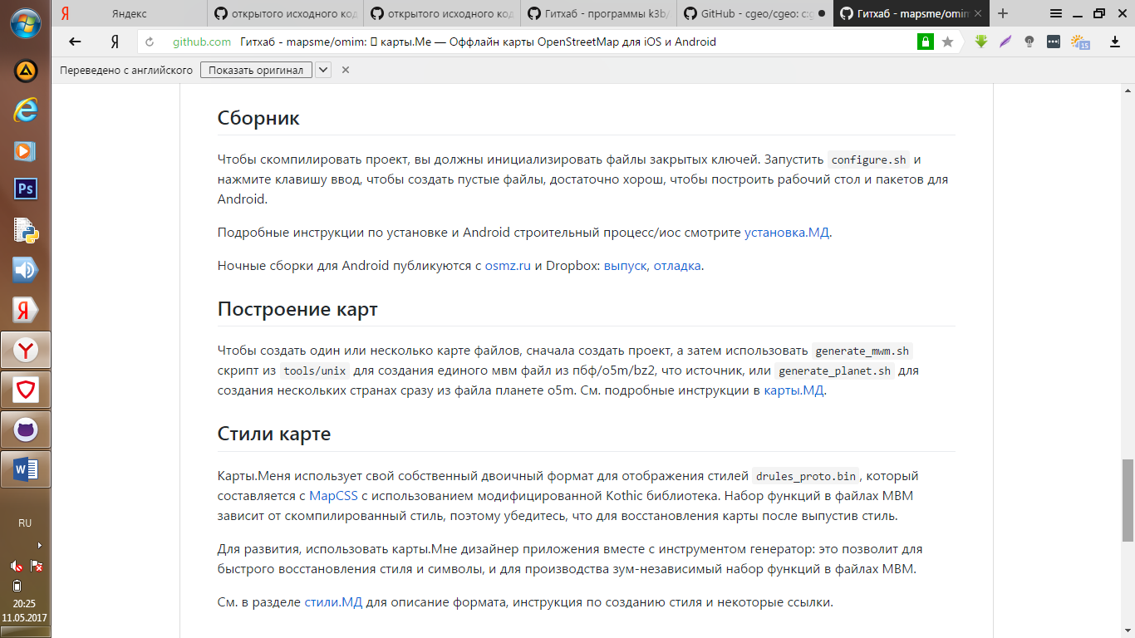

<https://github.com/mapbox/mapbox-android-demo>

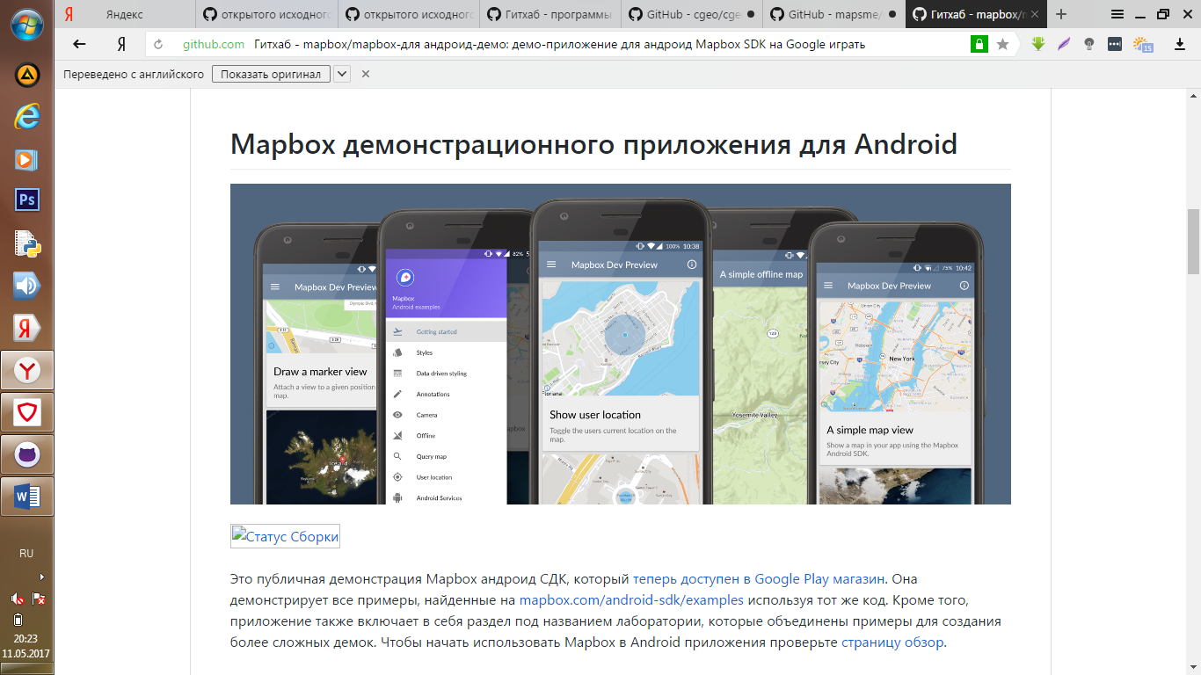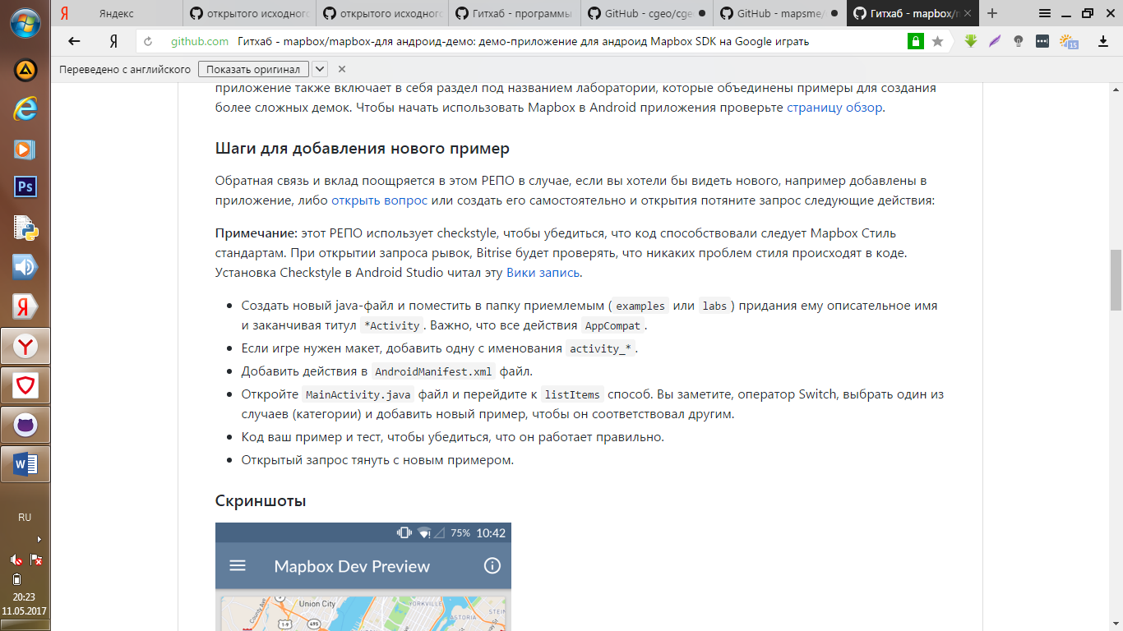

<https://github.com/nextgis/android_gisapp>

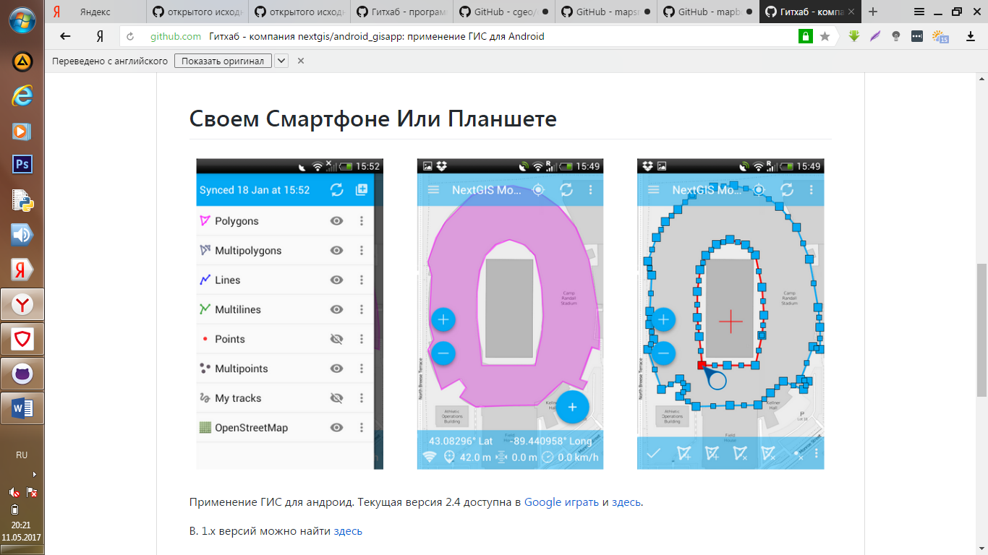

https://github.com/hemant3370/Picoroid