

Multimedia Press Release Templates – Made with Prowly's Press Release Creator

[templates.prowly.com](http://templates.prowly.com)

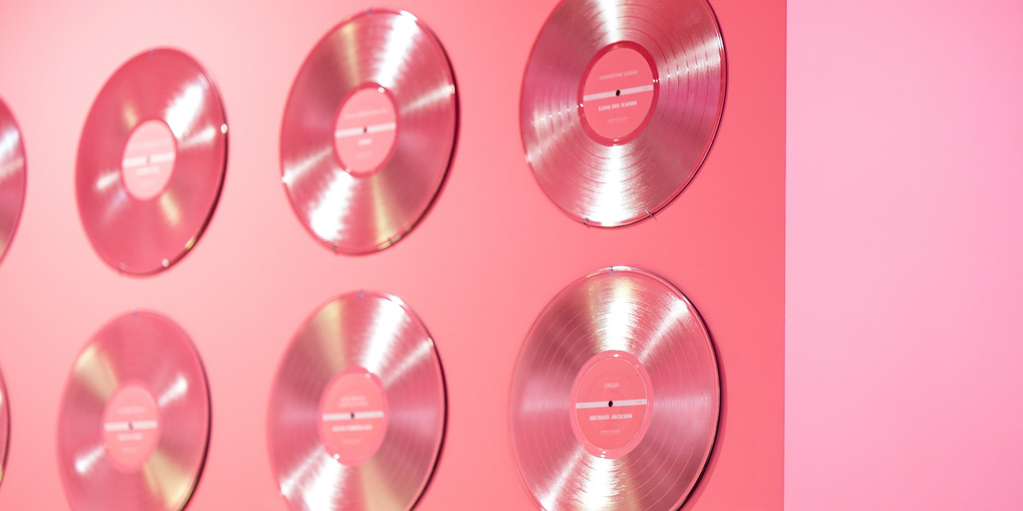

[Optional: Source: unsplash.com]

**Music Press Release Template**

A music press release helps the artist or distributor to get the word out about their latest song or album.

**Headline: {Record Company and/or Artist} Announces the New Album {Title of Album} from {Name of Artist}**

Lead: {City, State} - {Record Company and/or Artist} is thrilled to announce the release of the {latest, debut, etc.} album from {Artist}, {Title of Album}, available everywhere on {Date}.

{Album title} is {description of album, including genre and any other relevant details. Also, include any information about singles, whether already released or about to be released}.

{More details about artist and/or label, including artist's relationship with label}.

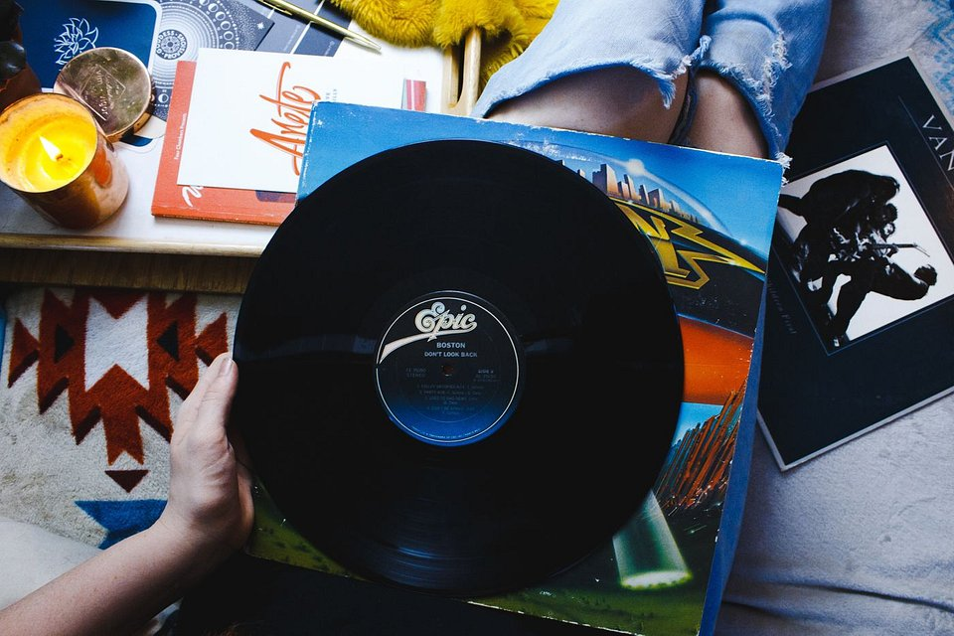

{Image caption}

{Quotes from artist, label representative and/or any critics that received early copies of the album}.

{Name, Surname and Position}

{Boilerplate about record company and/or artist}.

Contact Information:{Record Company and/or Artist}{Contact person and his/her info}:



**Name**

Position at {Record Company and/or Artist}

music@e-mail.com

[Twitter](Twitter Profile)

[Facebook](Facebook Profile)

[Linkedin](LinkedIn Profile)

Photos ready to download:

