**Memo**

**Senior Design**

ENG EC 463

To: Professor Pisano, Professor Alshaykh

From: Michael Ethier, Solomon Utain, Ami Vyas, Alexander Wang

Team: Team 3

Date:

Subject: Second Deliverable Test Report

**1.0 Project Objective**

1.1 The overall goal of this project is to develop a miniature DOS probe capable of measuring metabolic changes in fatty tissue over time. This data would give insight into the hemodynamics of a patient when used as a finger probe and it would also show the effectiveness of various chemotherapy treatments in individual cases of breast cancer when used as a breast probe.

**2.2.0 Test Objective and Significance**

2.1 The significance of this testing is to show that all 4 wavelengths can be emitted from the VCSEL board simultaneously in order to conduct measurements of optical properties of silicone phantoms. Also, the primary goal of this test is to show that the new and improved APD PCB can be placed flush onto a phantom and be tested along with the VCSEL. This should allow for a much less noisy signal since no optical fiber is used to couple the source and detector.

**2.3.0 Equipment and Setup**

PCB Design

To design a PCB, one first needs a circuit diagram to base it off of. In order to make the APD PCB, we obtained some old schematics of APD PCBs from the Electronics Design Facility and analyzed them. The current APD PCB in use in Professor Roblyer’s lab was used as a base for our design. In addition, members of the Electronics Design Facility gave us tips and advice for good PCB design.

The PCB design software ExpressPCB was used to design the board. Factors such as simplicity, ease of use, depth of the individual parts (to keep the APD flush with the surface), soldering ability, and size were considered in the design process. In addition, we tried to take into account the characteristic impedance of the traces themselves, and thus made the traces for the high voltage connection and the RF outputs much larger. Once the board arrived, we soldered the parts on by hand, with the exception of the APD itself. For the APD, we had the EDF solder it on for us, due to its incredibly small contact points.

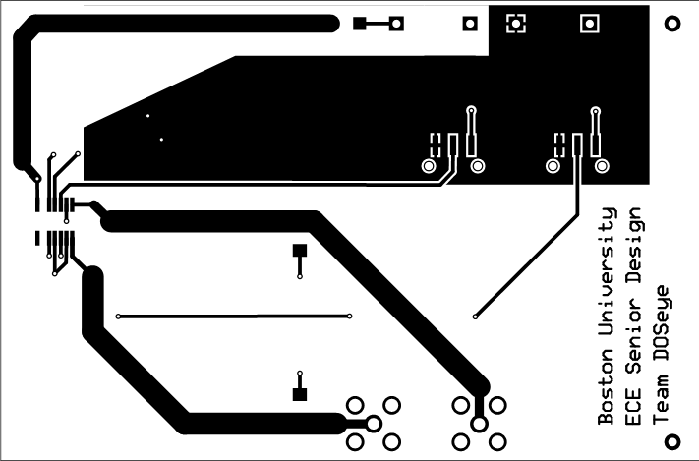

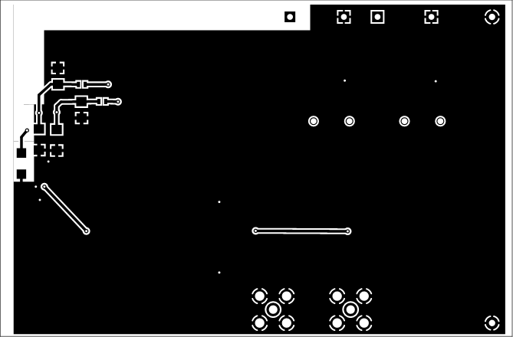

PCB Testing

Place the VCSEL into the VCSEL PCB and make sure that the ground pin on the VCSEL lines up with the top pin on the VCSEL PCB. Connect the current controller to the biased T and then connect the biased T to both the VCSEL PCB and the RF switch. Make all of these connections using RF connectors. The VCSEL will need UMCX adapters. Make the above connections for all 4 wavelengths. Supply 5 V DC to the RF switch. Connect the voltage source to the low voltage input of theAPD PCB and set it to 3.3 V DC. The high voltage inputs should be connected to a high voltage power supply set to 200 V DC. Make sure the APD PCB switches are in the correct configuration. For the first test, they should be in Low Gain, DCFB off. These switch settings correspond with the table below. Make sure all of the USB connections are in place and the computer is running in 32-bit mode for LabView control of components. Make sure that output 1 for the APD board is connected to Port 2 on the network analyzer using an RF connector. Turn on the network analyzer, the current control, the DC power supplies, and the high voltage supply.

For the network analyzer, change measurement to S21 and autoscale the graph. The start and stop frequencies are set to 50 MHz and 500 MHz with a 6 dBm power limit. On the current supply, the current for the lasers should be as written in the table above (can be changed in “Change Settings”). The lasers that are connected should be turned on. In this case lasers 1 through 4 should be turned on.

On the computer, open the DOS System -> Benchtop DOS System -> Senior Design to open the LabView system. Enable saving, and input a file name and ID. Hold the VCSEL so it outputs into the Acrin 009 phantom (This phantom is used because it simulates breast tissue). Place the APD flush onto the surface of the phantom near the VCSEL and measure the source detectorseparation. Input this separation into the LabView program. Make sure that both the VCSEL and APD are near the center of the phantom because near the edges the light scatters in a different way which is not ideal for testing. Click “Change Settings” and set the appropriate currents for each laser. Make sure to take note of which laser is connected to which wavelength of the VCSEL since each wavelength takes a different current and we don’t want to blow out the VCSEL. The VCSEL current table is shown below. Finally, hit the “Take Measurements” button to start the measurements. Repeat thismeasurement for the next test setting with the switches set to Low Gain and Background Correction (DCFB) on. Also, take noise-floor measurements for each of the two settings. This is done by placing the VCSEL and fiber flush onto a piece of rubber which allows no light scattering. For the high gain setting use a balun and connect both output ports on the APD PCB to the inputs of the balun and connect the output of the balun to the Network Analyzer.

Switch Setting Table

|  |  |  |
| --- | --- | --- |
|  | Position 1 | Position 2 |
| Switch 1 | High Gain | Low Gain |
| Switch 2 | DCFBon | DCFBoff |

VCSEL Current Setting Table

|  |  |  |  |
| --- | --- | --- | --- |
| Pin Number | Connection | Max Current | Used Current |
| 1 | 660 nm | 16 mA | 10 mA |
| 2 | 680 nm | 30 mA | 15 mA |
| 3 | 775 nm | 12 mA | 5 mA |
| 4 | 795 nm | 50 mA | 10 mA |
| 5 | Ground | N/A | N/A |

**2.4.0 Measurements and Data**

2.4.1 - Lab Test Results 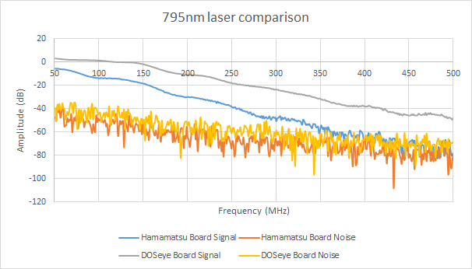

It is clear that the new board made by the DOSeye team had a much higher signal to noise ratio and a much higher overall signal than the old evaluation board. This is most likely because of the elimination of the optical fiber and the new orientation of the board. The matched impedances of the traces on the new board may have also played a role. This graph shows one wavelength out of four for a clear comparison. Both are on the same switch setting - high gain, background correction on.

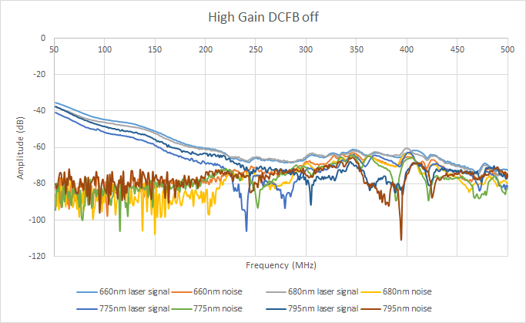

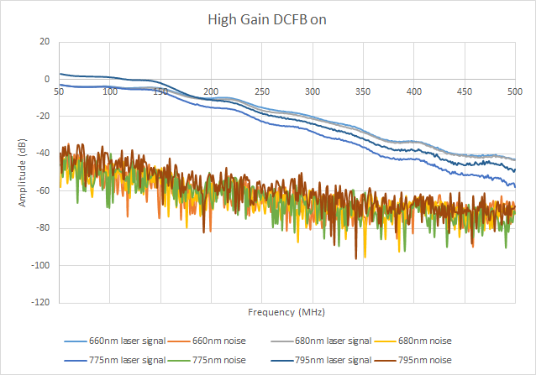

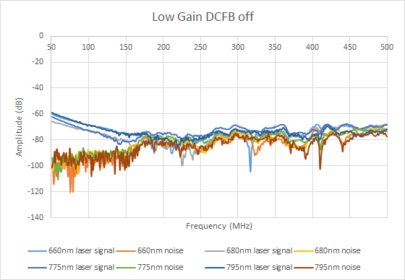

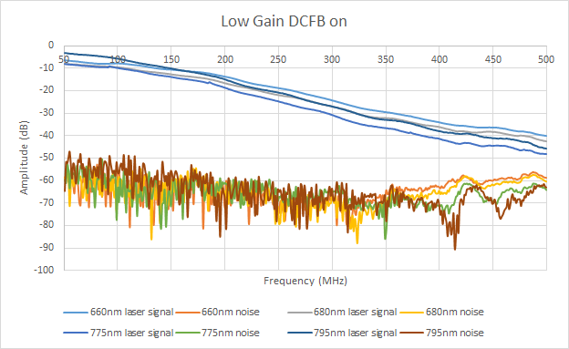

From these results, it can be seen that the DCFB on setting is much better than the DCFB off setting. On this board even more than the other, it is almost crucial that background correction be on for optimal measurements. Otherwise, the signal is almost completely attenuated relatively early on.

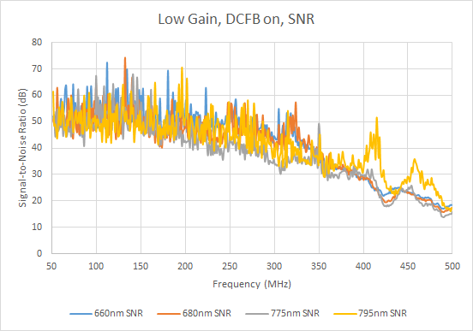

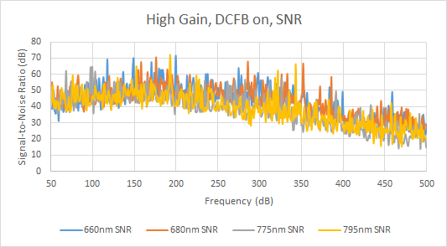

We see a higher signal in the high gain setting, but a higher signal to noise ratio in the low gain setting. However, the SNR in the low gain setting dips in the higher frequencies. This is consistent with the results from the Hamamatsu Evaluation Board. All four wavelengths can be detected with relatively the same consistency, which is good because this will allow the data processing to obtain more accurate scattering and absorption properties of the tissue being measured.

**2.5.0 Conclusions**

2.5.1 Looking at the graphs of the laser measurements, it appears that the graphs for the Low Gain and DCFB ON settings had the best and smoothest results with the least noise. Compared to our first deliverable testing data, these signal to noise ratios are higher which show that our goal of making an improved APD PCB was successful. Now we are able to place the APD flush with the surface of the phantom. This allows us to not have to fiber couple the source and detector which is why the signal to noise ratio for the data from this new APD PCB is much higher than that of the original evaluation board from Hamamatsu.

**3.2.0 Test Objective and Significance**

3.2.1 A crucial component of the database that will be used to store patient data is the tags associated with database uploads. Tags are what will organize data by such categories as patent name, date of recording, equipment used, etc. Each data recording session creates multiple files composed data and metadata. For autonomous database uploads, a script is needed to parse through these files, generating relevant tags from the metadata. Metadata is always stored in a distinct number of known locations in the file, so with a predefined file structure, generating tags is a matter of parsing through text.

**3.3.0 Equipment and Setup**

3.3.1 *Environment*

The C++ script was run in a Linux environment using the G++ compiler, with data files in a known local directory.

3.3.2 *Program flow*

*Detect File Structure*

Depending on the DOSI system used, data output has different file structures. The vast majority have their metadata as a header in the first several lines of the file, with a descriptive filename that designates the order which the data was recorded. A minority of files from DOSI systems used in clinical trials have metadata in both headers and footers, with a descriptive filename that designates the date of data collection. Presently, all files generated from our probe contain all their data in the file’s header.

*Extract Metadata*

The text within the file formats is predictable and consistent, so the start and end of contained metadata is simple to detect. The lines that compose metadata are written into a vector of strings to be parsed through later.

*Organize as Tags*

Lines of metadata are typically of the format “title: value”. The script looks for this format in each line of metadata. Titles and values are separated by looking for “: ”, i.e. a space and a colon. These values are written to two vectors of strings, one vector for tags and the other for values for each title.

**3.4.0 Measurements and Data**

3.4.1 With an input file containing the following header:

*Patient ID: 1002*

*Source fiber name: miniLBS*

*Study file: B*

*Number of Lasers: 4*

*Data Calibrated?: 0*

*Source-Detector (mm): 22.00*

*Number of scans: 1*

*Number of sweeps/scan: 2*

*Freq Range(MHz): 50.000 - 500.000*

*Number of points: 451*

*Date acquired: 03-24-2016 10:01:23*

*Laser names: 659 689 781 829 *End of laser names*

*\*\*\*\*\*\*\*\*\*\*\*\*\*\*\*\*\*\*\*\*\*\*\*\*\*\*\*\*\*\*\*\*\*end of header*

The program produces the following results:

*TAG 1: Patient ID*

*VALUE 1: 1002*

*TAG 2: Source fiber name*

*VALUE 2: miniLBS*

*TAG 3: Study file*

*VALUE 3: B*

*TAG 4: Number of Lasers*

*VALUE 4: 4*

*TAG 5: Data Calibrated?*

*VALUE 5: 0*

*TAG 6: Source-Detector (mm)*

*VALUE 6: 22.00*

*TAG 7: Number of scans*

*VALUE 7: 1*

*TAG 8: Number of sweeps/scan*

*VALUE 8: 2*

*TAG 9: Freq Range(MHz)*

*VALUE 9: 50.000 - 500.000*

*TAG 10: Number of points*

*VALUE 10: 451*

*TAG 11: Date acquired*

*VALUE 11: 03-24-2016 10:01:23*

*TAG 12: Laser names*

*VALUE 12: 659 689 781 829*

**3.5.0 Conclusions**

3.5.1 This script provides reliable tag generation from the data files produced by our DOSI system. This is essential functionality for organizing these data files into a database. With these tags, all recorded data can be grouped into categories and filtered by the information they contain. Because this script is capable of interpreting metadata and outputting tag values as text, these values can be easily passed onto what will become the next script in the database commit process. Further, because this system is capable of *interpreting* the formatting in the metadata rather than looking for keywords, it supports any arbitrary tag name as long as it follows the defined format, which is relevant for expanding this system to support different DOSI systems used in the clinic which produce a variance of tag names.