5. Producing trace messages and accessing trace span in Jaeger

Publishing messages using a simple jms application

We have provided a simple JMS publishing application in solace-publisher.jar.

As you follow the steps in this codelab don’t forget to replace the IP address in the command with your system's IP address if docker compose is not running on a same host.

If Docker is running on the same system (which is expected) where you are running solace-publisher, you can use the following command:

[pl89@dev tracing-codelab]$

java -Dsolace.host=localhost:55557 -Dsolace.vpn=default -Dsolace.user=default -Dsolace.password=default -Dsolace.topic=solace/tracing -jar solace-publisher.jar/tracing -jar ace-publisher.jar

Jaeger UI

As part of an earlier step, the Jaeger UI was launched. It can be accessed using your favourite browser.

If Docker is running on the same system your browser is running on, you can access the Jaeger UI using the following URI: <http://0.0.0.0:16686/>. If Docker is running on another system in your network, simply replace 0.0.0.0 to the system's IP, e.g. http://192.168.3.166:16686/.

Verify published messages are traced in the Jaeger UI

After the OpenTelemetry Collector has received a message, you should be able to see the solbroker trace. Once the right service has been selected, select "Find Traces" button. 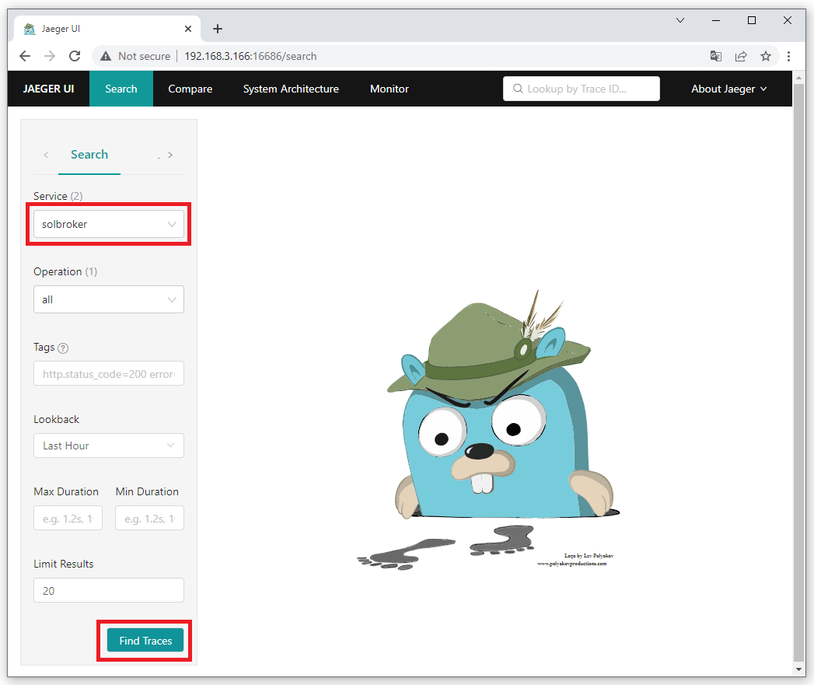

You should now see a trace for the message published using solace-publisher from the previous step. 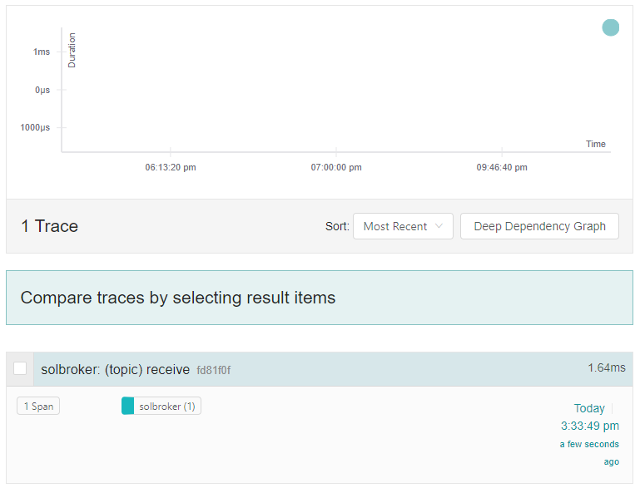

To view more details about this trace, click on it. You can also expand various boxes for more information.displayed. 