6. Jaeger UI - Searching for traces

Publishing more interesting messages

Let's publish three messages with user properties so that we can search for them on Jaeger. The messages will contain the following {key,value} pairs.

1. {myKey,myValue1}
2. {myKey,myValue2}
3. {myKey,myValue3}

java -Dsolace.user-properties=“myKey=myValue1” -Dsolace.host=localhost:55557 -Dsolace.vpn=default -Dsolace.user=default -Dsolace.password=default -Dsolace.topic=solace/tracing -jar solace-publisher.jar

java -Dsolace.user-properties=“myKey=myValue2” -Dsolace.host=localhost:55557 -Dsolace.vpn=default -Dsolace.user=default -Dsolace.password=default -Dsolace.topic=solace/tracing -jar solace-publisher.jar

java -Dsolace.user-properties=“myKey=myValue3” -Dsolace.host=localhost:55557 -Dsolace.vpn=default -Dsolace.user=default -Dsolace.password=default -Dsolace.topic=solace/tracing -jar solace-publisher.jar

Verifying traced messages in the Jaeger UI

If you look at the details for the third message published, notice how it has a tag with the user property provided by the publisher. 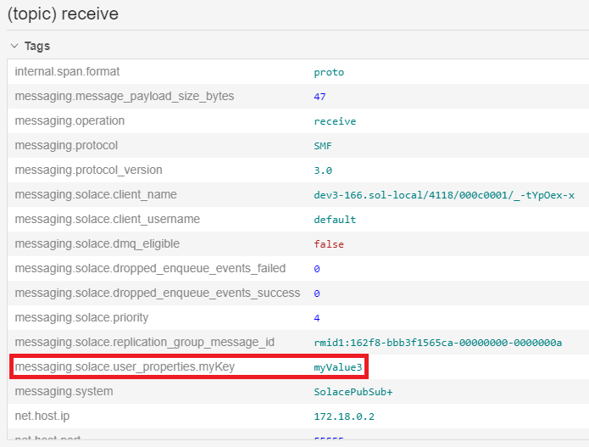

That value can be used for searching traces. On the Search page, search for the following tag: messaging.solace.user_properties.myKey=myValue3 This request should find the third message published.

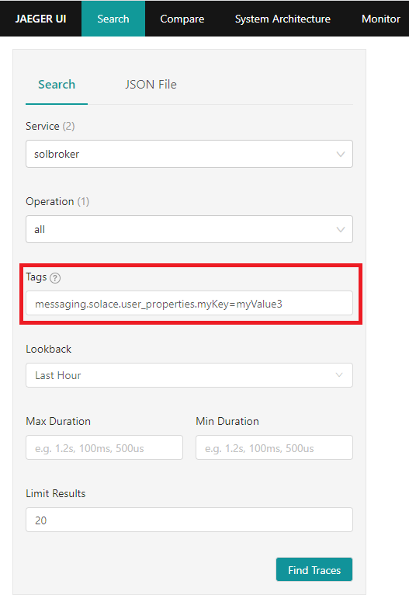

Using Jaeger to debug problems

In an earlier section, we created a queue which had a subscription to topic solace/tracing. Let's try publishing a message to the topic solace/tracing2, a topic for which no client or endpoint is subscribed.

[pl89@dev tracing-codelab]$

java -Dsolace.host=localhost:55557 -Dsolace.vpn=default -Dsolace.user=default -Dsolace.password=default -Dsolace.topic=solace/tracing2 -jar solace-publisher.jar

Notice the message from the app No Subscription Match - Topic 'solace/tracing2'. The message is considered as errored because it was discarded by the broker.

From the Jaeger UI, search for the following tag error=true

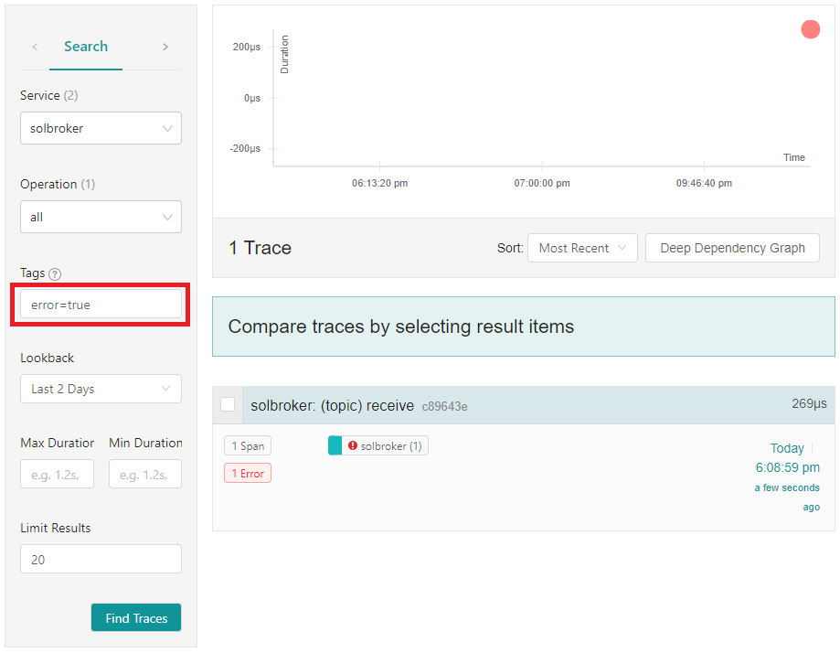

If you select the message and expand its detailed view, you will see that the message published had No Subscription Match. 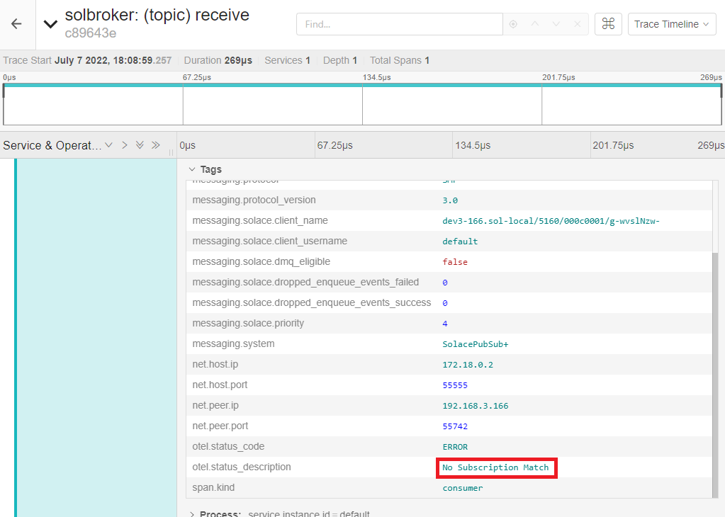

This information can be used to perform any corrective actions, e.g.:

* Fix the publisher and have it publish to the intended topic
* Update the broker configuration and have your queue also subscribe to topic solace/tracing2