Hawassa University
Institute of Technology
Department of Computer Science

Advisor:- Mr. Merodak

Project Title:
Tutor-Connect Web-Application
A group project submitted to the department of Computer Science, Institute of Technology, Hawassa University, in meeting the preliminary project requirement for partial fulfillment of the award of Bachelor of Science degree in Computer Science

Name | Id
Solomon Timiso | 1316/15
Lidiya Simeneh | 0891/15
Fenan Gadisa | 0568/15
Tebarek Zewude | 1353/15

Declaration
We declare that this project has been composed solely by ourselves and that it has not been submitted, in whole or in part, in any previous application for a degree. Except where stated otherwise by reference or acknowledgement, the work presented is entirely our own. Group members name and signature:
Name signature
Solomon Timiso _____________
Lidiya Simeneh _____________
Fenan Gadisa ______________
Tebarek Zewude ______________

Approval sheet
This group project entitled “Tutor-Connect Web-Application” has been read and approved as meeting the preliminary project requirements of the Department of Computer Science in partial fulfillment for the award of Bachelor of Science degree in Computer Science, University of Hawassa, Hawassa, Ethiopia.

Name of advisor: __________________________
Date: _____________________ Signature: _________________
Name of project coordinator: ___________________________________
Date ____________________ Signature ________________
Name of department head: ___________________________________
Date ____________________ Signature _______________
Name of examiner 1: ___________________________________
Date ____________________ Signature _______________
Name of examiner 2: ___________________________________
Date ____________________ Signature ______________

Acknowledgment
First and foremost, and above all, we give our deepest thanks to Almighty God, whose grace, guidance, and blessings made everything possible. Without His will, strength, and protection, the successful completion of this project would not have been achievable.
Secondly, we would like to express our sincere and heartfelt gratitude to our advisor, Mr. Merodak, for his scholarly guidance, constructive comments, continuous encouragement, and unreserved support throughout every stage of this project. His valuable advice, patience, and professional supervision from the very beginning up to the final accomplishment of the project were truly instrumental in shaping this work.
We would also like to extend our appreciation to the Department of Computer Science and the Institute of Technology, Hawassa University, for providing us with the necessary academic environment, resources, and support required to carry out this project successfully.

Contents
Declaration ii
Approval sheet iii
Acknowledgment iv
List of Figure viii
List of Table ix
Abbreviations and acronyms xi
CHAPTER ONE 1
Background of the Study 1
Statement of the Problem 2
General Objective 3
Specific Objectives 3
Scope of the Study 4
Limitation of the Study 4
Methodology 5
Data Collection Methodology 6
Interview 6
Survey 6
Document and Record Review 6
System Analysis and Design Methodology 6
1. Requirement Analysis 6
2. System Design 7
3. Implementation 7
4. Testing Methodology 8
5. Deployment 8
Development and Working Environment 8
Software Environment 8
Hardware Environment 9
Feasibility Study 9
Technical Feasibility 9
Operational Feasibility 9
Economic Feasibility 9
Estimated Budget 10
Gantt Chart Timeline 10
CHAPTER TWO 12
2 DESCRIPTIONS OF THE EXISTING SYSTEM 12
2.1 Introduction of the Existing System 12
2.2 Objectives of the Existing System Study 12
2.3 Description of the Existing System 12
2.4 Strengths of the Existing System 13
2.5 Weaknesses of the Existing System 14
2.6 Proposed System Description 14
2.7 Comparison Between the Existing and Proposed Systems 15
CHAPTER THREE 17
3.1 Functional Requirements 17
3.1.1. User Management & Authentication 17
3.1.2. Tutor Verification & Administration 17
3.1.3. Tutor Search & Booking 17
3.1.4. Wallet and Payment System 18
3.1.5. Classroom & Activity Management 18
3.1.6. Administrative Operations 19
3.2 Non-Functional Requirements 19
3.2.1. Performance Requirements 19
3.2.2. Security Requirements 19
3.2.3. Reliability and Availability Requirements 20
3.2.4. Usability Requirements 20
3.2.5. Maintainability and Extensibility Requirements 20
3.3 Analysis Models 21
3.3.1 Use-Case Diagram 22
3.3.2 Use-Case Description 23
3.3.3 Sequence Diagram 42
ActivityDiagram 54
3.4 Class Diagram 67
3.5 User Interface Diagram 68
Chapter 4 71
4. SYSTEM DESIGN 71
4.1. Introduction to System Design 71
4.2. Purpose of the System Design Document 71
4.3. Scope of the System Design 72
4.4. Architectural Design 73
4.2.5 Logical Database Design 94
4.2.6 Physical Database Design 95
4.2.7 Normalization 96
CHAPTER FIVE 100
5. CONCLUSION AND RECOMMENDATION 100
5.1. Conclusion 100
5.2. Recommendation 101
APPENDIX 102
References 103

List of Figure
Figure 1 Use-Case Diagram for Tutor Connect 22
Figure 2 Registration Sequence Diagram 43
Figure 3 Login Sequence Diagram 44
Figure 4 Upload Verification Sequence Diagram 45
Figure 5 Booking Sequence Diagram 46
Figure 6 Search Sequence Diagram 47
Figure 7 Complaint Sequence Diagram 48
Figure 8 Deposit Money Sequence Diagram 49
Figure 9 Withdraw Sequence Diagram 50
Figure 10 Edit Profile Sequence Diagram 51
Figure 11 Create class Sequence Diagram 52
Figure 12 Join Class Sequence Diagram 53
Figure 13 Registration activity diagram 54
Figure 14 login activity diagram 55
Figure 15 Tutor portfolio upload activity diagram 56
Figure 16 Tutor Portifolio Approval Activity Diagram 57
Figure 17 Book Tutor activity diagram 58
Figure 18 TutorAccept Booking Activity Diagram 59
Figure 19 Booking Schedule Management Activity Diagram 60
Figure 20 Wallet deposit and withdraw activity diagram 61
Figure 21 Payment Handling Activity Diagram 62
Figure 22 Online Classroom Learning Diagram 63
Figure 23 User account management Activity Diagram 64
Figure 24 Staff Account Management Activity Diagram 65
Figure 25 Complaint management Activity Diagram 66
Figure 26 Class diagram 67
Figure 27 Home page 68
Figure 28 Login page 69
Figure 29 Book session 69
Figure 30 Main dashboard 70
Figure 31 Registration page 70
Figure 32 Architectural Design 74
Figure 33 Process Model. 75
Figure 34 Process Model to Design Model 77
Figure 35 Processes to Implementation 77
Figure 36 Deployment diagram 80
Figure 37 E-R diagram 94
Figure 38 Logical Database 95
Figure 39 Physical database 96

List of Table
Table 1 Estimated budget 10
Table 2 Timeline 11
Table 3 Comparison 16
Table 4 Register Use Case description 23
Table 5 Login Use Case description 24
Table 6 Upload Verification Documents Use Case description 24
Table 7 Review Tutor Documents and Approve/Reject Tutor Use Case description 25
Table 8 Search Tutor Use Case description 25
Table 9 Book Tutor & Pay Booking Use Case description 26
Table 10 Complete Class Use Case description 26
Table 11 Release Payment Use Case description 27
Table 12 Deposit Money Use Case description 28
Table 13 Withdraw Money (Student) Use Case description 28
Table 14 View Balance & Transaction History (Student) Use Case description 29
Table 15 Withdraw Earnings (Tutor) Use Case description 29
Table 16 View Earnings (Tutor) Use Case description 30
Table 17 Submit Complaint Use Case description 31
Table 18 Handle Complaint Use Case description 31
Table 19 Manage Users Account (Activate/Deactivate) Use Case description 32
Table 20 Create Class Use Case description 32
Table 21 Join Class Use Case description 33
Table 22 Create Virtual Meeting Use Case description 33
Table 23 Cancel Class Use Case description 33
Table 24 Submit Classroom Exercises Use Case description 34
Table 25 Rate/Review Tutor Use Case description 34
Table 26 Reschedule Booking Use Case description 35
Table 27 Request Refund Use Case description 35
Table 28 Manage Profile Use Case description 35
Table 29 View Verification Status Use Case description 36
Table 30 Availability Use Case description 36
Table 31 Update Availability Use Case description 37
Table 32 View Transaction History (Tutor) Use Case description 37
Table 33 View Analytics Dashboard Use Case description 38
Table 34 View System Logs Use Case description 38
Table 35 Manage Staff Accounts Use Case description 39
Table 36 View Tutor Use Case description 40
Table 37 Accept or Reject Bookings Use Case description 40
Table 38 View Pending Tutor Applications Use Case description 40
Table 39 Use Case Name: Accept Complaints 41
Table 40 Deactivate Account Use Case description 41
Table 41 Activate Account Use Case description 42
Table 42 Update Account (Staff Controlled) Use Case description 42
Table 43 Delete Staff Account Use Case description 42
Table 44 User 80
Table 45 Student Profile 81
Table 46 Tutor Profile 81
Table 47 Wallet 82
Table 48 Subject 82
Table 49 Tutor subject 83
Table 50 Availability 83
Table 51 Booking 84
Table 52 Classroom 85
Table 53 Class Chapter 85
Table 54 Classwork 86
Table 55 Submission 87
Table 56 Hold Payment 87
Table 57 Wallet Transaction 88
Table 58 Withdrawal Request 89
Table 59 Refund Request 89
Table 60 Complaint 90
Table 61 Rating Review 90
Table 62 Notification 91
Table 63 Progress Tracking 91
Table 64 Session Plan 92
Table 65 Unnormalized Data 97
Table 66 First Normalization 97
Table 67 User 98
Table 68 User Role 98
Table 69 User Phone 99
Table 70 Subject 99
Table 71 User_subject 100
Table 72 Subject 100
Table 73 User_subject 100

Abbreviations and acronyms
AI – Artificial Intelligence
API – Application Programming Interface
CGPA – Cumulative Grade Point Average
DFD – Data Flow Diagram
ER Diagram (ERD) – Entity Relationship Diagram
ETB – Ethiopian Birr
GPA – Grade Point Average
HTML – HyperText Markup Language
ID – Identification
IT – Information Technology
JWT – JSON Web Token
ML – Machine Learning
MVP – Minimum Viable Product
NFR – Non-Functional Requirement
OS – Operating System
RBAC – Role-Based Access Control
SDLC – System Development Life Cycle
UI – User Interface
UAT – User Acceptance Testing
URL – Uniform Resource Locator

CHAPTER ONE

Background of the Study
In the current Ethiopian education landscape, there is a high demand for extracurricular academic support. There are many students and parents actively seeking private tutoring to improve academic achievement, pass public exams, and become competitive. However, searching for competent and credible tutors is largely informal and based on word of mouth, recommendations through social media, or unverified local postings. This patchy approach tends to leave one suspicious of a tutor's credentials, authenticity, and background.
While this is happening, many qualified tutors and potential tutors lack the ability to contact students who need their services. They lack a structured platform to showcase their abilities, gain credibility, and gain more visibility beyond their immediate social networks. This disparity serves as a bottleneck to accessing education for students alongside work opportunities for the tutors.
The "Tutor-Connect" website is proposed to fill this gap. It will establish an official, secure, and transparent online marketplace connecting students with certified tutors across Ethiopia. Utilizing a formal verification process for tutor credentials as well as user identities, the website will establish a safe platform for educational support. This project not only makes it easier to recruit and hire tutors but also aligns with Ethiopia's national digital vision, the "Digital Ethiopia 2025" strategy, which is aimed at using technology to enhance accessibility and efficiency in core sectors like education. The site will establish connections for remote and face-to-face tutoring to accommodate the different needs of learners in urban and rural areas.

Statement of the Problem
The existing mechanisms for finding private tutors in Ethiopia are inefficient, unreliable, and lack a quality and security check standard process. This disorganized setting presents significant challenges to students, parents, and tutors, discrediting quality learning support. The core issues can be classified as follows:
• Lack of a Centralized and Available Platform: Currently, there is no structured, dedicated digital platform in Ethiopia for locating tutors. Students and parents need to work their way through a chaotic system of social media groups, messaging apps, and word of mouth, which is time-consuming and typically provides limited options.
• Lack of Verification and Trust: The greatest issue is the fact that there is no formal verification process. Tutors do not have verified qualifications, proof of competence, or ID checks. This exposes students to fraud, low-quality instruction, and safety hazards for themselves, creating a massive shortfall of trust in the market.
• Limited Visibility and Reach for Tutors: Trained tutors risk rendering their services futile because they have no appropriate means to market their services. They can only access their immediate network and therefore have no access to a broad group of potential customers.
• Poor Communication: Everything is done by way of scheduling, negotiation, and communication through different informal avenues (calls, other messaging platforms), and these lead to no clear records, possibility of miscommunication, and inability to handle tutoring arrangements professionally.
These are causes of an unorganized, inefficient, and unreliable setting that is profitable for neither students seeking reliable educational support nor competent tutors seeking employment. "Tutor-Connect" aims to solve these problems by providing a solitary, genuine, and secure platform through which all the tutoring-related transactions occur.

General Objective
The general objective of this project is to develop web-based tutoring platform that connects students with verified tutors.

Specific Objectives
To achieve the general objective, the following specific objectives will be pursued:
- To design and develop a secure system architecture with distinct user roles and interfaces for Students, Tutors, and Verification Staff.
- To implement a comprehensive, staff-led verification workflow to authenticate tutor portfolios (educational certificates, experience) and the identities of all users before their accounts are activated.
- To develop system that allows students to search for and filter tutors based on criteria such as subject, grade level, location, and user ratings.
- To build a secure communication channel that facilitates initial contact between verified users for arranging both virtual and in-person tutoring sessions.
- To integrate features that promote transparency and trust, including a two-way rating and feedback system for engagements between tutors and students.
- To ensure the platform is accessible to a wide audience by providing user interfaces in both English and Amharic.
- To conduct thorough testing of the system's functionality, security, and usability to deliver a stable and reliable final product.
- To develop a secure wallet-based payment system that supports deposits and withdrawals using Chapa or Telebirr, with automated fee holding, release, and refund mechanisms.
- To implement virtual classroom features including online meetings, chat-based negotiation, class scheduling, task management (classwork, homework, assignments, quizzes), and progress tracking.
- To provide an administrative dashboard enabling staff management, financial analytics, system monitoring.

Scope of the Study
This project is focused on delivering a Minimum Viable Product (MVP) of the "Tutor-Connect" web platform. The scope is confined to the core functionalities necessary to create a secure and usable environment for connecting students and tutors. In addition to these core features, the system will include a wallet-based payment module, virtual classroom capabilities, a structured scheduling system, online meeting support, and a comprehensive Admin dashboard. These functionalities ensure that the platform not only connects students and tutors but also manages the full lifecycle of tutoring sessions, payments, verification, and communication. The primary features included in the scope are:
- User Roles and Profiles: Development of four distinct user roles: Student, Tutor, Verification Staff, and Admin. each with a dedicated dashboard and functionalities. Tutors will be able to create detailed profiles and upload portfolio documents. Admin, will be included to manage Staff accounts, oversee system-wide analytics, and ensure smooth financial and verification operations.
- Verification System: Implementation of a manual, staff-led verification process for tutor credentials and the identities of all users. A profile will only become publicly visible after successful verification.
- Search and Connection: A search and filter mechanism for students to find tutors. A secure system for sending contact requests and establishing initial communication will be included.
- Ratings and Administration: A feature for students and tutors to rate each other after an engagement. An admin dashboard will also be developed for system oversight and basic analytics.

Limitation of the Study
To ensure the project is completed successfully within the final year project timeline, certain advanced features will be considered limitations and will be excluded from the scope of this project. These limitations include:
- No AI-Powered Recommendations: The tutor matching system will be based on user-selected filters. The project will not implement an AI or machine learning model for automated tutor recommendations this limitation happens because Lack of advanced programming, AI and ML practical skills due to limited exposure.
- Time and resources: As the project will be developed in one semester which limits the number of advanced features.
- Data availability: It might be hard to find reliable local data or reliable references about tutoring services.
- Internet connectivity: Unstable connections can slow down implementation, development and testing stages.
- Budget constraints: Limited funds restrict options for hosting or purchasing premium tools.
Methodology
Our project intended to build web platform that connect tutors with students for virtual study or In person study according to the needs and availability of the students. The project assumes many tutors(High School Students, University students, and Teachers) struggles to find an opportunity to change their knowledge in to pocket money. In other side the Students(anyone who needs tutoring services for themselves or for their children as a parent) struggles to find a verified and qualified tutors around their environment for in person study or wherever it is they are challenged to find virtual tutors also. To find other unseen real-world problems and to fill the gap tutor connect need to understand how students and tutors are connected in Ethiopia. To do this our team collect quantitative and qualitative data from both sides using interviews and survey This methodology section explains the methods we will use to gather and analyze data, and how we will apply this information during system design, development, testing, and deployment phases of our project. The techniques we have chosen are interview, survey, and document review aligned within the common research tradition in software development projects. These methods are effective for identifying user requirements and validating the system design.For this project we will use the Agile methodology because Agile divides the work into short cycles (sprints) and it follows continuous feedback loop. This kind of flexibility is important for our project, where new ideas or user requirements and refinement with our advisor may appear during development of the project.

Data Collection Methodology
The following techniques were selected because they are effective and suitable for gathering both qualitative and quantitative data and information.

Interview
We will conduct short interviews with students, tutors, and parents because these interviews will help us to understand what kind of real-world challenges they are facing, how Students/parents are finding tutors and how tutors also finding clients from their personal experiences. In addition to this we collect what kind of features both sides are expecting from the platform. This method allows open discussions and flexibility so it helps us to get detailed feedback.

Survey
Using this technique, we will distribute short survey using google Forms and Hard copy paper written forms. The survey includes multiple choice and rating questions because it will help us to gather measurable data like percentage of students who prefer tutor, the most requested subject and other related data. This data helps us in designing filtering and matching system for the platform.

Document and Record Review
We will also review existing materials such as social media posts, flyers, and websites where tutors currently advertise their services. This helps us identify what information students usually look for (like subject, price, or experience) and what is missing most of the time.

System Analysis and Design Methodology
After collecting all the required data, our team will analyze the information to clearly understand the system requirements and will change them into a practical design. On this stage our team defines how the system will work and how users will interact with it. We will follow System Development Life Cycle (SDLC) which includes requirement analysis, system design, implementation, testing, and deployment phases.

1. Requirement Analysis
Starting from the data gathered through interviews, surveys, and record/document review we will identify the main functional and non-functional requirements.
- Functional requirements: - which include functions like user registration, tutor verification, profile management, search and filtering, and scheduling.
- Non-functional requirements: - which focus on performance, security, and usability.

2. System Design
In this stage we will prepare diagrams and models to describe the system architecture and data flow.
- Use Case Diagram: Shows how students, tutors, and staff/admin interact with the system. Which is necessary before implementing the system.
- Entity Relationship (ER) Diagram: which describes how data like users (admin, student, tutor), subjects, schedules, and reviews are matched in the database with their relationships with each other.
- Data Flow Diagram (DFD): Illustrates how information moves between different system components.
- Interface Design (UI): Using Figma we will design a responsive for every smart device screen, simple and user-friendly layout with clear navigations.
We will also plan the backend and frontend structure. The frontend will be developed using Next.js(a JavaScript framework), while the backend will use Node.js and Postgres will store data, and Next AUTH (built in authentication method of Nextjs framework) will be used for authentication and authorization.

3. Implementation
After finishing the system design we follow Agile development methodology which will divide the work into small sprints and the team will focus on delivering the required features in each phase and then the coding stage starts with the implementation of each functions or modules. Our team uses Git and GitHub for collaboration and version control and each module will be tested immediately after development to avoid delays later.
The implementation will include:
- User Registration Function
- Tutor Verification Function
- Search and Matching Algorithm
- Booking and Review System
- Admin Dashboard for Staff
- Payment Integrated system

4. Testing Methodology
Testing is a one of the main parts of ensuring the system works properly. Bugs or errors found during testing will be fixed immediately before moving to deployment.
We will apply several common testing methods: -
- Unit Testing:- To check if individual parts (like login or search) work correctly.
- Integration Testing:- To ensure modules work well together.
- System Testing:- To test the entire system as one unit.
- User Acceptance Testing (UAT):- Students and tutors will test the system and give feedback.

5. Deployment
Once testing is complete, the system will be deployed on a live server. We plan to use Vercel for deployment because it supports Next.js easily. The database will be hosted on Supabase because it supports Postgres deployment. After deployment, the system will be tested again in a live environment to make sure it runs smoothly online.

Development and Working Environment

Software Environment
- Operating System: Windows 10 or 11
- Programming Languages: JavaScript (Node.js and React.js/Next.js)
- Database: Postgres
- Design Tool: Figma for UI design
- Testing Tools: Postman for API testing
- Version Control: Git and GitHub
- Hosting Platform: Vercel.

Hardware Environment
- Laptop with at least 8GB RAM and Intel i5 or higher processor
- 500GB hard drive storage
- Reliable internet connection
We chose this environment because it supports modern web development and all the tools are open-source and freely available which makes it affordable for students.

Feasibility Study

Technical Feasibility
We use open-source technologies (React.js, Node.js, Postgres) as they are easy to learn, and supported by developers worldwide which makes them easy to find tutorials and support from developers. The team has enough programming knowledge to build and test the system. The tools also work well on low-cost hardware, making them practical and effective for our environment.

Operational Feasibility
The system will be user-friendly and responsive. Both tutors and students can access it easily from computers or smartphones. As the verification process handled by staff this will increase trust between users. And the filtering functionality helps users to find what they need according to place, qualification, experience easily in short minutes.

Economic Feasibility
The cost is low since most software tools are free and opensource. The main costs will include internet, and hosting. The project does not require paid software or high-end hardware, making it financially realistic for our team.

Estimated Budget
Item | Description | Estimated Cost (ETB)
Domain & Hosting | Domain purchase and hosting on Vercel for frontend and supabase for database deployment | 7,000
Transportation | For collecting data from students and parents around schools | 1,500
Internet & Utilities | Internet and direct phone calls for group meetings and coding | 2,000
Documentation & Printing | Reports, proposal, and presentation | 1,000
Miscellaneous | Backup and unexpected costs | 1,500
Total Estimated Cost | — | 13,000 ETB
Table 1 Estimated budget

Gantt Chart Timeline
Task | Month 1 | Month 2 | Month 3
Requirement Analysis | █████
System Design | ███
Backend Development |  | █████
Frontend Development |  | █████
Verification & Testing |  |  | ████
Deployment & Documentation |  |  | ████
Table 2 Timeline

CHAPTER TWO

2 DESCRIPTIONS OF THE EXISTING SYSTEM

2.1 Introduction of the Existing System
While most existing tutor-connection systems in Ethiopia are concentrated in Addis Ababa, we identified a small startup operating in Hawassa called Fidel Tutor. It connects Hawassa University students who want income opportunities through tutoring with high school and elementary students who need academic support. The startup operates only in Hawassa city and is managed manually, using Telegram and phone communication.
The main business logic of Fidel Tutor (the existing system) is connecting students who need academic support or tutoring service with university students (tutors) who want to earn income through tutoring. However, the whole process is carried out without a proper digital platform, which makes it difficult to organize and keep accurate records. Understanding this business workflow helps us identify its strengths and weaknesses and design an improved solution through our web-based Tutor-Connect platform.

2.2 Objectives of the Existing System Study
The purpose of studying the Fidel Tutor system is to understand its operation and to use the findings for our system design. To achieve this, our team collected information by interviewing one of the startup’s representatives. They provided detailed information about how they manage tutor registration, student requests, communication, and payment processes.
The specific objectives of studying this system are:
- To understand how Fidel Tutor connects tutors and students manually.
- To identify how tutor data is collected, stored, and used in the matching process.
- To learn how the payment and commission system works.
- To recognize the strengths and weaknesses of their operation.
- To use the collected information as a reference for designing a more efficient and structured tutoring platform.

2.3 Description of the Existing System
The existing system operates with a semi-manual approach that uses both Telegram social media and phone calls for communication and data handling. The process works as follows:
- Advertisement: They distribute posters and flyers around high schools and elementary schools in Hawassa to inform parents and students about their tutoring service.
- Client Communication: Interested parents contact Fidel Tutor through Telegram or by direct phone call. During this communication, they describe what kind of tutor they need (subject, gender preference, schedules, etc.). Most parents prefer female tutors for younger students.
- Tutor Registration Requirements: Hawassa University students must meet the following requirements and provide the listed documents in order to become tutors with Fidel Tutor:
  - University ID: A photo of the Hawassa University student ID card for identity verification.
  - Academic Records: Copies of the tutor’s academic transcripts from grades 9–12, along with their Grade 12 matric exam result, and proof of the tutor’s current university CGPA, which must be at least 3.0.
  - Department Information: Details about the tutor’s field of study at the university.
  - Contact Number: The tutor’s personal phone number.
  - Photograph: A 3:4 size photo of the tutor for identification purposes in Fidel Tutor’s records.
  - Experience (Optional): Information about any previous tutoring or teaching experience the tutor might have.
- Matching Process: When Fidel Tutor receives a tutoring request, they check their stored information (manually recorded on their laptop or phone) to find the best candidate who meets the client’s requirements. After selecting the candidate, they facilitate a direct connection between the tutor and the parent by arranging the tutoring sessions to take place at the student’s home.
- Payment Arrangement: The typical tutor salary is arranged through Fidel Tutor. When a parent and tutor have agreed to start lessons, Fidel Tutor charges a fixed one-time admission fee from the parent for arranging the service. In addition, Fidel Tutor takes 50% of the tutor’s first month salary as a commission for the match. For example, if a tutor’s first month payment is 2,400 Birr, Fidel Tutor would receive 1,200 Birr as their commission. This commission is only taken once, from the first month’s salary of the tutor.

2.4 Strengths of the Existing System
Although the Fidel Tutor system is manual, it still provides valuable services to the community. Its main strengths include:
- Community Connection: The company targets the local Hawassa community, focusing on real educational needs.
- Employment for University Students: It offers income opportunities for university students who want to teach and earn while studying.
- Verification Process: Even though the system is manual, tutors are still asked to submit important documents like their university ID, academic records, and GPA. This helps in building a basic level of trust with parents.
- Low Operational Cost: Since most communication happens through Telegram and phone calls, it does not require advanced technology or expensive tools.
- Flexibility: Parents can directly discuss subjects, payment, and schedule preferences with the management.

2.5 Weaknesses of the Existing System
Despite these strengths, the existing system has several weaknesses that limit its efficiency and growth potential:
- Manual Matching Process: Tutor selection and matching are done by checking stored lists manually, which is slow and prone to mistakes.
- Limited Geographic Coverage: The service only operates in Hawassa, so students and tutors in other areas do not benefit.
- Lack of Automated Database: Information is stored on paper, phones, or basic files, making it hard to update or retrieve quickly.
- No Feedback System: Parents have no structured way to rate or review tutors, so there is no formal method to evaluate tutor performance.
- Unstandardized Payment System: Payments are handled privately, with no digital record or proof of transaction.
- No Scheduling or Reminder System: Parents and tutors must manage lesson times manually, which can often cause confusion and missed sessions.
These weaknesses highlight the need for a structured, web-based solution that automates tutor matching, securely stores verified data, and provides feedback and scheduling tools.

2.6 Proposed System Description
The goal of the proposed system, Tutor-Connect, is to replace this semi-manual procedure with a secure, verified, and automated web platform. For both students and tutors, it will enhance accessibility, organization, and communication, and it will support both virtual and in-person tutoring.
The key features of Tutor-Connect include:
- User Registration: Online registration is available to tutors, students, and parents. Tutors are required to upload their academic records, a photo, and their university ID.
- Verification by Staff: A dedicated verification staff member will examine and approve tutor portfolios and identification documents before their profiles become active and visible in search results.
- Tutor Search : Students will be able to search for tutors by subject, gender preference, experience level, price, location, and tutoring mode (virtual or in-person). The system will support intelligent filtering to make matching more efficient and transparent.
- Booking and Scheduling: Using the platform’s shared calendar, students can schedule tutoring sessions. Bookings can be created for virtual or in-person classes, and both parties can see the agreed schedule.
- Rating and Review System: Parents and students can rate tutors and leave feedback after sessions. This helps other users choose tutors based on performance and reliability.
- Virtual or In-person Options: Users can choose between online (virtual) tutoring using integrated video calls or traditional in-person tutoring, depending on their preference and location.
- Integrated Payment and Record System: The platform will provide a wallet-based digital payment system. Students can deposit and withdraw balance through providers such as Chapa or Telebirr. When a class starts, the agreed fee is deducted from the student’s wallet and held by the system until the schedule is completed or the class is cancelled. After completion or cancellation, the system automatically distributes payment to the tutor (after service fee) and refunds any remaining balance to the student, while keeping a complete digital record of all transactions for transparency and dispute prevention.

2.7 Comparison Between the Existing and Proposed Systems
The following table summarizes the main differences between the existing Fidel Tutor system and the proposed Tutor-Connect system:

Feature | Existing System (Fidel Tutor) | Proposed System (Tutor-Connect)
Operation Mode | Manual via Telegram and phone calls | Fully digital web platform with dashboards for students, tutors, staff, and admin
Tutor Registration | Through Telegram with ID, photo, transcript, and CGPA shared informally | Online registration form with required documents uploaded, stored securely, and reviewed by verification staff
Data Storage | Paper notes, phone contacts, and basic local files | Secure cloud database with structured records for users, tutors, bookings, and payments
Tutor Search | Manual matching by the manager based on stored lists | Automated search and filtering by subject, price, location, gender, experience, and mode (virtual/in-person)
Payment Process | Manual negotiation; one-time admission fee and 50% commission from first month salary; no digital records | Wallet-based payment system with online deposits/withdrawals, held balances during tutoring, automatic commission/service fee handling, and full digital transaction history
Verification | ID, photo, transcript, and CGPA checked manually by managers | Full identity and portfolio verification by dedicated staff before tutors appear in search results
Geographic Coverage | Hawassa city only | Designed for nationwide
Feedback System | None; performance is not formally tracked | Rating and review system after each session to evaluate tutors and support better choices
Scheduling | Managed manually through phone calls and informal agreements | Shared calendar, structured schedules, and automated reminders for both virtual and in-person sessions
Tutoring Mode | In-person only at the student’s home | Both in-person and virtual (online virtual meeting) tutoring supported by integrated classroom and meeting tools
Table 3 Comparison

CHAPTER THREE

3.1 Functional Requirements
Here are the Functional Requirements for the Tutor-Connect platform, organized by the main user roles and system components.

3.1.1. User Management & Authentication
These requirements cover system access and identity management:
- Registration: The system must allow users to register an account using email/password or an email link. During registration, the user must select their initial role as Student or Tutor.
- Login: The system must allow registered users (Student, Tutor, Staff, Admin) to log in using valid credentials.
- Profile Management: The system must allow all users to manage (view/edit) their own profile details.
- Role Enforcement: The system must use a reliable method (e.g., NextAuth + middleware) to enforce access control based on the user's role, protecting routes that are role-specific (e.g., analytics, staff management).

3.1.2. Tutor Verification & Administration
These requirements enforce the "legit and professional" nature of the tutors:
- Document Upload: Tutors must be able to upload required verification documents (ID, certificates, transcripts, etc.) and fill out necessary profile fields after registration.
- Verification Status: The system must track the Tutor's verification status, which can be PENDING, APPROVED, or REJECTED.
- Tutor Review (Staff): Staff must be able to view a list of tutors with PENDING applications, review their uploaded documents and profiles, and Approve or Reject the tutor with a reason.
- Search Eligibility: Only APPROVED tutors must appear in the Student search results.

3.1.3. Tutor Search & Booking
These requirements facilitate the core transaction between students and tutors:
- Tutor Search: The system must provide a search interface for Students to find tutors using filters such as subject, grade level, price range, location, gender preference, and rating.
- Profile Viewing: Students must be able to view a detailed tutor profile, including their avatar, name, subjects, experience, price per session, and rating.
- Booking Schedule: The system must allow Students to select a Tutor, Subject/grade, and Preferred schedule (date/time or multiple sessions).
- Availability Check: The system must check the Tutor's availability before confirming a booking.
- Booking Confirmation: The system must create a booking record and notify the Tutor upon successful confirmation.

3.1.4. Wallet and Payment System
These requirements govern the financial transactions within the platform:
- Wallet Deposit: The system must allow Students to deposit money into their personal wallet BEFORE booking any class.
- Balance Check: Prior to booking confirmation, the system must check the Student’s wallet balance against the agreed session fee.
- Fee Holding (Escrow): If the Student's balance is sufficient, the system must reserve/hold that amount from the Student's wallet balance for the booking.
- Tutor Payment (Release): After a class is finished, the system must allow the Student to trigger the payment which transfers the held funds to the Tutor's earnings (wallet).
- Earnings View: Tutors must be able to view their wallet balance and earnings.
- Payment Logs (Read-only): Staff must be able to view high-level, read-only payment logs.
- Financial Overview (Admin): The Admin must have access to advanced financial overviews, including platform earnings and fees.

3.1.5. Classroom & Activity Management
These requirements cover the educational environment created post-booking:
- Classroom Creation: For each active booking, the Tutor must be able to create a virtual Classroom.
- Online Meeting: The Tutor must be able to start an online meeting from within each Classroom.
- Schedule & Progress Tracking: The system must allow both Students and Tutors to view a schedule of completed and upcoming sessions and track the progress of each Classroom.

3.1.6. Administrative Operations
These cover the super-user and operational duties:
- Staff Management (Admin Only): The Admin must be able to create, edit, and remove Staff accounts.
- Complaint Handling: Staff and Admin must be able to handle and resolve complaints.
- Analytics (Admin Only): The Admin must have access to an Analytics Dashboard displaying statistics on the number of users, active classrooms, total revenue, service fees, growth charts, usage, and payments over time.
- System Monitoring (Staff/Admin): Staff and Admin must be able to view lists of users, classrooms, and bookings for monitoring purposes.

3.2 Non-Functional Requirements
Non-Functional Requirements (NFRs) describe how well the system performs those functions. They are essential for defining the quality attributes of your Tutor-Connect platform.
Here are the key Non-Functional Requirements:-

3.2.1. Performance Requirements
These define the speed and efficiency of the system.
- Search Response Time: The Tutor Search page must load and display filtered results to the Student within 3 seconds.
- Booking Confirmation: The system must process and confirm a session booking (including wallet hold and notification) within 2 seconds of the Student clicking the "Confirm Booking" button.
- Scalability: The platform must be able to handle a peak load of 5,000 concurrent active users (logged in and interacting) without performance degradation (i.e., maintaining sub-3 second response times).

3.2.2. Security Requirements
These define how the system protects data and maintains integrity.
- Authentication Standard: All user logins must use the NextAuth framework and enforce secure practices like password hashing (e.g., bcrypt or Argon2).
- Data Encryption (Transit): All data transmitted between the client and server (e.g., login credentials, payment information, documents) must be encrypted.
- Document Storage: Uploaded Tutor verification documents must be stored in a secure, encrypted, and isolated file storage system (e.g., Amazon S3 or Google Cloud Storage with encryption at rest).
- Authorization (Role-Based Access Control): The system must strictly enforce role-based access control (RBAC) via middleware to ensure, for example, that only the Admin can access the Staff management routes.
- Payment Integrity: The Wallet and Transaction modules must be designed to prevent unauthorized deposit, deduction, or fund transfer, ensuring all transactions are logged and auditable.

3.2.3. Reliability and Availability Requirements
These define the system's ability to operate without failure and remain accessible.
- Availability: The platform must maintain a minimum uptime of 99.9%.
- Data Backup: A full backup of all transactional and user data must be performed daily and stored off-site, allowing for restoration within 4 hours.
- Fault Tolerance (Payment): In the event of an external payment gateway failure, the system must automatically implement a rollback mechanism to ensure no funds are wrongly held or deducted, logging the error for immediate review.

3.2.4. Usability Requirements
These define how easy and intuitive the system is to use.
- Consistency: The user interface must maintain a consistent look, feel, and navigation scheme across all roles (Student, Tutor, Staff).
- Error Handling: All errors (e.g., login failure, insufficient wallet balance, document upload failure) must provide clear, informative messages and suggest corrective actions.
- Tutor Profile Clarity: The tutor profile information (subjects, rate, bio, rating) must be easily digestible and organized to allow students to make booking decisions in under 60 seconds.

3.2.5. Maintainability and Extensibility Requirements
These define how easy the system is to update and expand.
- Code Standard: The codebase must adhere to established industry standards (e.g., ESLint, TypeScript) and be extensively documented to allow a new developer to understand and modify a core module (like Booking) in less than two days.
- Modularity: The system architecture must be modular (e.g., separating Wallet, Classroom, and User modules) to allow for the independent addition of new features (like a Group Class module) without impacting core functionality.
- Payment Gateway Integration: The payment system must be implemented using an abstraction layer (interface) to allow for the easy integration of a second payment gateway within two weeks.

3.3 Analysis Models
This section presents the analysis models that visually describe the system's behavior, workflows, user interactions, and structural organization. These models translate the system requirements into clear diagrams that will guide the detailed system design. Each diagram type supports understanding of how system components interact and how the system functions overall.

3.3.1 Use-Case Diagram
A Use Case Diagram is a high-level visual representation of how different users (actors) interact with a system. It shows the major functions the system provides and which users initiate or participate in each function. The purpose of the diagram is to clearly define the scope of the system, identify all external actors, and illustrate the system’s main services from the user’s perspective.
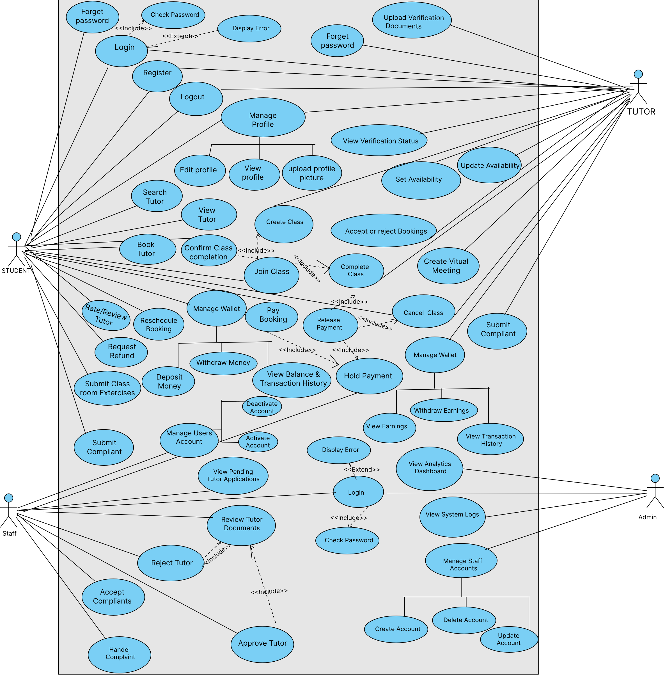
Figure 1 Use-Case Diagram for Tutor Connect

Use-Case Description
A Use Case Description tables provides detailed information about each use case identified in the system. Unlike the use case diagram, which shows only the relationships between actors and system functions, the description table explains how each use case works internally. It includes key fields such as: Use Case Name , Actor(s) , Description , Preconditions, Trigger, Main Flow , Postconditions.
- Register Use Case description
Field | Details
Actor(s) | Student, Tutor
Description | Allows a new user (student or tutor) to create an account on the Tutor-Connect platform by providing basic personal information and choosing a role.
Preconditions | • User is not logged in.  • User has a valid email address and phone number.
Trigger | User clicks the “Register” button/link from the home or login page.
Main Flow | 1. System displays the registration form with fields (Full Name, Email, Phone Number, Password, Confirm Password, Role).  2. User fills all required fields and selects their role (Student or Tutor).  3. User clicks “Create Account”.  4. System validates that all required fields are filled and that the email format is valid.  5. System checks that the email is not already registered.  6. If validation passes, system creates a new user record with the chosen role and initial status Active (for students) or Unverified (for tutors).  7. System securely stores the password (hashed) and user profile data.  8. System displays a confirmation message indicating that registration was successful and prompts the user to log in.
Postconditions | • A new user account is created and stored.  • The user can log in using the registered credentials.  • If the user is a tutor, they must still complete verification before appearing in search results.
Table 4 Register Use Case description

2. Login Use Case description
Field | Details
Actor(s) | Student, Tutor, Staff, Admin
Description | Authenticates a registered user using their email and password and redirects them to the appropriate dashboard based on their role.
Preconditions | • User has already registered an account.
Trigger | User opens the login page and submits email and password.
Main Flow | 1. System displays the login form.  2. User enters email and password and clicks “Sign In”.  3. System calls the internal Check Password function to validate the credentials.  4. System verifies that the email exists and that the entered password matches the stored hashed password.  5. If credentials are valid, system creates a session for the user.  6. System checks the user’s role (Student, Tutor, Staff, Admin).  7. System redirects the user to the corresponding dashboard (Student Dashboard, Tutor Dashboard, Staff Dashboard, or Admin Dashboard).
Postconditions | • User is authenticated and has an active session.  • User can access functions allowed by their role until they log out or the session expires.
Table 5 Login Use Case description

3. Upload Verification Documents Use Case description
Field | Details
Actor(s) | Tutor
Description | Enables a tutor to upload identity and academic documents required for verification before they can appear in student search results.
Preconditions | Tutor is registered and logged in.  Tutor account status is Unverified or Pending Verification.
Trigger | Tutor selects “Upload Verification Documents” or navigates to the verification section.
Main Flow | 1. System displays the verification form and lists required documents.  2. Tutor enters academic details.  3. Tutor selects and uploads each required document file and profile photo.  4. System validates file type and size for each document.  5. Tutor reviews all entered information and clicks “Submit for Verification”.  6. System checks that all mandatory fields and documents are provided.  7. System stores the uploaded files and verification data in the database.  8. System sets the tutor’s verification status to Pending Verification.  9. System notifies staff that a new tutor portfolio is waiting for review.
Postconditions | • Tutor’s verification data and documents are stored.  • Tutor status is updated to Pending Verification and visible to staff for review.  • Tutor is not yet shown in public search results until approved.
Table 6 Upload Verification Documents Use Case description

4. Review Tutor Documents and Approve/Reject Tutor Use Case description
Field | Content
Actor(s) | Staff
Description | Allow staff to review submitted tutor documents and either approve or reject the tutor for listing on the platform.
Preconditions | • Staff is logged in.  • One or more tutors have status Pending Verification and submitted documents.
Trigger | Staff opens the “Review Tutor Documents” or “Pending Tutor Applications” page.
Main Flow | 1. System displays a list of tutors with status Pending Verification.  2. Staff select a tutor from the list to review.  3. System shows tutor’s personal information, academic details, and all uploaded documents (ID, transcripts, photo, etc.).  4. Staff check that documents are complete, readable, and meet the platform’s criteria (e.g., minimum CGPA, correct department).  5. If additional clarification is needed, staff may note comments internally (optional). 6. Staff decide whether to approve or reject the tutor.  7. If the tutor satisfies requirements, staff clicks “Approve Tutor”:  7.1 System changes tutor status to Approved.  7.2 System makes the tutor visible in student search results.  7.3 System notifies the tutor that their profile has been approved.  8. If the tutor does not satisfy requirements, staff clicks “Reject Tutor”:  8.1 System requires staff to enter a rejection reason.  8.2 System changes tutor status to Rejected.  8.3 System notifies the tutor with a rejection reason.
Postconditions | • Tutor status is set to Approved or Rejected.  • Approved tutors can be found in search results; rejected tutors cannot.  • Staff decision and timestamp are recorded for auditing
Table 7 Review Tutor Documents and Approve/Reject Tutor Use Case description

5. Search Tutor Use Case description
Field | Content
Actor(s) | Student
Description | Allows a student to search for tutors based on subject, location, price, availability, tutoring mode (virtual or in-person), and other preferences.
Preconditions | • Student is registered and logged in.  • At least one tutor has status Approved.
Trigger | • Student navigates to the “Search Tutor” page.
Main Flow | 1. System displays search filters such as subject, grade level, location, mode (online/in-person), gender preference, price range, and availability.  2. Student selects or enters desired search criteria.  3. Student clicks “Search”.  4. System queries the database for Approved tutors that match the provided filters.  5. System orders the results (e.g., by relevance, rating, or price).  6. System displays a list of tutors showing key info: name, photo, subjects, hourly/daily rate, rating, availability, and verification badge.  7. Student browses the results and clicks on a tutor to view detailed profile (triggering View Tutor / View Profile).
Postconditions | • Student sees a list of matching tutors.  • Student can select a tutor to view details or proceed to booking
Table 8 Search Tutor Use Case description

6. Book Tutor & Pay Booking Use Case description
Field | Content
Actor(s) | • Student
Description | Student books a tutor for a class, and the agreed fee is deducted from the student’s wallet and held by the system (escrows) until the class is completed or cancelled.
Preconditions | • Student is logged in.  • Student has sufficient wallet balance to cover the booking fee.  • Selected tutor has status Approved and is available for the requested times.
Trigger | • Student clicks “Book Tutor” on a tutor’s profile.
Main Flow | 1. System displays the booking form with fields such as subject, preferred start date, number of days/sessions, time slots, and tutoring mode (virtual or in-person).  2. Student fills in the required booking details and reviews the calculated total price.  3. Student confirms the booking by clicking “Confirm & Pay”.  4. System checks the student’s wallet balance against the total price.  5. If balance is sufficient, system deducts the total price from the student’s wallet.  6. System creates a Hold Payment record (escrow) for the deducted amount and links it to this booking.  7. System creates a booking record with appropriate status (e.g., Active / Awaiting Class).  8. System notifies the tutor about the new booked class and shows schedule details.  9. System shows a confirmation message to the student, including booking details and that payment is currently held.
Postconditions | • Booking record is created and linked to the student and tutor.  • Agreed amount is deducted from the student wallet and marked as Held Payment.  • Tutor can see the booked class and prepare to teach.
Table 9 Book Tutor & Pay Booking Use Case description

7. Complete Class Use Case description
Field | Content
Actor(s) | Tutor
Description | Enables the tutor to mark a booked class as successfully completed, so that payment can later be released from the held amount.
Preconditions | • Tutor is logged in.  • Booking is active and the class schedule has been delivered.  • Payment for this booking is held in escrow (Hold Payment exists).
Trigger | • Tutor opens the booking/classroom page and clicks “Complete Class”.
Main Flow | 1. Tutor navigates to My Classes / Bookings and selects the relevant booking.  2. System displays class details, schedule, and student information.  3. Tutor reviews that the class has been fully delivered.  4. Tutor clicks “Complete Class”.  5. System verifies that a held payment exists and that the booking is in a state that can be completed.  6. System updates booking status to Completed – Pending Payment Release.  7. System flags the related held payment as ready for release.  8. System notifies staff that this class is completed and ready for payment processing.
Postconditions | • Booking status is set to Completed –Pending Payment Release.  • Held payment is marked as eligible for Release Payment.  • Tutor can no longer modify the class schedule for this booking.
Table 10 Complete Class Use Case description

8. Release Payment Use Case description
Field | Content
Actor(s) | Staff
Description | Staff reviews completed classes and releases the held payment from escrow to the tutor’s wallet, applying the appropriate service fee and finalizing the transaction.
Preconditions | • Staff is logged in.  • One or more bookings are in status Completed – Pending Payment Release with an associated held payment.
Trigger | Staff opens the Payment Management / Release Payment page.
Main Flow | 1. System displays a list of bookings with status Completed – Pending Payment Release and their held amounts.  2. Staff selects a specific booking to process.  3. System shows detailed information: student, tutor, class dates, held amount, and any related complaints or refund requests.  4. Staff confirm that the class was legitimately completed and there are no unresolved disputes.  5. Staff clicks “Release Payment”.  6. System calculates the platform service fee and tutor’s net earnings.  7. System transfers the net payment amount from held escrow to the tutor’s wallet balance.  8. System records the service fee as platform revenue and closes the held payment record.  9. System updates booking status to Completed – Paid (or equivalent).  10. System notifies the tutor that payment has been released and notifies the student that the class is fully closed.
Postconditions | • Held payment is converted into a tutor wallet credit and recorded as a completed transaction.  • Booking status reflects that payment has been settled.  • Platform earnings for this class are recorded.
Table 11 Release Payment Use Case description

9. Deposit Money Use Case description
Field | Content
Actor(s) | Student
Description | Allows a student to add funds to their wallet using an external payment provider so that they can pay for tutoring bookings.
Preconditions | • Student is registered and logged in.
Trigger | • Student clicks “Deposit Money” from the Manage Wallet section.
Main Flow | 1. System displays the Deposit Money form with fields for amount and payment method (Chapa, Telebirr, etc.).  2. Student enters the deposit amount and selects a payment method.  3. Student clicks “Proceed to Pay”.  4. System validates that the amount is positive and within allowed limits.  5. System sends a payment request to the selected payment gateway and redirects or opens its payment interface.  6. Student completes the payment through the gateway (e.g., confirms with mobile or card).  7. Payment gateway returns a success response to the system.  8. System verifies the payment status and transaction reference.  9. System increases the student’s wallet balance by the deposited amount.  10. System records a Deposit transaction in the wallet transaction history.  11. System displays a confirmation message showing the new wallet balance.
Postconditions | • Student’s wallet balance is increased by the deposited amount.  • A deposit transaction record is stored for auditing and history.
Table 12 Deposit Money Use Case description

10. Withdraw Money (Student) Use Case description
Field | Content
Actor(s) | Student
Description | Allows a student to withdraw unused wallet funds back to their external account via Chapa/Telebirr.
Preconditions | • Student is logged in.  • Student’s wallet balance is greater than or equal to the requested withdrawal amount.
Trigger | • Student clicks “Withdraw Money” from the Manage Wallet section.
Main Flow | 1. System displays the Withdraw Money form with fields for withdrawal amount and destination (e.g., phone or account linked to the gateway).  2. Student enters the amount they wish to withdraw and fills necessary destination details.  3. Student clicks “Request Withdrawal”.  4. System validates that the amount is positive, within allowed limits, and not greater than the current wallet balance.  5. System creates a withdrawal transaction with status Pending.  6. System sends a payout request to the selected payment gateway with amount and destination information.  7. Payment gateway processes the payout and returns a success response.  8. System updates the withdrawal transaction status to Completed.  9. System subtracts the withdrawn amount from the student’s wallet balance.  10. System displays a confirmation message and shows the updated balance.
Postconditions | • Student’s wallet balance is reduced by the withdrawn amount.  • A withdrawal transaction is stored with status Completed (or appropriate status if your system uses more states).
Table 13 Withdraw Money (Student) Use Case description

11. View Balance & Transaction History (Student) Use Case description
Field | Content
Actor(s) | Student
Description | Allow students to see their current wallet balance and a detailed list of all deposit, withdrawal, booking, refund, and payment transactions.
Preconditions | • Student is logged in.
Trigger | • Student selects “View Balance & Transaction History” from the wallet or dashboard.
Main Flow | 1. System retrieves the student’s current wallet balance from the database.  2. System fetches all transactions associated with the student’s wallet (deposits, withdrawals, booking payments, refunds, holds, and releases).  3. System orders transactions by date (newest first) and categorizes them by type.  4. System displays the balance at the top and a table or list of transactions below, including date, type, amount, and status.  5. Student scrolls through the list to review their financial history.  6. (Optional) Student can filter transactions by type or date range; system updates the displayed list.
Postconditions | • Student has a clear view of their wallet balance and past financial activity.  • No changes are made to data; it is a read-only operation.
Table 14 View Balance & Transaction History (Student) Use Case description

12. Withdraw Earnings (Tutor) Use Case description
Field | Content
Actor(s) | Tutor
Description | Allows a tutor to withdraw money earned from completed and paid classes from their wallet to an external account using an integrated payment provider.
Preconditions | • Tutor is logged in.  • Tutor’s wallet contains sufficient available earnings for withdrawal.
Trigger | Tutor clicks “Withdraw Earnings” from the Manage Wallet section.
Main Flow | 1. System displays the Withdraw Earnings form, showing current wallet balance and a field for withdrawal amount.  2. Tutor enters the amount to withdraw and selects the payout method (Chapa, Telebirr, etc.) and destination details.  3. Tutor clicks “Request Withdrawal”.  4. System verifies that the requested amount is not greater than the tutor’s available wallet balance and is within any minimum/maximum threshold.  5. System creates a tutor withdrawal transaction with status Pending.  6. System sends a payout request to the payment gateway with tutor’s payout details and amount.  7. Payment gateway processes the payout and returns a success response.  8. System updates the withdrawal transaction status to Completed.  9. System reduces the tutor’s wallet balance by the withdrawn amount.  10. System records the transaction in the tutor’s wallet history and displays a confirmation message.
Postconditions | • Tutor’s wallet balance is decreased by the withdrawn earnings.  • A completed withdrawal transaction is stored for reporting and audit.
Table 15 Withdraw Earnings (Tutor) Use Case description

13. View Earnings (Tutor) Use Case description
Field | Content
Actor(s) | Tutor
Description | Provides the tutor with a summary of their earnings from completed classes, including total earnings, recent payments released, and current wallet balance.
Preconditions | • Tutor is logged in.  • Tutor has at least one completed class or wallet transaction (optional but typical).
Trigger | Tutor selects “View Earnings” or opens the earnings section of the tutor dashboard.
Main Flow | 1. System retrieves all earning-related transactions for the tutor(total earnings, this month’s earnings, current balance, withdrawals)  2. System calculates:  - Total earnings  - Earnings for recent periods (e.g., this month)  - Current wallet balance  - Withdrawals  3. System displays these values in summary cards (e.g., total earnings, this month’s earnings, current balance, Withdrawals).  4. System lists recent earning transactions with date, booking reference, and amount credited.  5. Tutor view the summary and recent transactions.
Postconditions | • Tutor has up-to-date information about how much they have earned and how much remains in their wallet.  • No data changes occur; it is a read-only view.
Table 16 View Earnings (Tutor) Use Case description

14. Submit Complaint Use Case description
Field | Content
Actor(s) | Student, Tutor
Description | Allow a student or tutor to report a problem related to payments, behavior, class quality, or platform issues so that staff can investigate and respond.
Preconditions | • User (student or tutor) is logged in.
Trigger | • User clicks “Submit Complaint” from a booking page or support/help section.
Main Flow | 1. System displays the Submit Complaint form with fields for complaint category, related booking (optional but recommended), and description.  2. User selects a complaint category (e.g., Payment Issue, Tutor Behavior, Student Behavior, Schedule Problem, Technical Issue).  3. User selects the related booking/class if applicable.  4. User describes the problem in the text field.  5. User clicks “Submit”.  6. System validates that at least the category and description are filled.  7. System creates a new complaint record with status Pending and links it to the user and related booking (if provided).  8. System saves the complaint and notifies staff that a new complaint has been submitted.  9. System shows a confirmation message to the user that their complaint has been received.
Postconditions | • A new complaint record with status Pending is stored.  • Staff can see and process the complaints in the complaints management area.
Table 17 Submit Complaint Use Case description

15. Handle Complaint Use Case description
Field | Content
Actor(s) | Staff
Description | Allow staff to review, investigate, and resolve complaints submitted by students or tutors, optionally coordinating with payment or account actions.
Preconditions | • Staff is logged in.  • One or more complaints exist with status Pending or In Progress.
Trigger | • Staff opens the Complaints Management / Handle Complaint page.
Main Flow | 1. System lists complaints with their basic details (complainant, category, related booking, current status).  2. Staff filters or selects a specific complaint to handle.  3. System displays full complaint details, including description, related booking information, and user profiles.  4. Staff reviews the history of the booking, payments, messages (if available), and any previous actions.  5. If needed, staff may contact the parties involved outside the system or via internal notes (depending on your implementation).  6. Staff decide on a resolution, for example:  o Approve a partial or full refund  o Issue a warning to a tutor or student  o Reject the complaint if not justified  7. Staff enters a resolution note explaining the decision.  8. Staff updates the complaint status to Resolved, Dismissed, or In Progress (if more time is needed).  9. System saves the resolution, status, and timestamp.  10. System notifies the complainant (and optionally the other party) about the outcome and staff’s message.
Postconditions | • Complaint status is updated from Pending to Resolved, Dismissed, or In Progress.  • Resolution details are stored and can be viewed later for audit and reporting.
Table 18 Handle Complaint Use Case description

16. Manage Users Account (Activate/Deactivate) Use Case description
Field | Content
Actor(s) | Staff
Description | Allow staff to manage student and tutor accounts by activating or deactivating them when there are policy violations, complaints, or corrections required.
Preconditions | • Staff is logged in.  • User accounts (students and tutors) already exist in the system.
Trigger | • Staff opens the “Manage Users Account” section from the staff dashboard.
Main Flow | - System displays a list of users (students and tutors) with key information:  name, email, role, and current account status (Active, Deactivated, Suspended, etc.).  2. Staff searches or filters the list to locate a specific user (e.g., by name, email, or role).  3. Staff select a user to manage.  4. System displays detailed info for that user, including any complaints history or flags.  5. If the user is currently Active, staff may choose “Deactivate Account”:  5.1 System asks for confirmation and optional reason.  5.2 Staff confirms.  5.3 System sets the user’s status to Deactivated and prevents further login.  6. If the user is currently Deactivated, staff may choose “Activate Account”:  6.1 System asks for confirmation.  6.2 Staff confirms.  6.3 System changes the status back to Active.  7. System logs the change (staff ID, date/time, old status, new status).  8. System optionally notifies the affected user about the change (e.g., via email or in-app message).
Postconditions | • The selected user’s account status is updated (Activated or Deactivated).  • An audit log of the status change is stored for future reference.
Table 19 Manage Users Account (Activate/Deactivate) Use Case description
17. Create Class Use Case description
Field | Content
Actor(s) | Tutor
Description | Allows a tutor to create a structured class inside the virtual classroom for a booked student. The class may include topics, chapters, and learning materials.
Preconditions | • Tutor is logged in.  • The tutor has at least one active booking with a student.
Trigger | • Tutor selects “Create Class” from their dashboard or booking page.
Main Flow | 1. Tutor opens the booking details and clicks “Create Class”.  2. System displays a form for entering class details (title, subject, chapter, description, schedule).  3. Tutor fills in the required class information.  4. Tutor clicks “Save Class”.  5. System validates the input and stores the class details.  6. System links the new class to the booking and student.  7. System notifies the student that a new class has been created.
Postconditions | • Class is created and stored in the database.  • Student can see the class and its contents.
Table 20 Create Class Use Case description

18. Join Class Use Case description
Field | Content
Actor(s) | Student, Tutor
Description | Allows both student and tutor to enter a class session, access its contents, and interact through exercises or virtual meeting links.
Preconditions | • User is logged in.  • Class has been created by the tutor.
Trigger | • User selects “Join Class” from the dashboard or booking page.
Main Flow | 1. System displays a list of classes associated with the booking.  2. User selects a class.  3. System displays class content (chapters, tasks, meeting link, schedule).  4. User can interact with materials or join the virtual meeting if active.
Postconditions | • User gains access to class materials and virtual session link.
Table 21 Join Class Use Case description

19. Create Virtual Meeting Use Case description
Field | Content
Actor(s) | Tutor
Description | Allow a tutor to generate an online meeting room for live instruction, which is linked to a class.
Preconditions | • Tutor is logged in.  • A class has been created for a booking.
Trigger | • Tutor clicks “Create Virtual Meeting”.
Main Flow | 1. Tutor selects a class and clicks “Create Virtual Meeting”.  2. System generates a unique meeting URL or room ID through integrated meeting service.  3. System attaches the meeting link to the class.  4. System notifies the student that the meeting is ready.
Postconditions | • A virtual meeting link is created and stored.  • Student and tutor can join the meeting through the class page.
Table 22 Create Virtual Meeting Use Case description

20. Cancel Class Use Case description
Field | Content
Actor(s) | • Tutor, Student
Description | Allows either tutor or student to cancel a scheduled class. If the class has not started, refund rules apply. If class has progressed, fees may be adjusted.
Preconditions | • User is logged in.  • Class exists and is scheduled.
Trigger | • User clicks “Cancel Class” on booking or class page.
Main Flow | 1. User selects the class to cancel.  2. System displays cancellation terms (refund rules, progress status).  3. User confirms cancellation.  4. System updates class and booking status to Cancelled.  5. System applies refund logic (full or partial depending on class progress).  6. System notifies the other party (student or tutor).
Postconditions | • Class is cancelled.  • Payment logic updates (refund/adjustments) are applied.
Table 23 Cancel Class Use Case description

21. Submit Classroom Exercises Use Case description
Field | Content
Actor(s) | Student
Description | Allows a student to submit homework, assignments, quizzes, or other tasks created by the tutor inside the virtual classroom.
Preconditions | • Student is logged in.  • Tutor has created exercises in the class.
Trigger | Student selects an exercise and clicks “Submit”.
Main Flow | 1. System displays exercise instructions and submission options (file upload, text input, quiz form).  2. Student completes the exercise and submits it.  3. System validates file type or form inputs.  4. System stores the submission under the correct class and exercise.  5. System notifies the tutor that the submission is available.
Postconditions | • Exercise is stored and marked as submitted.  • Tutor can review the submission.
Table 24 Submit Classroom Exercises Use Case description

22. Rate/Review Tutor Use Case description
Field | Content
Actor(s) | Student
Description | Allows a student to leave feedback rating and optional written review after class completion.
Preconditions | • Student is logged in.  • Booking has status Completed – Paid or fully finished.
Trigger | Student clicks “Rate/Review Tutor”.
Main Flow | 1. Student selects a rating from 1–5 stars.  2. Student optionally writes a comment about tutor performance.  3. Student submits review.  4. System stores the rating and review.  5. System updates tutor’s overall rating score.
Postconditions | • Tutor’s public rating is updated.  • Review becomes visible to future students.
Table 25 Rate/Review Tutor Use Case description

23. Reschedule Booking Use Case description
Field | Content
Actor(s) | Student
Description | Allow a student to reschedule a booked session before the class is completed.
Preconditions | • Student is logged in.  • Booking is active and not completed.
Trigger | • Student clicks “Reschedule Booking”.
Main Flow | 1. Student selects a new date/time.  2. System checks tutor availability.  3. System updates the schedule if the tutor is available.  4. System notifies the tutor of the rescheduled time.
Postconditions | • New schedule is stored.  • Tutor and student see the updated booking.
Table 26 Reschedule Booking Use Case description

24. Request Refund Use Case description
Field | Content
Actor(s) | Student
Description | Allows a student to request a refund if a class is canceled or issues justify a refund according to policy.
Preconditions | • Student is logged in.  • Booking has refundable status.
Trigger | Student clicks “Request Refund”.
Main Flow | 1. Student selects a booking and opens the refund request page.  2. Student enters reason for refund.  3. Student submits the request.  4. System creates a refund request with status Pending.  5. Staff is notified to review the refund.
Postconditions | • Refund request is logged.  • Staff can process or deny the refund.
Table 27 Request Refund Use Case description

25. Manage Profile Use Case description
Field | Content
Actor(s) | Student, Tutor
Description | Allows a student or tutor to manage their own profile information, including viewing current details, editing personal data, and accessing options to upload a profile picture.
Preconditions | User (student or tutor) is logged in.
Trigger | User clicks “Manage Profile” from the navigation menu or dashboard.
Main Flow | 1. System opens the Manage Profile page.  2. System displays current profile information (name, email, phone, location, short bio, role).  3. System shows actions such as View Profile, Edit Profile, and Upload Profile Picture. 4. User chooses the desired action:  o If View Profile → system shows read-only details.  o If Edit Profile → system displays editable fields.  o If Upload Profile Picture → system shows an image upload control.  5. After user completes the selected action and confirms, system validates and saves any changes.  6. System displays a confirmation message indicating that profile updates have been applied.
Postconditions | • User’s profile information is updated accordingly in the database.  • Any new profile picture becomes visible wherever user profiles are displayed.
Table 28 Manage Profile Use Case description

26. View Verification Status Use Case description
Field | Content
Actor(s) | Tutor
Description | Allow a tutor to see the current status of their verification process (e.g., Pending, Approved, Rejected) and any staff remarks.
Preconditions | • Tutor is logged in.  • Tutor has previously submitted verification documents.
Trigger | • Tutor clicks “View Verification Status” from the verification section or profile.
Main Flow | 1. System retrieves the tutor’s verification record from the database.  2. System displays the current status (e.g., Pending, Approved, Rejected) and the date of last update.  3. If the tutor is Rejected, system also displays the rejection reason or notes from staff.  4. If the tutor is Pending, system may show a message such as “Your documents are under review.”  5. Tutor reviews the status and, if rejected, may decide to update documents (handled by other use cases).
Postconditions | • Tutor is informed of their current verification status.  • No data is changed; this is a read-only operation.
Table 29 View Verification Status Use Case description

27. Availability Use Case description
Field | Content
Actor(s) | Tutor
Description | Allows a tutor to define their initial availability schedule so that students can book sessions only in free time slots.
Preconditions | • Tutor is logged in.  • Tutor profile exists.
Trigger | • Tutor navigates to “Set Availability” from their dashboard or profile menu.
Main Flow | 1. System displays a weekly or calendar-based view with time slots (e.g., days of the week and hours).  2. Tutor selects available days and time ranges for teaching (e.g., Monday 2–5 PM, Wednesday 10–12 AM).  3. Tutor clicks “Save Availability”.  4. System validates that selected time slots are in a valid format and do not conflict with existing fixed sessions (if any).  5. System stores the availability settings for the tutor in the database.  6. System updates the search and booking logic so that students see only these available slots.
Postconditions | • Tutor’s availability schedule is stored.  • Future student search and booking results respect these available time windows.
Table 30 Availability Use Case description

28. Update Availability Use Case description
Field | Content
Actor(s) | Tutor
Description | Allows a tutor to modify or remove previously set availability slots, for example when their schedule changes.
Preconditions | • Tutor is logged in.  • Initial availability has been set (or the tutor has at least some existing slots).
Trigger | • Tutor clicks “Update Availability” from the availability or schedule page.
Main Flow | 1. System retrieves and displays current availability slots on a calendar or weekly view.  2. Tutor adjusts the schedule by:  o Adding new available time slots  o Editing existing slots  o Removing slots they are no longer available for  3. Tutor clicks “Save Changes”.  4. System validates that the new availability does not contradict already confirmed bookings (if conflicts exist, system alerts the tutor and may block those changes).  5. System updates the availability records in the database.  6. System refreshes search and booking configuration so that only the updated availability is offered to students.
Postconditions | • Tutor’s updated availability is stored and used by the booking system.  • Any unavailable times are excluded from future booking options.
Table 31 Update Availability Use Case description
29. View Transaction History (Tutor) Use Case description
Field | Content
Actor(s) | Tutor
Description | Allows a tutor to view a detailed list of their financial transactions, including payments received from classes and withdrawals of earnings.
Preconditions | • Tutor is logged in.  • Tutor has at least one wallet transaction (payment or withdrawal), or the system supports viewing an empty history.
Trigger | Tutor clicks “View Transaction History” in the wallet or earnings section.
Main Flow | 1. System retrieves all wallet transactions associated with the tutor (Earning, withdrawals, adjustments).  2. System orders transactions by date, newest first.  3. System displays each entry with date, type (e.g., “Class Payment”, “Withdrawal”), amount, and status (e.g., Completed, Pending).  4. Tutor scrolls through or pages through the list to review their history.  5. (Optional) Tutor applies filters (date range, transaction type); system refreshes the list based on selected filters.
Postconditions | • Tutor has clear visibility of historical earnings movements and withdrawals.  • No data is modified; this is a read-only operation.
Table 32 View Transaction History (Tutor) Use Case description

30. View Analytics Dashboard Use Case description
Field | Content
Actor(s) | Admin
Description | Provides the administrator with a visual summary of key platform metrics such as number of users, active tutors, total bookings, and financial statistics.
Preconditions | • Admin is logged in.  • System has collected relevant data (users, bookings, payments).
Trigger | Admin selects “View Analytics Dashboard” from the admin menu.
Main Flow | 1. System aggregates metrics from users, bookings, and payment tables, such as:  o Total registered students and tutors  o Number of active tutors  o Number of bookings (by status)  o Total transaction volume and platform earnings over a time period  2. System generates summary values and charts (e.g., line charts or bar charts) for each metric.  3. System displays the analytics dashboard with cards, charts, and key performance indicators.  4. Admin may change filters (e.g., date range, city, subject); system recalculates metrics and updates the dashboard views.  5. Admin reviews the analytics to monitor platform growth and performance.
Postconditions | • Admin gains insight into system usage and financial health.  • No transactional data is changed; this is a reporting view.
Table 33 View Analytics Dashboard Use Case description
31. View System Logs Use Case description
Field | Content
Actor(s) | Admin
Description | Allows the administrator to view an audit trail of important actions on the platform (logins, tutor approval, account status changes, payment releases), used for monitoring and security.
Preconditions | • Admin is logged in.  • System is configured to log key events.
Trigger | • Admin clicks “View System Logs” from the admin area.
Main Flow | 1. System retrieves log entries from the log storage (database or logging service).  2. System displays each log record with timestamp, actor (user/staff/admin ID), action description (e.g., “Tutor Approved”, “Payment Released”), and related entity (e.g., user ID, booking ID).  3. Admin scrolls through the log list.  4. Admin optionally filters by date range, user, action type, or severity level; system refreshes and shows filtered logs.  5. Admin uses this information to audit actions or investigate problems.
Postconditions | • Admin has read-only access to the history of critical system events.  • No changes are made to underlying operational data.
Table 34 View System Logs Use Case description

32. Manage Staff Accounts Use Case description
Field | Content
Actor(s) | Admin
Description | Allows the administrator to create, update, and delete staff accounts that are responsible for tutor verification, complaint handling, and payment release.
Preconditions | • Admin is logged in.
Trigger | Admin selects “Manage Staff Accounts” from the admin dashboard.
Main Flow | 1. System displays a list of existing staff accounts, including name, email, role, and status.  2. Admin may perform one of the following actions:  a. Create Staff Account  1. Admin clicks “Create Account”.  2. System shows a form for staff details (name, email, phone, initial password or  invite).  3. Admin fills the form and submits.  4. System validates uniqueness of email and required fields.  5. System creates a new user with role Staff and sets status to Active.  b. Update Staff Account  6. Admin selects an existing staff user and clicks “Update Account”.  7. System shows editable fields (e.g., name, phone, status).  8. Admin edits details and saves.  9. System validates and updates the staff account record.  c. Delete Staff Account  10. Admin selects a staff user and clicks “Delete Account”.  11. System asks for confirmation.  12. Admin confirms; system removes or disables the staff account according to policy. 3. System logs all changes to staff accounts (who changed what and when).  4. System refreshes the list of staff to show the updated state.
Postconditions | • Staff accounts reflect the latest changes (created, updated, or deleted).  • Only valid staff users can log in and access staff functions.
Table 35 Manage Staff Accounts Use Case description

33. View Tutor Use Case description
Field | Content
Actor(s) | Student
Description | Allows a student to open and read the detailed profile of a tutor, including subjects, pricing, availability, ratings, and verification status.
Preconditions | • Student is logged in.  • At least one tutor exists and is approved.
Trigger | • Student clicks a tutor’s profile from the search results.
Main Flow | 1. Student selects a tutor from the search result list.  2. System retrieves the tutor’s full profile details (bio, subjects, price, location, rating, reviews, verification status, availability).  3. System displays the tutor’s complete profile page.  4. Student reviews details and may proceed to Book Tutor.
Postconditions | • Student gains information needed to decide whether to book the tutor.
Table 36 View Tutor Use Case description

34. Accept or Reject Bookings Use Case description
Field | Content
Actor(s) | Tutor
Description | Allows tutors to accept or decline booking requests made by students.
Preconditions | • Tutor is logged in.  • At least one new booking request exists.
Trigger | Tutor opens “Booking Requests” from their dashboard.
Main Flow | 1. System displays a list of pending booking requests for the tutor.  2. Tutor selects a booking request.  3. System shows booking details (student name, schedule, subject, mode, class duration).  4. Tutor chooses Accept or Reject.  5. If Accept:  o System updates booking status to Accepted.  o System notifies the student.  6. If Reject:  o System updates status to Rejected.  o System notifies the student.
Postconditions | • Booking status is updated based on tutor’s decision.  • Student is informed immediately.
Table 37 Accept or Reject Bookings Use Case description

35. View Pending Tutor Applications Use Case description
Field | Content
Actor(s) | Staff
Description | Allow staff to view tutors who have uploaded documents and are waiting for verification.
Preconditions | • Staff is logged in.  • At least one tutor has verification status Pending.
Trigger | • Staff clicks “Pending Tutor Applications”.
Main Flow | 1. System retrieves all tutors with status Pending Verification.  2. System displays them in a list with summary details.  3. Staff selects a tutor to review.  4. System opens full verification details (linked with Review Tutor Documents).
Postconditions | • Staff can now proceed to approve or reject tutors.
Table 38 View Pending Tutor Applications Use Case description

36. Use Case Name: Accept Complaints
Field | Content
Actor(s) | Staff
Description | Allow staff to acknowledge and take ownership of user-submitted complaints before fully handling them.
Preconditions | • Staff is logged in.  • At least one complaint has status Pending.
Trigger | Staff opens “Accept Complaints” section.
Main Flow | 1. System displays a list of complaints with status Pending.  2. Staff selects a complaint.  3. Staff clicks “Accept Complaint”.  4. System changes complaint status to In Progress.  5. System logs which staff members have taken ownership.
Postconditions | • Complaint is now assigned and ready for investigation under Handle Complaint.
Table 39 Use Case Name: Accept Complaints
37. Deactivate Account Use Case description
Field | Content
Actor(s) | Staff
Description | Allow staff to disable an account due to violations, issues, or complaints.
Preconditions | • Staff is logged in.  • A user account (student or tutor) exists and is currently active.
Trigger | Staff selects a user under Manage Users Account.
Main Flow | 1. System displays the user profile and current status.  2. Staff clicks “Deactivate Account”.  3. System asks for confirmation and optional reasons.  4. Staff confirms.  5. System updates user status to Deactivated.  6. System logs the action and restricts user login.
Postconditions | • User can no longer access the system.  • Staff action is recorded.
Table 40 Deactivate Account Use Case description
38. Activate Account Use Case description
Field | Content
Actor(s) | Staff
Description | Allow staff to reactivate a previously deactivated student or tutor account.
Preconditions | • Staff is logged in.  • The target account is currently Deactivated.
Trigger | • Staff selects user under Manage Users Account.
Main Flow | 1. System displays user details with status Deactivated.  2. Staff clicks “Activate Account”.  3. System confirms action.  4. Staff confirms activation.  5. System updates account status to Active.  6. System logs who activated the account and when.
Postconditions | • User regains access to the platform.  • Activation event is recorded.
Table 41 Activate Account Use Case description
39. Update Account (Staff Controlled) Use Case description
Field | Content
Actor(s) | Admin
Description | Allows the admin to update staff account details such as contact info, access rights, or status.
Preconditions | • Admin is logged in.  • The staff account exists.
Trigger | Admin clicks “Update Account” within the Manage Staff Accounts section.
Main Flow | 1. System displays editable staff account details (name, email, phone, status).  2. Admin updates necessary fields.  3. Admin clicks “Save Changes”.  4. System validates input (e.g., unique email).  5. System updates staff account record.  6. System logs the admin action.
Postconditions | • Staff account details are updated successfully.
Table 42 Update Account (Staff Controlled) Use Case description

40. Delete Staff Account Use Case description
Field | Content
Actor(s) | Admin
Description | Allow an admin to remove or disable staff member’s access to the system.
Preconditions | • Admin is logged in.  • The staff account exists.
Trigger | Admin selects staff profile and clicks “Delete Account”.
Main Flow | 1. System displays staff account details.  2. Admin clicks “Delete Account”.  3. System asks for confirmation.  4. Admin confirms deletion.  5. System removes or disables the account (depending on platform policy).  6. System logs the deletion event.
Postconditions | • Staff member can no longer log in.  • Account removal is recorded for audit.
Table 43 Delete Staff Account Use Case description

3.3.3 Sequence Diagram
A Sequence Diagram is a behavioral UML diagram that shows how different parts of the system interact with each other over time. It illustrates the flow of messages between actors and system components in the order they occur. The diagram focuses on when and how operations happen during a specific use case.

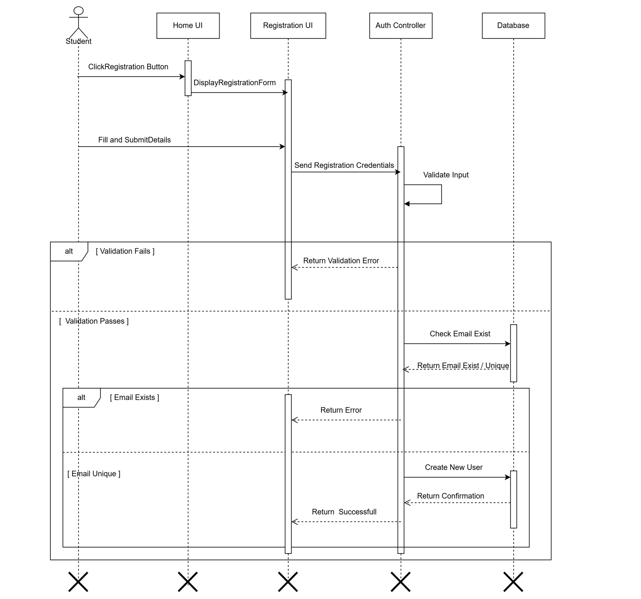
Figure 2 Registration Sequence Diagram

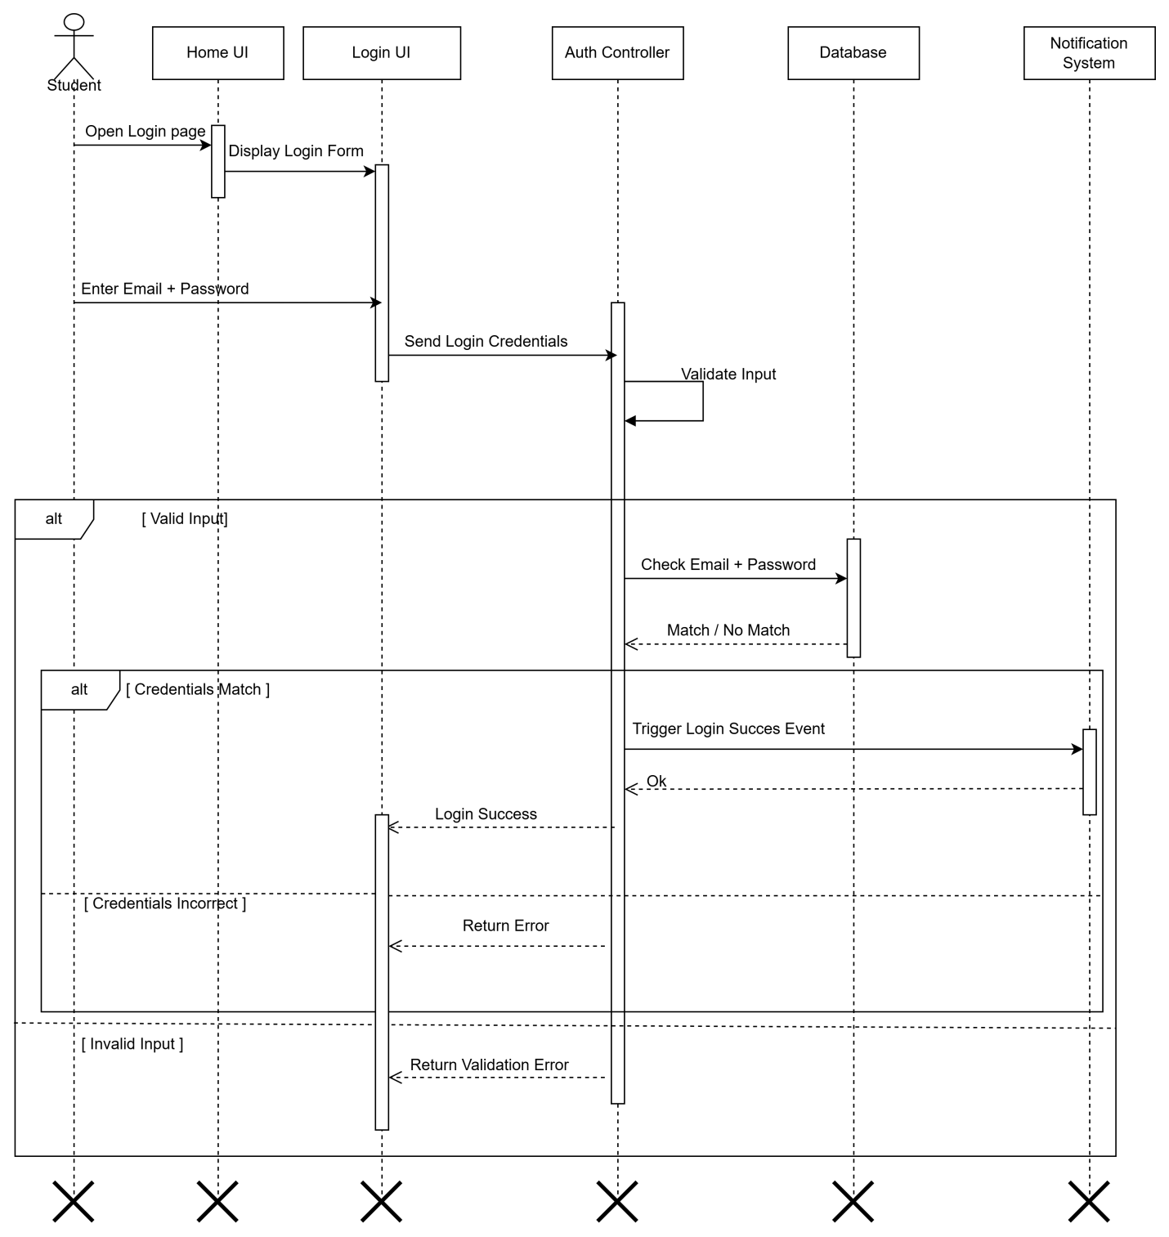
Figure 3 Login Sequence Diagram

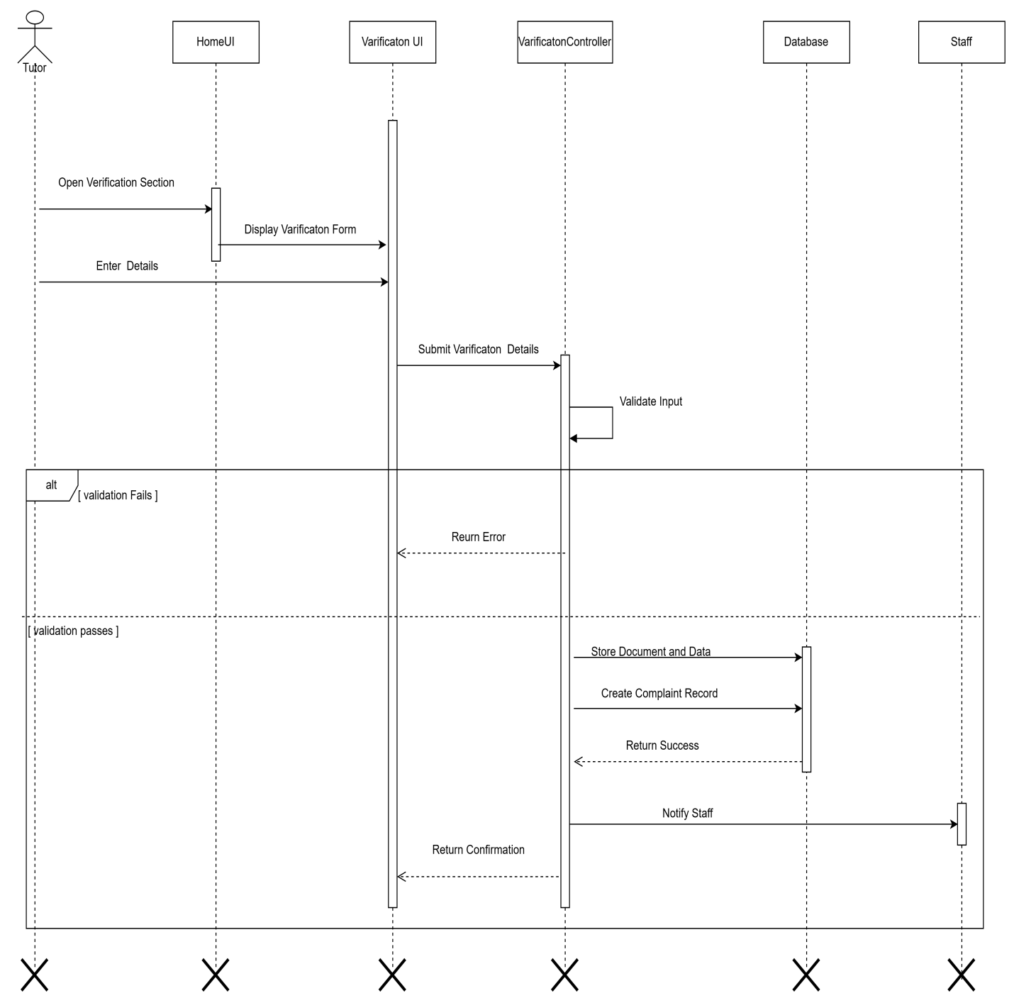
Figure 4 Upload Verification Sequence Diagram

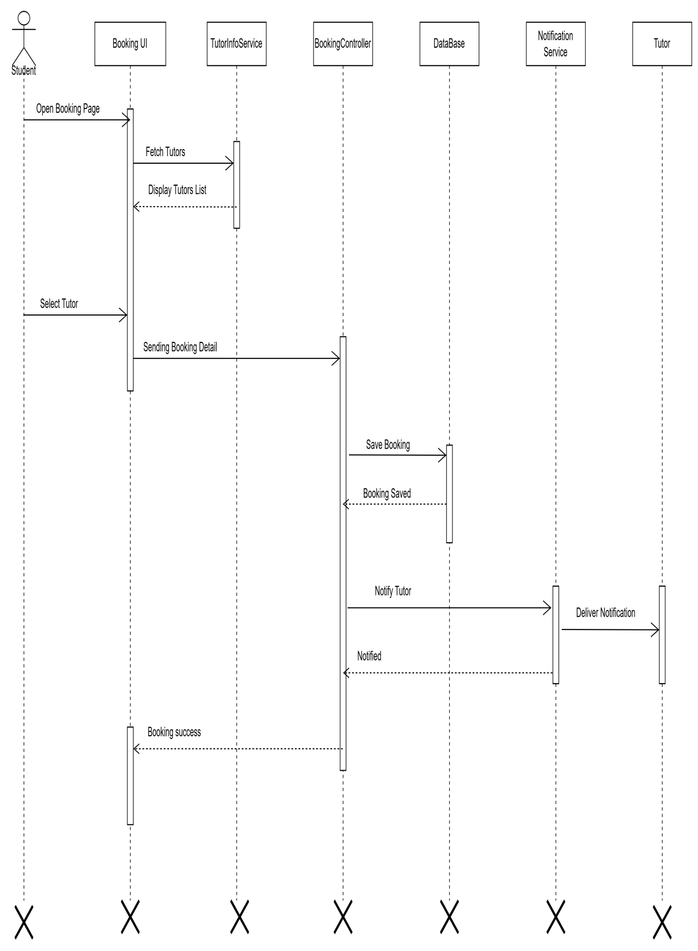
Figure 5 Booking Sequence Diagram

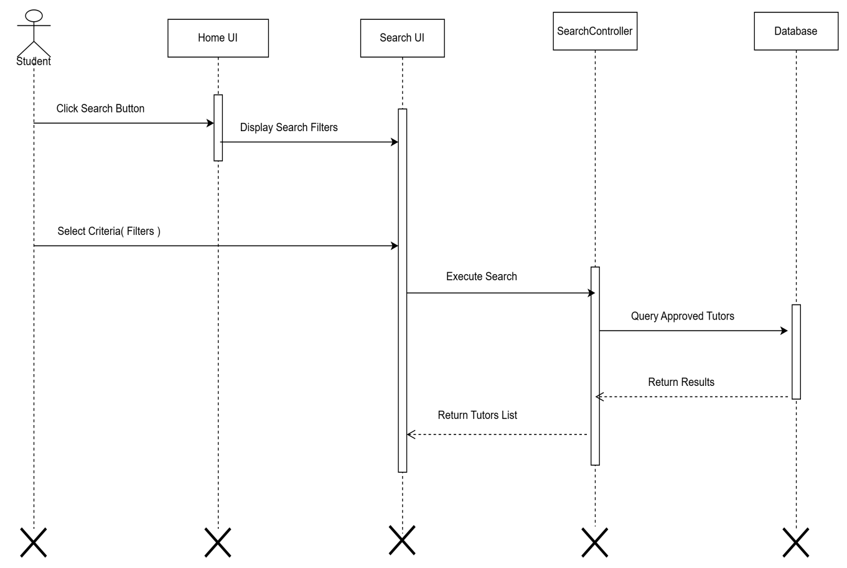
Figure 6 Search Sequence Diagram

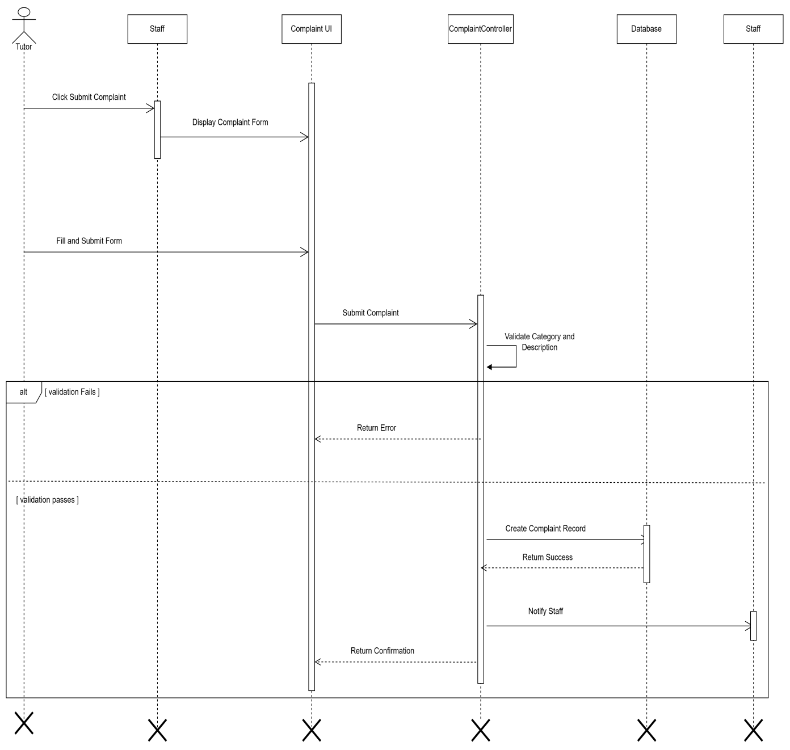
Figure 7 Complaint Sequence Diagram

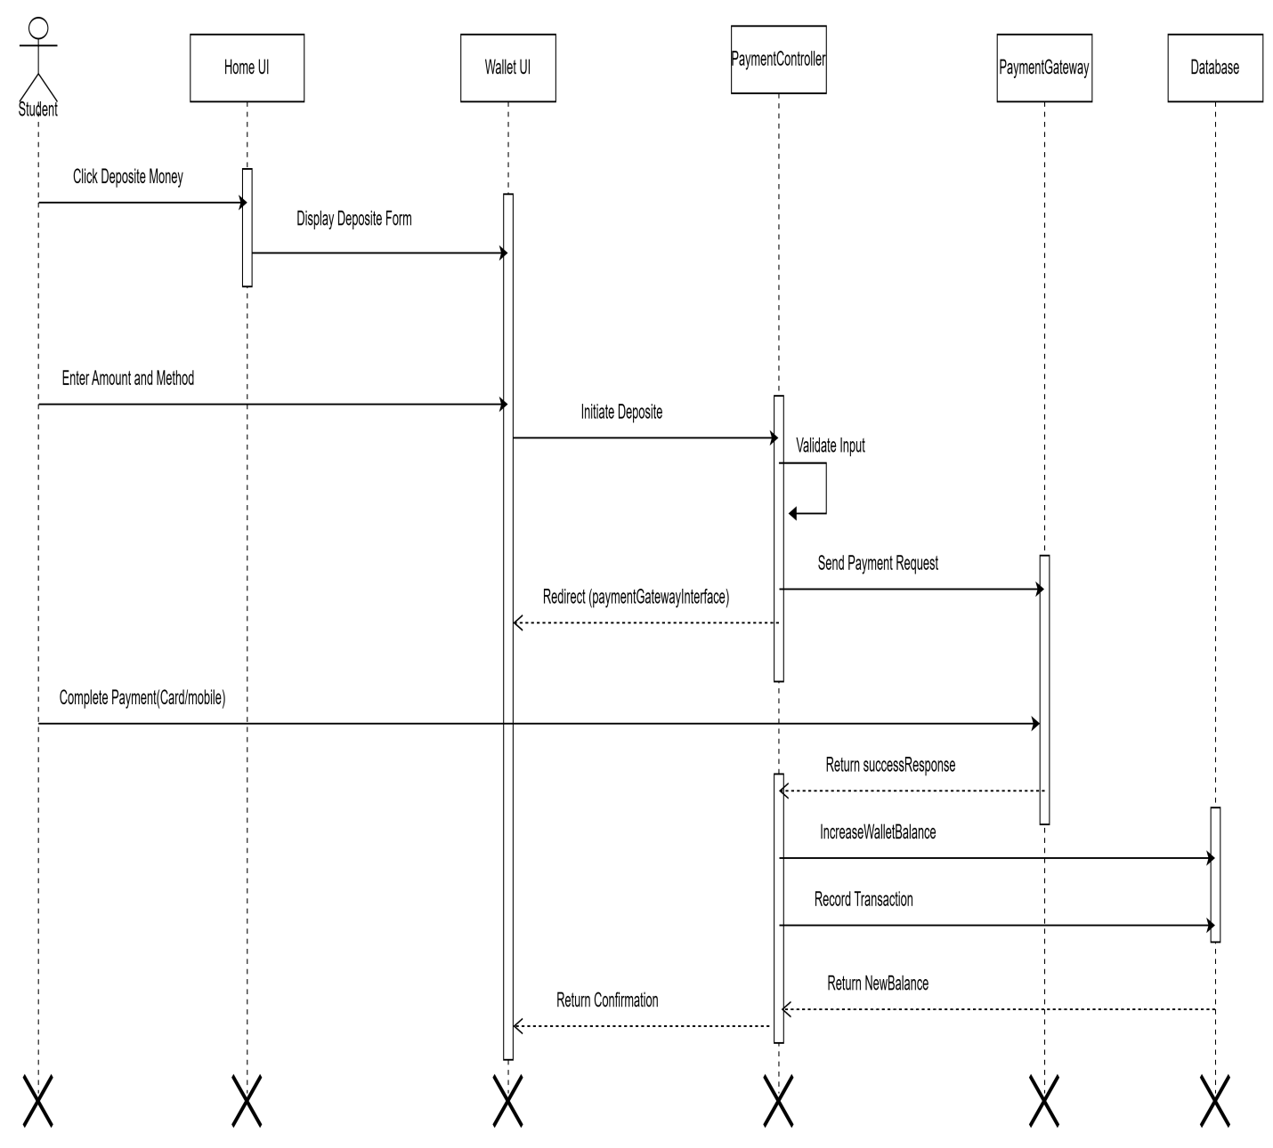
Figure 8 Deposit Money Sequence Diagram

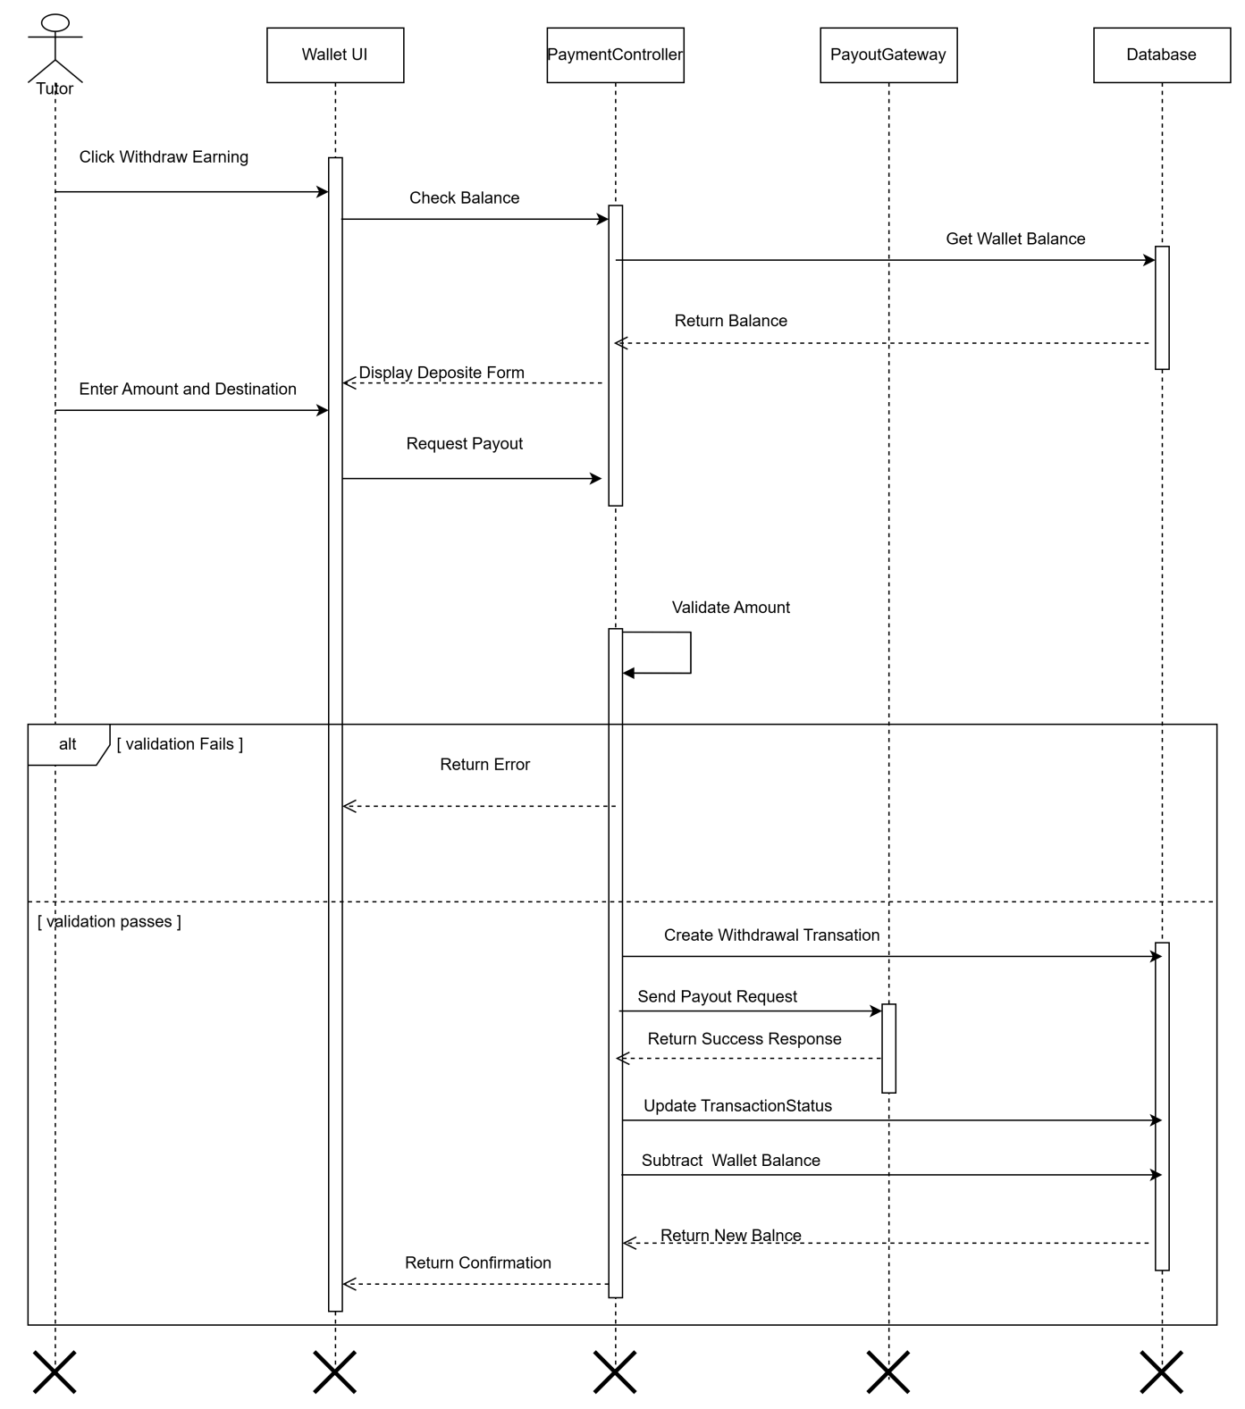
Figure 9 Withdraw Sequence Diagram

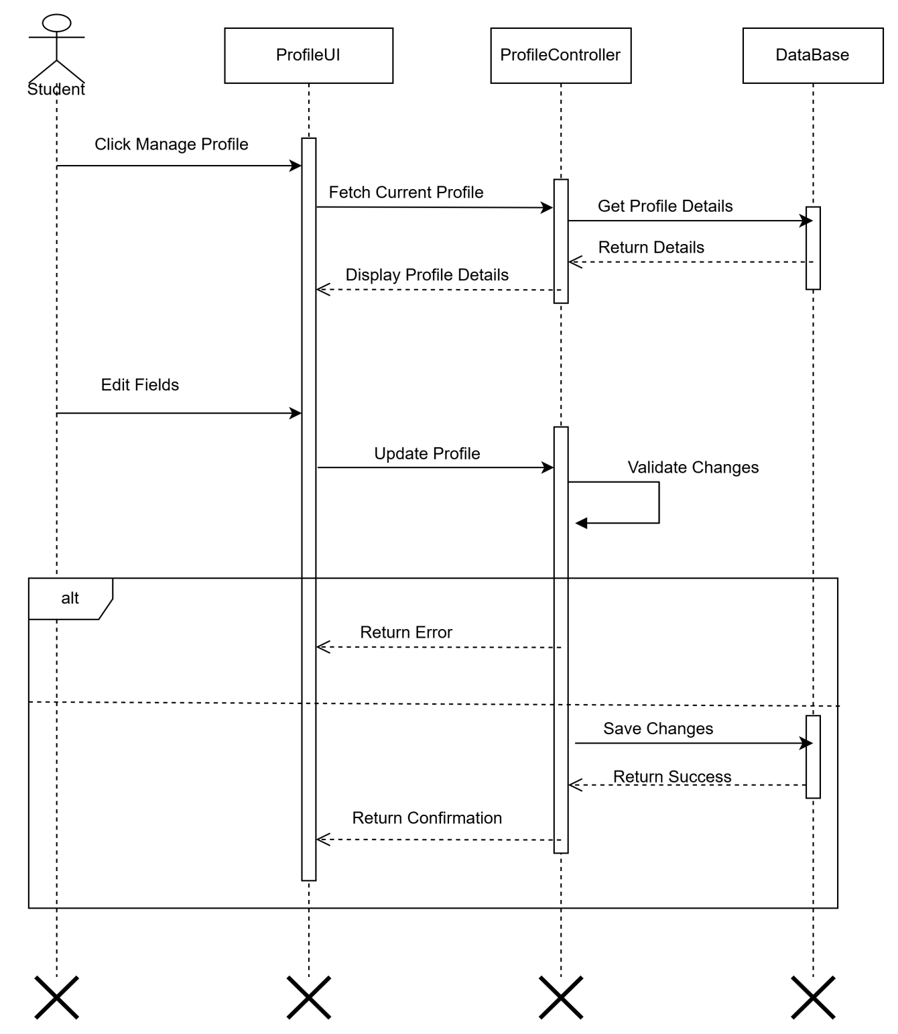
Figure 10 Edit Profile Sequence Diagram

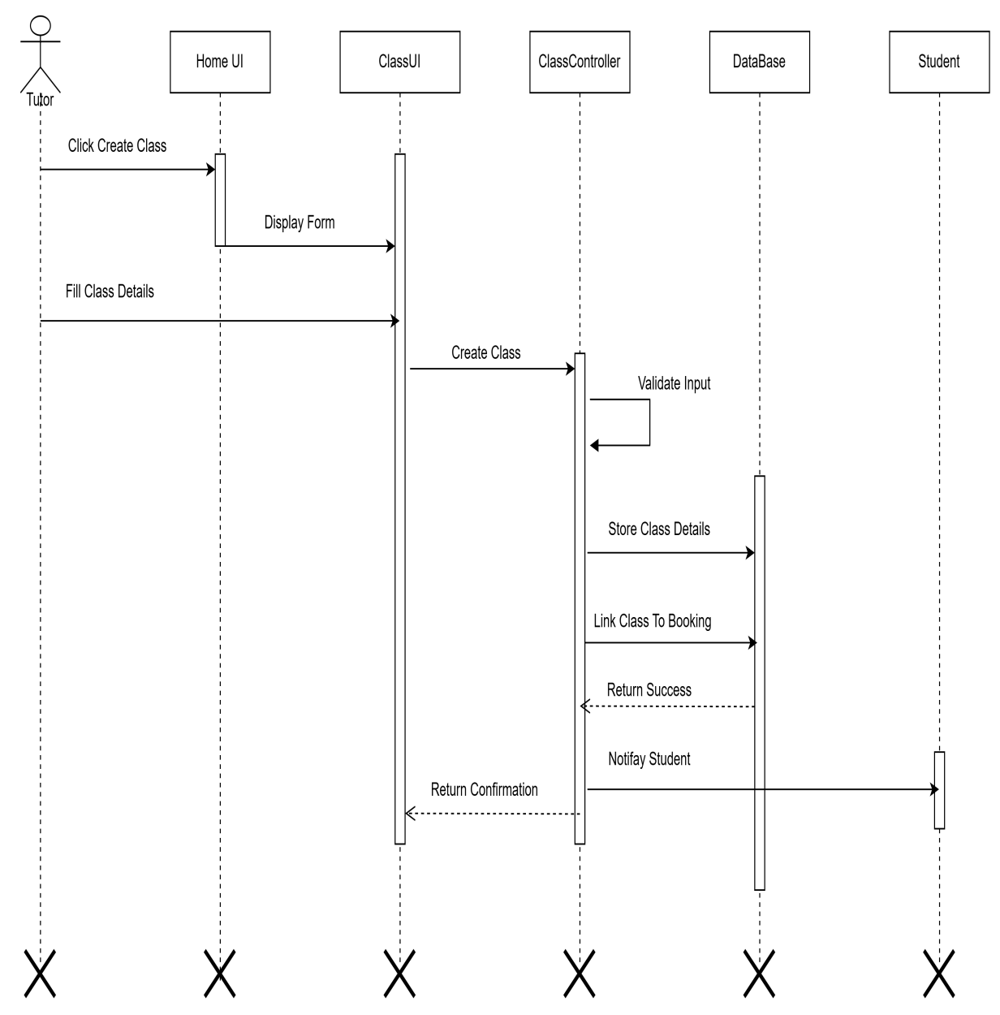
Figure 11 Create class Sequence Diagram
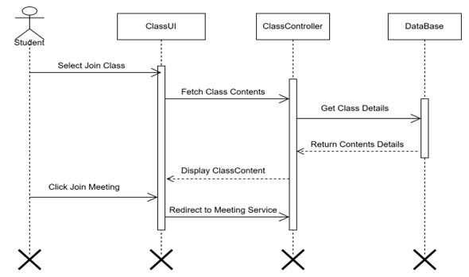
Figure 12 Join Class Sequence Diagram

ActivityDiagram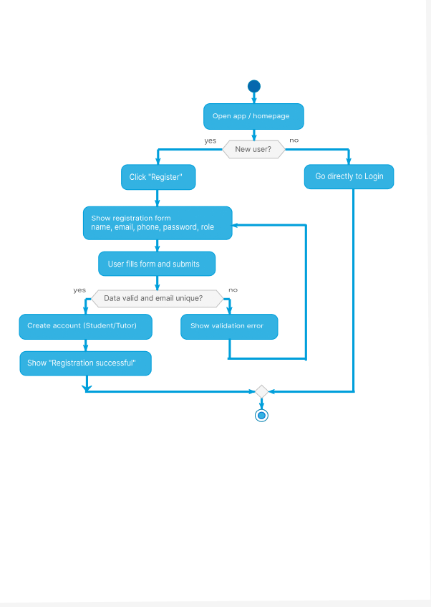
Figure 13 Registration activity diagram

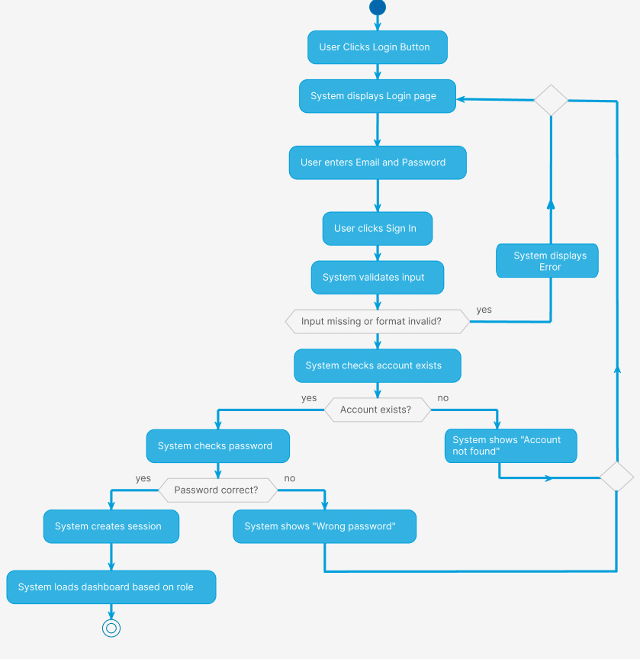
Figure 14 login activity diagram

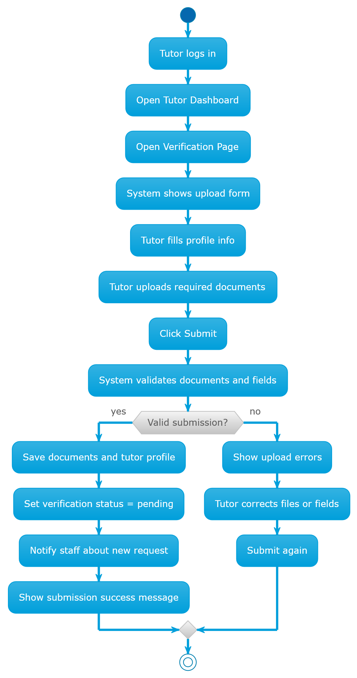
Figure 15 Tutor portfolio upload activity diagram

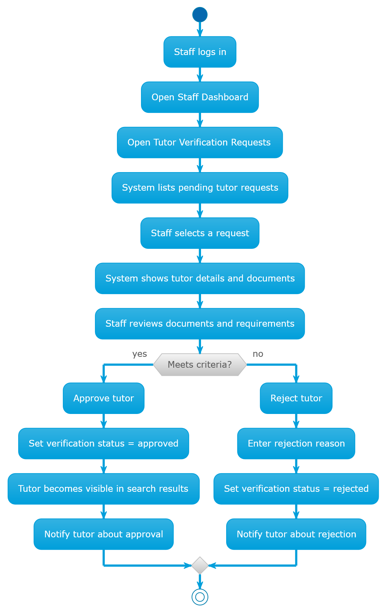
Figure 16 Tutor Portifolio Approval Activity Diagram

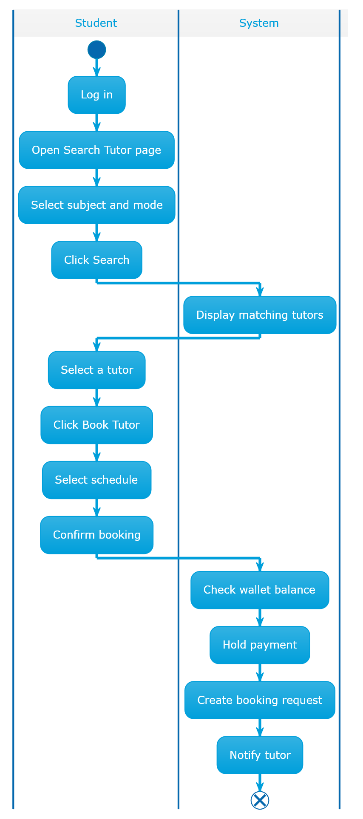
Figure 17 Book Tutor activity diagram

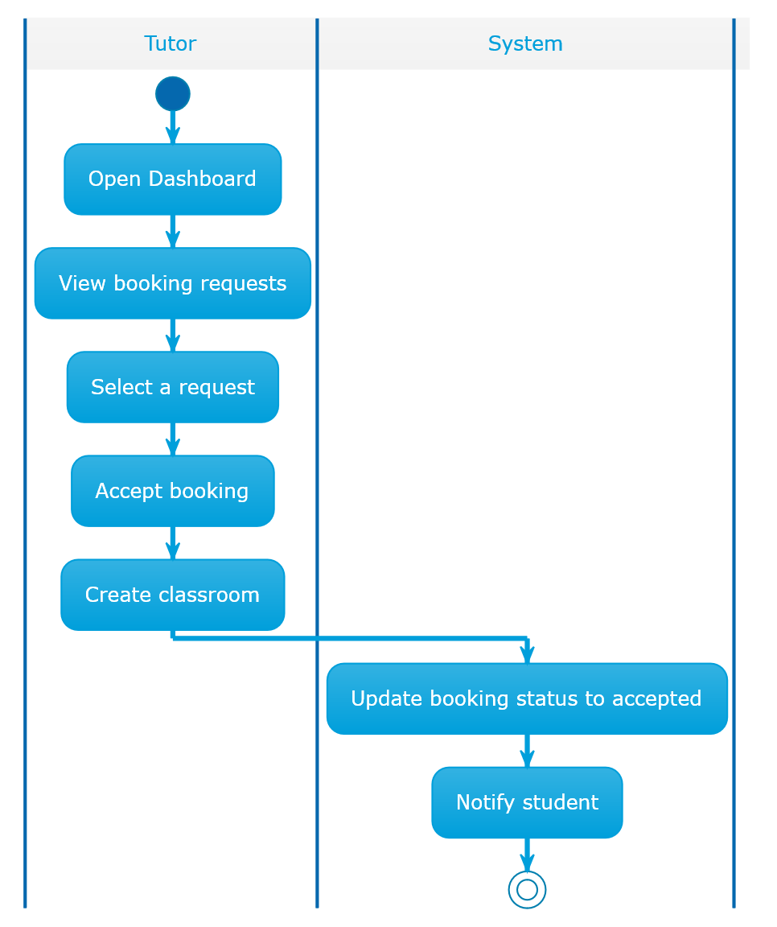
Figure 18 TutorAccept Booking Activity Diagram

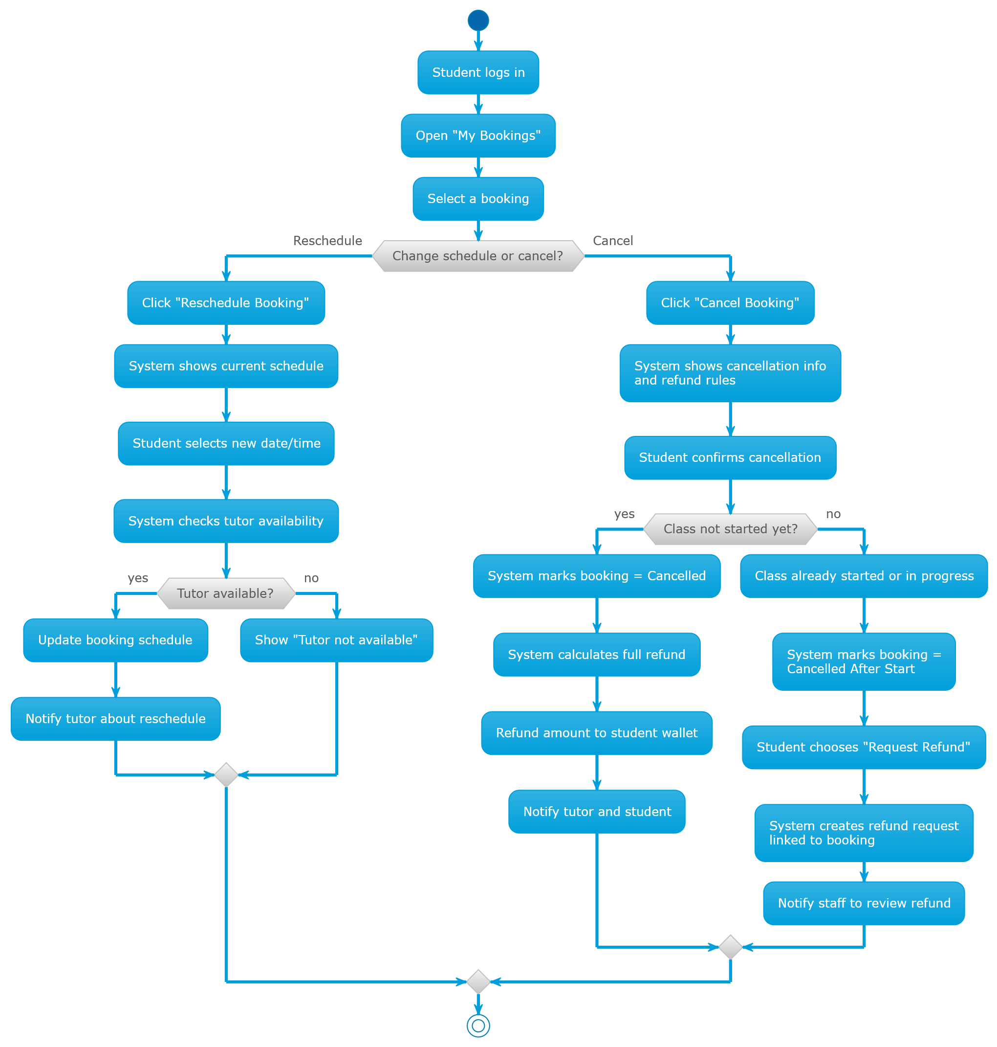
Figure 19 Booking Schedule Management Activity Diagram

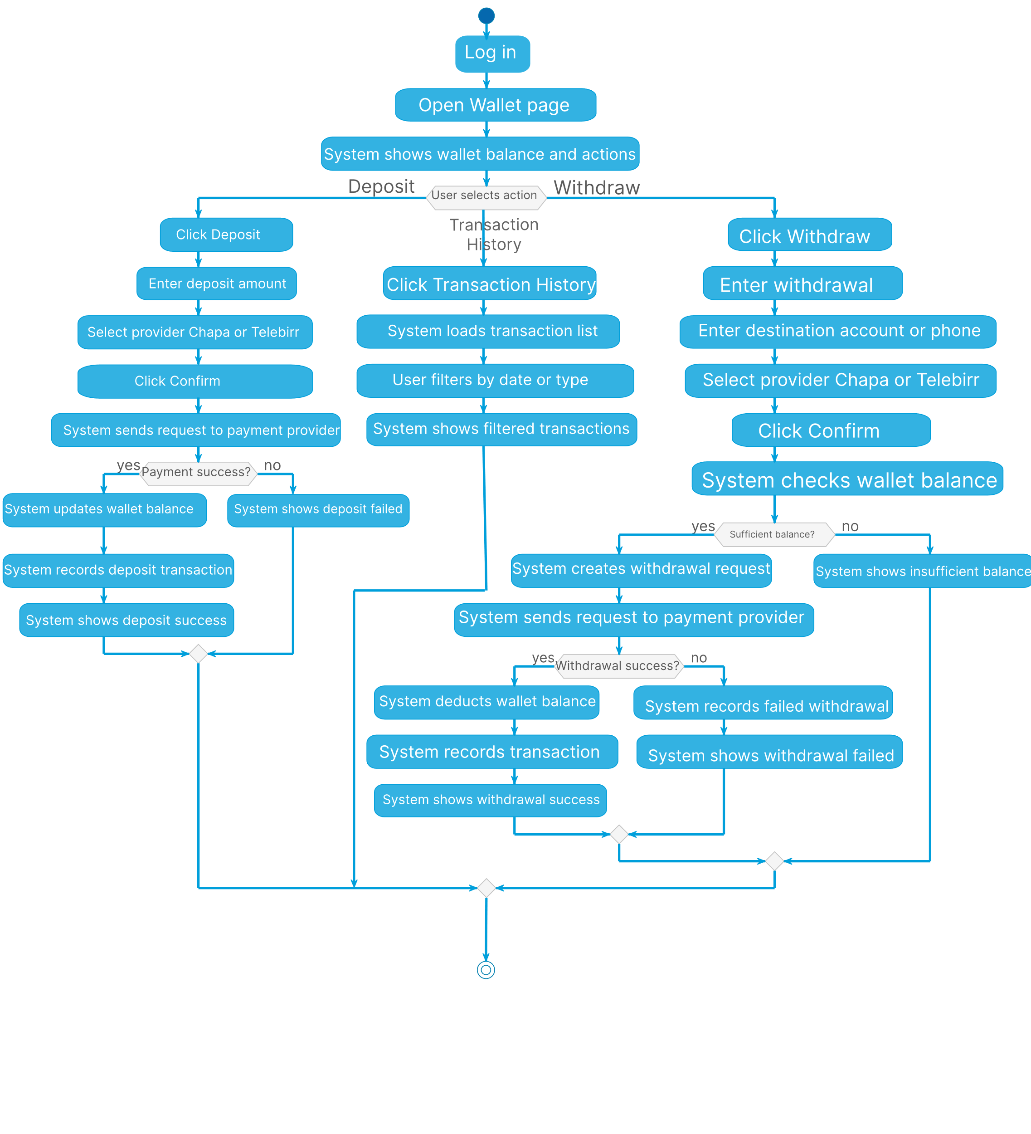
Figure 20 Wallet deposit and withdraw activity diagram

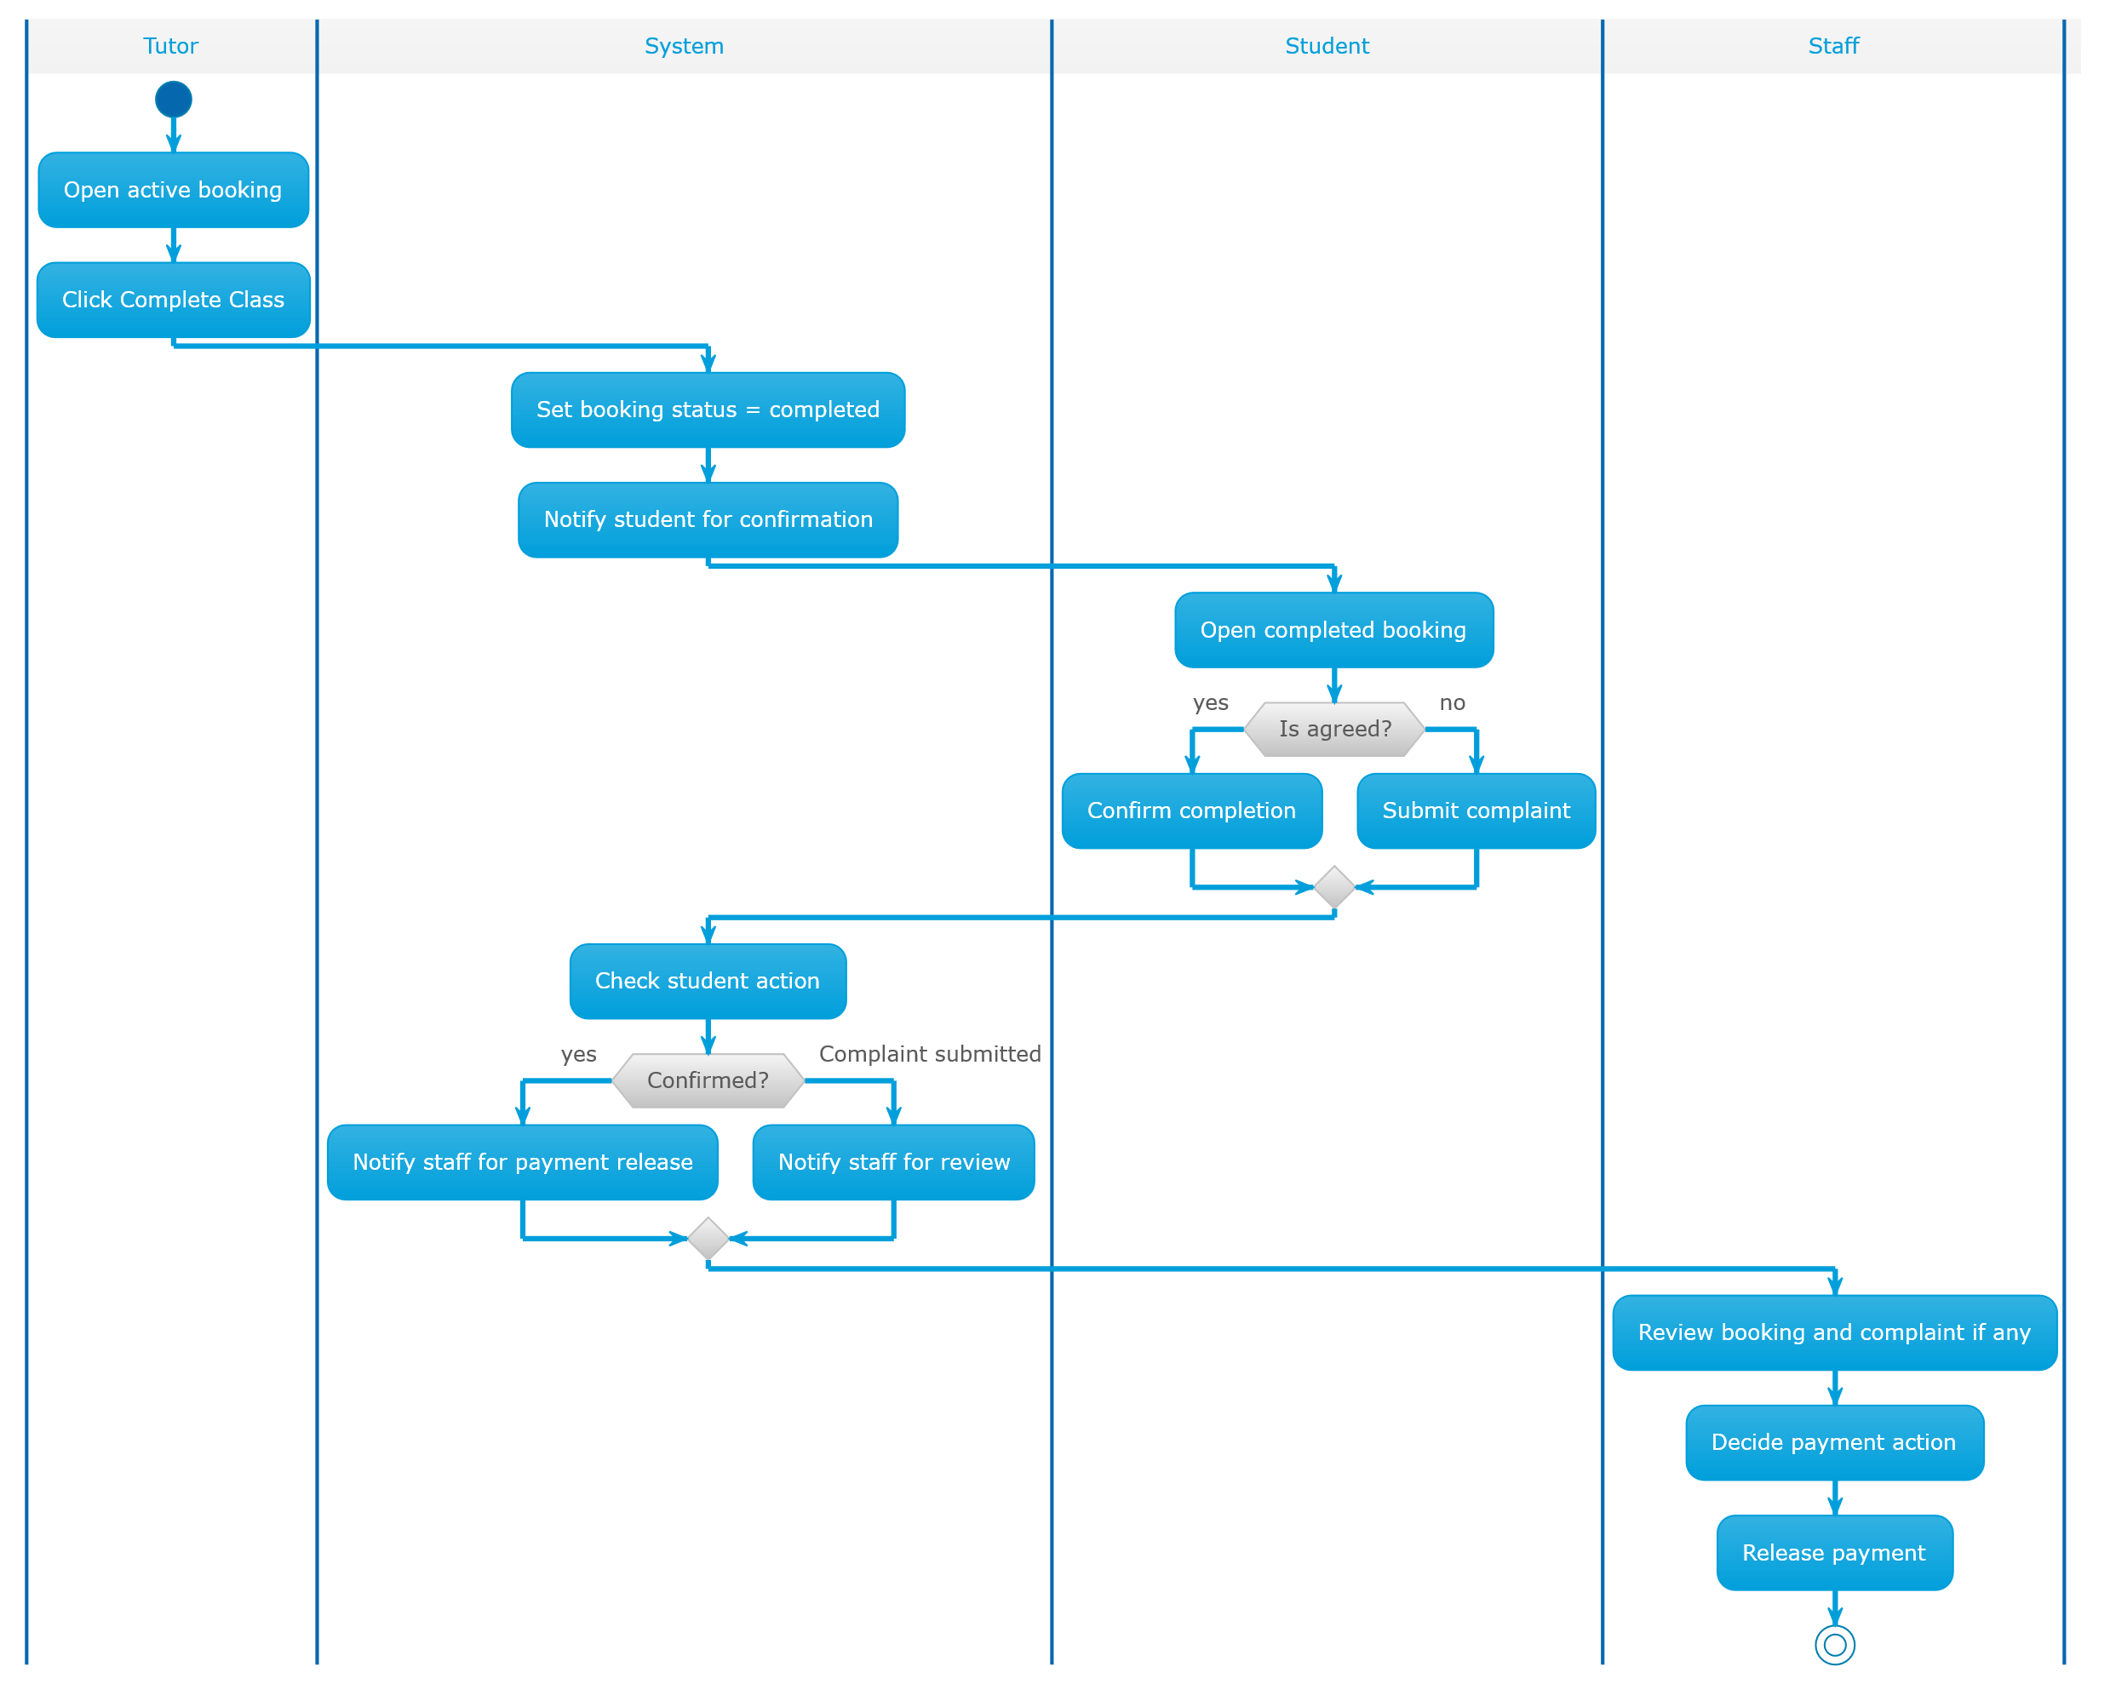
Figure 21 Payment Handling Activity Diagram

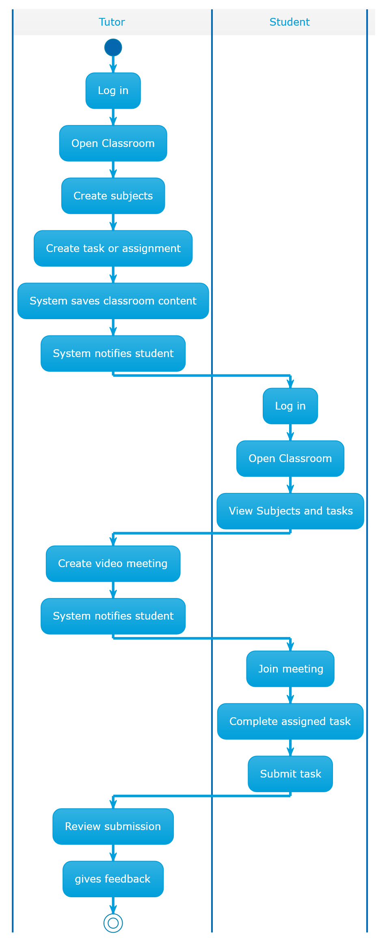
Figure 22 Online Classroom Learning Diagram

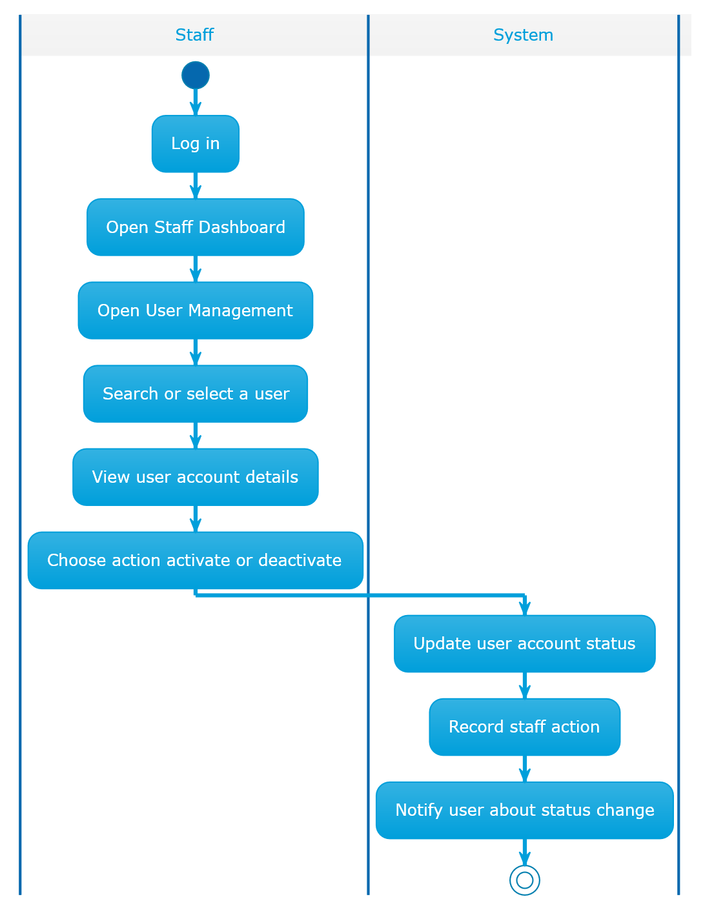
Figure 23 User account management Activity Diagram

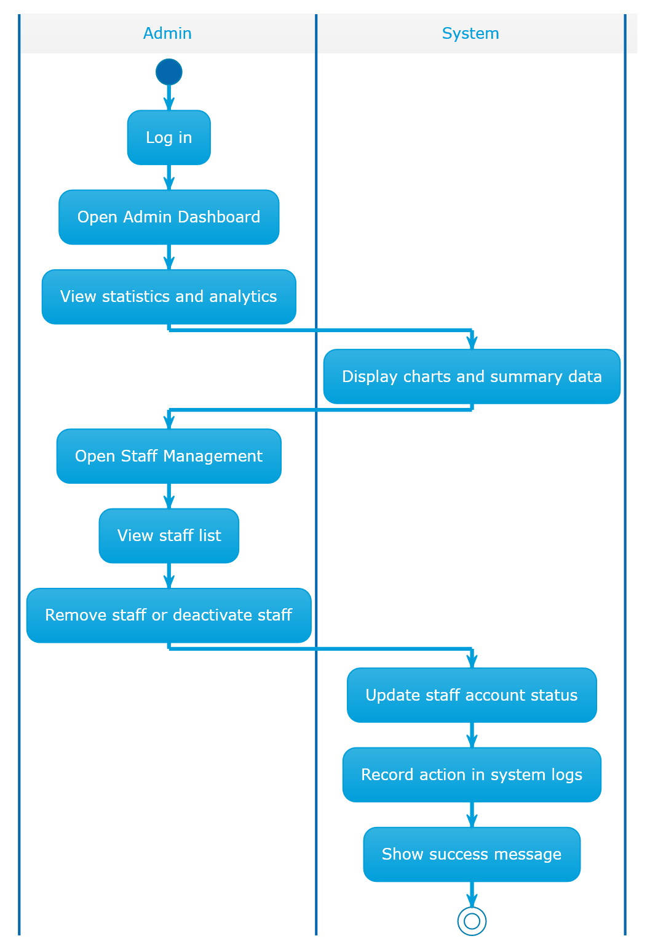
Figure 24 Staff Account Management Activity Diagram

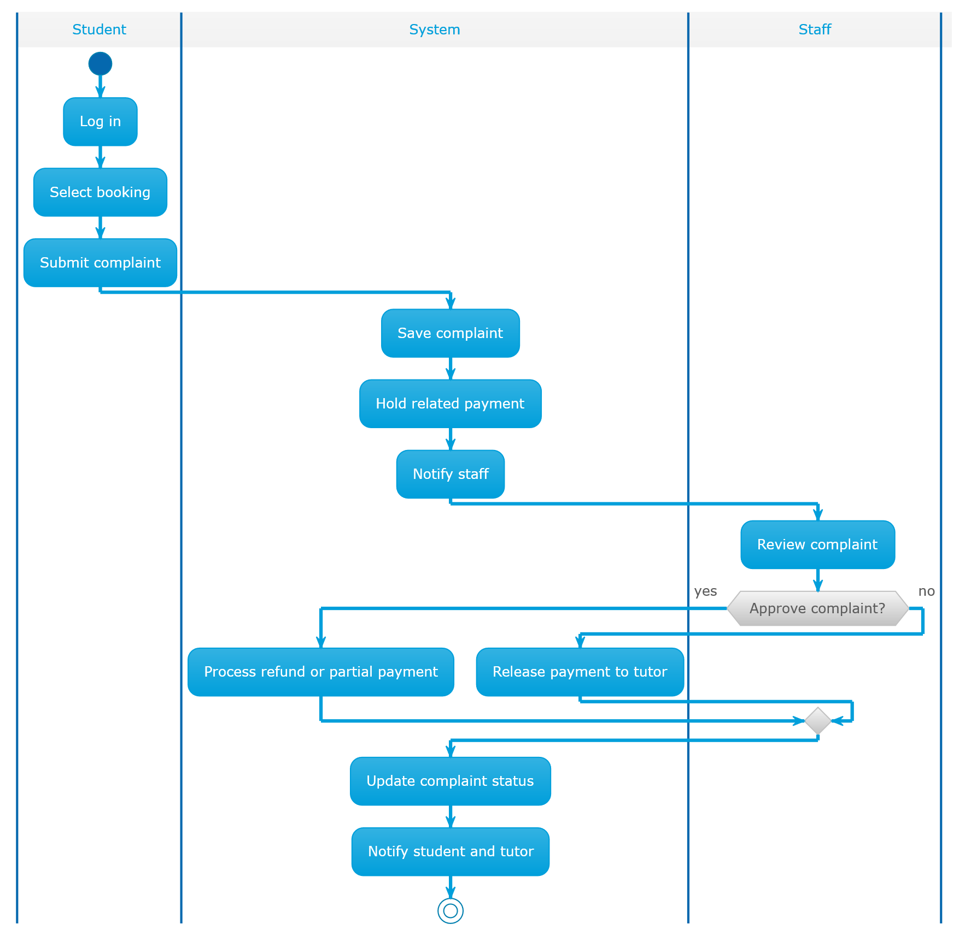
Figure 25 Complaint management Activity Diagram

3.4 Class Diagram
A Class Diagram is a structural UML diagram that represents the static design of a system. It shows the system’s main classes, their attributes, methods, and the relationships between them. Class diagrams provide a blueprint of how data is organized and how different components interact at the code or model level.
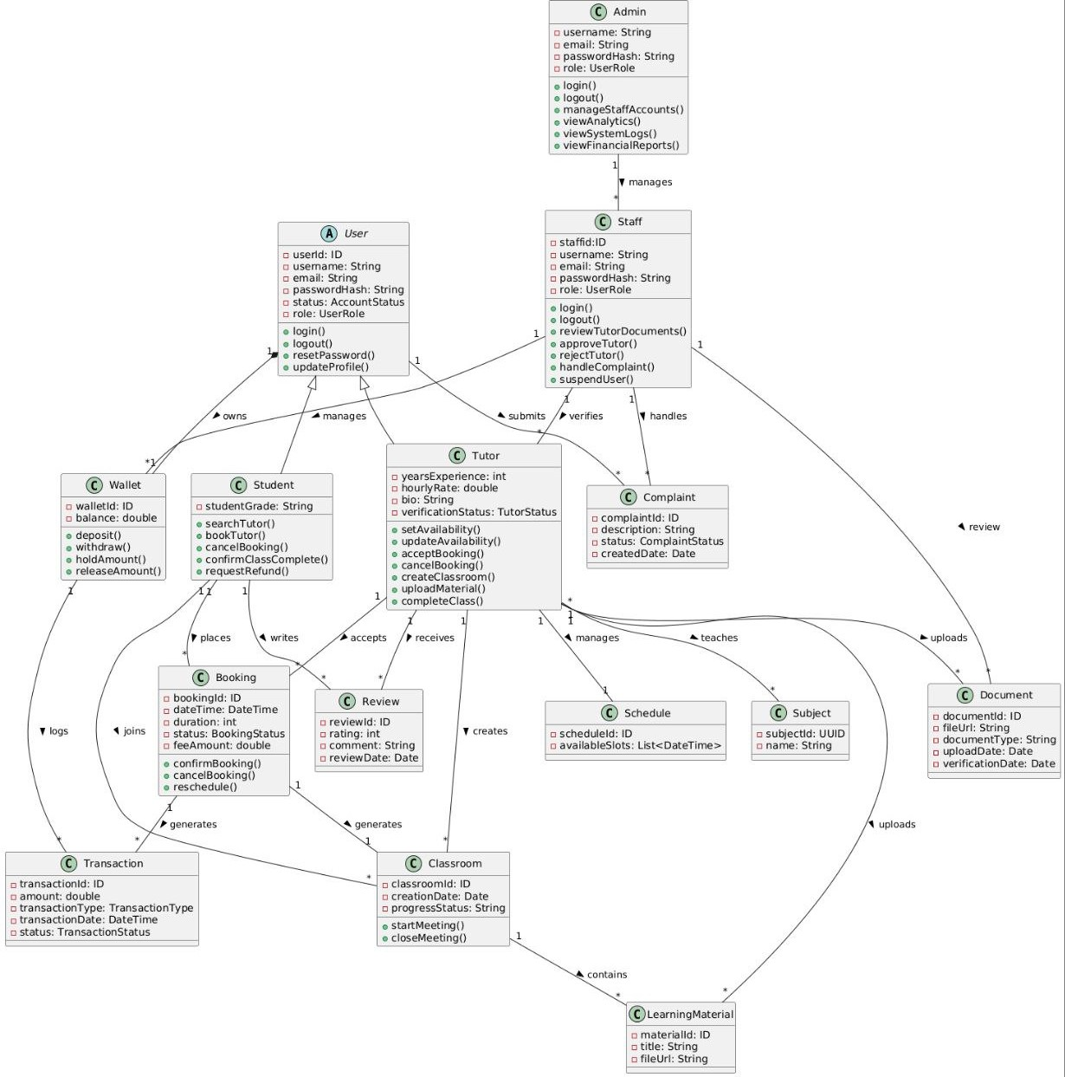
Figure 26 Class diagram

3.5 User Interface Diagram
User interface can be interpreted in many ways. It can be regarded as an overview that describes where users can navigate in a website or a product. It can also mean the actual quality and experience of the path users take to accomplish a task. The other meaning could have been that it can mean the actual sequence of steps the user takes to complete a task.
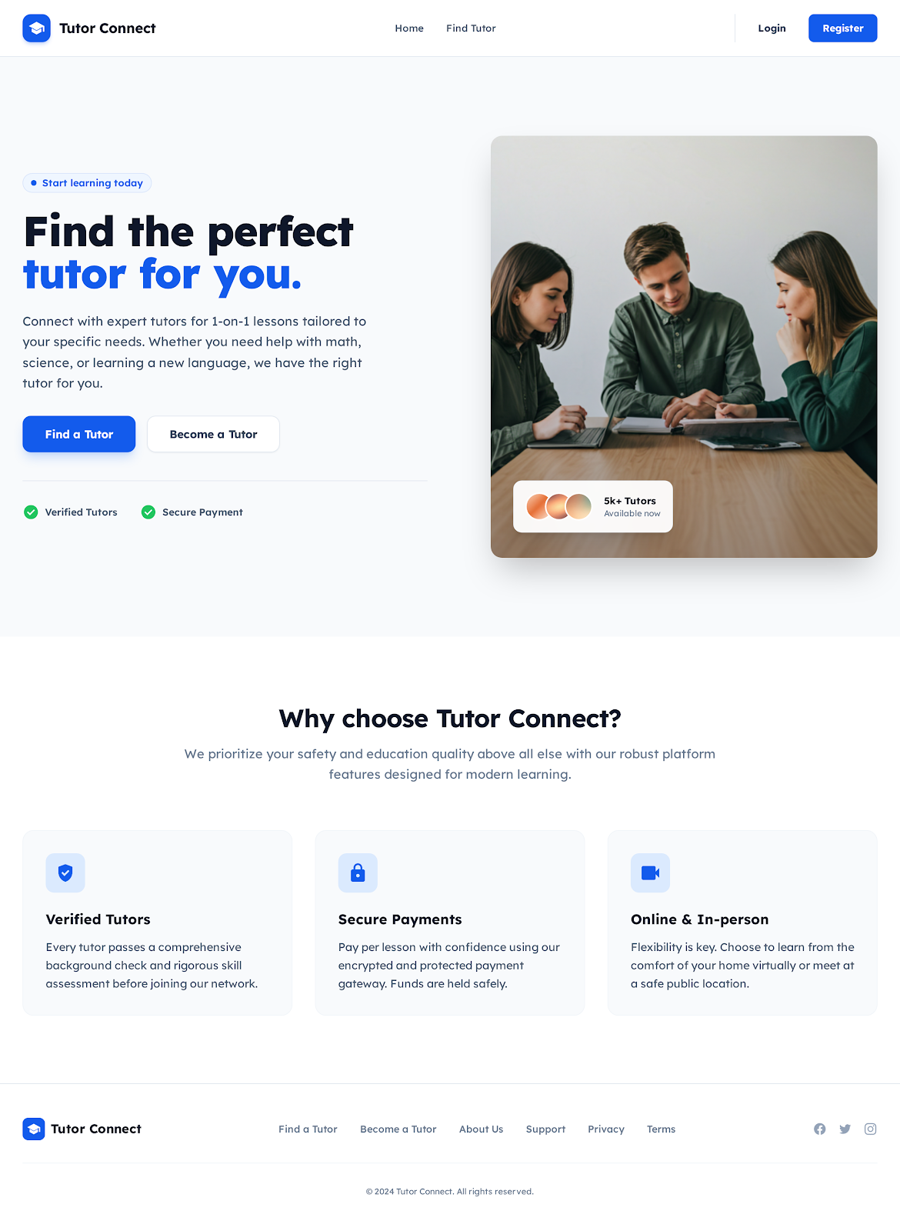
Figure 27 Home page
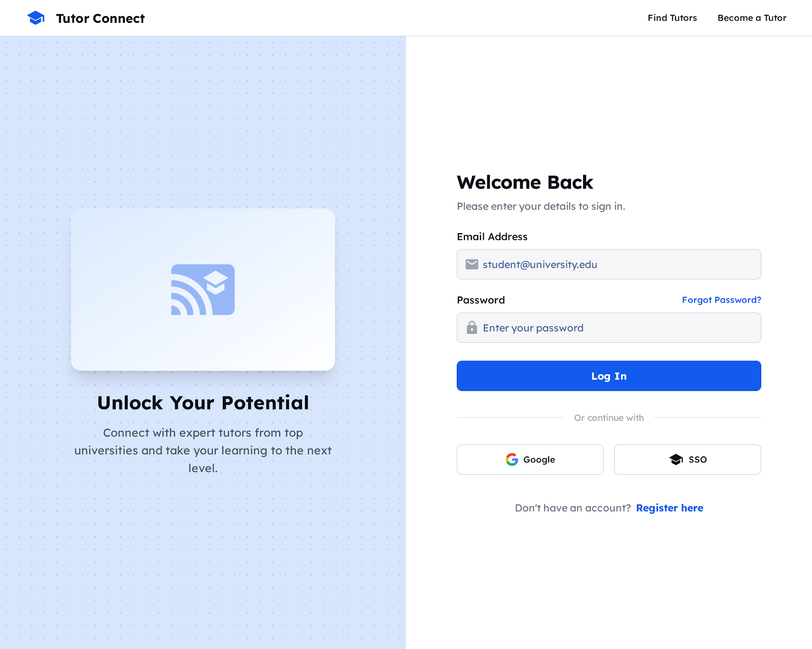
Figure 28 Login page
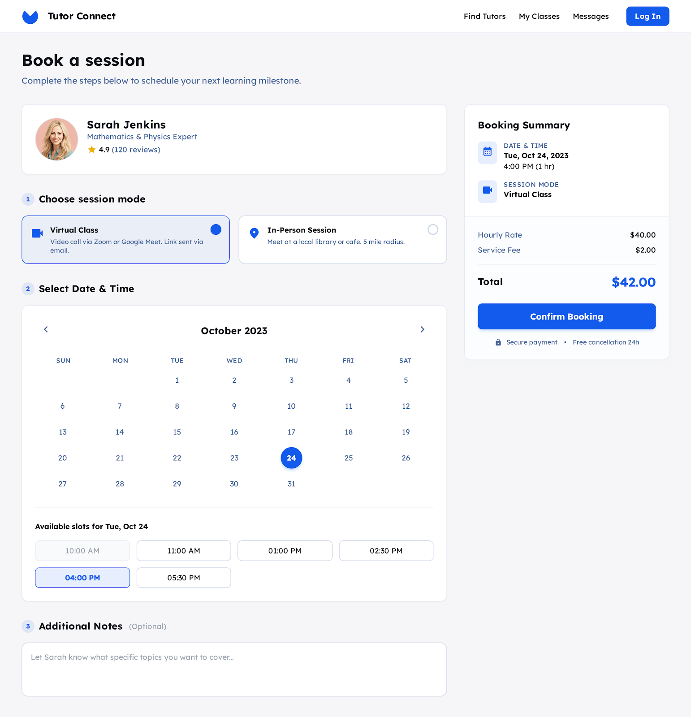
Figure 29 Book session

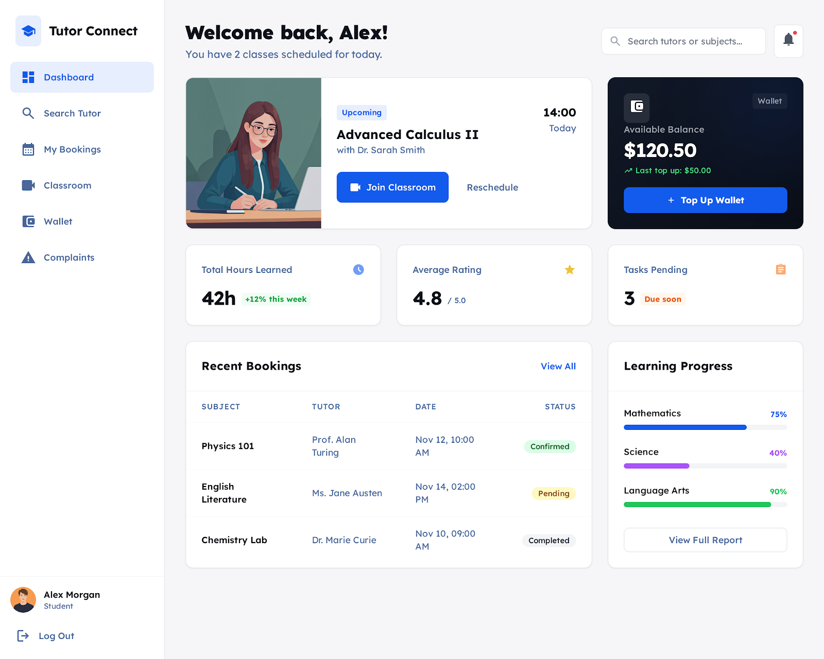
Figure 30 Main dashboard


Figure 31 Registration page

Chapter 4

4. SYSTEM DESIGN

4.1. Introduction to System Design
System design is the stage where the results from system analysis are changed into a clear system structure. In this phase, we decide how the Tutor-Connect system will be built and how different parts of the system will work together. The system design gives a clear guide for developers before starting the actual implementation.
The main goal of system design is to create a system that is easy to understand, easy to use, and easy to maintain. A good system design helps the developers to build a high-quality system that works correctly and efficiently. If the system is designed properly, it will also be easy to modify or upgrade in the future when new requirements come.
System design is very important because decisions made at this stage directly affect the success of the project. Poor design can lead to errors, low performance, and difficulties in maintenance. Good design improves system reliability, performance, and security. Therefore, system design is the best way to transform user requirements into a real working system.

4.2. Purpose of the System Design Document
The System Design Document (SDD) for the Tutor-Connect web application is prepared to describe how the system will be structured and how it will function. This document serves as an important reference for developers, project supervisors, and future maintainers of the system.
The main purposes of the System Design Document are:
System Architecture Description
It explains the overall structure of the Tutor-Connect system, including major components such as the user interface, application logic, and database. This helps stakeholders understand how the system is organized.
Technical Guidance for Developers
The document provides technical details such as technologies used, system layers, and component responsibilities. This helps developers follow a clear direction during implementation.
Functional Requirements Mapping
It shows how system features like tutor search, booking, verification, and payments are designed to meet user requirements.
Non-Functional Requirements Support
The document explains how performance, security, usability, and reliability requirements are handled in the system design.
Data Design Explanation
It describes how data such as users, tutors, bookings, and payments are stored and managed to ensure data accuracy and consistency.
Future Maintenance and Improvement
The SDD acts as a reference for future updates, debugging, and system expansion, making the system easier to maintain and improve.
The System Design Document ensures that Tutor-Connect is built in a structured, secure, and efficient way that meets both user needs and project objectives.

4.3. Scope of the System Design
The scope of system design for the Tutor-Connect platform covers all major components required to build a functional and reliable tutoring system. It focuses on both technical and functional aspects needed to connect students with verified tutors.
The main areas included in the system design scope are:
User Interface Design
Designing simple and user-friendly interfaces for students, tutors, staff, and admin users. The interface should be easy to navigate on both computers and mobile devices.
Tutor Management and Verification System
Designing a system that allows tutors to register, upload documents, and get verified by staff before becoming visible to students.
Tutor Search and Booking System
Designing a search and filtering mechanism that helps students find tutors based on subject, location, price, availability, and tutoring mode (online or in-person).
Wallet and Payment System Design
Designing a secure wallet-based payment system that allows students to deposit money, pay for tutoring sessions, and allows tutors to withdraw their earnings.
Classroom and Scheduling System
Designing features for class scheduling, virtual classrooms, online meetings, assignments, and progress tracking.
Database Design
Designing structured databases to store user profiles, tutor documents, bookings, payments, reviews, and system logs securely.
Security Design
Designing security mechanisms to protect user data, authentication, authorization, and financial transactions from unauthorized access.
The system design scope of Tutor-Connect ensures that all important features are planned clearly before development, helping to build a secure, scalable, and user-friendly tutoring platform.

4.4. Architectural Design
System architecture shows how the whole system is organized and how different parts of the system work together. It explains the main components of the system, their roles, and how they communicate with each other. A good architecture helps developers understand the system easily and makes the system simple to maintain and upgrade in the future.
The Tutor Connect system follows a three-layer architecture. This type of architecture divides the system into three main layers. Each layer has its own responsibility, which helps to make the system more organized, secure, and flexible.
The three layers used in the Tutor Connect system are:
User Interface Layer (Client Layer)
This layer is the part of the system that users interact with. It includes web pages accessed through a user’s browser.
Students use this layer to search for tutors, view tutor profiles, send requests, and manage learning sessions.
Tutors use this layer to create profiles, accept tutoring requests, and manage schedules.
This layer focuses on ease of use and user-friendly design.
Application Layer (Server Layer)
This layer contains the main logic of the Tutor Connect system. It processes user requests and controls how the system works.
It handles login and authentication.
It manages tutor matching, session scheduling, and communication between students and tutors.
It sends and receives data from the database.
This layer acts as a bridge between the user interface and the database.
Database Layer
This layer is responsible for storing and managing all system data.
It stores user information such as student and tutor profiles.
It keeps records of tutoring sessions, messages, and schedules
It ensures data security, consistency, and reliability.
Using a three-layer architecture helps the Tutor Connect system to be more secure and scalable. If one layer needs changes, it can be updated without affecting the other layers. This architecture also improves system performance and makes future improvements easier.
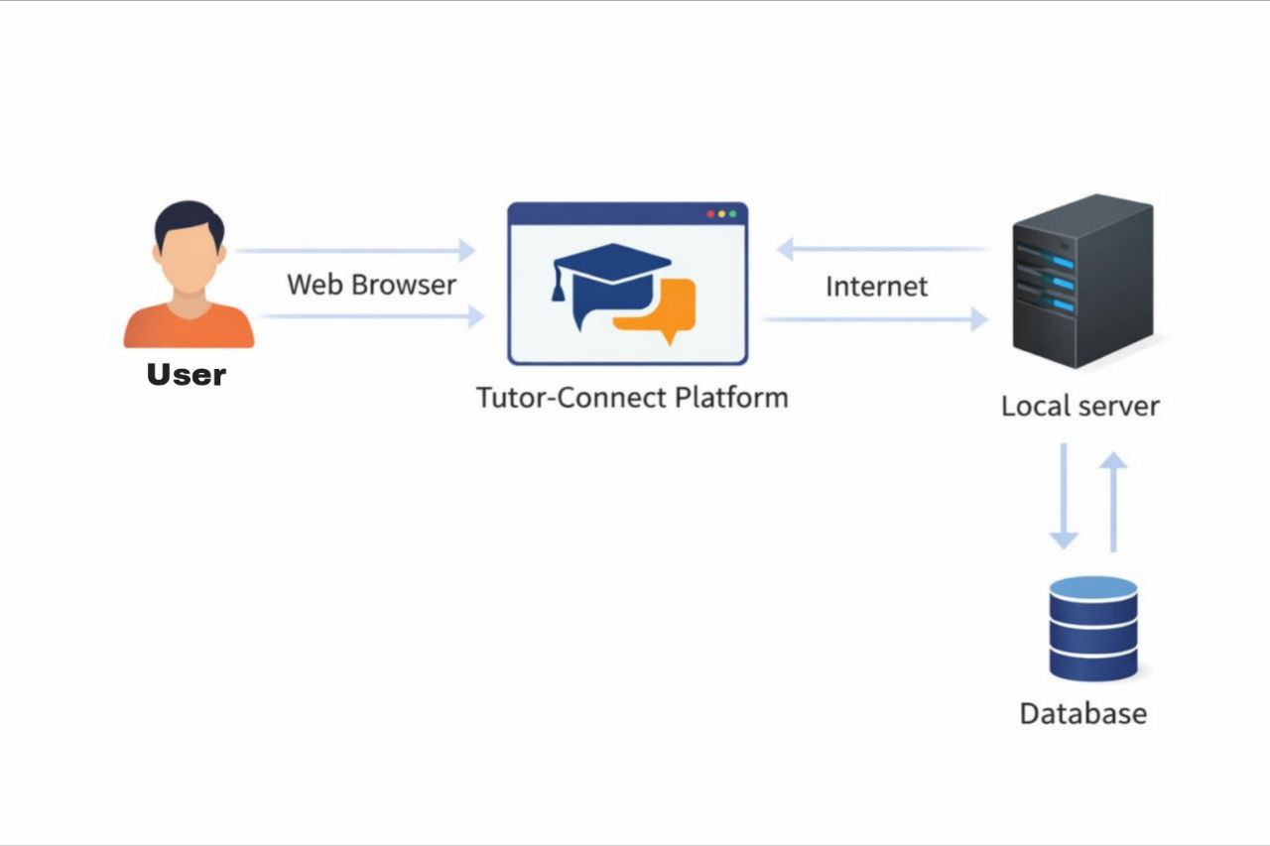
Figure 32 Architectural Design

4.2 Process View
The Process View explains how Tutor Connect works while it is running. It shows the main running parts (processes) like the web client, the web server, database access, payment gateway access, and meeting access. It also shows background jobs such as notifications and payment checks.
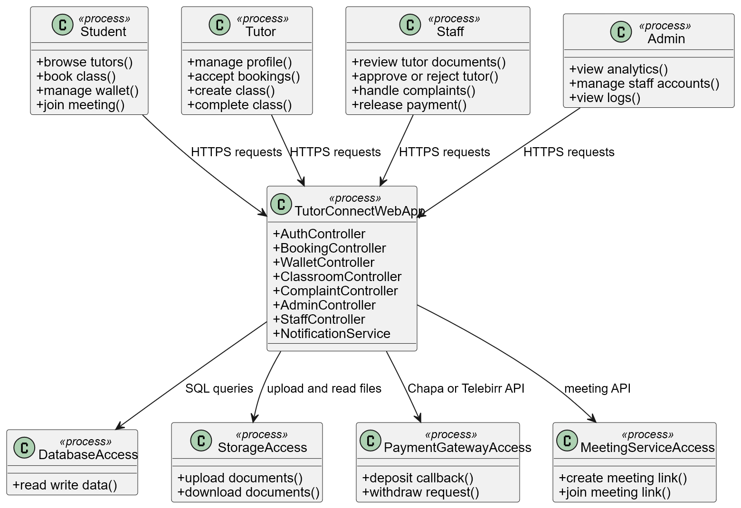
4.2.1 Process Model Diagram
Figure 33 Process Model.

4.2.2 Process Descriptions
Student process
This process represents the student browser session. It displays pages and sends requests to the Tutor Connect web app. There is one instance for each student who is logged in.
Tutor process
This process represents the tutor browser session. It is used for profile management, accepting bookings, class creation, meeting creation, and class completion. There is one instance for each tutor who is logged in.
Staff process
This process represents the staff browser session. Staff review tutor documents, approve or reject tutor applications, handle complaints, and release payments when the tutor completes the class and the student confirms completion.
Admin process
This process represents the admin browser session. Admin can view analytics, manage staff accounts, and view system logs.
TutorConnectWebApp process
This is the main server side process. It runs the Next.js web application and API endpoints. It coordinates authentication, booking, wallet logic, held payment logic, classroom tools, complaint handling, and notifications.
DatabaseAccess process
This process manages access to the Postgres database hosted on Supabase. It stores users, roles, tutor profile, bookings, wallets, transactions, held payments, classrooms, tasks, complaints, and logs.
StorageAccess process
This process manages file storage for tutor verification documents and profile images. It is mainly used during tutor portfolio upload and staff review.
PaymentGatewayAccess process
This process communicates with Chapa and Telebirr services for deposit and withdrawal. It confirms payments using callbacks or verification endpoints, then updates wallet balances.
MeetingServiceAccess process
This process provides meeting link creation and usage for virtual tutoring. The link is stored in the classroom or session record and then shared with tutor and student.

4.2.3 Process to Design Elements
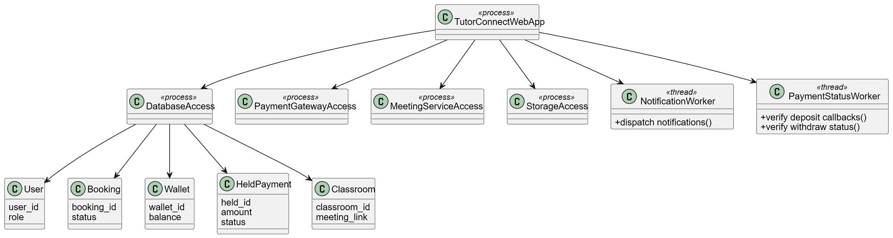
Figure 34 Process Model to Design Model

4.2.4 Processes to Implementation
1. Remote access
  - API endpoints act like remote services.
  - Examples are login API, booking API, wallet API, and classroom API.
  - Only these endpoints are accessible from the client side.
- Runnable or background work
  - Background jobs are used for tasks that should not block the user request.
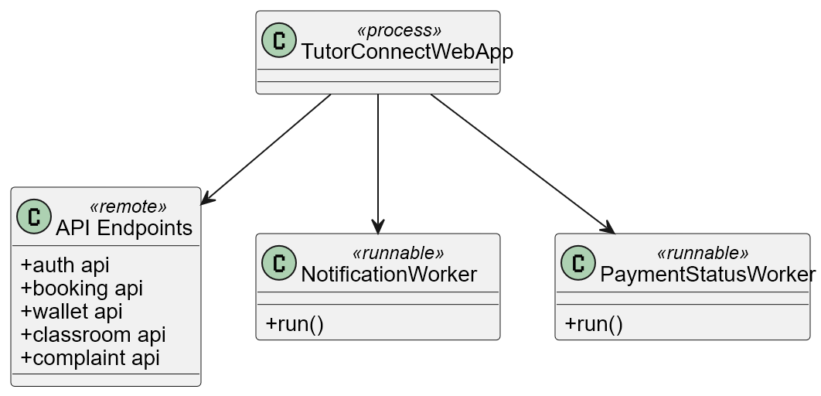
  - Examples are notification dispatch and payment status checks.
Figure 35 Processes to Implementation

Deployment View for Tutor Connect Platform
Tutor Connect is a web based tutoring platform used by four main user roles: Student, Tutor, Staff, and Admin. The system uses Next.js for the website user interface, Node.js for backend services, Postgres for database storage, and NextAuth for login and access control. The website will be hosted on Vercel and the database will be hosted on Supabase.
2. Main deployment nodes and their tasks
2.1 Client device
Actors using this node:
Student, Tutor, Staff, Admin
Main tasks:
- Open the Tutor Connect website using a web browser
- Display pages such as home page, login, register, dashboards
- Send requests to the system through HTTPS
- Join virtual class meeting through a meeting link
2.2 Web application host
Main tasks:
- Serve the UI pages (Next.js pages)
- Run backend APIs (Node.js services)
- Handle login and authorization using NextAuth
- Manage booking and scheduling functions
- Manage wallet functions such as deposit request, withdrawal request, hold payment, and release payment
- Manage classroom functions such as create class, create tasks, create meeting link
- Store notifications and trigger notification messages
2.3 Database and file storage host
Main tasks:
- Store system data in Postgres tables such as users, tutor profile, booking, payment, wallet, transactions, complaints, classrooms, and tasks
- Store tutor verification documents and images using file storage
2.4 Payment providers
Main tasks:
- Process student deposit to wallet
- Process student withdrawal from wallet
- Process tutor withdrawal of earnings
- Send confirmation callback to Tutor Connect backend after payment success or fail
2.5 Video meeting service
Main tasks:
- Create a meeting session or meeting link
- Allow tutor and student to join online class meeting
3. Communication between nodes
- Client device communicates with the web application host using HTTPS
- Web application host communicates with database using secure database connection
- Web application host communicates with file storage using HTTPS upload and download
- Web application host communicates with payment providers using HTTPS API calls and receives callback results
- Client device communicates with meeting service to join the virtual class
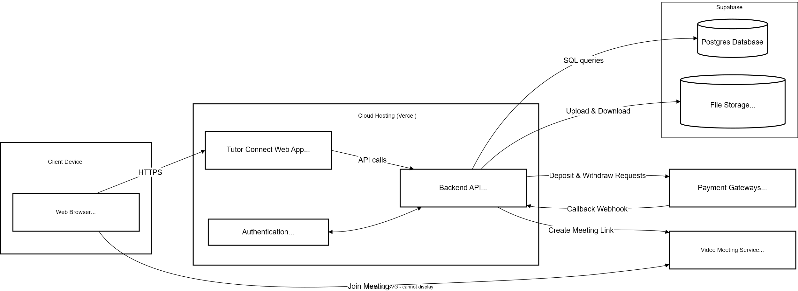
- Deployment diagram

Figure 36 Deployment diagram

Table 1 User
Attribute | Datatype | Description | Constraint
user_id | INT | System id for each user | Primary key
full_name | VARCHAR(100) | Full name of the user | Not null
email | VARCHAR(120) | Email address used for login | Not null, unique
phone_number | VARCHAR(30) | Mobile phone number | Not null
Password_hash | VARCHAR(255) | Encrypted password | Not null
role | VARCHAR(20) | Role of the user such as (student or tutor or staff or admin) | Not null
status | VARCHAR(20) | Account status such as (active or deactivated or pending) | Not null, default active
Created_at | DATETIME | Date and time the user account was created | Not null
Upd  ated_at | DATETIME | Date and time the user record was last changed | Not null
Table 44 User

Table 2 Student Profile
Attribute | Datatype | Description | Constraint
student_id | INT | Unique id for student profile record | Primary key, not null
user_id | INT | The user id that owns this student profile | Foreign key references User user_id, not null
grade_level | VARCHAR(30) | Grade level or school year of the student | Nullable
learning_mode | VARCHAR(20) | Preferred tutoring mode such as virtual or in person | Nullable
address_city | VARCHAR(60) | City where the student lives | Nullable
address_area | VARCHAR(60) | Area or sub city where the student lives | Nullable
emergency_contact_name | VARCHAR(100) | Name of emergency contact person | Nullable
emergency_contact_phone | VARCHAR(30) | Phone number of emergency contact person | Nullable
Table 45 Student Profile
Table 3 Tutor Profile
Attribute | Datatype | Description | Constraint
wallet_id | INT | Unique id for wallet record | Primary key
user_id | INT | The user id that owns this wallet | Foreign key references User user_id, Not null, Unique
current_balance | DECIMAL(12,2) | Current balance stored in the wallet | Not null, Default 0
currency | VARCHAR(10) | Currency type such as ETB | Not null
last_updated | DATETIME | Date and time when wallet balance was last changed | Not null
is_locked | BOOLEAN | Shows if wallet is locked because money is held for a booking | Not null, Default false
Table 46 Tutor Profile
Table 4 Wallet
Attribute | Datatype | Description | Constraint
wallet_id | INT | Unique id for wallet record | Primary key
user_id | INT | The user id that owns this wallet | Foreign key references User user_id, Not null, Unique
current_balance | DECIMAL(12,2) | Current balance stored in the wallet | Not null, Default 0
currency | VARCHAR(10) | Currency type such as ETB | Not null
last_updated | DATETIME | Date and time when wallet balance was last changed | Not null
is_locked | BOOLEAN | Shows if wallet is locked because money is held for a booking | Not null, Default false
Table 47 Wallet

Table 5 Subject
Attribute | Datatype | Description | Constraint
subject_id | INT | Unique id for each subject | Primary key
subject_name | VARCHAR(80) | Name of the subject such as Mathematics, English, Physics | Not null, Unique
grade_level | VARCHAR(30) | Grade level or education level for this subject | Nullable
created_at | DATETIME | Date and time when the subject is added | Not null
Table 48 Subject
Table 6 Tutor subject
Attribute | Datatype | Description | Constraint
tutor_subject_id | INT | Unique id for tutor subject record | Primary key
tutor_id | INT | Tutor id who teaches the subject | Foreign key references TutorProfile tutor_id, Not null
subject_id | INT | Subject id that tutor can teach | Foreign key references Subject subject_id, Not null
level_note | VARCHAR(50) | Short note about level such as beginner, intermediate, advanced | Nullable
is_active | BOOLEAN | Shows if tutor is currently offering this subject | Not null, Default true
Table 49 Tutor subject
Table 7 Availability
Attribute | Datatype | Description | Constraint
availability_id | INT | Unique id for availability record | Primary key
tutor_id | INT | Tutor id who owns this availability | Foreign key references TutorProfile tutor_id, Not null
day_of_week | VARCHAR(15) | Day name such as Monday, Tuesday, Wednesday | Not null
start_time | TIME | Start time of availability slot | Not null
end_time | TIME | End time of availability slot | Not null
mode | VARCHAR(20) | Mode for this slot such as virtual, in person, or both | Not null
is_available | BOOLEAN | Shows if this slot is active and can be booked | Not null, Default true
Table 50 Availability
Table 8 Booking
Attribute | Datatype | Description | Constraint
booking_id | INT | Unique id for each booking | Primary key
student_id | INT | Student who booked the tutor | Foreign key references StudentProfile student_id, Not null
tutor_id | INT | Tutor who is booked | Foreign key references TutorProfile tutor_id, Not null
subject_id | INT | Subject selected for this booking | Foreign key references Subject subject_id, Not null
tutoring_mode | VARCHAR(20) | Tutoring mode such as virtual or in person | Not null
start_date | DATE | Date when the schedule starts | Not null
end_date | DATE | Date when the schedule ends | Not null
total_days | INT | Total number of days in the schedule | Not null
total_amount | DECIMAL(12,2) | Total agreed amount for the full schedule | Not null
service_fee | DECIMAL(12,2) | Platform service fee for this booking | Not null, Default 0
status | VARCHAR(60) | Booking status such as pending, accepted, active, completed, cancelled | Not null
accepted_at | DATETIME | Date and time when tutor accepted the booking | Nullable
tutor_completed_at | DATETIME | Date and time when tutor clicked complete class | Nullable
student_confirmed | BOOLEAN | Shows if student confirmed class completion | Not null, Default false
student_confirmed_at | DATETIME | Date and time when student confirmed completion | Nullable
location_city | VARCHAR(60) | City for in person tutoring if used | Nullable
location_area | VARCHAR(60) | Area or sub city for in person tutoring if used | Nullable
meeting_address | TEXT | Detailed address for in person tutoring if used | Nullable
created_at | DATETIME | Date and time when booking was created | Not null
Table 51 Booking
Table 9 Classroom
Attribute | Datatype | Description | Constraint
classroom_id | INT | Unique id for each classroom | Primary key
booking_id | INT | Booking id that owns this classroom | Foreign key references Booking booking_id, Not null, Unique
tutor_id | INT | Tutor who created the classroom | Foreign key references TutorProfile tutor_id, Not null
student_id | INT | Student who joins this classroom | Foreign key references StudentProfile student_id, Not null
title | VARCHAR(120) | Classroom title such as Grade 10 Math Class | Not null
description | TEXT | Short classroom description | Nullable
meeting_link | VARCHAR(255) | Online meeting link for video call | Nullable
meeting_status | VARCHAR(30) | Meeting status such as not created, created, ended | Not null, Default not created
created_at | DATETIME | Date and time when classroom is created | Not null
Table 52 Classroom

Table 10 Class Chapter
Attribute | Datatype | Description | Constraint
chapter_id | INT | Unique id for each chapter record | Primary key
classroom_id | INT | Classroom that owns this chapter | Foreign key references Classroom classroom_id, Not null
chapter_title | VARCHAR(120) | Chapter title such as Algebra, Grammar, Biology Unit 1 | Not null
chapter_order | INT | Chapter sequence number in the classroom | Not null
created_at | DATETIME | Date and time when chapter was added | Not null
Table 53 Class Chapter
Table 11 Classwork
Attribute | Datatype | Description | Constraint
classwork_id | INT | Unique id for each classwork record | Primary key
classroom_id | INT | Classroom that owns this task | Foreign key references Classroom classroom_id, Not null
chapter_id | INT | Chapter linked with this task if needed | Foreign key references ClassChapter chapter_id, Nullable
work_type | VARCHAR(30) | Type of work such as classwork, homework, assignment, or quiz | Not null
title | VARCHAR(150) | Title of the task | Not null
instructions | TEXT | Task instructions written by tutor | Nullable
due_date | DATETIME | Due date and time for submission | Nullable
status | VARCHAR(30) | Status such as open, closed, graded | Not null, Default open
created_at | DATETIME | Date and time when task was created | Not null
Table 54 Classwork
Table 12 Submission
Attribute | Datatype | Description | Constraint
submission_id | INT | Unique id for each submission | Primary key
classwork_id | INT | Task id that student is submitting | Foreign key references Classwork classwork_id, Not null
student_id | INT | Student who submitted the work | Foreign key references StudentProfile student_id, Not null
submitted_text | TEXT | Student answer written in text form | Nullable
file_url | VARCHAR(255) | File link if student uploads a file | Nullable
submitted_at | DATETIME | Date and time when submission is made | Not null
grade | DECIMAL(5,2) | Grade score given by tutor | Nullable
feedback | TEXT | Tutor feedback for student | Nullable
status | VARCHAR(30) | Status such as submitted, reviewed, graded | Not null, Default submitted
Table 55 Submission
Table 13 Hold Payment
Attribute | Datatype | Description | Constraint
hold_id | INT | Unique id for held payment record | Primary key
booking_id | INT | Booking that created this held payment | Foreign key references Booking booking_id, Not null, Unique
student_wallet_id | INT | Wallet id of the student | Foreign key references Wallet wallet_id, Not null
tutor_wallet_id | INT | Wallet id of the tutor | Foreign key references Wallet wallet_id, Not null
held_amount | DECIMAL(12,2) | Money amount held by the system for this booking | Not null
held_status | VARCHAR(30) | Status such as held, ready_to_release, released, or on_hold | Not null, Default held
held_at | DATETIME | Date and time when money was held | Not null
released_at | DATETIME | Date and time when money was released | Nullable
Table 56 Hold Payment
Table 14 Wallet Transaction
Attribute | Datatype | Description | Constraint
transaction_id | INT | Unique id for each wallet transaction | Primary key
wallet_id | INT | Wallet that is affected by this transaction | Foreign key references Wallet wallet_id, Not null
booking_id | INT | Booking linked to this transaction if related | Foreign key references Booking booking_id, Nullable
transaction_type | VARCHAR(30) | Type such as deposit, withdraw, hold, release, refund, or fee | Not null
amount | DECIMAL(12,2) | Transaction money amount | Not null
direction | VARCHAR(10) | Direction such as in or out | Not null
provider | VARCHAR(30) | Payment provider such as Chapa or Telebirr | Nullable
reference_code | VARCHAR(120) | Payment reference id from provider if available | Nullable
status | VARCHAR(30) | Status such as pending, success, or failed | Not null
created_at | DATETIME | Date and time when transaction is created | Not null
Table 57 Wallet Transaction
Table 15 Withdrawal Request
Attribute | Datatype | Description | Constraint
withdrawal_id | INT | Unique id for withdrawal request | Primary key
wallet_id | INT | Wallet that is withdrawing money | Foreign key references Wallet wallet_id, Not null
user_id | INT | User who requested withdrawal | Foreign key references User user_id, Not null
amount | DECIMAL(12,2) | Amount requested for withdrawal | Not null
provider | VARCHAR(30) | Provider such as Chapa or Telebirr | Not null
destination | VARCHAR(120) | Destination account or phone number | Not null
status | VARCHAR(30) | Status such as pending, completed, or failed | Not null, Default pending
requested_at | DATETIME | Date and time when request is created | Not null
processed_at | DATETIME | Date and time when withdrawal is processed | Nullable
Table 58 Withdrawal Request
Table 16 Refund Request
Attribute | Datatype | Description | Constraint
refund_id | INT | Unique id for refund request | Primary key
booking_id | INT | Booking that the refund is related to | Foreign key references Booking booking_id, Not null
student_id | INT | Student who is requesting refund | Foreign key references StudentProfile student_id, Not null
request_reason | TEXT | Reason why student requests refund | Nullable
refund_amount | DECIMAL(12,2) | Amount requested to be refunded | Not null
status | VARCHAR(30) | Status such as pending, approved, rejected, or completed | Not null, Default pending
requested_at | DATETIME | Date and time when request is created | Not null
reviewed_by | INT | Staff user id who reviews the request | Foreign key references User user_id, Nullable
reviewed_at | DATETIME | Date and time when staff reviewed it | Nullable
Table 59 Refund Request
Table 17 Complaint
Attribute | Datatype | Description | Constraint
complaint_id | INT | Unique id for each complaint record | Primary key
booking_id | INT | Booking related to this complaint | Foreign key references Booking booking_id, Not null
user_id | INT | User who submitted the complaint | Foreign key references User user_id, Not null
complaint_type | VARCHAR(50) | Type of complaint such as class issue, payment issue, behavior issue | Not null
description | TEXT | Detailed explanation of the complaint | Nullable
status | VARCHAR(30) | Complaint status such as pending, in progress, resolved, or rejected | Not null, Default pending
submitted_at | DATETIME | Date and time when complaint is submitted | Not null
handled_by | INT | Staff user id who handles the complaint | Foreign key references User user_id, Nullable
resolved_at | DATETIME | Date and time when complaint is resolved | Nullable
Table 60 Complaint

Table 18 Rating Review
Attribute | Datatype | Description | Constraint
review_id | INT | Unique id for each rating or review | Primary key
booking_id | INT | Booking that this review belongs to | Foreign key references Booking booking_id, Not null, Unique
tutor_id | INT | Tutor who is being reviewed | Foreign key references TutorProfile tutor_id, Not null
student_id | INT | Student who gives the rating | Foreign key references StudentProfile student_id, Not null
rating_score | INT | Rating value given by student such as 1 to 5 | Not null
review_text | TEXT | Optional written feedback from student | Nullable
created_at | DATETIME | Date and time when review is submitted | Not null
Table 61 Rating Review
Table 19 Notification
Attribute | Datatype | Description | Constraint
notification_id | INT | Unique id for each notification | Primary key
user_id | INT | User who receives the notification | Foreign key references User user_id, Not null
title | VARCHAR(100) | Short title of the notification | Not null
message | TEXT | Notification message content | Not null
notification_type | VARCHAR(30) | Type such as booking, payment, approval, or system | Not null
is_read | BOOLEAN | Shows if user has read the notification | Not null, Default false
created_at | DATETIME | Date and time when notification is created | Not null
Table 62 Notification

Table 20 Progress Tracking
Attribute | Datatype | Description | Constraint
progress_id | INT | Unique id for progress tracking record | Primary key
booking_id | INT | Booking linked to this progress | Foreign key references Booking booking_id, Not null, Unique
total_sessions | INT | Total number of sessions planned for the booking | Not null
completed_sessions | INT | Number of sessions already completed | Not null, Default 0
progress_percent | DECIMAL(5,2) | Progress percentage from 0 to 100 | Not null
last_updated | DATETIME | Date and time when progress was last updated | Not null
Table 63 Progress Tracking
Table 21 Session Plan
Attribute | Datatype | Description | Constraint
session_id | INT | Unique id for each session record | Primary key
booking_id | INT | Booking that owns this session plan | Foreign key references Booking booking_id, Not null
session_date | DATE | Date for the tutoring session | Not null
start_time | TIME | Start time for the session | Not null
end_time | TIME | End time for the session | Not null
session_mode | VARCHAR(20) | Mode such as virtual or in person | Not null
meeting_link | VARCHAR(255) | Meeting link for this session if virtual | Nullable
status | VARCHAR(30) | Status such as planned, completed, cancelled | Not null, Default planned
tutor_marked_done | BOOLEAN | Shows if tutor marked this session as done | Not null, Default false
tutor_marked_at | DATETIME | Date and time when tutor marked session done | Nullable
student_confirmed | BOOLEAN | Shows if student confirmed this session completion | Not null, Default false
student_confirmed_at | DATETIME | Date and time when student confirmed session completion | Nullable
created_at | DATETIME | Date and time when session plan was created | Not null
Table 64 Session Plan

E-R diagram
E-R diagram or the conceptual diagram with cardinality: ER modeling is a model used to represent the conceptual view of the database.
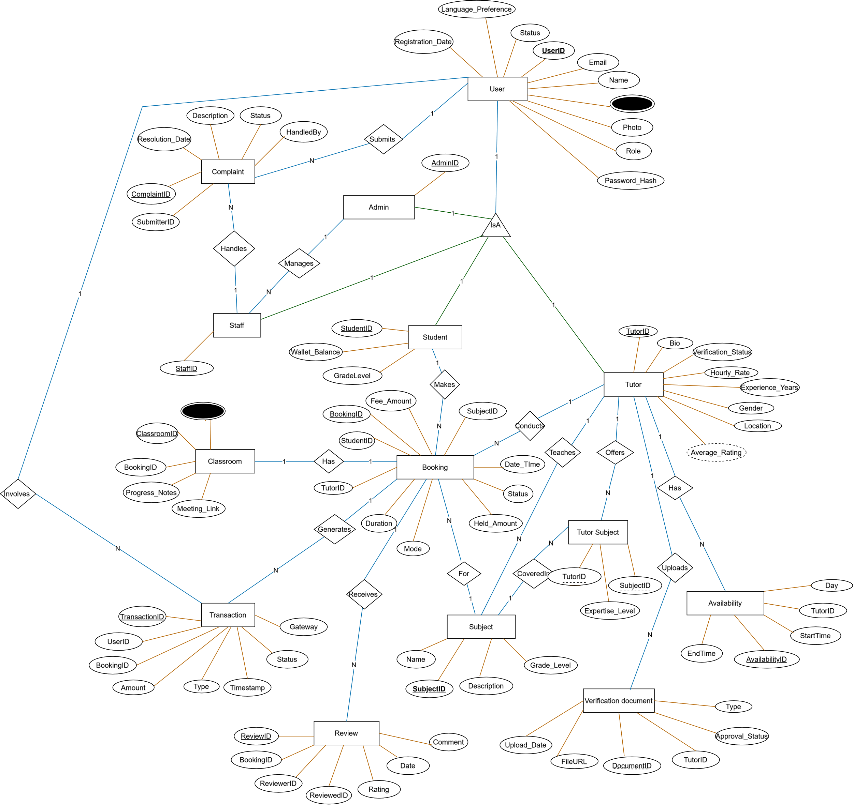
Figure 37 E-R diagram

4.2.5 Logical Database Design
It is the process of transforming (or mapping) a conceptual schema of the application domain into a schema for the data model underlying a particular DBMS.
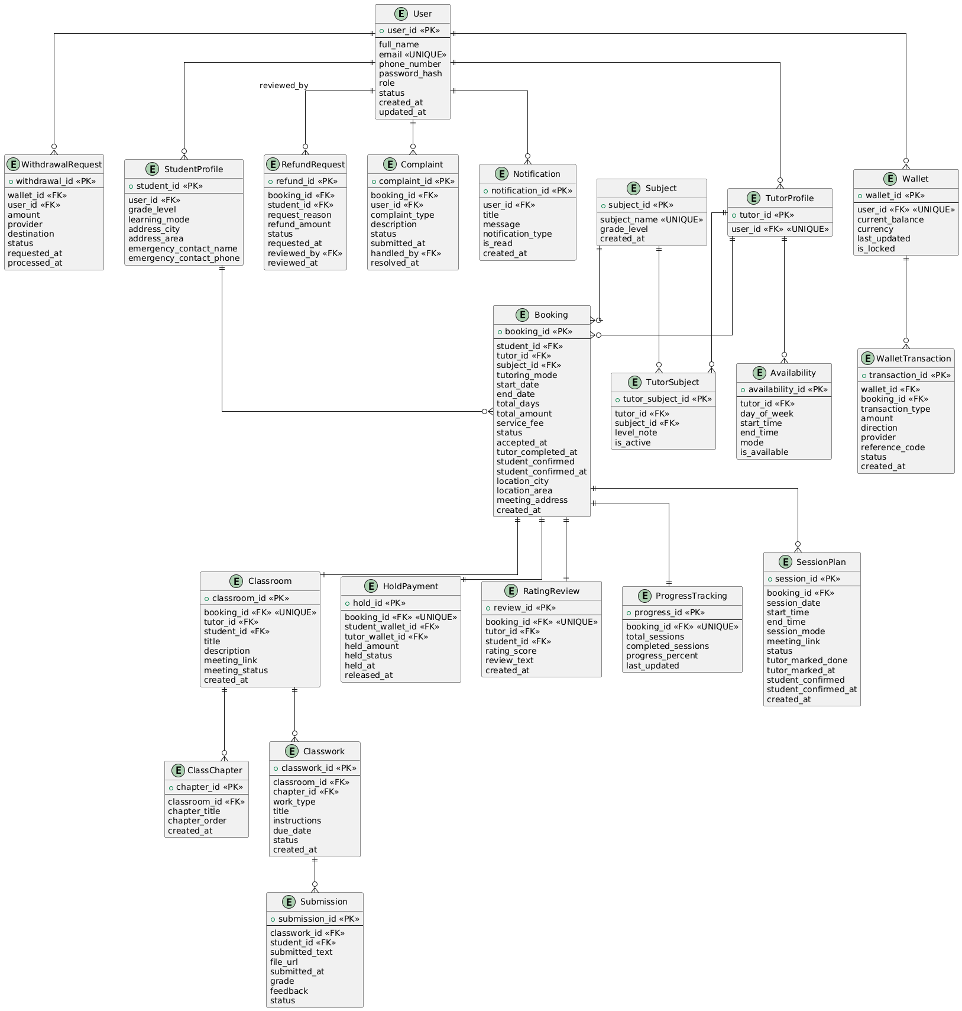
Figure 38 Logical Database

4.2.6 Physical Database Design
Relational database design focuses on the logical structure of the database, including the tables, their relationships, and the constraints that govern those relationships. It involves designing the database schema, specifying the tables, columns, primary keys, foreign keys, and relationships between tables.

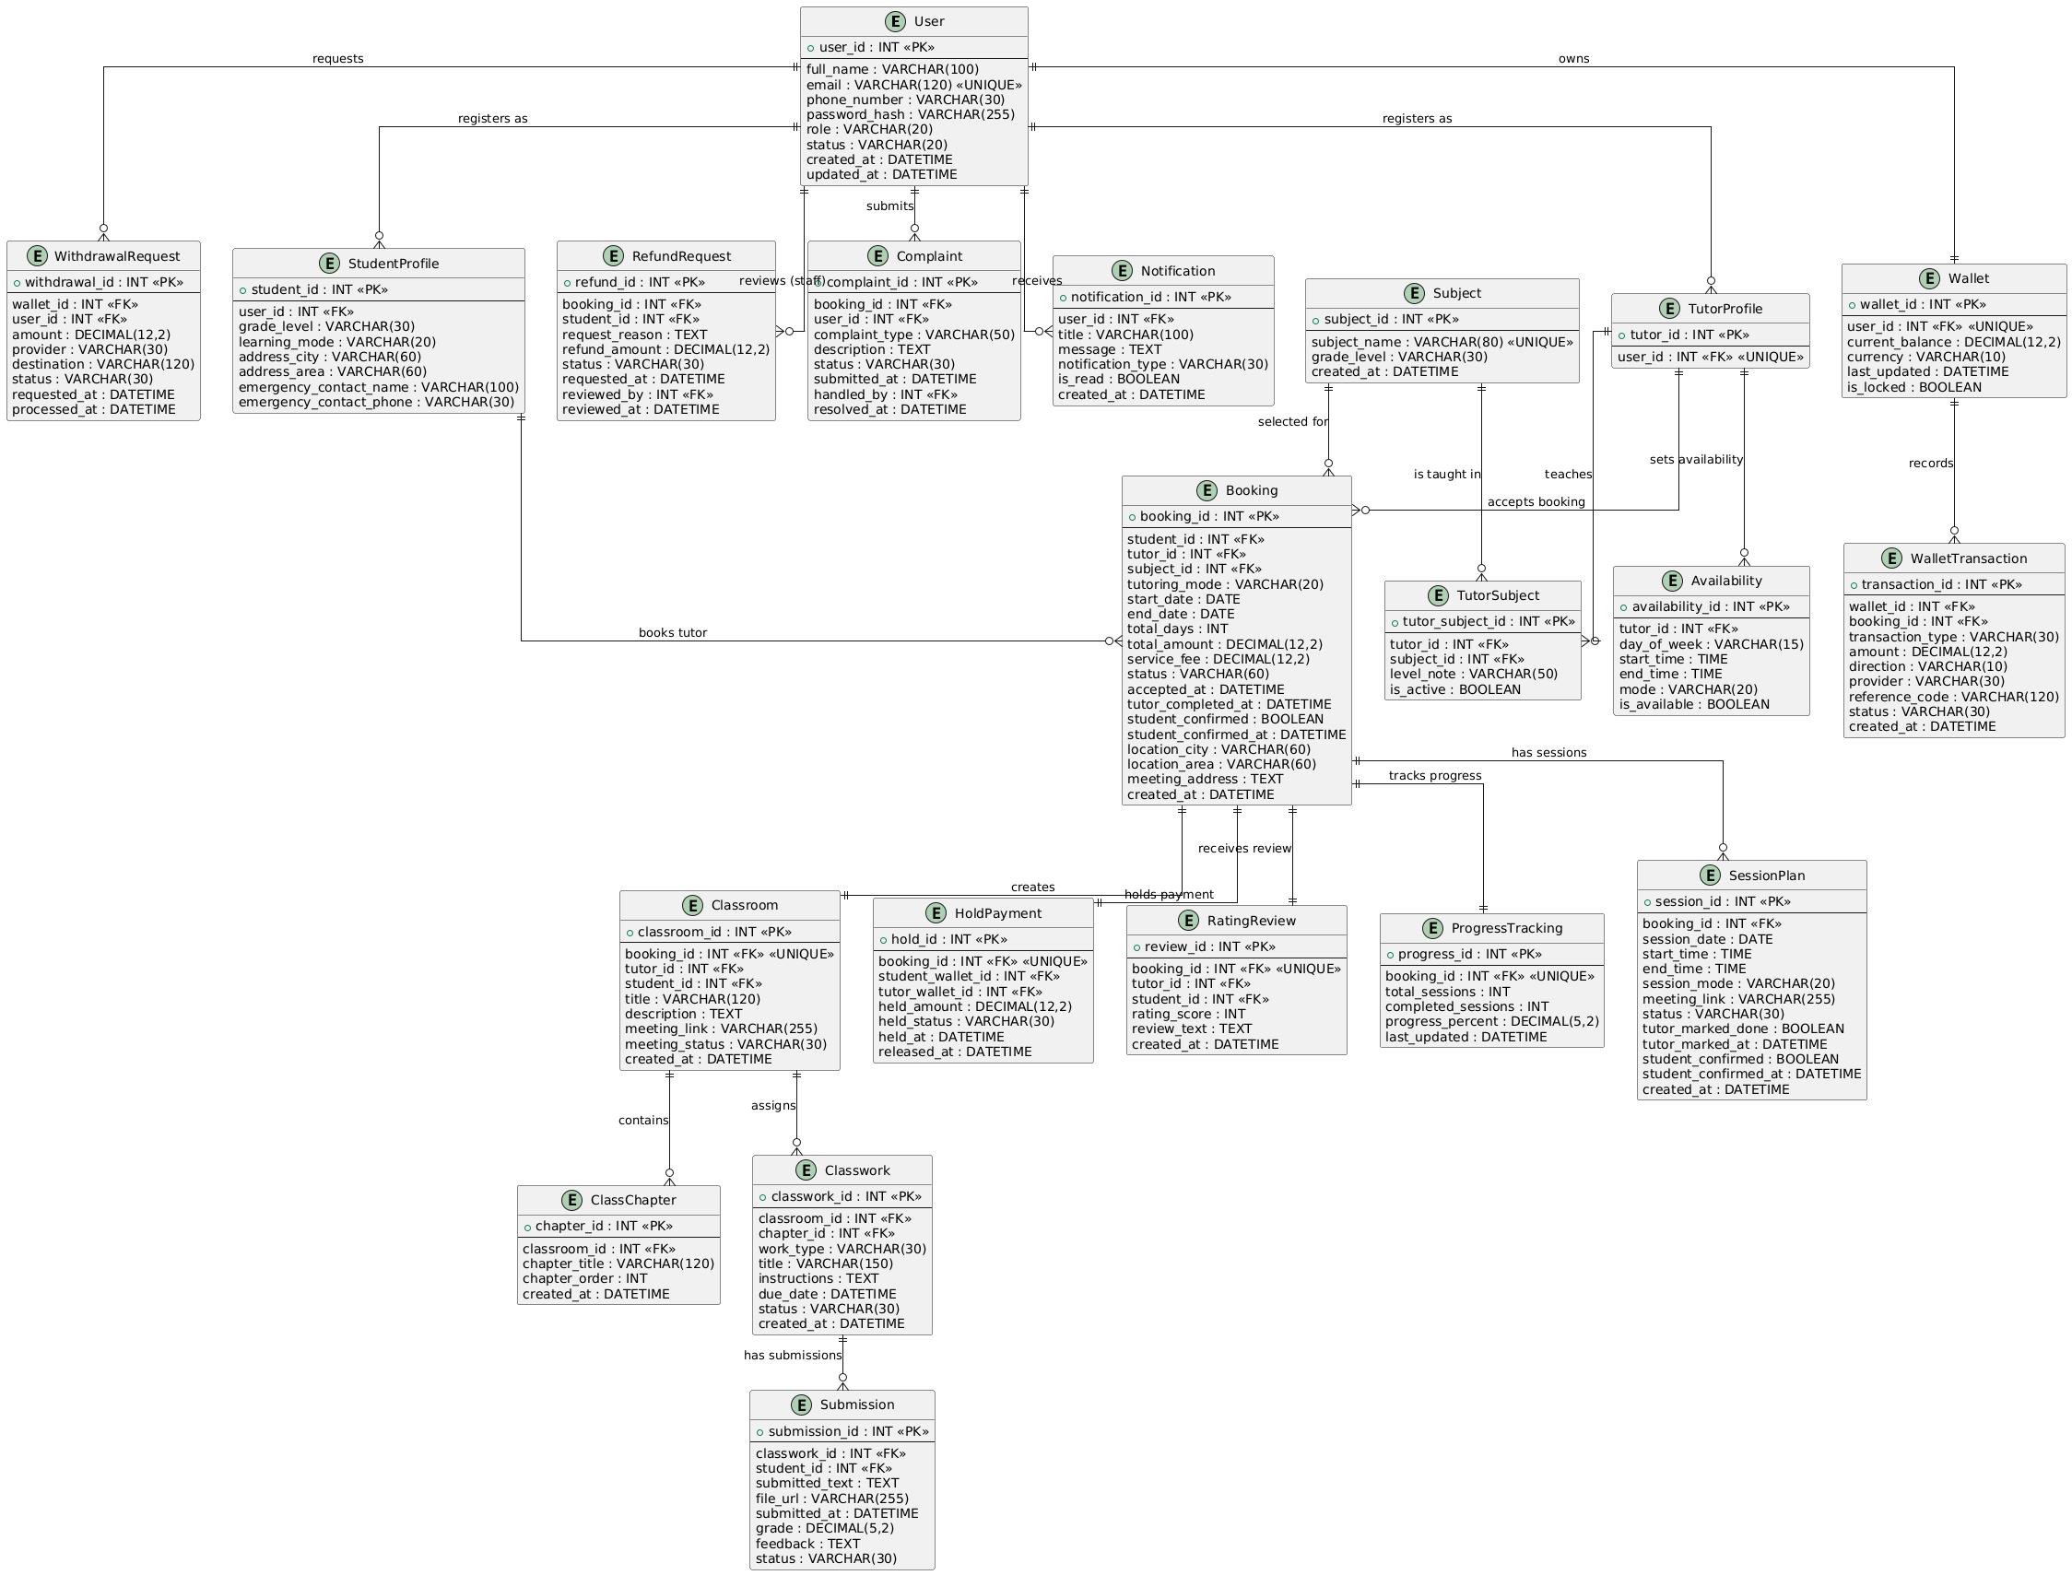
Figure 39 Physical database

4.2.7 Normalization
Normalization ensures that the database structure is efficient, free from redundancy, and follows relational database design principles. Below is the normalization process for the Tutor-Connect Web-Application
Unnormalized Data
Table 65 Unnormalized Data
user_id | name | roles | phone_numbers | subjects | subject_category
1 | Solomon Timiso | Tutor, Student | 0911111111, 0922222222 | Math, Physics | Science
2 | Lidiya Simeneh | Tutor | 0933333333 | Chemistry | Science
3 | Fenan Gadisa | Tutor | 0944444444, 0955555555 | Biology, Math | Science
4 | Tebarek Zewude | Tutor | 0966666666 | Physics | Science
5 | Abel Tesfaye | Student | 0977777777 | Math | Science
6 | Hana Bekele | Student | 0988888888 | Chemistry | Science

First Normalization
user_id | name | role | phone_number | subject
1 | Solomon Timiso | Tutor | 0911111111 | Math
1 | Solomon Timiso | Tutor | 0911111111 | Physics
1 | Solomon Timiso | Student | 0922222222 | Math
2 | Lidiya Simeneh | Tutor | 0933333333 | Chemistry
3 | Fenan Gadisa | Tutor | 0944444444 | Biology
3 | Fenan Gadisa | Tutor | 0955555555 | Math
4 | Tebarek Zewude | Tutor | 0966666666 | Physics
5 | Abel Tesfaye | Student | 0977777777 | Math
6 | Hana Bekele | Student | 0988888888 | Chemistry
Table 66 First Normalization

SECOND NORMAL FORM (2NF)
To normalize the table to 2NF: Split the table into smaller tables, ensuring that non-key attributes depend only on the primary key.
Decomposed Tables (2NF)
User
user_id (PK) | name
1 | Solomon Timiso
2 | Lidiya Simeneh
3 | Fenan Gadisa
4 | Tebarek Zewude
5 | Abel Tesfaye
6 | Hana Bekele

Table 67 User

User Role
role_id (PK) | user_id (FK) | role
R01 | 1 | Tutor
R02 | 1 | Student
R03 | 2 | Tutor
R04 | 3 | Tutor
R05 | 4 | Tutor
R06 | 5 | Student
R07 | 6 | Student
Table 68 User Role

User Phone
phone_id (PK) | user_id (FK) | phone_number
P01 | 1 | 0911111111
P02 | 1 | 0922222222
P03 | 2 | 0933333333
P04 | 3 | 0944444444
P05 | 3 | 0955555555
P06 | 4 | 0966666666
P07 | 5 | 0977777777
P08 | 6 | 0988888888
Table 69 User Phone
Subject
subject_id (PK) | subject_name
S01 | Math
S02 | Physics
S03 | Chemistry
S04 | Biology
Table 70 Subject
User_subject
user_id | subject | subject_category
1 | Math | Science
1 | Physics | Science
2 | Chemistry | Science
3 | Biology | Science
3 | Math | Science
4 | Physics | Science
5 | Math | Science
6 | Chemistry | Science
Table 71 User_subject
THIRD NORMAL FORM (3NF)

Subject
subject_id (PK) | subject_name | subject_category
S01 | Math | Science
S02 | Physics | Science
S03 | Chemistry | Science
S04 | Biology | Science
Table 72 Subject
User_Subject
user_id (FK) | subject_id (FK)
1 | S01
1 | S02
2 | S03
3 | S04
3 | S01
4 | S02
5 | S01
6 | S03
Table 73 User_subject

CHAPTER FIVE

5. CONCLUSION AND RECOMMENDATION

5.1. Conclusion
This project has brought to life "Tutor-Connect," a modern, secure, and user-friendly web platform designed specifically to transform private tutoring in Ethiopia. From the very beginning, we carefully studied the challenges in the current informal tutoring system—things like unreliable recommendations, lack of trust, and limited options for both students and tutors. We gathered requirements, designed the system, built it step by step, tested thoroughly, and prepared it for real-world use.
"Tutor-Connect" successfully bridges the gap between students and parents who need quality extra academic help and qualified tutors looking for steady opportunities. The platform creates a safe, centralized space where tutors are properly verified, making it easy for families to find and book the right person with confidence. No more relying solely on word-of-mouth or scattered social media posts. Students can search for tutors by subject, grade, location, or ratings, book sessions (online or in-person), make secure payments, join virtual classes, submit assignments, track their progress, and leave honest feedback—all from their phone or computer. Tutors, on the other hand, get better visibility, simple booking management, professional profiles, and reliable ways to receive their earnings.
Some of the key features we delivered include:

- Easy registration and login for different roles (students, tutors, and admins).
- Document upload and admin approval to verify tutor credentials.
- Powerful search tools with smart filters.
- Safe booking and payment system with a built-in wallet and escrow (money held until classes are completed).
- Full online classroom support: scheduling, virtual meetings, homework submission, and progress monitoring.
- Tools for reviews, complaints, refunds, and rescheduling.
- Admin dashboard for managing users, viewing analytics, and keeping everything running smoothly.

We chose Object-Oriented Analysis and Design (OOAD) along with an iterative development approach because they allowed us to build a clean, reusable, and flexible system. The iterative process was especially helpful—it let us incorporate feedback and new ideas as we went along without starting over.
Overall, "Tutor-Connect" supports Ethiopia's "Digital Ethiopia 2025" vision by using technology to make education more accessible, create jobs for teachers, and connect people across cities and rural areas. It sets a new benchmark for safe and professional private tutoring, helping students achieve better results while giving tutors a fair and sustainable way to earn a living.

5.2. Recommendation
I strongly recommend that students, parents, tutors, schools, and education authorities in Ethiopia adopt "Tutor-Connect." It's affordable, eliminates many of the old costs (like printed ads or middlemen), and makes everything from booking to reporting much simpler and faster.
Schools and tutoring centers could partner with the platform to reach more families, and similar systems could be adapted for other countries facing the same challenges.
During development, we faced some hurdles—like changing requirements, integrating local payment options, and ensuring strong security—but teamwork and guidance from our advisors helped us overcome them.
Looking ahead, there’s plenty of room to grow the platform:
  - Add group classes or school partnerships.
  - Include AI to suggest the best tutor matches or personalized study plans.
  - Build dedicated mobile apps for even easier access.
  - Improve video tools with better whiteboards and recording features.
  - Partner with telecom companies to offer affordable data packages for rural users.

Future developers and researchers are welcome to build on this work—perhaps adding advanced analytics, chat support, or more languages to make it even more inclusive.
"Tutor-Connect" shows how technology can solve real everyday problems in education. It’s more than just a website—it’s a step toward a more connected, trustworthy, and effective learning environment for everyone in Ethiopia.

APPENDIX
Appendix-1: Interview Questions
Date of interview: November, 2025
Interviewees: Selected students, parents, private tutors, and school administrators in Hawassa
The following open-ended questions were used to understand the current tutoring landscape in Ethiopia:

How do you currently find private tutors for yourself/your child?
What challenges have you faced when searching for or hiring a tutor?
Have you ever had concerns about a tutor's qualifications or background? Can you share an example?
How do you usually communicate and schedule lessons with tutors?
What payment methods do you use, and have you encountered any issues?
Would you prefer online/virtual tutoring, in-person, or a mix of both? Why?
What features would you like to see in an online tutoring platform?
How important is tutor verification (ID, certificates, background check) to you?
As a tutor, how do you currently advertise your services and find students?
What difficulties do you face in getting paid reliably or managing bookings?
Have you ever taught students from outside your local area? If not, would you be interested?
What subjects and grade levels do you specialize in?
How do you track student progress and share feedback with parents?
Are there any government regulations or standards you're aware of for private tutoring?
Any other suggestions for improving private tutoring in Ethiopia?

Appendix-2: Glossary of Terms

Escrow Payment: Money held securely by the platform until the service (tutoring session) is completed.
Virtual Classroom: Online space for live video lessons, screen sharing, and interactive tools.
Wallet System: Digital balance where users deposit funds for bookings and tutors withdraw earnings.

References
[1] Federal Democratic Republic of Ethiopia. Digital Ethiopia 2025 Strategy. Ministry of Innovation and Technology, 2020.
[2] UNESCO. Education in Ethiopia: Strengthening the Foundation for Sustainable Development. 2022.
[3] Pressman, R. S. Software Engineering: A Practitioner's Approach. 8th Edition. McGraw-Hill Education, 2014.
[4] Sommerville, I. Software Engineering. 10th Edition. Pearson, 2015.
[5] Larman, C. Applying UML and Patterns: An Introduction to Object-Oriented Analysis and Design. 3rd Edition. Prentice Hall, 2004.
[6] Ethiopian Ministry of Education. National Education Roadmap 2018-2030.
[7] Booch, G., Rumbaugh, J., & Jacobson, I. The Unified Modeling Language User Guide. 2nd Edition. Addison-Wesley, 2005.

