**Lab Report of Signal & System**

**Experiment Number: 01**

**Experiment Name: Simulate the signals (sinusoidal, impulse, ramp and step signals) in Mat lab.**

**Submitted To:**

**Engr. Md. Zahirul Islam**

**Senior Lecturer**

**Department of ETE**

**Daffodil International University**

**Submitted By:**

**Md. Shahadat Hossain Bhuiya**

**ID: 151-19-1666**

**Section: A1**

**Department of ETE**

**Daffodil International University**

**Date of Submission:**

**27th August,2016**

**Theory:**

Sinusoids are the building block of analog signal processing. All real world signals can be represented as an infinite sum of sinusoidal functions via a Fourier series. A sinusoidal function can be represented in terms of an exponential by the application of Euler's Formula.

An impulse is defined as a signal that has an infinite magnitude and an infinitesimally narrow width with an area under it of one, centered at zero. An impulse can be represented as an infinite sum of sinusoids that includes all possible frequencies. It is not, in reality, possible to generate such a signal, but it can be sufficiently approximated with large amplitude, narrow pulse, to produce the theoretical impulse response in a network to a high degree of accuracy. The symbol for an impulse is δ(t). If an impulse is used as an input to a system, the output is known as the impulse response. The impulse response defines the system because all possible frequencies are represented in the input.

The ramp function is an unary real function ,easily computable as the mean of the independent variable and its absolute value.The name ramp is derived from the appearance of its graph.

A unit step function is a signal that has a magnitude of zero before zero and a magnitude of one after zero. The symbol for a unit step is u(t). If a step is used as the input to a system, the output is called the step response. The step response shows how a system responds to a sudden input, similar to turning on a switch. The period before the output

stabilizes is called the transient part of a signal. The step response can be multiplied with other signals to show how the system responds when an input is suddenly turned on.

The unit step function is related to the Dirac delta function by;



**Procedure and Observation:**

**Mat lab code for discrete sinusoidal signal generation:**

*clc; clear all;*

*close all;*

*disp('Sinusoidal Signal generation'); N=input('Enter no of samples: ');*

*n=0 : 0.1 : N; x=sin(n); figure, stem(n,x); xlabel('Samples'); ylabel('Amplitude'); title('Sinusoidal Signal');*

*The sin(n) function returns an array which corresponds to sine value*

*of the array ‘n’.*

**Figure for Sinusoidal code:**

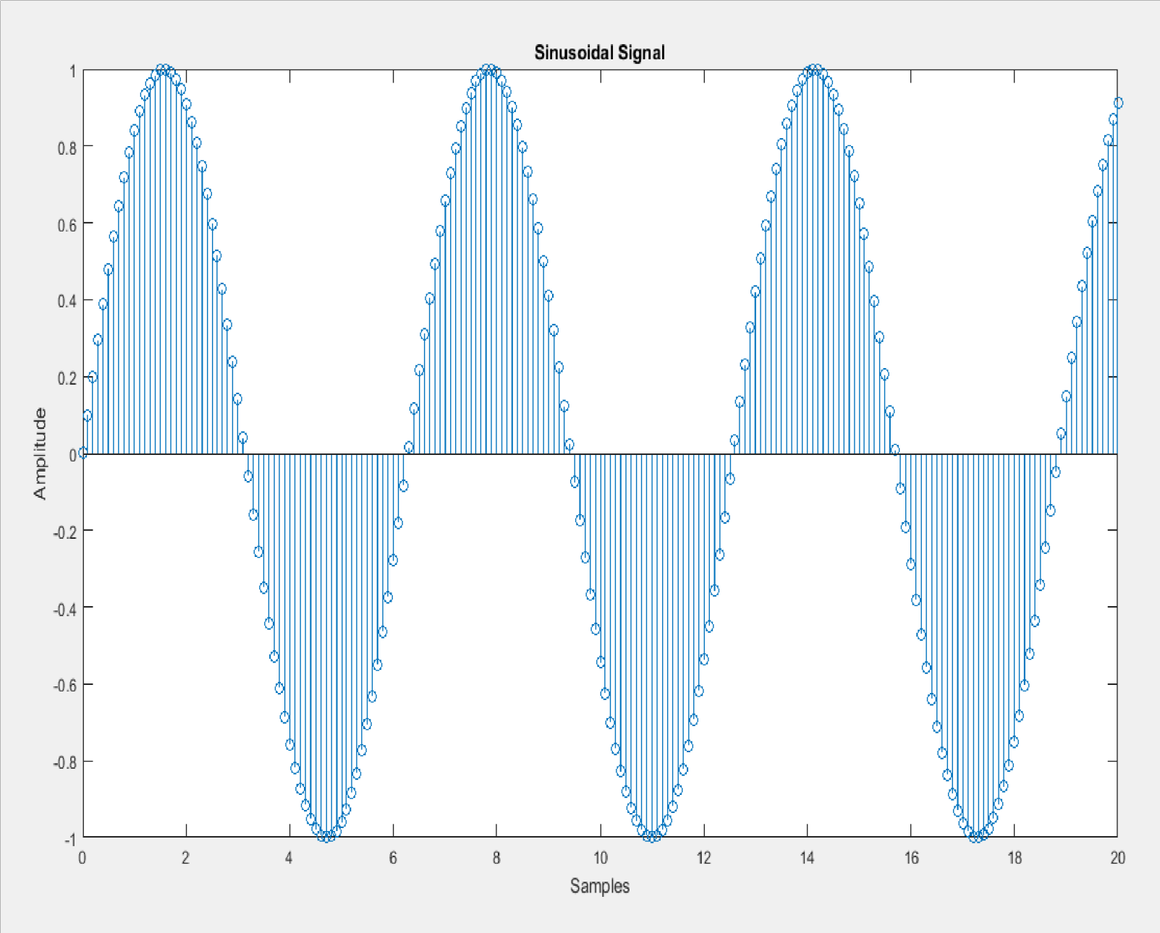

**Mat lab code for unit impulse signal generation:**

*disp('Unit Impulse Signal Generation'); N*

*= input('Enter no of samples: ');*

*n = -N : 1 : N;*

*x = [zeros(1,N),1,zeros(1,N)]; stem(n,x); xlabel('Sample'); ylabel('Amplitude'); title('Unit Impulse Signal');*

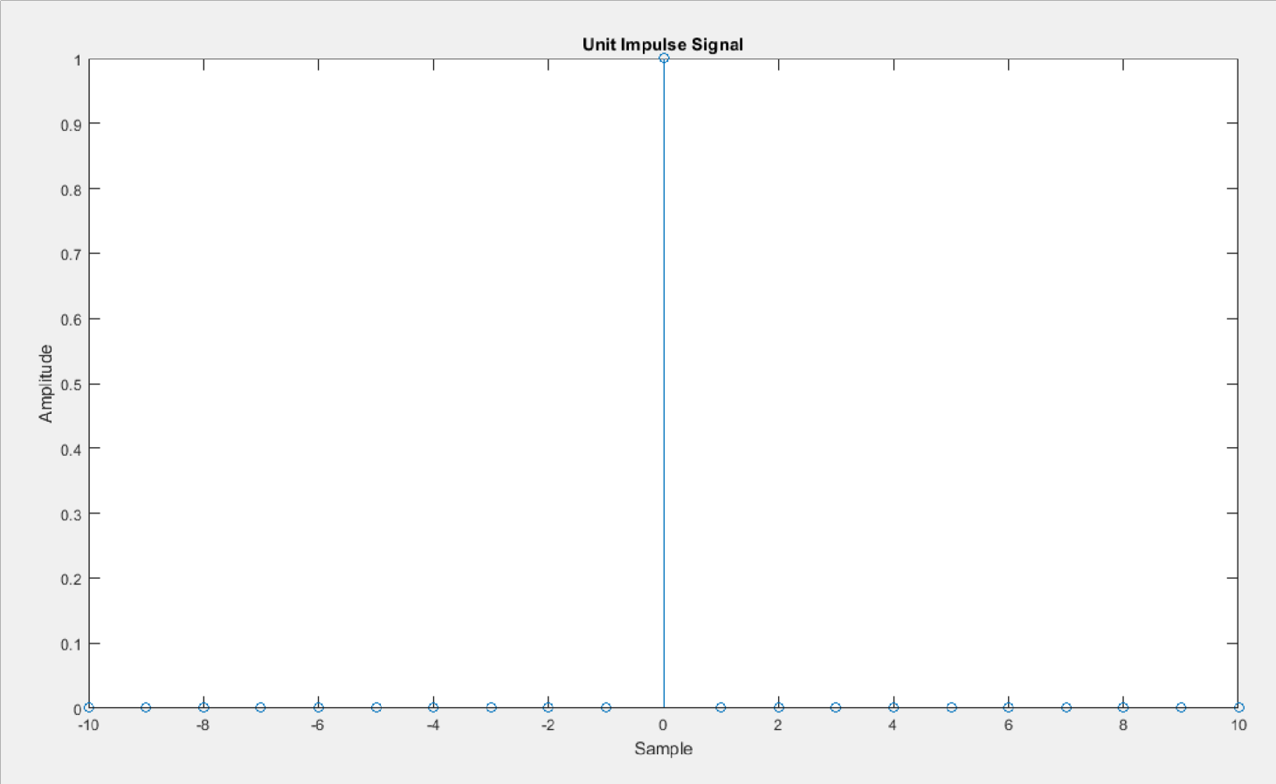

**Figure for unit impulse code:**

**Mat lab code for unit ramp signal generation:**

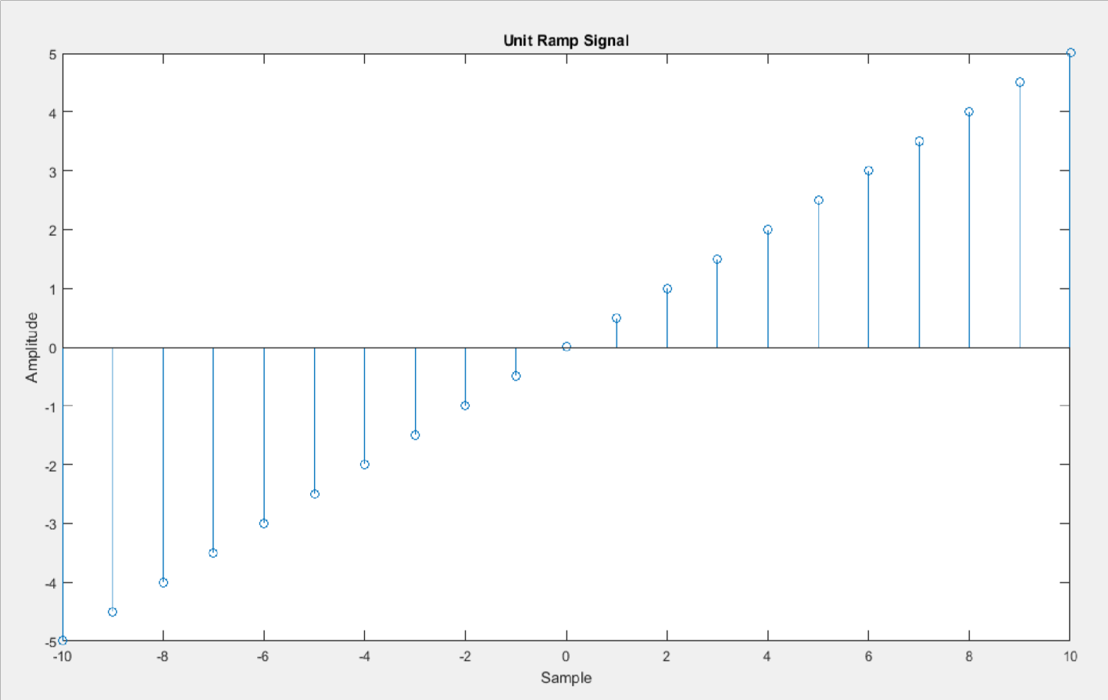

*disp('Unit Ramp Signal Generation'); N = input('Enter no of samples: '); a = input(' Max Amplitude: ');*

*n = -N : 1 : N; x = a*n/N; stem(n,x); xlabel('Sample'); ylabel('Amplitude'); title('Unit Ramp Signal');*

**Figure for ramp signal code:**

**Mat lab code for unit step signal generation:**

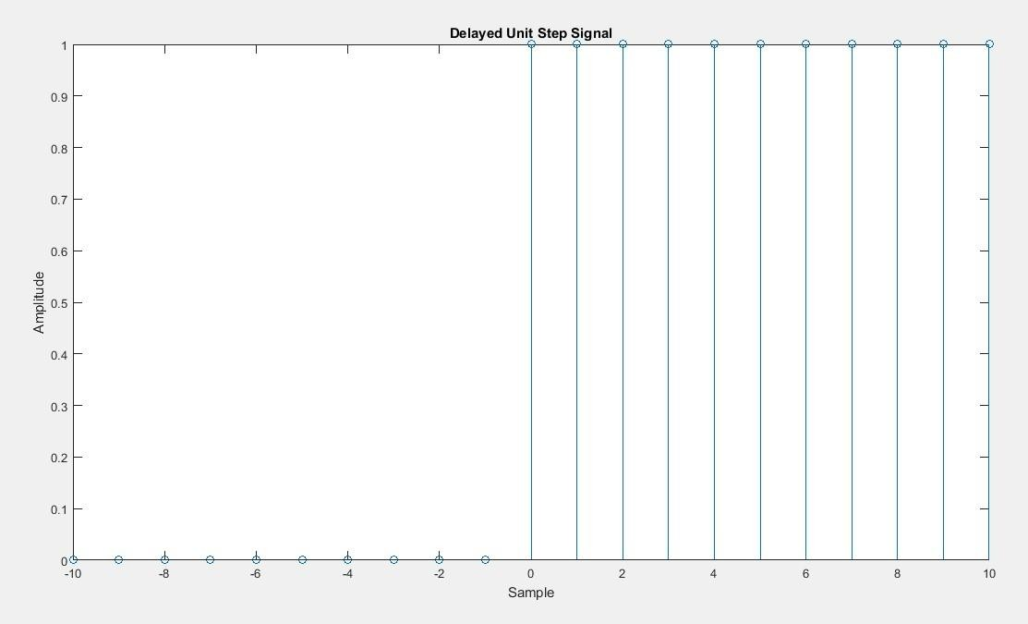

*disp('Delayed Unit Step Signal Generation'); N = input('Enter no of samples: ');*

*n = -N : 1 : N;*

*x = [zeros(1,N),ones(1,N+1)]; stem(n,x); xlabel('Sample'); ylabel('Amplitude'); title('Unit Step Signal');*

**Figure for unit step signal code:**

**Discussion:**

➢ For sinusoidal signal The sin(n) function returns an array which

corresponds to sine value of the array ‘n’.

➢ And I take the sample value 20 for simulation.

➢ In unit impulse generation code, the impulse is generated by using ZEROS(x,y) function, which produces an array of size X,Y with all elements as ZERO.

➢ I took all the samples value 20 to simulate those figure.

➢ Observed the highest value in zero for impulse signal.

➢ Observed that the all samples value is one for the unit step signal.