**This problem will help you remember the idea of implementing Comparable in java** (readSW 1.4)

**Problem 1.** *(Die.java)* Implement a data type Die in Die.java that represents a six-sided die and supports the following API:



$java Die 3 3 5

*

*

*

true

false

0

-2

$ java Die 5 5 3

* *

*

* *

true

false

0

2

**These problems will help you understand the Analysis of Algorithms** (read CLRS)

**Problem 2.** (True or False): No comparison-based sorting algorithm can do better than *Ω(n log n)* in the worst-case

True

**Problem 3.** We can extend our notion to the case of two parameters n and m that can go to infinity independently at different rates. For a given function *g(n, m)*, we donate by *O(g(n, m))* the set of functions

*O(g(n,m))* = { *f(n, m)* : there exist positive constants *c, n0*, and *m0*,

such that *0 <= f(n, m) <= c g(n, m)* for all *n >= n0* or *m >= m0*}

Give corresponding definitions for *Ω(g(n, m))* and *Θ(g(n, m))*

*Ω(g(n,m) = { f(n,m):* there exist positive constants *c, n0*, and *m0*,

Such that 0<= c g(n,m) <= f(n,m) for all n>= n*0* or m>= m*0*

Θ(g(n,m)) = { f(n,m): there exists positive constants c1, c2*, n0*, and *m0*

Such that 0 <= c1g(n,m) <= f(n,m) <= c2 g(n,m)

**Problem 4.** Consider functions *f(n)* and *g(n)* as given below. Use the most precise asymptotic notation to show how function *f* is related to function g in each case ( i.e. , *f ∈ ?(g)*). For example, if you were given the pair of functions *f (n) = n* and *g(n) = n2* then the correct answer would be: *f ∈ o(g)*. To avoid any ambiguity between *O(g)* and *o(g)* notations due to writing, use *Big-O(g)* instead of *O(g).*

**Problem 5.** Indicate, for each pair of expressions (A, B) in the table below, whether A is O, Ω, Θ, o, ω of B. Assume that k>= 1, ϵ > 0 and *c* >1 are constant. Your answer should be in the form of the table with “yes” or “no” written in each box.

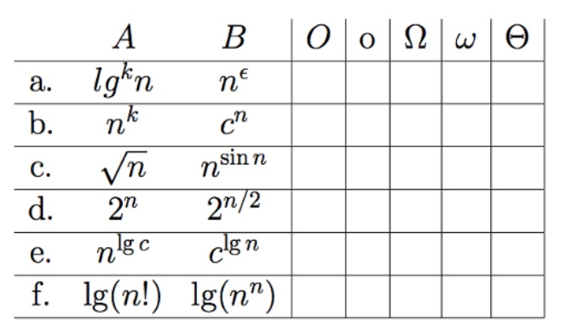

no

no

no

A is upper bounded by B and it is tight

no

no

no

noo

yes

yes

no

no

no

no

yes

no

no

no

yes

no

no

no

no

no

no

no

no

no

yes

no

yes

**Submitting Information:**

* Use the code I provided for each problem. DON’T DELETE ANY FUNCTION
* You should have each problem in a separate .java files (ex: Die.java, hw2.pdf).
* Submit your work on Canvas in one Zip file.
* The deadline is Monday, Sep 23st at 5:59PM