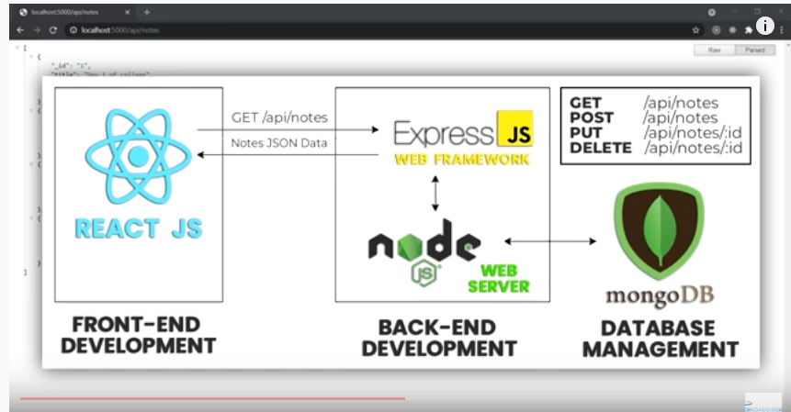

Install and configure

1. Install nodejs
2. Text editor
3. Git
4. Postman

Vs code Extensions download

1. Auto Rename
2. Brackets pair colorizer
3. Es7 react/redux/…. Boiler plate
4. Java script es6 code snippets
5. Material icon theam 🡪 for folders
6. Prettier code-> for code alignment

* After that go to setting -> make prettier as default formate

Project setup

1. Create project folder of any name eg: CMS

2. create package.json file using:- npm init

3. install express i.e npm I express

4. create a file -> server.js

const express = require("express");

const app = express();

app.listen(5000, console.log("server started on port 5000"));

this is your first webserver

you can run it using :- node server.js

1. Create folder i.e "backend" inside CMS
2. Move server.js inside backend folder
3. Modify the package.json file to run server.js easily
4. {
5. "name": "auth",
6. "version": "1.0.0",
7. "description": "",
8. "main": "server.js",
9. "scripts": {
10. "start": "node backend/server.js"
11. },
12. "author": "srinath",
13. "license": "ISC",
14. "dependencies": {
15. "express": "^4.17.1"
16. }
17. }

Now run using command: npm start

**API**

Create API end points

What is end points ??

Data sent from front end should be targeted to backend for further processing, the backend point are called end point or API.

//Server.js

const express = require("express");

const app = express();

//first API start

app.get("/", (req, res) => {

  res.send("API is running");

});

//first API end

app.listen(5000, console.log("server started on port 5000"));

now go to browser and type in url

localhost:5000

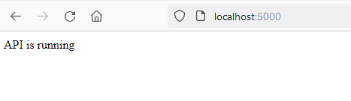

1. Create folder name="data" inside the backend folder
2. Create file notes.js inside data folder and put json data in it.

//notes.js

const notes = [

  {

    _id: "1",

    title: "Day 1 of college",

    content:

      "I made a few new friends and introduced myself to a lot of new teachers.",

    category: "College",

  },

  {

    _id: "2",

    title: "Learned some Node JS",

    content: "Learned how to create a server in node JS and my first API",

    category: "Learning",

  },

  {

    _id: "3",

    title: "Watched some Anime",

    content: "Finished 2 seasons of Attack on Titan and My Hero academia.",

    category: "Entertainment",

  },

  {

    _id: 4,

    title: "Started React JS",

    content:

      "Made my first App in React JS, feels awesome to learn something new. I aim to be a full stack dev someday",

    category: "Learning",

  },

];

module.exports = notes;

const express = require("express");

const notes = require("./data/notes");

const app = express();

//first API start

app.get("/", (req, res) => {

  res.send("API is running");

});

//first API end

app.get("/api/notes", (req, res) => {

  res.json(notes);

});

app.listen(5000, console.log("server started on port 5000"));

at url:

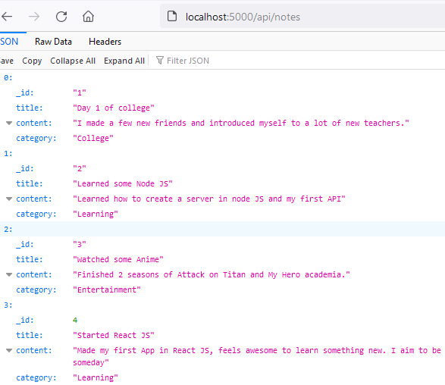

Task-1

Print first content on the monitor i.e

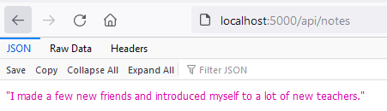

Solution :-

app.get("/api/notes", (req, res) => {

  res.json(notes[0].content);

});

Task-2

Dynamically print any particular record ??

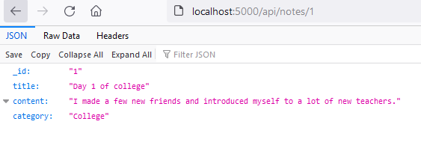

Solution

app.get("/api/notes/:id", (req, res) => {

  const note = notes.find((n) => n._id === req.params.id);

  res.send(note);

});

Or

app.get("/api/notes/:id", (req, res) => {

  const note = notes.find((n) => {

    return n._id === req.params.id;

  });

  res.send(note);

});

**Dotenv**

What is dotenv ? How to use dotenv configuration file ??

Dotenv is used to store all our configuration information like secret password, port no, etc,

So that it will be helpful during project deployment

1. Create file ".env" in project folder "CMS"
2. Install dotenv using command

Npm i dotenv

1. Include dotenv into the project using (add in program)

const dotenv=require("dotenv");

1. Call its process by using (add in program )

dotenv.config();

1. Now use it

Go to .env file and type/assign port number as shown below

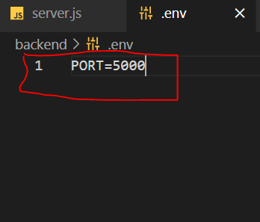

1. Use in project (add in server.js program) as shown

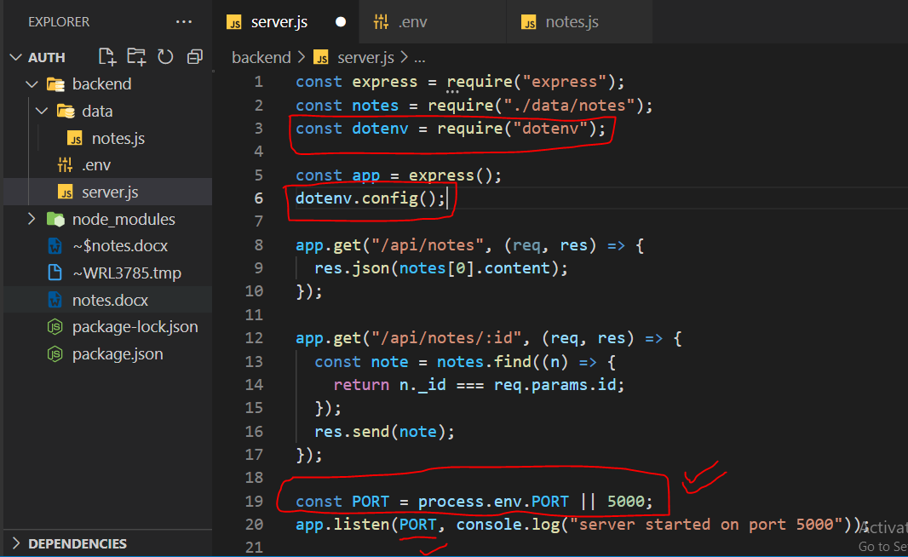

**NODEMON**

What is nodemon ??

Whenever we make changes to the file it will restart server automatically.

1. Install nodemon use the command

Npm i nodemon

1. Make changes in package.json file

    "start": "nodemon backend/server.js"

1. To run us command

nodemon backend/server.js

**POSTMAN**

What is postman ??

This will make us to check the api or end point working correctly or not by sending dummy data from front end.

1. Install postman from the official website

There are two type of postman a) web b ) localhost

Go for local host

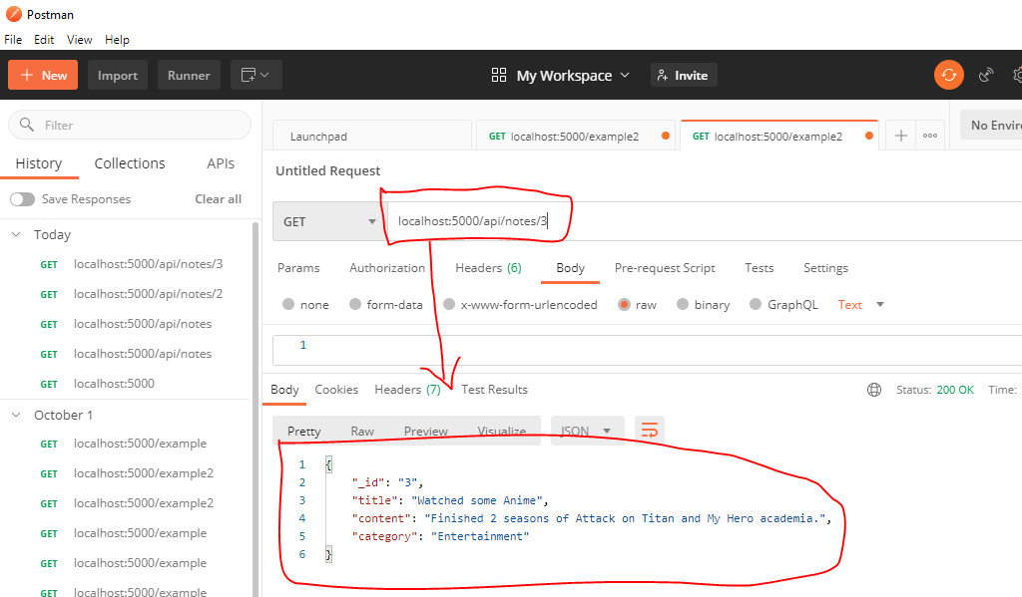

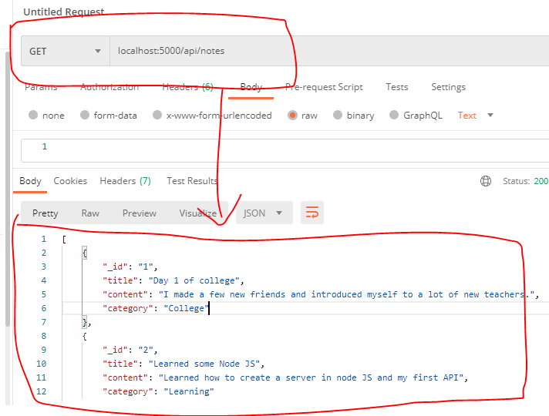

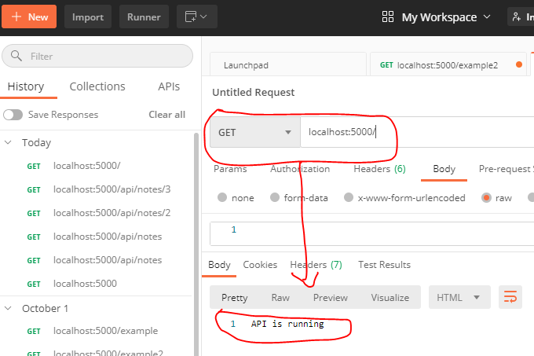

**REACT APP**

What is creat-react-app ??

It will get basic boiler plate from the server to us

1. Go to project folder "CMS" , in terminal type command

npx create-react-app frontend

*patients it takes 15 min depends on ur net speed.*

*Wait till you get* ***happy hacking*** *msg*

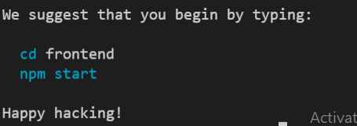

1. Now change the directory to front end and run the code using

npm start

1. Delete all unnecessary files and lines of code from the project
2. App.test.js b. logo.svg c. setupTest.js
3. Delete the content of app.css also

**GIT**

What is GIT

Git is version mgmt system used to keep track of version of our project.

1. Copy gitignore file from frontend folder and copy to put in the project folder (CMS)

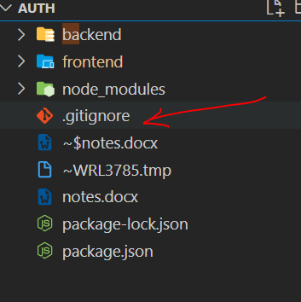

1. Add few other files which you should not push into git such as
2. node_modules b. .env file in the gitignore file

