MODULE : 1

SE OVERVIEW OF IT INDUSTRY

1. What is software? What is software engineering?

What is software:-

Software is a collection of instruction, information and data.

What is software engineering: -

Software is a set of data, instruction processes that helps you to complete particular task of a specific purpose.

But to perform this specific task there are so many tasks running behind it.

so, this all the processes and tasks that help us get the work done is called as software engineering.

1. Explain types of software.

There are 5 types of software:-

1. System software

System software is software that provides a platform for other software.

For example: - operating system,

antivirus system,

disk formatting software

computer language translator etc.

1. Application software

Application software refers to software that perform specific function for a user.

When user interact directly with a piece of software, it is called application software.

* Mobile application

Application that running on phone that Is called mobile application.

For example: - WhatsApp, Instagram, twitter etc...

* Desktop application

application that running on computer that is called desktop application.

For Example: - vs code, MS office, web browser, turbo c++ it’s all are desktop application.

* Web application

App that running on browser that is called web application.

For Example: - amazon, google workspace, eBay etc…

1. Programming software

Computer programmers use programming software to write code.

Example of programming software is compilers, interpreters, debugger etc…

* High level language (near to human far to machine)

High level language are programming languages which is used for writing programs or software.

Which could be understood by humans and computer.

* POP (procedure-oriented language)

-C, basic, fortan

* OOP (Object oriented language)

-Java, c++, pearl, .net, c#

* logical programming

-prolog

* functional programming

-python

* scripting language

-JavaScript, PHP, Perl

* Low level language (near to machine far to human)

Low level languages which are closer to hardware as compared to high level languages instead of software.

Low level language are divided into two types.

* Machine language

It is only follow the binary system ( 0 and 1)

Machine language is low level language which consist of binary code which are directly operated by CPU.

* Assembly language

Assembly language is a way of writing computer programs that are very close to how the computer works.

Low level language are used in : operating system development, embedded system, real time system etc…

1. Driver software

It is also known as device driver

Every device that is connected to a computer needs at least one device driver to function.

Examples: - USB, printer, keyboard, headphones etc…

1. Middleware software

Middleware software is mediate between application and system software or between two different kinds of application software.

For example: - database etc…

1. What is SDLC? Explain each phase of SDLC.

SDLC is stands for Software Development Life Cycle.

1. PLANNING: -

Planning is the first step of SDLC.

Int this stages the developers will plan for the impending projects.

It is helpful in defining the problems as well as the extent of any current systems, and determining the goals for their new systems.

1. ANALYSIS: -

In this stage gathering all specific details which is required for project.

This is the phase that defines the requirements.

1. DESIGN: -

Develop a blueprint of the system architecture and components.

Example: - for the CRM system, this involves creating a detailed design that outlines the database structure, user interphases, and system functionalities.

It serves as a guide for the developers during the coding phase.

1. IMPLIMENTATION

Transform the design into an operational system.

For example: - developer writes the code for CRM system based on the design specification.

This phase involves testing to identify and rectify nay bug or error.

1. TESTING INTEGRATION

After implementation you have to make sure that your program is work properly or not.

It is used to verify that the system meets the specified requirements.

1. MAINTANANCE

Ensure the ongoing functionality and address any issue that arise.

1. What is DFD? Create a DFD diagram on flipchart.

-DFD stands for Data Flow Diagram.

* It is a graphical representation of an application.
* The flow of data of a system or a process is represented by DFD.
* DFD does not have control flow and no loops or decision rules are present.
* DFDs can be hierarchically organized which help in progressively partitioning and analysing large system.

Components of DFD: -

The data flow diagram has the 4 components.

1. Process

Input to output transformation in a system takes places because of process function.

The symbol of a process is rectangular with rounded corners, ovel, rectangle or a circle.

The process is named a short sentence in one word or a phase to express its essence.

1. Dataflow

dataflow describes the information transferring between different parts of the systems.

The arrow symbol is the symbol of data flow.

1. Warehouse

The data is stored in the warehouse for later use.

Two horizontal lines represent the symbol of the store.

The data warehouse can be viewed independent of its implementation.

1. Terminator

The terminal is an external entity that stands outside of the system and communicate with the system.

**DAIGRAM ON FLIPCART**

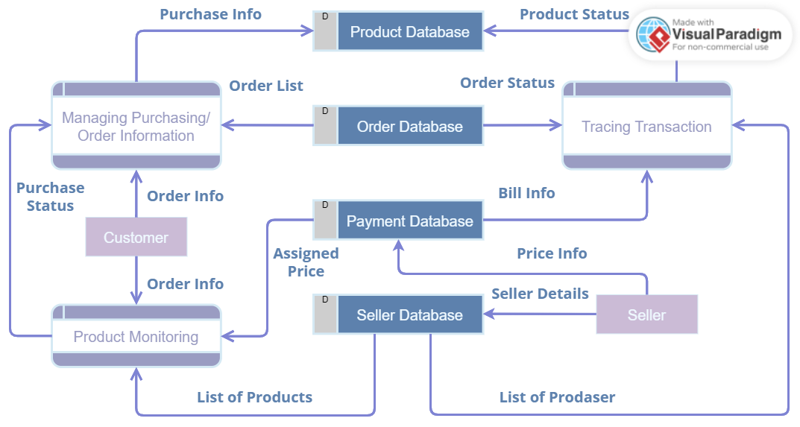

1. What is a flowchart? Create a flowchart to make addition of two numbers.

Flowchart: -

* Flowcharts are nothing but a graphical representation of the data or the algorithm FOR A better understanding of the code visually.
* It displays step by step solution to a problem.
* It’s easy to interpret and understand the process.

Flowchart symbols: -

1. Terminal/terminator

* This box is of an ovel shape which is used to start or end of the program.

1. Process

* This is rectangle box.
* Inside which a programmer writes the main data.

1. Decision

* this is a Dimond shape box.
* It is a Control statement use like 3 > 0 etc.

1. Flow arrow

* This arrow line is represent the flow of the process.
* It represents the direction of the process flow.
* We included arrows in every steps to display the flow of the program.
* Arrow increases the readability of the program.

Flowchart of addition of two numbers

**Print sum 30**

**Sum num1 + num2**

**10 + 20**

**Read “number 1” 20**

**Read “number 1” 10**

1. What is use case diagram? Create a use case on bill payment on Paytm.

Use case diagram: -

* A use case diagram is defined as a graphical representation of the interaction between users and a system.
* Use of use case diagram:
* Requirement analysis
* Communications
* scope definition
* System design
* Testing and validation
* Project planning
* Documentation

Use case diagram on bill payment Paytm:

