Documentation

Sport club management application



Created by **Volodymyr Kalinin s24773**

Table of Contents

1. Project Overview: 2

2. User Requirements: 3

User Registration: 3

Group Sessions: 3

Clients: 3

Subscription Requirements: 3

Service Selection: 3

Employees: 3

Coach: 3

Dietitians: 4

3. Use case diagram: 4

4. Analytical class diagram: 5

5. Project class diagram: 5

6. Scenario for the "Join group" class use case 6

7. Activity diagram: 7

8. State diagram for the ClassSession 8

9. User interface: 9

Login page 9

Schedule page 10

Day schedule table 11

10. Discussion of design decisions and implications of the analysis dynamic analysis 12

1. Discussion of design decisions 12

Overlapping in inheritance is person, client and employee: 12

Disjoint inheritance between workers. 12

Relationship between GroupClass, ClassSession, Schedule. 12

Multiple inheritance in the CoachDietitian class from the Coach and Dietitian classes. 12

2. Implications of the analysis dynamic analysis 12

1. Project Overview:

SportClub is a comprehensive management system designed for sports clubs. The system facilitates seamless interaction between employees and clients, offering tailored functionalities based on user privileges.

# User Requirements:

## User Registration:

- Users must register in the system to gain access.

- Post-registration, users are granted specific privileges based on their roles (client, trainer, dietitian, administrator).

## Group Sessions:

- Group sessions have a schedule with a defined minimum and maximum number of participants, ensuring optimal class sizes.

- Each group class consists of sessions. Each session repeats once a week.

- Users have access to a schedule with group sessions.

- Completed sessions are archived and removed from the system if they concluded more than six months ago.

## Clients:

### Subscription Requirements:

- Clients must have an active subscription (membership) to access the club's facilities.

- Memberships are categorized into three types: Basic, Standard, and Premium, each granting different levels of access to various zones within the club.

- Clients with a lapsed subscription exceeding six months are automatically removed from the system.

Service Selection:

- Clients can choose and register with trainers or dietitians.

- They can also sign up for group sessions.

## Employees:

- Employees can also be clients within the system.

- Employees work in different departments and have contractual obligations.

### Coach:

- Must possess a certification from specialized courses.

- Can develop personalized training plans for their clients.

- Have the ability to create and conduct group sessions.

### Dietitians:

- Must hold a medical degree.

- Can prescribe dietary plans to their clients.

- A trainer can also hold the role of a dietitian, provided they meet the qualifications.

# Use case diagram:

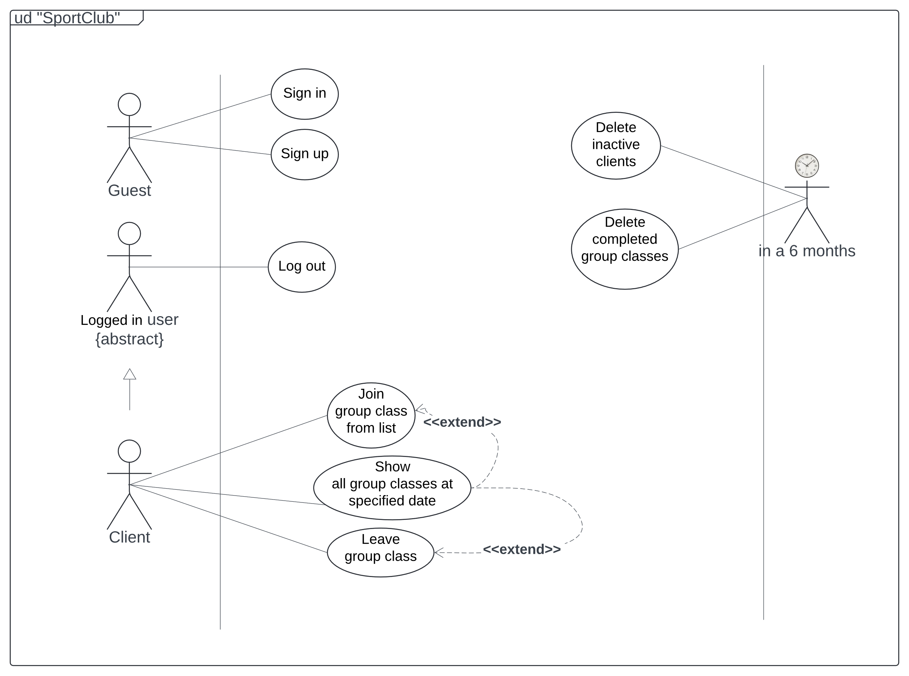

# Analytical class diagram:

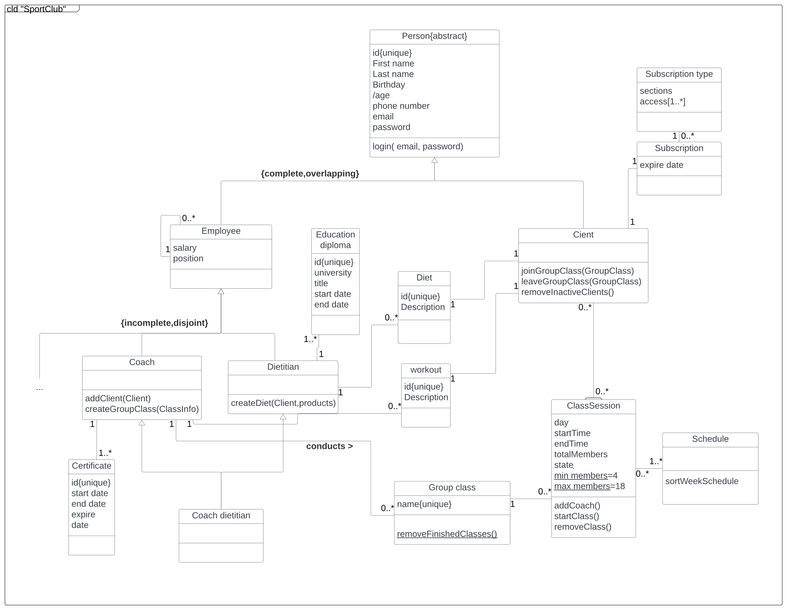

# Project class diagram:

# Scenario for the "Join group" class use case

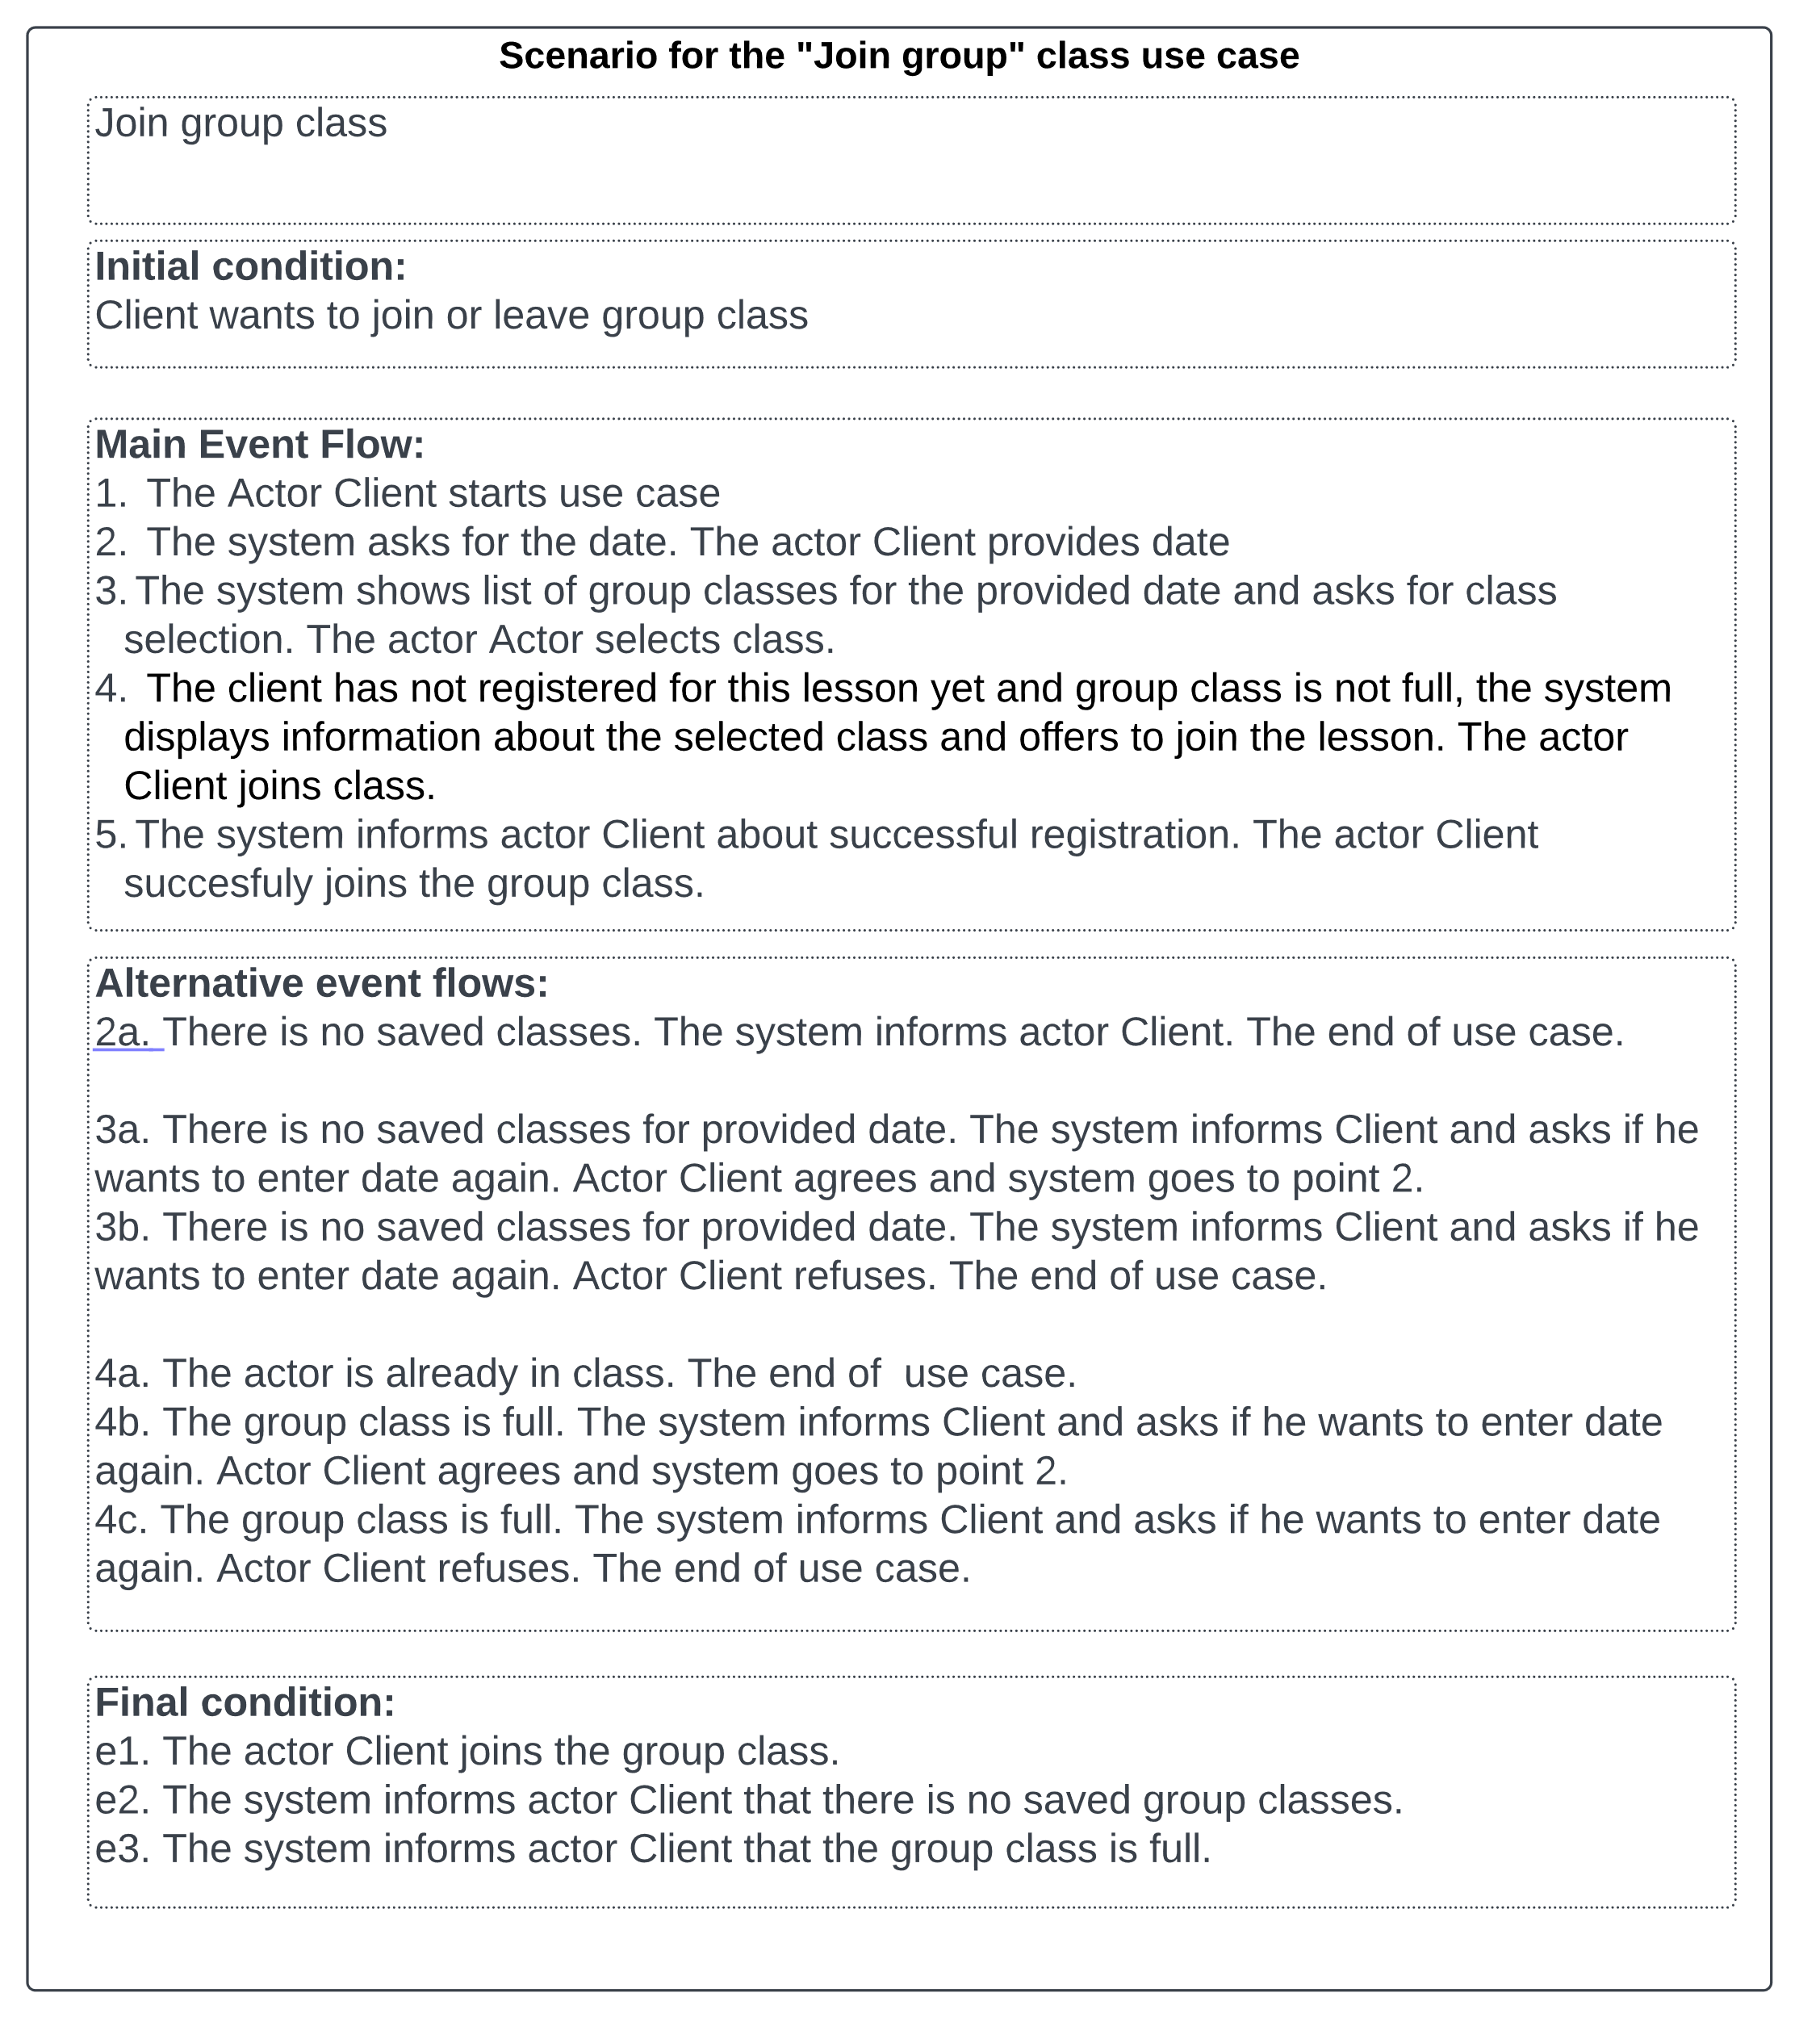

# Activity diagram:

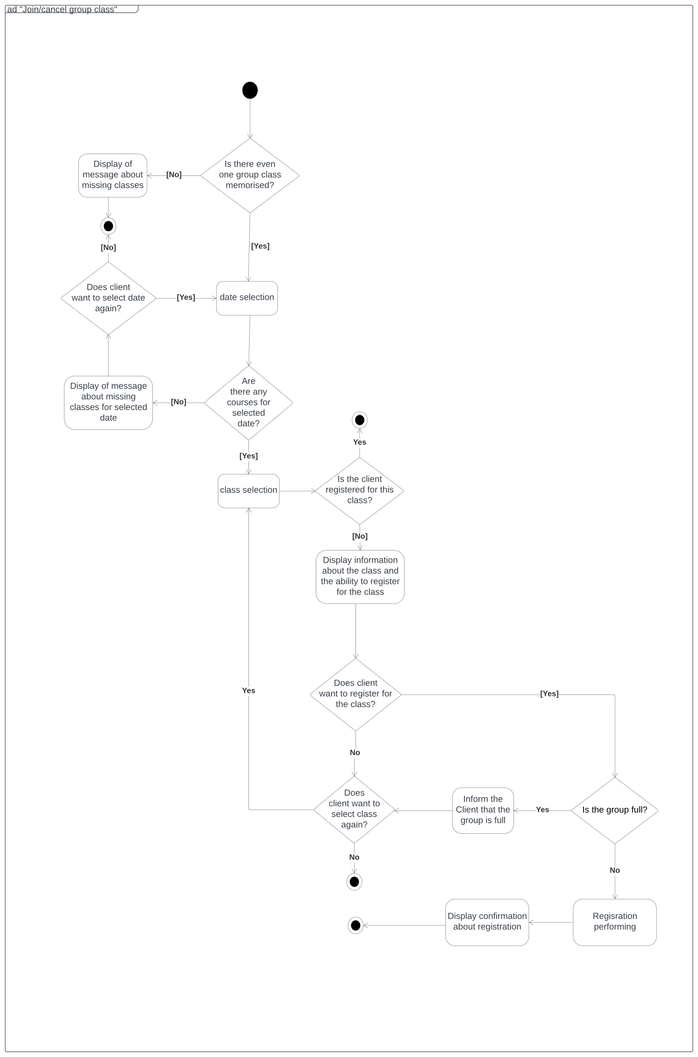

# State diagram for the ClassSession

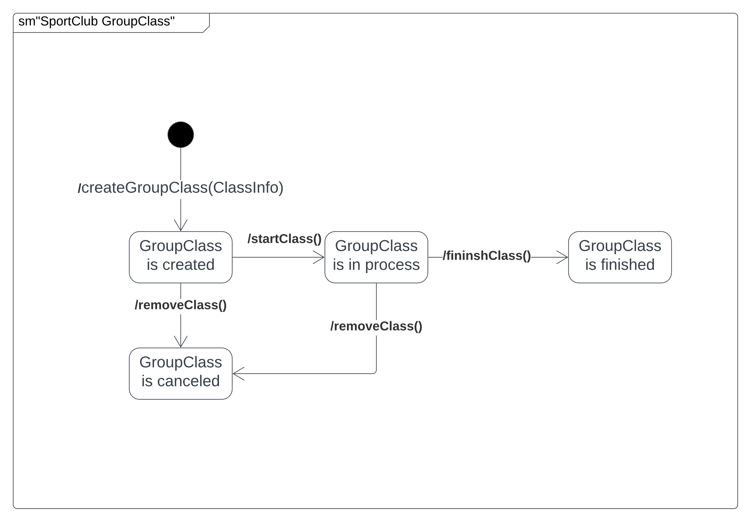

# User interface:

## Изображение выглядит как текст, снимок экрана, Шрифт, диаграмма Автоматически созданное описаниеLogin page

## Изображение выглядит как текст, снимок экрана, число, Параллельный Автоматически созданное описаниеSchedule page

## Изображение выглядит как текст, снимок экрана, число, программное обеспечение Автоматически созданное описаниеDay schedule table

# Discussion of design decisions and implications of the analysis dynamic analysis

## Discussion of design decisions

### Overlapping in inheritance is person, client and employee:

This was due to the fact that if the same person works in our hall and at the same time comes as a client, he remains the same person. Therefore, a person has the opportunity to connect to it the status of both a client and an employee. And since this is not possible in the Java programming language, I had to disable the ability to create instances of the person class in public form and do composition instead of inheritance

### Disjoint inheritance between workers.

This connection was made on the principle of a clear division of responsibilities.

### Relationship between GroupClass, ClassSession, Schedule.

In this case, we have a schedule in which we see sessions of different group classes. Since it is inconvenient to separately create multiple sessions of the same group activity, they are all stored in the GroupClass class. By selecting a session in the schedule and choosing to connect to it, the client will automatically be connected to all sessions of that class at the same time on the same day of the week.

### Multiple inheritance in the CoachDietitian class from the Coach and Dietitian classes.

Since multiple inheritance is not possible in the Java or C# programming languages, I had to create an IDietitian interface that stores the methods inherent in a Dietitian.

## Implications of the analysis dynamic analysis

After dynamic analysis, the ClassSession class appeared. It was recognized that it was impossible to store regular classes in a timetable in a quick and convenient way, so a class was developed to streamline the process