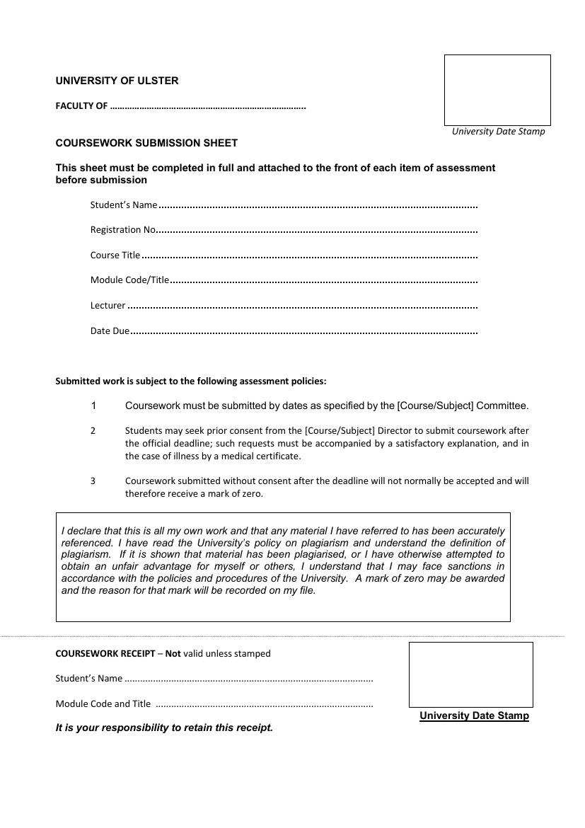

Computing, Engineering and

the Built Environment

COM 809 – 84365

Ciaran O’Boyle, Michelle Loughran, Melissa Melaugh

B00743475, B00, B00

Professional Software Development II

COM 809 – 84365

Rosaleen Hegarty

14 December 2020

Melissa Melaugh, Ciaran O’Boyle, Michelle Loughran

Contents

Abstract 3

Introduction 4

Development Methodology 6

Requirements Analysis 7

Design 8

UML Designs 8

Implementation and Testing 9

Conclusions 10

References 11

Appendix 12

Burn Down Charts 12

Checklist 13

Sprint Discussion 14

Design Interface Ideas 15

# Abstract

The purpose of this project is to create a booking system for air travel. The system will check the flight status and assign seating tickets accordingly. Passengers will be sent the prices for flights dependant on age, Adult, child, senior citizen. After the passenger has entered their details, selected seats and entered the date of booking. The Program will return to the passenger their booking information, assigned seating, the flight details, date of booking and complete costing.

# Introduction

The aim of the project is to provide a booking system for a small airline start up IntelliJ Airport.

The members designing, implementing and testing the project are, Melissa Melaugh, Ciaran O’Boyle, and Michelle Loughran. Each member of team has been allocated a range of duties to ensure equality and effectiveness at each stage of the design, implementation and testing process as well as a colour to be able to easily view important information. Melissa was assigned purple, Ciaran was assigned red, Michelle was assigned green, and work that everyone needed to do was assigned blue. These colours will be used throughout the project and are also discussed in the Appendix under Colours.

The success of the project will be dependent on teamwork, and this will be achieved and regularly assessed through regular group meetings on Blackboard and Zoom. This is to ensure all members are on task, can discuss issues problems with the tasks assigned, and as a support network to ensure all members are being heard and can discuss concerns grievances with their individual tasks. Discuss whether they need additional support from the other team members. The assignment of tasks using a SCRUM framework were agreed at the beginning of the project:

Table : Task Development

|  |  |  |
| --- | --- | --- |
| **Team Leader** | Melissa Melaugh | Create a Plane Class  Create Scheduling Class  Create Plane Test  Create Schedule Test |
| **Team Member** | Ciaran O Boyle | Create Abstract Passenger class  Create Passenger Test  Create an Adult class  Create Adult Test |
| **Team Member** | Michelle Loughran | Create a Child Class  Create Child Test  Create Senior class  Create Senior Test  Create UML Documents  Create write-up |
| **Scrum Development**  **Team** | MM, COB, ML  Melissa Melaugh  Michelle Loughran  Ciaran O Boyle | Agree Project Title and Outline  Create TicketBookingSystem  Test overall Project  Create Presentation  Agree write-up and role responsibility  Use Trello Boards  Use Github  Use Blackboard  Use Zoom  Use IntelliJ |

As the overall outline of the project was agreed, we proceeded to continue to work on the tasks assigned ensuring that any queries could be followed up on Blackboard or Zoom and via a WhatsApp group and Trello boards. Melissa Melaugh was assigned Team Leader responsibilities and directed the overall direction of the program. Melissa assigned time frames and classes after breaking the program down into sections. Melissa undertook the Plane, Scheduling classes, whilst Ciaran undertook the Passenger and Adult classes, and Michelle undertook the Child and senior classes. Together the team worked on the main application. As information was to be shared across each class, it was important to work closely as a team to ensure each class worked as part of the overall program. There were quite a few issues writing, reviewing and implementing code to ensure the program would run effectively when assembled.

The reason for creating such a program was primarily to give all team members the opportunity to experience what it was like to work as a team. The chance to learn from each other and ensure there was peer learning throughout the group.

# Development Methodology

We decided to use an agile SCRUM management framework to complete and develop the Travel Booking Project using Trello. Scrum is one of the most popular agile methodologies used with software development teams and would enable the team to manage the project over a thirty-day sprint. This would empower the team to focus on a common goal of accumulating the project in full, and on-time.

Figure : Overview of how Scrum works.

Scrum would facilitate the team to manage tasks, track issues, and time using sprints, review questions about inefficiencies, prioritise and rank the tasks, issues raised and time as required. It means that as a team we would work together and commit to the project. Using a Scrum framework would support the structure of roles, meetings, rules and tools. As a team we should be able to create and adapt the processes involved using the Scrum framework.

Scrum would assist the team in conquering the complications caused by using a waterfall development process and would enable the team to identify conflicts early and quickly so that suitable modifications can be made.

We originally decided to use Trello boards to enable the process across the team. The team moved to a spreadsheet to track progress in the program. It was also used to illustrate a burndown chart (Appendix, Burndown Charts, Figure 2), main development points (Appendix, Checklist, Figure 3), meeting notes (Appendix, Sprint Discussion, Figure 4) and future directions of the program (Future Directions).

At each meeting we would review the tasks assigned, completed to date and the backlog. This supported effective task completion, sharing of responsibility, open discussion and peer learning to ensure the program would be completed on time. Problems were shared and resolved on WhatsApp and through email. This was especially useful during the implementation and testing stage of the program.

# Requirements Analysis

The purpose for creating a booking system was because many businesses, from entertainment through to finance or education use a booking system. It could be for booking a ticket for the cinema, a hotel, a webinar, a flight, a room for conference amongst many other things. It would give us the chance to replicate a program that required such a booking system and we agreed the most common booking system used was probably a flight booking system and by implementing a program for a small and upcoming flight company we could recreate a program that would cover many of the demands required.

The aim of the program would be to enable the flight company to manage the planes within the company, manage the time schedules, enable passengers to select flight destinations, dates, book seats on the flight and if the passenger was a child or senior citizen avail of discounts that may apply. The program would take into consideration overall flight prices throughout the year taking account of peak and quieter times where passengers could benefit from cheaper purchase prices for flights and seat allocation. Passengers will be able to purchase and print their tickets on completion.

Additional requirements were to show our programming skills, therefore we created a checklist of key points we wished to show off. This checklist is in the Appendix, Checklist, Figure 3, under the Code heading.

# Design

Design of the program initial started with a booking interface, and a discussion as to what exactly was required. Who would be using the program aside from passengers, how it was going to be linked. Several flight booking websites were reviewed and after some discussion an agreement on the following interface was made, then an agreement on the requirements of each class that was to be designed. Aside from passengers booking the ticket, we had to think how this would link to the airport and what had to be deduced from a management perspective in terms of scheduling, organising flights and the booking of seats on a plane.

## UML Designs

UMLs were created as part of the design process with the help of a tutorial (insert reference <https://medium.com/@smagid_allThings/uml-class-diagrams-tutorial-step-by-step-520fd83b300b> )

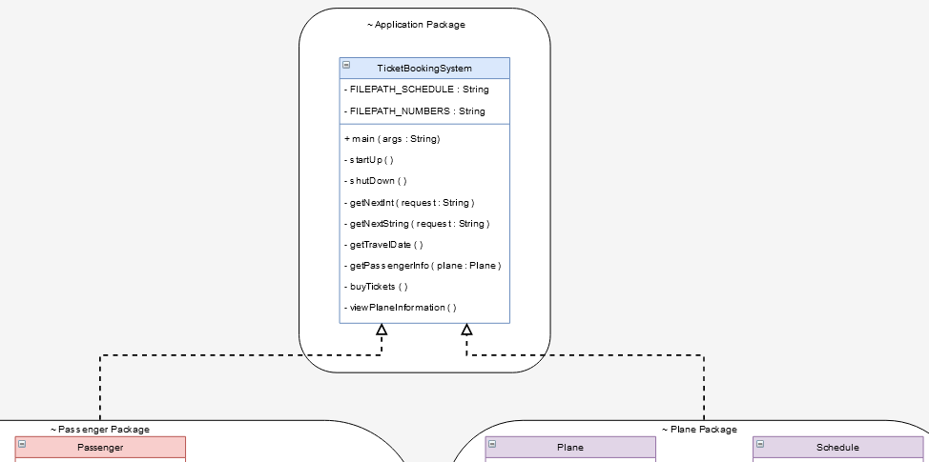

Figure : The Top of the UML showing the Application package and the connections to the Passenger Package and Plane Package

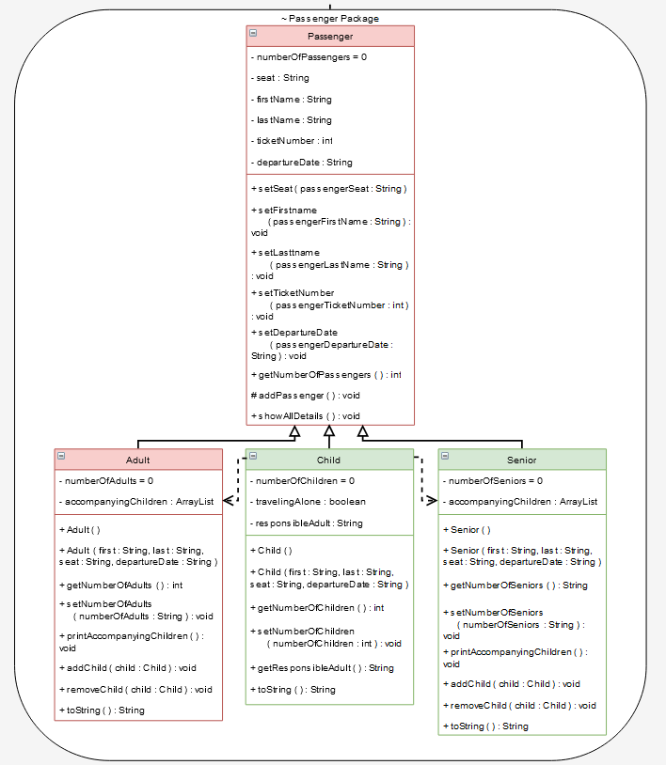

Figure : A UML showing the Passenger Package.

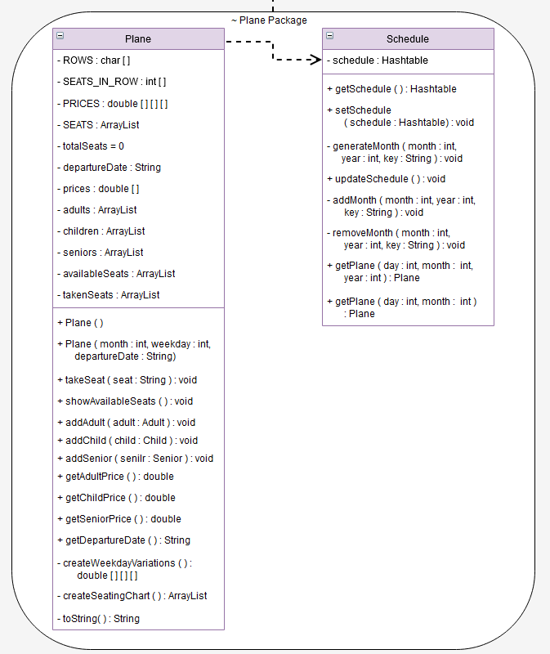

Figure : A UML showing the Plane Package

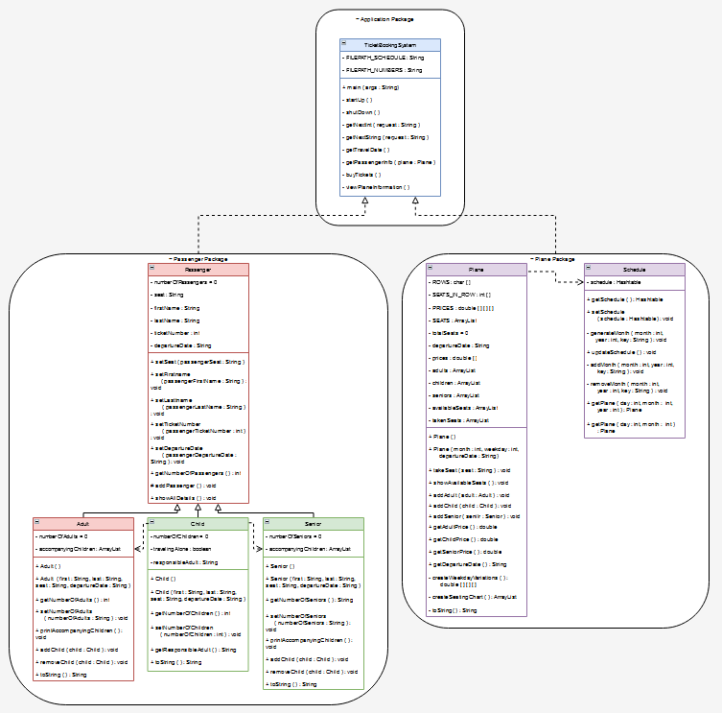

Figure :While the other figures show a more detailed version of each of the package UMLs this figure is included to show the overall view of how the UMLs fit together.

# Implementation and Testing

The implementation of the program - code examples with explanation and discussion of code use

# Conclusions

TODO

FUTURE DEVELOPMENT HERE

FINAL WORDS HERE

# References

**There are no sources in the current document.**

# Appendix

## Colours

The team used colours in order to easily find what was assigned to them.

Table : The colours that the team used to designate themselves

|  |  |
| --- | --- |
| **Team Member** | **Colour** |
| Melissa Melaugh | Variations of Purple |
| Ciaran O’Boyle | Variations of Red |
| Michelle Loughran | Variations of Green |
| Everyone | Variations of Blue |

It should be noted that different programs had slightly different colours, so the colours may vary slightly from screenshot to screenshot depending on the program that was used.

## Burn Down Charts



Figure : The Projected Burn Down Chart (left/top) along side the actual Burn Down Chart (right/bottom). The black line between the 20th and 23rd of November indicates where Melissa joined the team a week late. Between the Projected Burndown and the final creation of the Actual Burndown chart, a new file has been added to take care of the plane scheduling.

## Checklist



Figure : Checklist of items the team felt needed to be hit when working on the project

## Sprint Discussion



Figure : Scrum meeting notes.

## Design Interface Ideas

a.

From:

To:

Departure Date:

Return Date:

Passengers:

Search Flights:

MCM Flights:

One Way

Return

b.

From: Dublin

To: Aberdeen

16 DEC 2020

19 DEC 2020

Search Flights:

MCM Flights:

One Way

Return

3 Passengers:

Figure :The initial design for the booking ticket system.

## JavaDocs

//TODO