P3 ENERGY RESOURCES NOTES

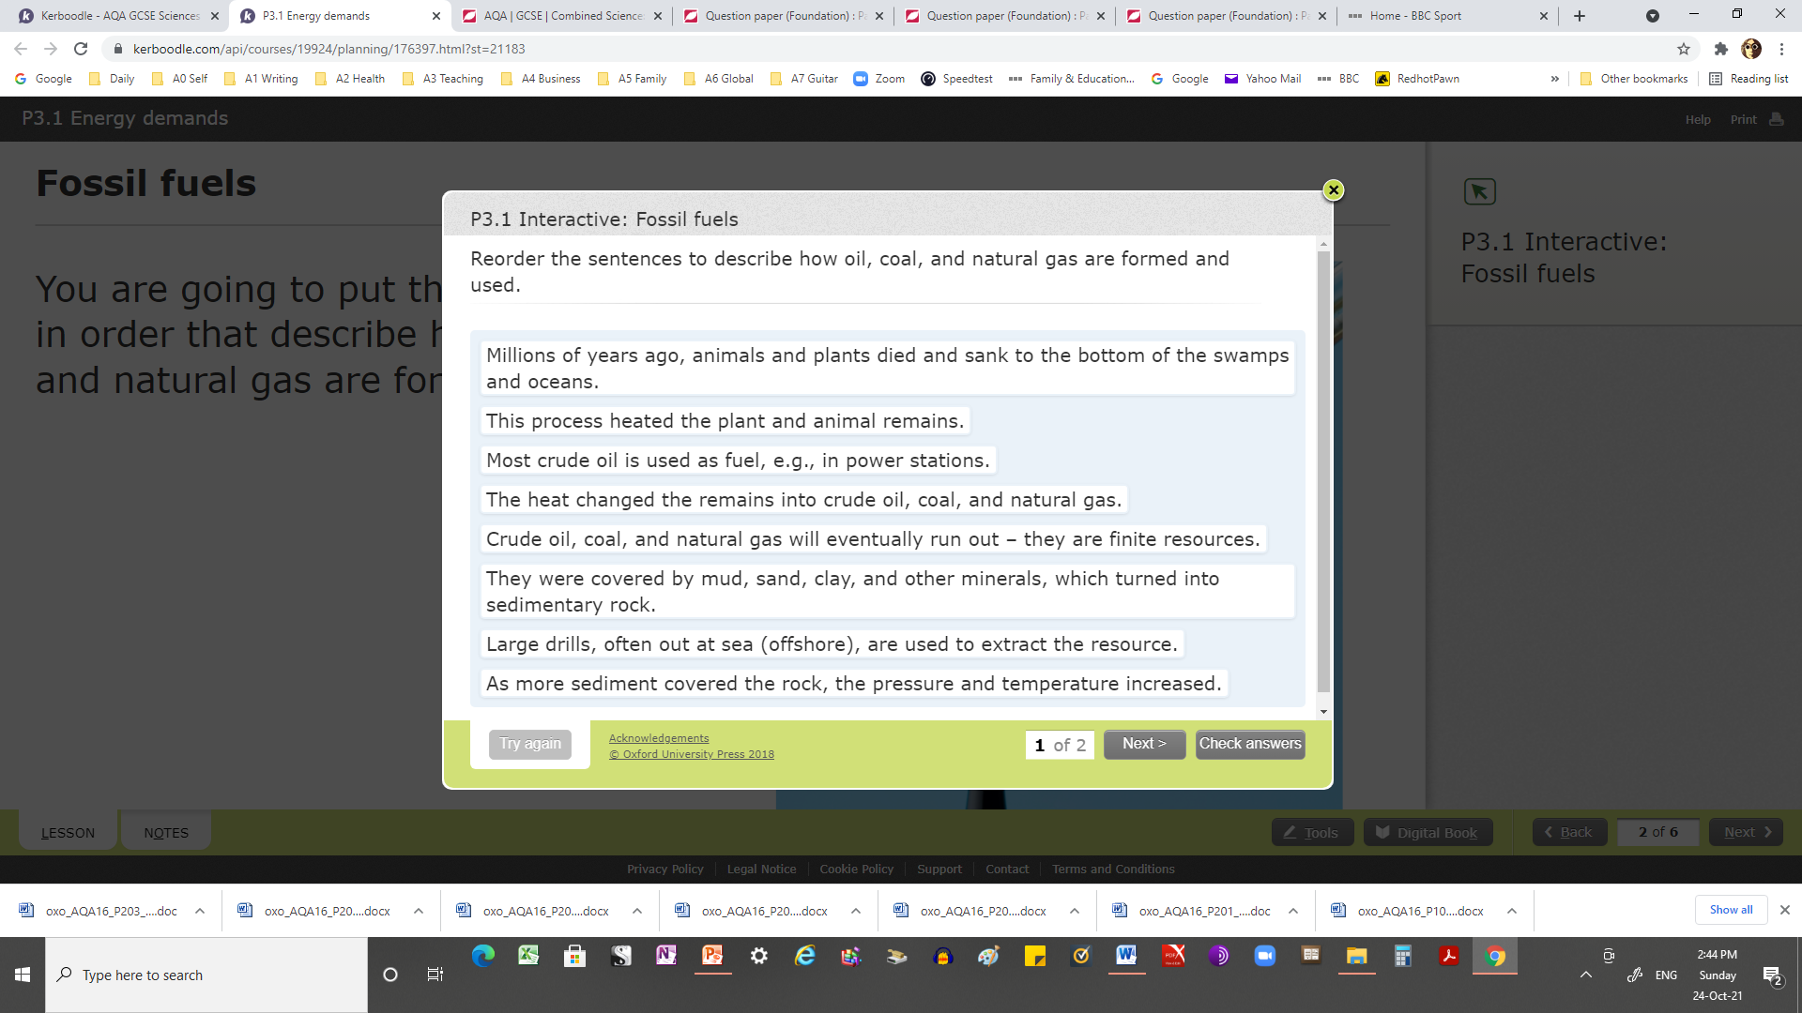

Your energy demands are met mostly by burning oil, coal, and gas

Nuclear power, biofuels, and renewable resources provide energy to generate some of the energy you use

Uranium or plutonium is used as the fuel in a nuclear power station. Much more energy is released per kilogram from uranium or plutonium than from fossil fuels

Biofuels are renewable sources of energy. Biofuels such as methane and ethanol can be used to generate electricity.

What are the differences of biofuels and fossil fuels?

What are the advantages and disadvantages of biofuels, and the effect biofuels have on the environment?

Put the labels in the correct place on the water cycle diagram.

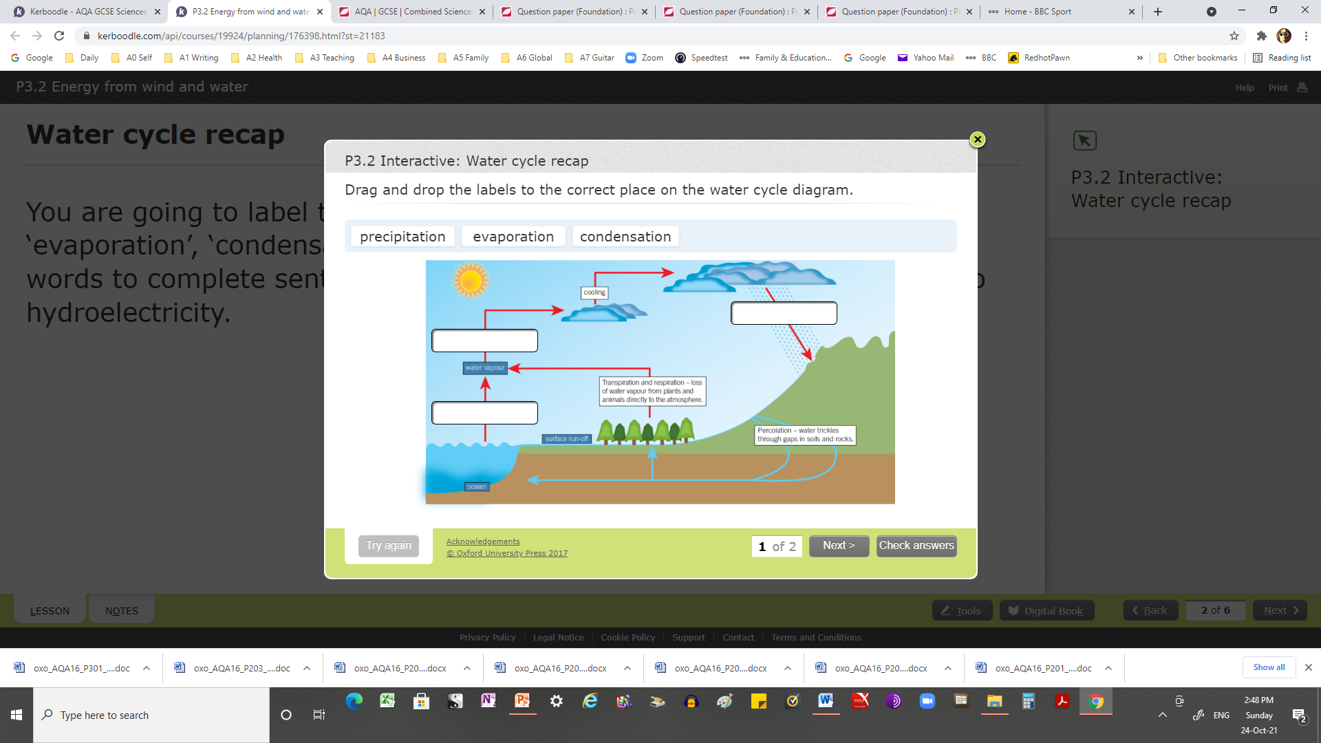

What are the advantages and disadvantages of wind power – including its renewable nature?

A wind turbine is an electricity generator on top of a tall tower

Waves generate electricity by turning a floating generator

Hydroelectricity generators are turned by water running downhill

A tidal power station traps each high tide and uses it to turn generators.

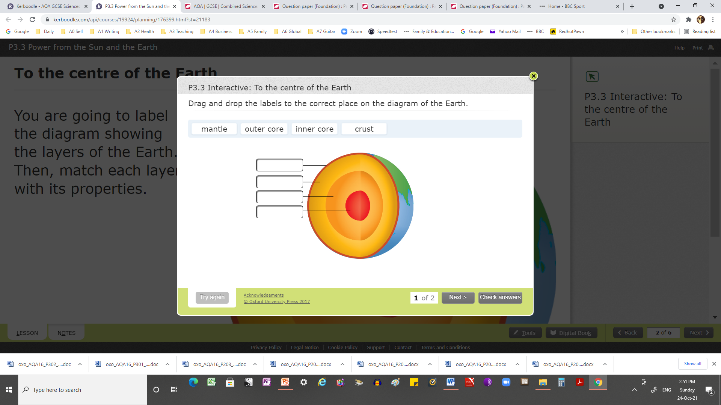

**Using solar cells -** how to investigate the operation of a solar cell:  Measure the effect of reducing the area exposed to light on the current and voltage output, and the effect of increasing the light level by moving a lamp closer or further away.

Solar cells are flat solid cells and use the Sun's light energy to generate electricity directly

Solar heating panels use the Sun's energy to heat water directly

Geothermal energy comes from the energy transferred by radioactive substances deep inside the Earth

Water pumped into hot rocks underground produces steam to drive turbines at the Earth's surface that generate electricity.

Sort the list of energy sources into either ‘renewable’ or ‘non-renewable’.

|  |  |  |
| --- | --- | --- |
|  | Why is this a problem? | What can be done about it  (apart from using less fuel)? |
| Burning fossil fuels releases carbon dioxide. | (*4 marks*) | (*3 marks*) |
| Burning fossil fuels releases sulfur dioxide. | (*3 marks*) | (*2 marks*) |
| Used fuel rods and other materials from nuclear power stations need to be disposed of. | (*3 marks*) | (*3 marks*) |
| Accidents can happen at nuclear  power stations. | (*3 marks*) | There are no guarantees, but many safety precautions are used and accidents are rare. Steps can be taken after an accident to reduce harmful effects on humans. |

Link the problem with use of an energy resource

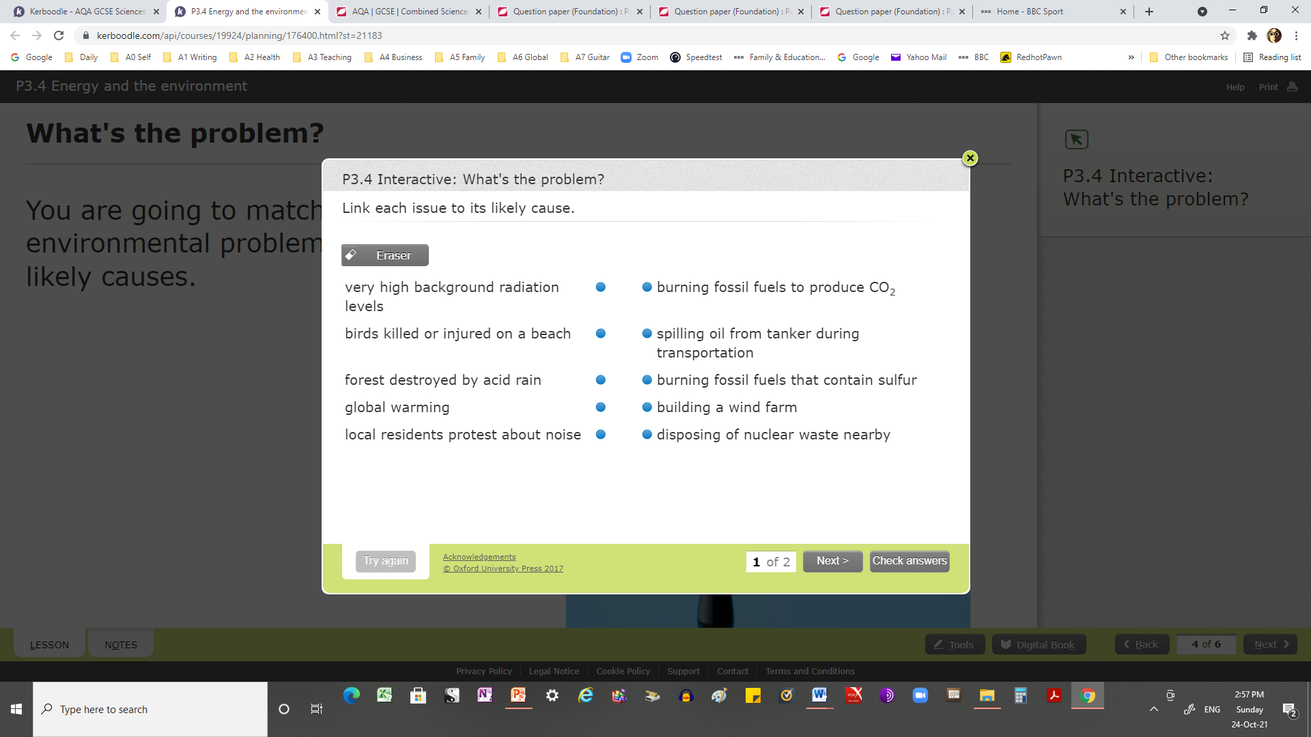

Put the issues with solar and wind energy resources into the correct category – **true**or **false**. 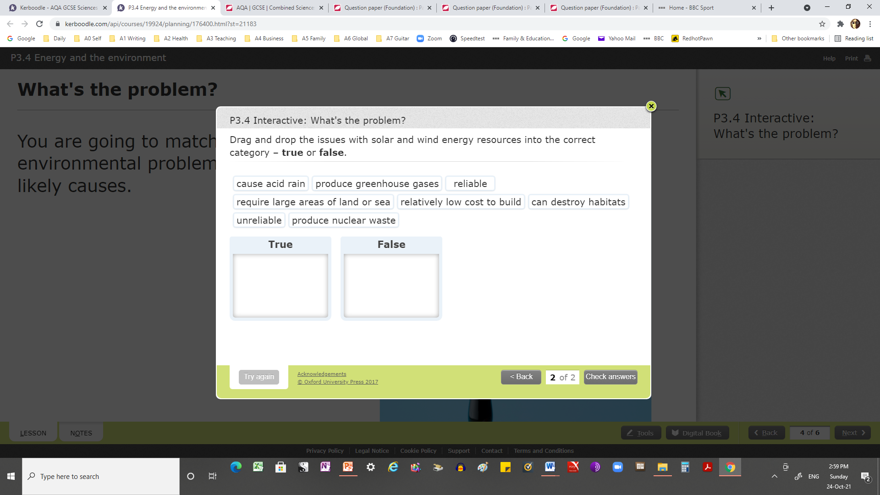

Fossil fuels produce increased levels of greenhouse gases, which could cause global warming

Nuclear fuels produce radioactive waste

Renewable energy resources will never run out, they do not produce harmful waste products (e.g., greenhouse gases or radioactive waste), and they can be used in remote places. But they cover large areas, and they can disturb natural habitats

Different energy resources can be evaluated in terms of reliability, environmental effects, pollution, and waste.

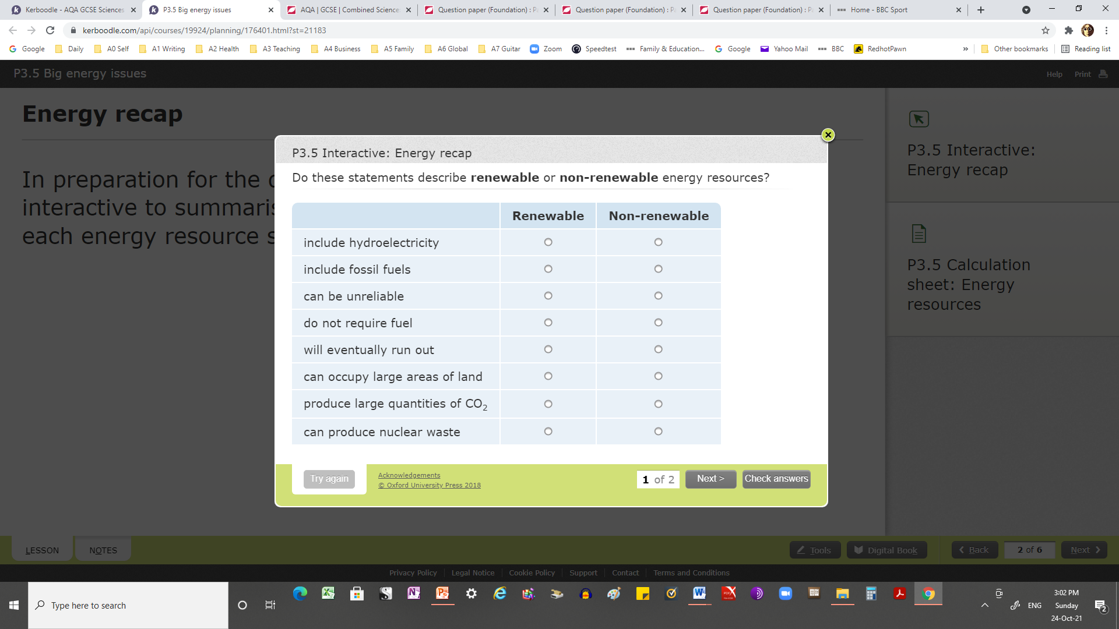

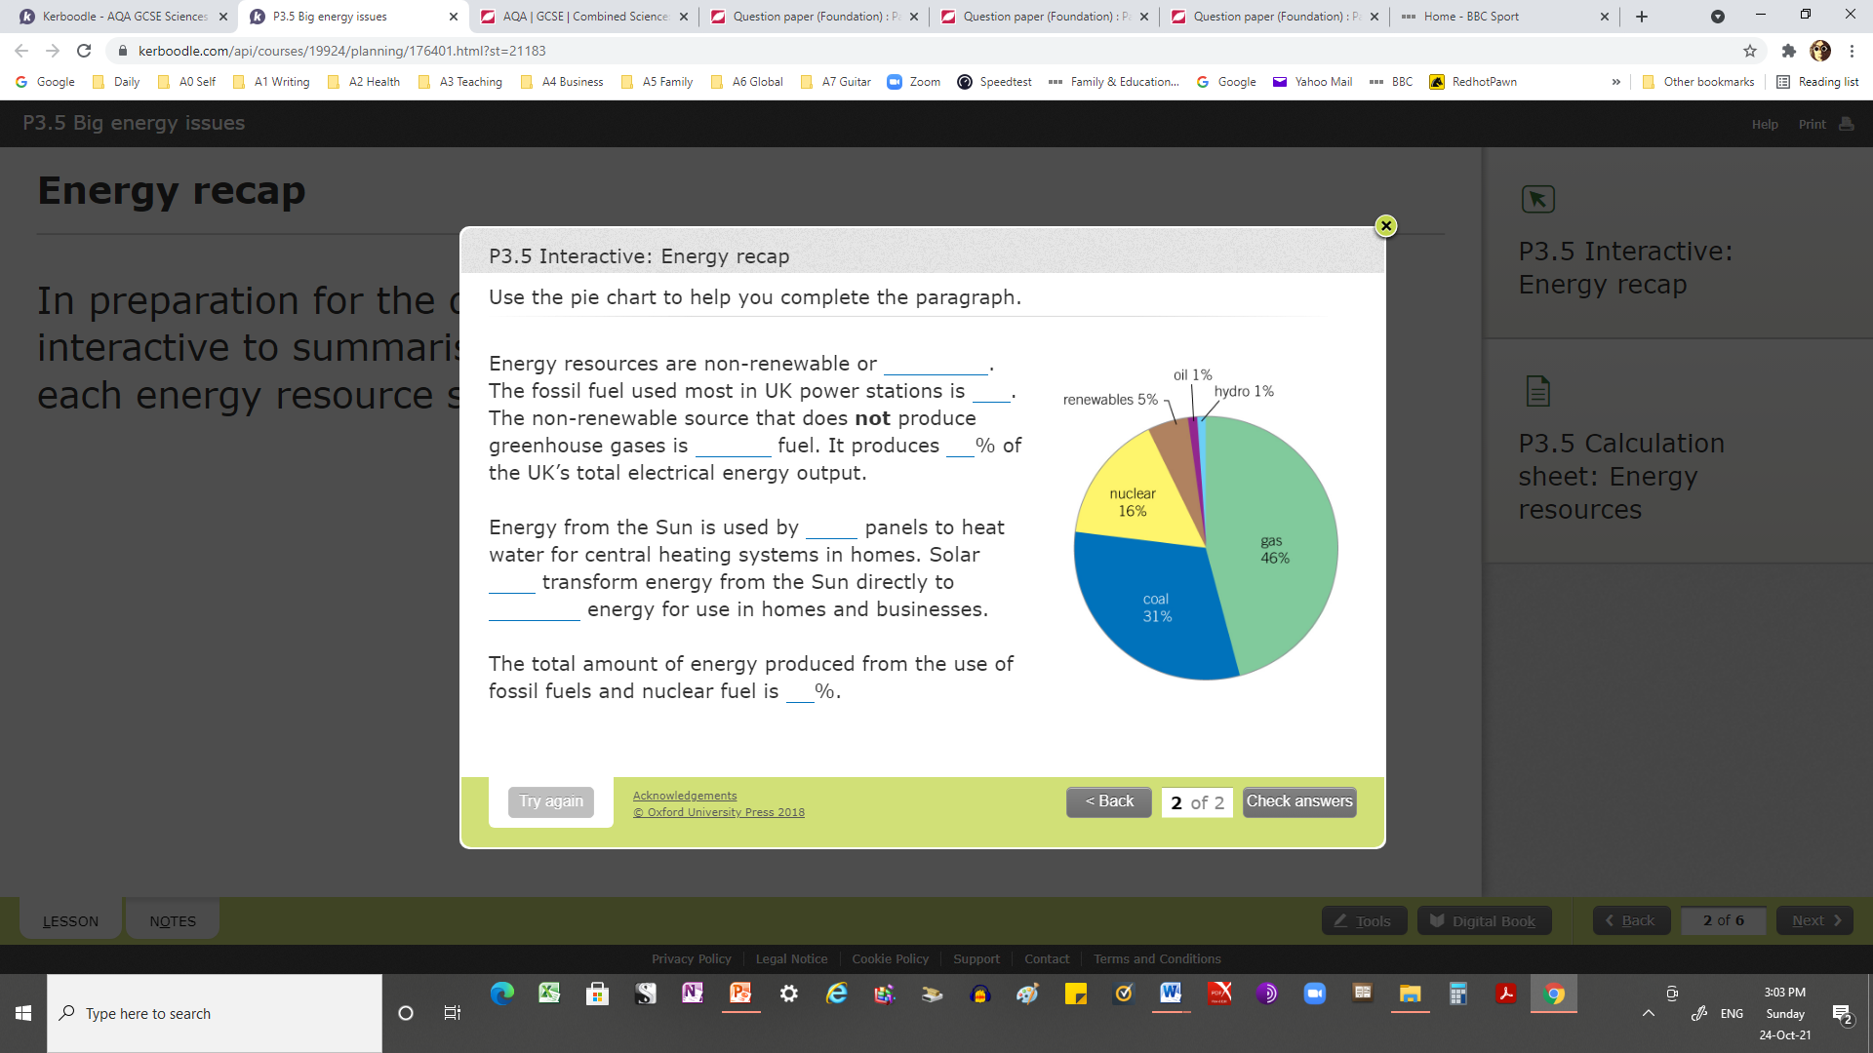

Gas fired power stations and pumped storage stations can meet variations in demand

Nuclear power stations are expensive to build, run, and decommission. Carbon capture of fossil fuel emissions is likely to be very expensive. Renewable resources are cheap to run but expensive to install

Nuclear power stations, fossil-fuel power stations that use carbon capture technology, and renewable energy resources are all likely to be needed for future energy supplies.