3.1

W = [0.05,0.29,0.07,0.08,0.14,0.23,0.03,0.11]; 二进制

求哈夫曼编码表



3.2

W = [0.4,0.18,0.1,0.1,0.07,0.06,0.05,0.04]; 三进制

求哈夫曼编码表

4.1 一一对应的无噪信道的信道容量

PYx = [1,0,0;0,1,0;0,0,1];



4.2 扩展无噪信道的信道容量

PYx = [1/2 1/4 1/4 0 0 0 0 0 0;

0 0 0 1/4 1/4 1/2 0 0 0;

0 0 0 0 0 0 1/4 1/2 1/4];



4.3 归并无噪信道的信道容量

PYx = [1 0 0;

1 0 0;

0 1 0;

0 1 0;

0 0 1];



4.4 准对称信道的信道容量

PYx = [1/3, 1/3, 1/6, 1/6; 1/6, 1/3, 1/6, 1/3]



4.5 一般信道的信道容量及最佳输入分布

PYx = [0.9,0.1;0.2,0.8]

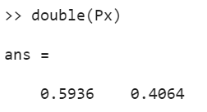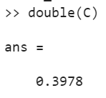

4.6 一般信道的信道容量及最佳输入分布

PYx = [0.5,0.2,0.3;0.4,0.4,0.2;0.1,0.3,0.6]

