南京信息工程大学 实验（实习）报告

实验名称 苹果橘子问题 日期 2023.11.30指导教师 赵晓平

专业信息安全年级班级 21奇安信姓名朱宸扬学号 202183760012

1. 实验目的

熟悉PV操作

1. 实验内容

模拟苹果橘子问题

1. 实验原理

一个盘子，mutex=1

父母分别放苹果和橘子

儿女分别吃苹果和橘子

对应apple=1 orange=1

1. 实验设计及编码
2. 模块分析

父母儿女

父放苹果，母放橘子，儿吃苹果，女吃橘子

1. 流程图

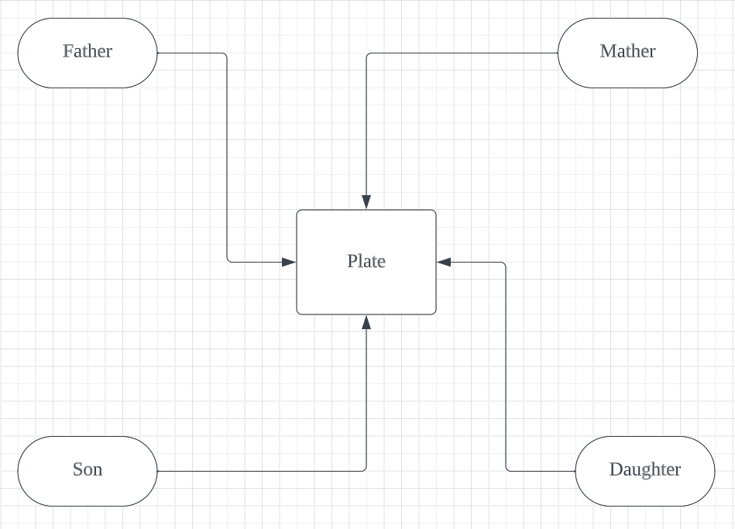

1. 代码实现

import threading

import time

import random

mutex = threading.Semaphore(1)

full_empty = threading.Lock()

not_full = threading.Condition(full_empty)

no_apple = threading.Condition(full_empty)

no_orange = threading.Condition(full_empty)

list = []

global count

count=0

def father():

global count

while(1):

with not_full:

while list and list[0] is not None:

print("盘子满了，父亲阻塞")

not_full.wait()

mutex.acquire()

print("父亲放苹果")

list.append("苹果")

print(list)

count+=1

time.sleep(random.randint(1,2))

no_apple.notify()

mutex.release()

time.sleep(random.randint(1,2))

def mother():

global count

while(1):

with not_full:

while list and list[0] is not None:

print("盘子满了，母亲阻塞")

not_full.wait()

mutex.acquire()

print("母亲放橘子")

list.append("橘子")

print(list)

count+=1

time.sleep(random.randint(1,2))

no_orange.notify()

mutex.release()

time.sleep(random.randint(1,2))

def son():

global count

while(1):

with no_apple:

while list==[] or (list[0] is None or list[0] != '苹果'):

print("盘子无苹果，儿子阻塞")

no_apple.wait()

print("儿子吃苹果")

list.pop()

print(list)

time.sleep(random.randint(1,2))

not_full.notify()

time.sleep(random.randint(1,2))

def daughter():

global count

while(1):

with no_orange:

while list==[] or (list[0] is None or list[0] != '橘子'):

print("盘子无橘子，女儿阻塞")

no_orange.wait()

print("女儿吃橘子")

list.pop()

print(list)

time.sleep(random.randint(1,2))

not_full.notify()

time.sleep(random.randint(1,2))

if __name__ == '__main__':

# 创建两个生产者线程和两个消费者线程

father = threading.Thread(target=father)

mother = threading.Thread(target=mother)

son = threading.Thread(target=son)

daughter = threading.Thread(target=daughter)

# 启动所有线程

father.start()

mother.start()

son.start()

daughter.start()

1. 结果及其相关分析（结果必须是图示）

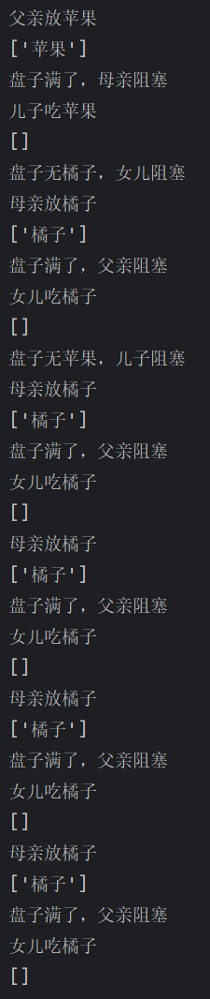

1. 实验小结

加深了对PV操作的理解