南京信息工程大学 实验（实习）报告

实验名称 多级反馈调度算法 日期 2023.11.30指导教师 赵晓平

专业信息安全年级班级 21奇安信姓名朱宸扬学号 202183760012

1. 实验目的

掌握处理器调度算法中的多级反馈调度算法

1. 实验内容

本系统采用多级反馈调度算法，模拟操作系统处理器调度的过程。

1. 实验原理

多级反馈调度队列算法是一种操作系统中用于进程调度的算法，其核心思想是为不同优先级的进程定义多个队列，并通过动态调整进程的优先级来实现不同程度的公平性和响应性。这种调度算法通常用于分时系统，其中多个进程共享系统资源，需要公平地分配CPU时间

以下是多级反馈调度队列算法的基本原理：

多级队列： 系统维护多个就绪队列，每个队列对应一个不同的优先级。通常，初始时将进程放入最高优先级的队列。

调度策略： 调度器根据某种策略从最高优先级的非空队列中选择一个进程执行。一旦一个进程的时间片用完，它将被移到下一个较低优先级的队列，以便为其他进程让出CPU资源。

时间片轮转： 每个队列都可以使用时间片轮转调度算法，确保每个进程在一个时间片内得到执行机会。当进程在当前队列用完时间片后，它将被移到下一个较低优先级的队列。

优先级提升： 如果一个进程等待了足够长的时间而没有得到执行，系统可以提升它的优先级，以确保等待时间过长的进程有更大的机会获得CPU执行时间。

优先级降低： 如果一个进程在其队列内执行了一段时间，而仍然需要CPU执行时间，那么它的优先级可能会降低，以便给其他进程更多的机会。

1. 实验设计及编码
2. 模块分析

进程有序号和工作量大小两个属性

列表选用了队列这种数据结构

采用多线程模拟进程不断进入1号队列和处理器处理进程两个任务同步进行

1. 流程图

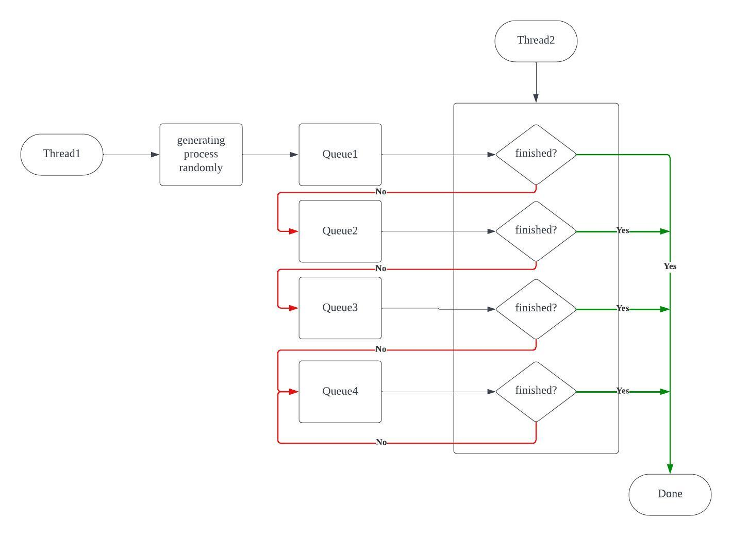

1. 代码实现

import random

import time

from queue import Queue

class Process:

def __init__(self, name, job_size):

self.name = name

self.job_size = job_size

# 创建四个队列，时间片分别为1、2、4、8

queues = [Queue() for _ in range(4)]

time_slices = [1, 2, 4, 8]

# 创建十个进程，每个进程具有随机的作业量

processes = [Process(f"Process-{i}", random.randint(1, 50)) for i in range(1, 11)]

# 放入第一个队列（最高优先级队列）

for process in processes:

print(f"Running {process.name} :(Job Size: {process.job_size})")

queues[0].put(process)

# 模拟调度器

while not all(queue.empty() for queue in queues):

for i in range(len(queues)):

while not queues[i].empty():

process = queues[i].get()

temp = process.job_size

process.job_size -= time_slices[i]

if(process.job_size<0):

time.sleep(temp/5)

process.job_size = 0

else:

time.sleep(time_slices[i]/5)

print(f"Running {process.name} (Time Slice: {time_slices[i]}) (Job Size: {process.job_size})")

if process.job_size > 0:

if i == 3:

queues[3].put(process)

else:

queues[i + 1].put(process) # Move the process to the next queue

else:

print(f" {process.name} 运行结束")

1. 结果及其相关分析（结果必须是图示）

Running Process-1 :(Job Size: 36)

Running Process-2 :(Job Size: 35)

Running Process-3 :(Job Size: 3)

Running Process-4 :(Job Size: 38)

Running Process-5 :(Job Size: 50)

Running Process-6 :(Job Size: 49)

Running Process-7 :(Job Size: 3)

Running Process-8 :(Job Size: 28)

Running Process-9 :(Job Size: 11)

Running Process-10 :(Job Size: 10)

Running Process-1 (Time Slice: 1) (Job Size: 35)

Running Process-2 (Time Slice: 1) (Job Size: 34)

Running Process-3 (Time Slice: 1) (Job Size: 2)

Running Process-4 (Time Slice: 1) (Job Size: 37)

Running Process-5 (Time Slice: 1) (Job Size: 49)

Running Process-6 (Time Slice: 1) (Job Size: 48)

Running Process-7 (Time Slice: 1) (Job Size: 2)

Running Process-8 (Time Slice: 1) (Job Size: 27)

Running Process-9 (Time Slice: 1) (Job Size: 10)

Running Process-10 (Time Slice: 1) (Job Size: 9)

Running Process-1 (Time Slice: 2) (Job Size: 33)

Running Process-2 (Time Slice: 2) (Job Size: 32)

Running Process-3 (Time Slice: 2) (Job Size: 0)

Process-3 运行结束

Running Process-4 (Time Slice: 2) (Job Size: 35)

Running Process-5 (Time Slice: 2) (Job Size: 47)

Running Process-6 (Time Slice: 2) (Job Size: 46)

Running Process-7 (Time Slice: 2) (Job Size: 0)

Process-7 运行结束

Running Process-8 (Time Slice: 2) (Job Size: 25)

Running Process-9 (Time Slice: 2) (Job Size: 8)

Running Process-10 (Time Slice: 2) (Job Size: 7)

Running Process-1 (Time Slice: 4) (Job Size: 29)

Running Process-2 (Time Slice: 4) (Job Size: 28)

Running Process-4 (Time Slice: 4) (Job Size: 31)

Running Process-5 (Time Slice: 4) (Job Size: 43)

Running Process-6 (Time Slice: 4) (Job Size: 42)

Running Process-8 (Time Slice: 4) (Job Size: 21)

Running Process-9 (Time Slice: 4) (Job Size: 4)

Running Process-10 (Time Slice: 4) (Job Size: 3)

Running Process-1 (Time Slice: 8) (Job Size: 21)

Running Process-2 (Time Slice: 8) (Job Size: 20)

Running Process-4 (Time Slice: 8) (Job Size: 23)

Running Process-5 (Time Slice: 8) (Job Size: 35)

Running Process-6 (Time Slice: 8) (Job Size: 34)

Running Process-8 (Time Slice: 8) (Job Size: 13)

Running Process-9 (Time Slice: 8) (Job Size: 0)

Process-9 运行结束

Running Process-10 (Time Slice: 8) (Job Size: 0)

Process-10 运行结束

Running Process-1 (Time Slice: 8) (Job Size: 13)

Running Process-2 (Time Slice: 8) (Job Size: 12)

Running Process-4 (Time Slice: 8) (Job Size: 15)

Running Process-5 (Time Slice: 8) (Job Size: 27)

Running Process-6 (Time Slice: 8) (Job Size: 26)

Running Process-8 (Time Slice: 8) (Job Size: 5)

Running Process-1 (Time Slice: 8) (Job Size: 5)

Running Process-2 (Time Slice: 8) (Job Size: 4)

Running Process-4 (Time Slice: 8) (Job Size: 7)

Running Process-5 (Time Slice: 8) (Job Size: 19)

Running Process-6 (Time Slice: 8) (Job Size: 18)

Running Process-8 (Time Slice: 8) (Job Size: 0)

Process-8 运行结束

Running Process-1 (Time Slice: 8) (Job Size: 0)

Process-1 运行结束

Running Process-2 (Time Slice: 8) (Job Size: 0)

Process-2 运行结束

Running Process-4 (Time Slice: 8) (Job Size: 0)

Process-4 运行结束

Running Process-5 (Time Slice: 8) (Job Size: 11)

Running Process-6 (Time Slice: 8) (Job Size: 10)

Running Process-5 (Time Slice: 8) (Job Size: 3)

Running Process-6 (Time Slice: 8) (Job Size: 2)

Running Process-5 (Time Slice: 8) (Job Size: 0)

Process-5 运行结束

Running Process-6 (Time Slice: 8) (Job Size: 0)

Process-6 运行结束

1. 实验小结

通过本次实验，我们深入了解了多级反馈调度算法的机制和运作方式。这不仅有助于我们理解操作系统中的进程调度，还为我们进一步研究和优化调度算法提供了基础。

实验的完成使我们更好地理解了理论知识，并通过实际操作加深了对多级反馈调度算法的认识。这将有助于我们更好地应用和理解操作系统的相关概念。