Raspberry Pi 2019 set up instructions

First, run eds set up downloaded from the github by Ben C

Set up vnc for pi. Type in terminal sudo raspi-config and enable vnc

Run code automatically

Make MasterManager.py an executable file

First type “#!/usr/bin/env python3.5

Then in terminal type the command “chmod +x MasterManager.py”

Finally make make MasterManager.py run on startup using systemd

First type “sudo nano /etc/systemd/system/MasterManager.service

Edit the file to match exactly this picture

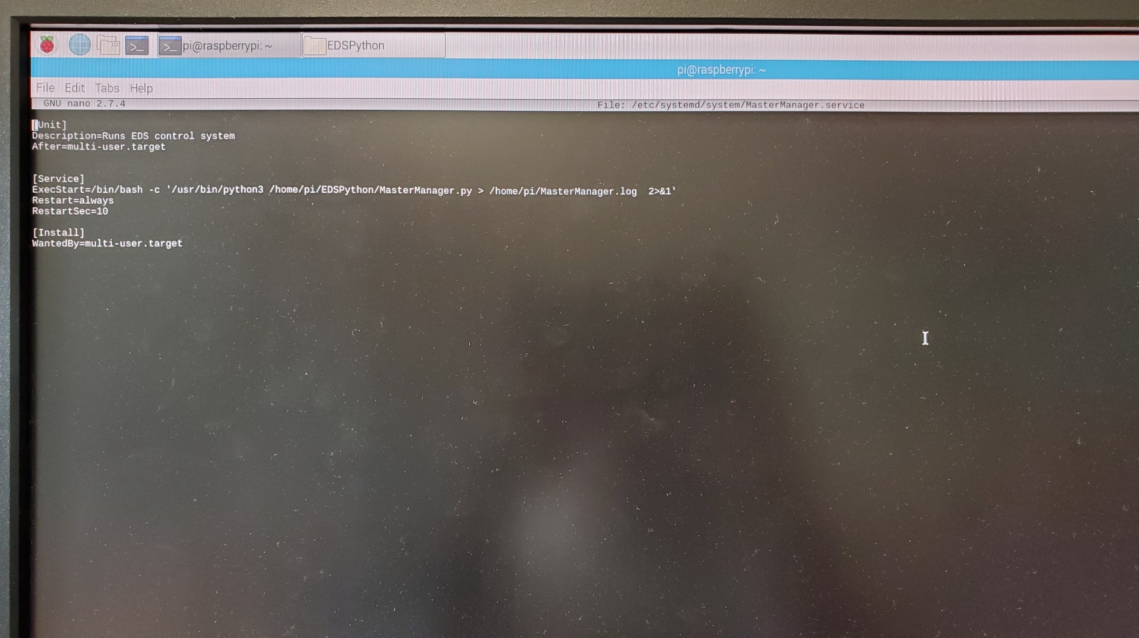

Type “chmod 644 /etc/systemd/system/MasterManager.service

Type “sudo systemctl daemon-reload”

Type”sudo systemctl enable MasterManager.service

Then your done!!!!

Finally in order to check the status of the program use “cat MasterManager.log” to see the full log on the command shell from the code

“sudo systemctl start(stop) MasterManager.service” to start or stop the code, you need to stop the code in order to read the log file

“sudo systelctl status MasterManager.service” to check if the code is running

“sudo systemd-analyze verify daphnei.service” to see if something in the .service file is wrong

RTC

**sudo nano /boot/config.txt**

to edit the pi configuration and add whichever matches your RTC chip:

dtoverlay=i2c-rtc,ds1307

or

dtoverlay=i2c-rtc,pcf8523

or

dtoverlay=i2c-rtc,ds3231

to the end of the file

Reboot

* sudo apt-get -y remove fake-hwclock
* sudo update-rc.d -f fake-hwclock remove
* sudo systemctl disable fake-hwclock

Run **sudo nano /lib/udev/hwclock-set**and comment out these three lines**:**

**#if [ -e /run/systemd/system ] ; then  
# exit 0  
#fi**

Also comment out the two lines

/sbin/hwclock --rtc=$dev --systz --badyear

and

/sbin/hwclock --rtc=$dev –systz

You can see, the date at first is invalid! You can set the correct time easily. First run date to verify the time is correct. Plug in Ethernet or WiFi to let the Pi sync the right time from the Internet. Once that's done, run **sudo hwclock -w** to **w**rite the time, and another **sudo hwclock -r** to **r**ead the time

https://learn.adafruit.com/adding-a-real-time-clock-to-raspberry-pi/set-rtc-time

Debugging (only on windows computer, preferably a laptop)

On your computer download vnc viewer and advances ip address scanner

First go on view network computer devices then go to advances sharing settings and turn on network discovery

Then go to change adapter settings, click on bu’s wifi, and properties, then enable sharing

On another network either a hotspot or via an Ethernet cable check properties then internet protocoal 4 and see what ip address and subnet address you have. The subnet address is the range of all the ip addresses your computer puts out from the shared network

Go to adances ip scanner and with the pi connected and with vnc on on the pi, scan your shared network to find the pi address using the ranges you found before

Finally using vnc viewer input the ip address user name and password for the pi to remotely access the pi desktop