1. Logo: will change later
2. Dashboard: just need to replace the text with my text and will send u pic tonight
3. UPGRADE Button Link: powerscrap.io
4. START Button: 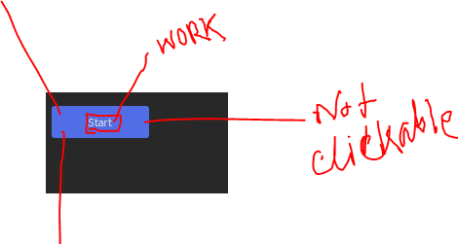
5. SCRAPPING PROGRESS Window: change windo ui color

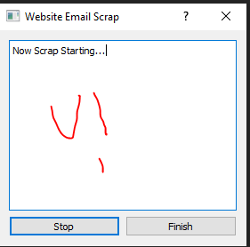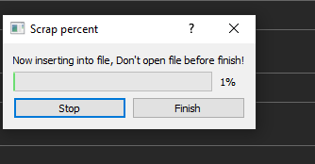

1. Scrapping succes window: change windo ui color

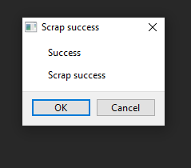

1. Social email selects email type:

@gmail,@yahoo,@hotmail,@zoho etc

@gmail

@yahoo

@hotmail

@zoho

1. In salesforce and sales nave its scrapping my user email and copying same email in each row so remove that email collecting functionality