School of Computer Science Engineering and Information Systems

Vellore Institute of Technology, Vellore

Fall Semester 2025–2026

Department of Software and Systems Engineering

SWE3004 – Software Design and Development Project

Date: 23.09.2025

GraphGuard: An Explainable Graph Neural Network
for Intelligent Intrusion Detection

Reg.No: 22MIS0541 – PARAMESHWAR P

Under the Guidance of

Dr. PRABHU J

Professor Grade 1

REVIEW – 1

SCORE: ________________________

Guide Signature with Date: ________________________

Internal Examiner-1 ________________________ Internal Examiner-2 ________________________

Signature ________________________ Signature ________________________

ABSTRACT:
GraphGuard is an explainable Graph Neural Network (GNN)-based framework designed to improve intrusion detection in modern enterprise, cloud, and Internet of Things (IoT) networks. Unlike conventional Intrusion Detection Systems (IDS) that primarily analyse network traffic as independent records, GraphGuard models communication as a graph, where network devices are represented as nodes and communication flows as edges. This enables the system to capture both traffic characteristics and relationships between network entities, helping identify coordinated and evolving cyber attacks. The framework introduces an Adaptive Graph Construction (AGC) mechanism to dynamically update network relationships according to changing communication behaviour. Explainable Artificial Intelligence (XAI) techniques are incorporated to provide understandable explanations for detected threats, improving the transparency and trustworthiness of the detection process. A proposed Threat Propagation Score (TPS) estimates the potential severity and spread of detected attacks, supporting effective alert prioritization. GraphGuard will be evaluated using benchmark intrusion detection datasets, including CICIDS2017, and compared with conventional machine-learning and graph-based approaches.
Keywords: Graph Neural Networks, Intrusion Detection System, GraphSAGE, Adaptive Graph Construction, Explainable AI, Threat Propagation Score, CICIDS2017

[1]. INTRODUCTION:
Network intrusion detection is a fundamental security requirement in modern enterprise, cloud, and Internet of Things (IoT) environments. Conventional Intrusion Detection Systems (IDS) predominantly analyse individual network flow records using signature-based rules or machine-learning classifiers, focusing primarily on traffic-level features while treating each flow as an independent observation. This approach misses important relational information about how hosts communicate over time and fails to capture coordinated or multi-stage attack patterns.
Graph Neural Networks (GNNs) have recently emerged as a powerful method for learning from graph-structured data, making them well-suited to network intrusion detection where the relationships between communicating entities carry important security signals. GraphGuard proposes an end-to-end GNN-based intrusion detection framework that models network traffic as a dynamic graph, applies Adaptive Graph Construction (AGC), produces inductive node embeddings using GraphSAGE, and classifies communication flows using an MLP edge classifier. The system further provides SHAP-based explainability and a Threat Propagation Score (TPS) for analyst-friendly alert prioritization.
[2]. PROBLEM STATEMENT:
Existing network intrusion detection approaches face several important limitations:
1. Flow independence: Classical ML and deep-learning IDS treat each network flow as isolated, ignoring relationships between communicating entities and structural network patterns.
2. Static graph representations: Early GNN-based IDS construct fixed graphs that do not adapt to changing network communication behaviour or new/disappearing connections.
3. Limited explainability: Most GNN-based IDS provide predictions without clear forensic justification, reducing analyst trust and operational usefulness.
4. Absence of threat propagation awareness: Existing IDS do not provide explicit scores to estimate the potential severity or spread of a detected threat across connected network entities.
GraphGuard addresses all four limitations through adaptive graph construction, inductive GNN learning, integrated SHAP explainability, and a Threat Propagation Score.
[3]. OBJECTIVES:
• Design a GNN-based NIDS that models network traffic as a directed communication graph.
• Implement Adaptive Graph Construction (AGC) to dynamically update graph relationships over time.
• Apply GraphSAGE inductive learning to generate topology-aware node embeddings.
• Train an MLP edge classifier using combined graph embeddings and flow traffic features.
• Provide SHAP-based explainability to identify important features, nodes, and relationships per prediction.
• Design and compute a Threat Propagation Score (TPS) for alert prioritization.
• Evaluate against conventional ML and GNN-based IDS baselines on CICIDS2017.
• Conduct component-wise ablation to quantify each component's contribution.
[4]. SCOPE OF THE PROJECT:
GraphGuard covers: graph-based network intrusion detection, adaptive graph construction over temporal windows, inductive GNN-based classification, SHAP explainability, Threat Propagation Score, and an interactive Streamlit demonstration dashboard. The system operates on CICIDS2017 network-flow data. Future work may include live packet ingestion, real-time streaming, and deployment on real network infrastructure.
[5]. PROPOSED SYSTEM:
1. Data Preprocessing: CICIDS2017 flow records are loaded, cleaned, normalized, and split chronologically.
2. Network Graph Construction: Nodes = IP endpoints. Edges = communication flows. Edge features = CICFlowMeter statistics. Node features = label-independent structural/traffic aggregates.
3. Adaptive Graph Construction (AGC): Dynamically updates the graph: new nodes/edges are added, active relationships are reinforced, edge weights decay exponentially, stale edges are pruned.
4. GraphSAGE Encoder: Two-layer inductive GNN that produces 64-dim node embeddings from graph structure without requiring test nodes during training.
5. MLP Edge Classifier: Concatenates source embedding + destination embedding + edge features -> MLP -> BENIGN / FTP-Patator / SSH-Patator classification.
6. SHAP Explainability (XAI): Provides forensic attribution for selected predictions by identifying the most important contributing traffic features.
7. Threat Propagation Score (TPS): Propagates detection probabilities across the graph to rank IP nodes by suspicion for analyst prioritization.
8. Evaluation & Ablation: Benchmarked against RF and XGBoost baselines with 5-component ablation study.

[6]. LITERATURE SURVEY: (minimum 15 papers)
S.NO | PAPER | APPROACH | MERITS | DEMERITS / GAP
1 | Lo et al. (2022). E-GraphSAGE: A GNN-based IDS for IoT. NOMS 2022 — IEEE. | GraphSAGE on flow graphs for IoT intrusion detection. | Directly demonstrates GNN effectiveness for network IDS. | No adaptive graph construction or XAI integration.
2 | Caville et al. (2022). Anomal-E: Self-supervised NIDS based on GNNs. Knowledge-Based Systems. | Self-supervised GNN for anomaly detection. | Reduces reliance on labelled data. | Does not address adaptive graph construction, XAI, or TPS.
3 | Liu & Guo (2025). DIGNN-A: Real-time NIDS with dynamic GNN. CMC. | Dynamic GNN for real-time intrusion detection. | Addresses dynamic graph changes. | No integrated XAI or TPS component.
4 | Xu et al. (2024). Self-supervised learning for flow graphs with GNN. Computer Networks. | Self-supervised GNN learning on network flow graphs. | Improves representation learning for network flows. | No adaptive construction mechanism or explainability.
5 | Guerra et al. (2026). Self-supervised learning of graph representations for NIDS. NeurIPS. | Self-supervised graph representation for IDS. | State-of-the-art self-supervised graph learning. | Lacks adaptability to evolving graphs and TPS.
6 | Van Langendonck et al. (2025). PPT-GNN: Pretrained spatio-temporal GNN. EuroS&PW. | Pretrained spatial-temporal GNN for network security. | Leverages pretraining for security tasks. | Does not integrate XAI or alert prioritization.
7 | Gu et al. (2024). Always be pre-training: GNNs for NIDS. ISQED. | Representation learning with GNNs via pre-training. | Improves detection with limited labelled data. | No adaptive graph construction or threat propagation.
8 | Lo et al. (2023). XG-BoT: Explainable deep GNN for botnet detection. IoT — Elsevier. | GNN + explainability for botnet forensics. | Demonstrates GNN + XAI value for cybersecurity. | Focuses on botnet; no adaptive graph or TPS.
9 | Hassija et al. (2024). Interpreting black-box models: A review on XAI. Cognitive Computation. | Comprehensive XAI review for AI systems. | Establishes XAI theoretical foundation. | General review; not IDS-specific.
10 | Zaccagnino et al. (2023). Geometric deep learning for NIDS using GNNs. SECRYPT. | Geometric deep learning applied to NIDS. | Demonstrates GNN applicability to cybersecurity. | No AGC, XAI, or TPS integration.
11 | Shone et al. (2018). Deep learning for NIDS. IEEE TETCI. | Deep autoencoder for network intrusion detection. | Effective deep learning baseline for NIDS. | No graph modelling or XAI.
12 | Sarhan et al. (2022). Standard feature set for NIDS datasets. Mobile Networks and Applications. | Analyses feature consistency across NIDS datasets. | Relevant to feature selection and dataset evaluation. | Does not propose a GNN detection architecture.
13 | Zhou et al. (2020). Graph neural networks: A review. AI Open — Elsevier. | Comprehensive GNN architecture review. | Theoretical foundation for GNN design. | General survey; not IDS-specific.
14 | Wu et al. (2020). Comprehensive survey on GNNs. IEEE TNNLS. | Survey of GNN models, learning paradigms, applications. | Broad GNN classification and understanding. | Not cybersecurity-focused.
15 | Sarker (2021). Machine learning: Algorithms, applications, directions. SN Computer Science. | Review of ML algorithms and applications. | General ML foundation for baseline comparison. | Not graph-specific or IDS-focused.

[6.1] FINDINGS IN LITERATURE SURVEY:
The literature survey indicates that network intrusion detection has been extensively studied using machine learning, deep learning, GNNs, dynamic graph learning, self-supervised learning, and XAI. The following key gaps were identified:
1. Limited adaptive graph construction: AGC based on continuously evolving communication behaviour is not sufficiently integrated into a unified IDS framework.
2. Insufficient integration of traffic and structural relationships: A unified approach considering both traffic features and changing structural relationships is needed.
3. Limited explainability in GNN-based IDS: Explainability is not consistently integrated with adaptive GNN-based detection.
4. Lack of threat propagation and alert prioritization: Existing approaches do not provide an explicit TPS to estimate severity or spread of detected threats.
5. Challenges in adapting to evolving attacks: Changing network patterns require frameworks that can adapt their graph representation.
6. Need for an integrated and interpretable framework: AGC + relationship-aware detection + explainability + TPS have not been combined into one system.

[7]. METHODOLOGY:
1. Literature Review and Baseline Selection: Existing GNN-based, dynamic graph, self-supervised, and explainable IDS approaches are reviewed to identify research gaps. Suitable baselines (Random Forest, XGBoost) are selected for comparison.
2. Dataset Acquisition and Preprocessing: CICIDS2017 is acquired and preprocessed: missing/duplicate records handled, irrelevant features removed, numerical features normalized, attack labels prepared. Data divided into training, validation, and testing sets using campaign-window chronological split.
3. Network Graph Construction: Preprocessed flow records are transformed into graph representations. Nodes = network hosts/IP endpoints. Edges = communication flows. Traffic characteristics are associated with nodes/edges.
4. Adaptive Graph Construction (AGC): AGC mechanism updates the graph over temporal windows: new nodes/edges added, active relationships reinforced, edge weights decay exponentially, stale edges pruned.
5. GNN-Based Intrusion Detection: The dynamically constructed graph is provided to GraphSAGE to learn representations from node features, edge features, and neighbourhood relationships.
6. Model Training and Attack Classification: The GNN model is trained on training data with appropriate optimization. Validation data is used for model selection. The test set is kept separate for final evaluation.
7. Explainable AI Analysis: SHAP-based XAI module identifies important traffic features, nodes, and graph relationships contributing to each prediction for forensic transparency.
8. Threat Propagation Score Calculation: TPS estimates potential severity and propagation of detected threats across connected network entities. Used for alert prioritization, not future-attack prediction.
9. Evaluation and Benchmarking: GraphGuard evaluated using accuracy, precision, recall, F1-score, FPR, confusion matrix. Compared against RF and XGBoost baselines.
10. Ablation and Explainability Analysis: Component-wise ablation studies measure the contribution of major components: AGC, graph context, adaptive weights, and GraphSAGE.
[8]. SOFTWARE REQUIREMENTS:
Functional Requirements:
ID | Requirement
FR1 | The system shall load and preprocess network intrusion datasets such as CICIDS2017, including data cleaning, feature handling, normalization, label preparation, and division into training, validation, and testing sets.
FR2 | The system shall construct a graph representation of network traffic by modelling network entities as nodes, communication flows as edges, and associating relevant traffic features with graph elements.
FR3 | The system shall implement Adaptive Graph Construction (AGC) to update graph relationships according to changing network communication behaviour.
FR4 | The system shall train a GNN to learn traffic and structural relationships and classify network activities as normal or malicious, including supported attack categories and prediction confidence.
FR5 | The system shall implement an XAI module to identify important traffic features, nodes, edges, and graph relationships contributing to intrusion-detection predictions.
FR6 | The system shall calculate a Threat Propagation Score (TPS) for detected threats and use it to prioritize security alerts, displaying attack categories, explanations, confidence, and threat-priority information.
FR7 | The system shall evaluate and benchmark GraphGuard using standard performance metrics and compare with conventional ML and GNN-based IDS approaches, including component-wise ablation analysis.

Non-Functional Requirements:
ID | Requirement
NFR1 | Accuracy & Reliability: The system should provide reliable intrusion detection while minimizing incorrect classifications and false-positive alerts.
NFR2 | Performance & Efficiency: The system should process network traffic, construct graphs, and perform GNN-based prediction within practically acceptable time and computational requirements.
NFR3 | Scalability: The system should handle large network intrusion datasets and graph representations without significant performance degradation.
NFR4 | Adaptability: The system should accommodate changes in network communication relationships through AGC.
NFR5 | Explainability & Usability: The system should provide understandable intrusion predictions, important contributing features, and threat-priority information in a clear form for security analysts.
NFR6 | Maintainability & Extensibility: The system should use modular components so preprocessing, graph construction, GNN, XAI, TPS, datasets, and model architectures can be independently modified.
NFR7 | Reproducibility & Security: The pipeline should maintain documented preprocessing, dataset splits, model configurations, and data integrity so results can be reliably reproduced.

[9]. SYSTEM ARCHITECTURE:
CICIDS2017 -> Preprocessing -> Chronological split -> Graph construction -> AGC -> GraphSAGE -> Node embeddings -> [Source + Destination embeddings + Edge features] -> MLP Classifier -> Prediction -> SHAP XAI + TPS -> Dashboard. (RF and XGBoost evaluated separately as independent baselines.)
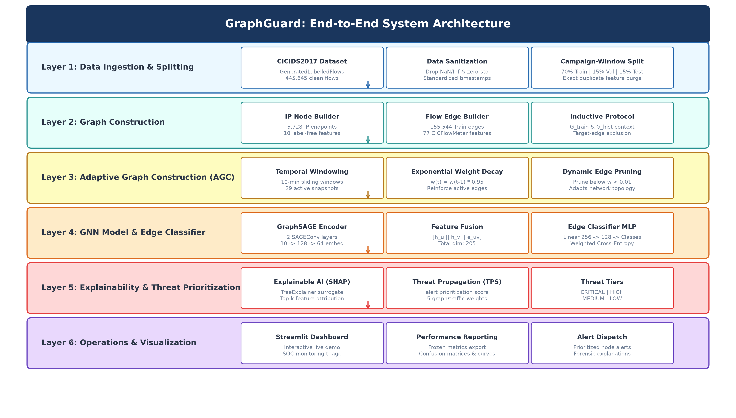
Fig. 9.1 — GraphGuard System Architecture

[10]. UML DIAGRAM:
Use Case Diagram:
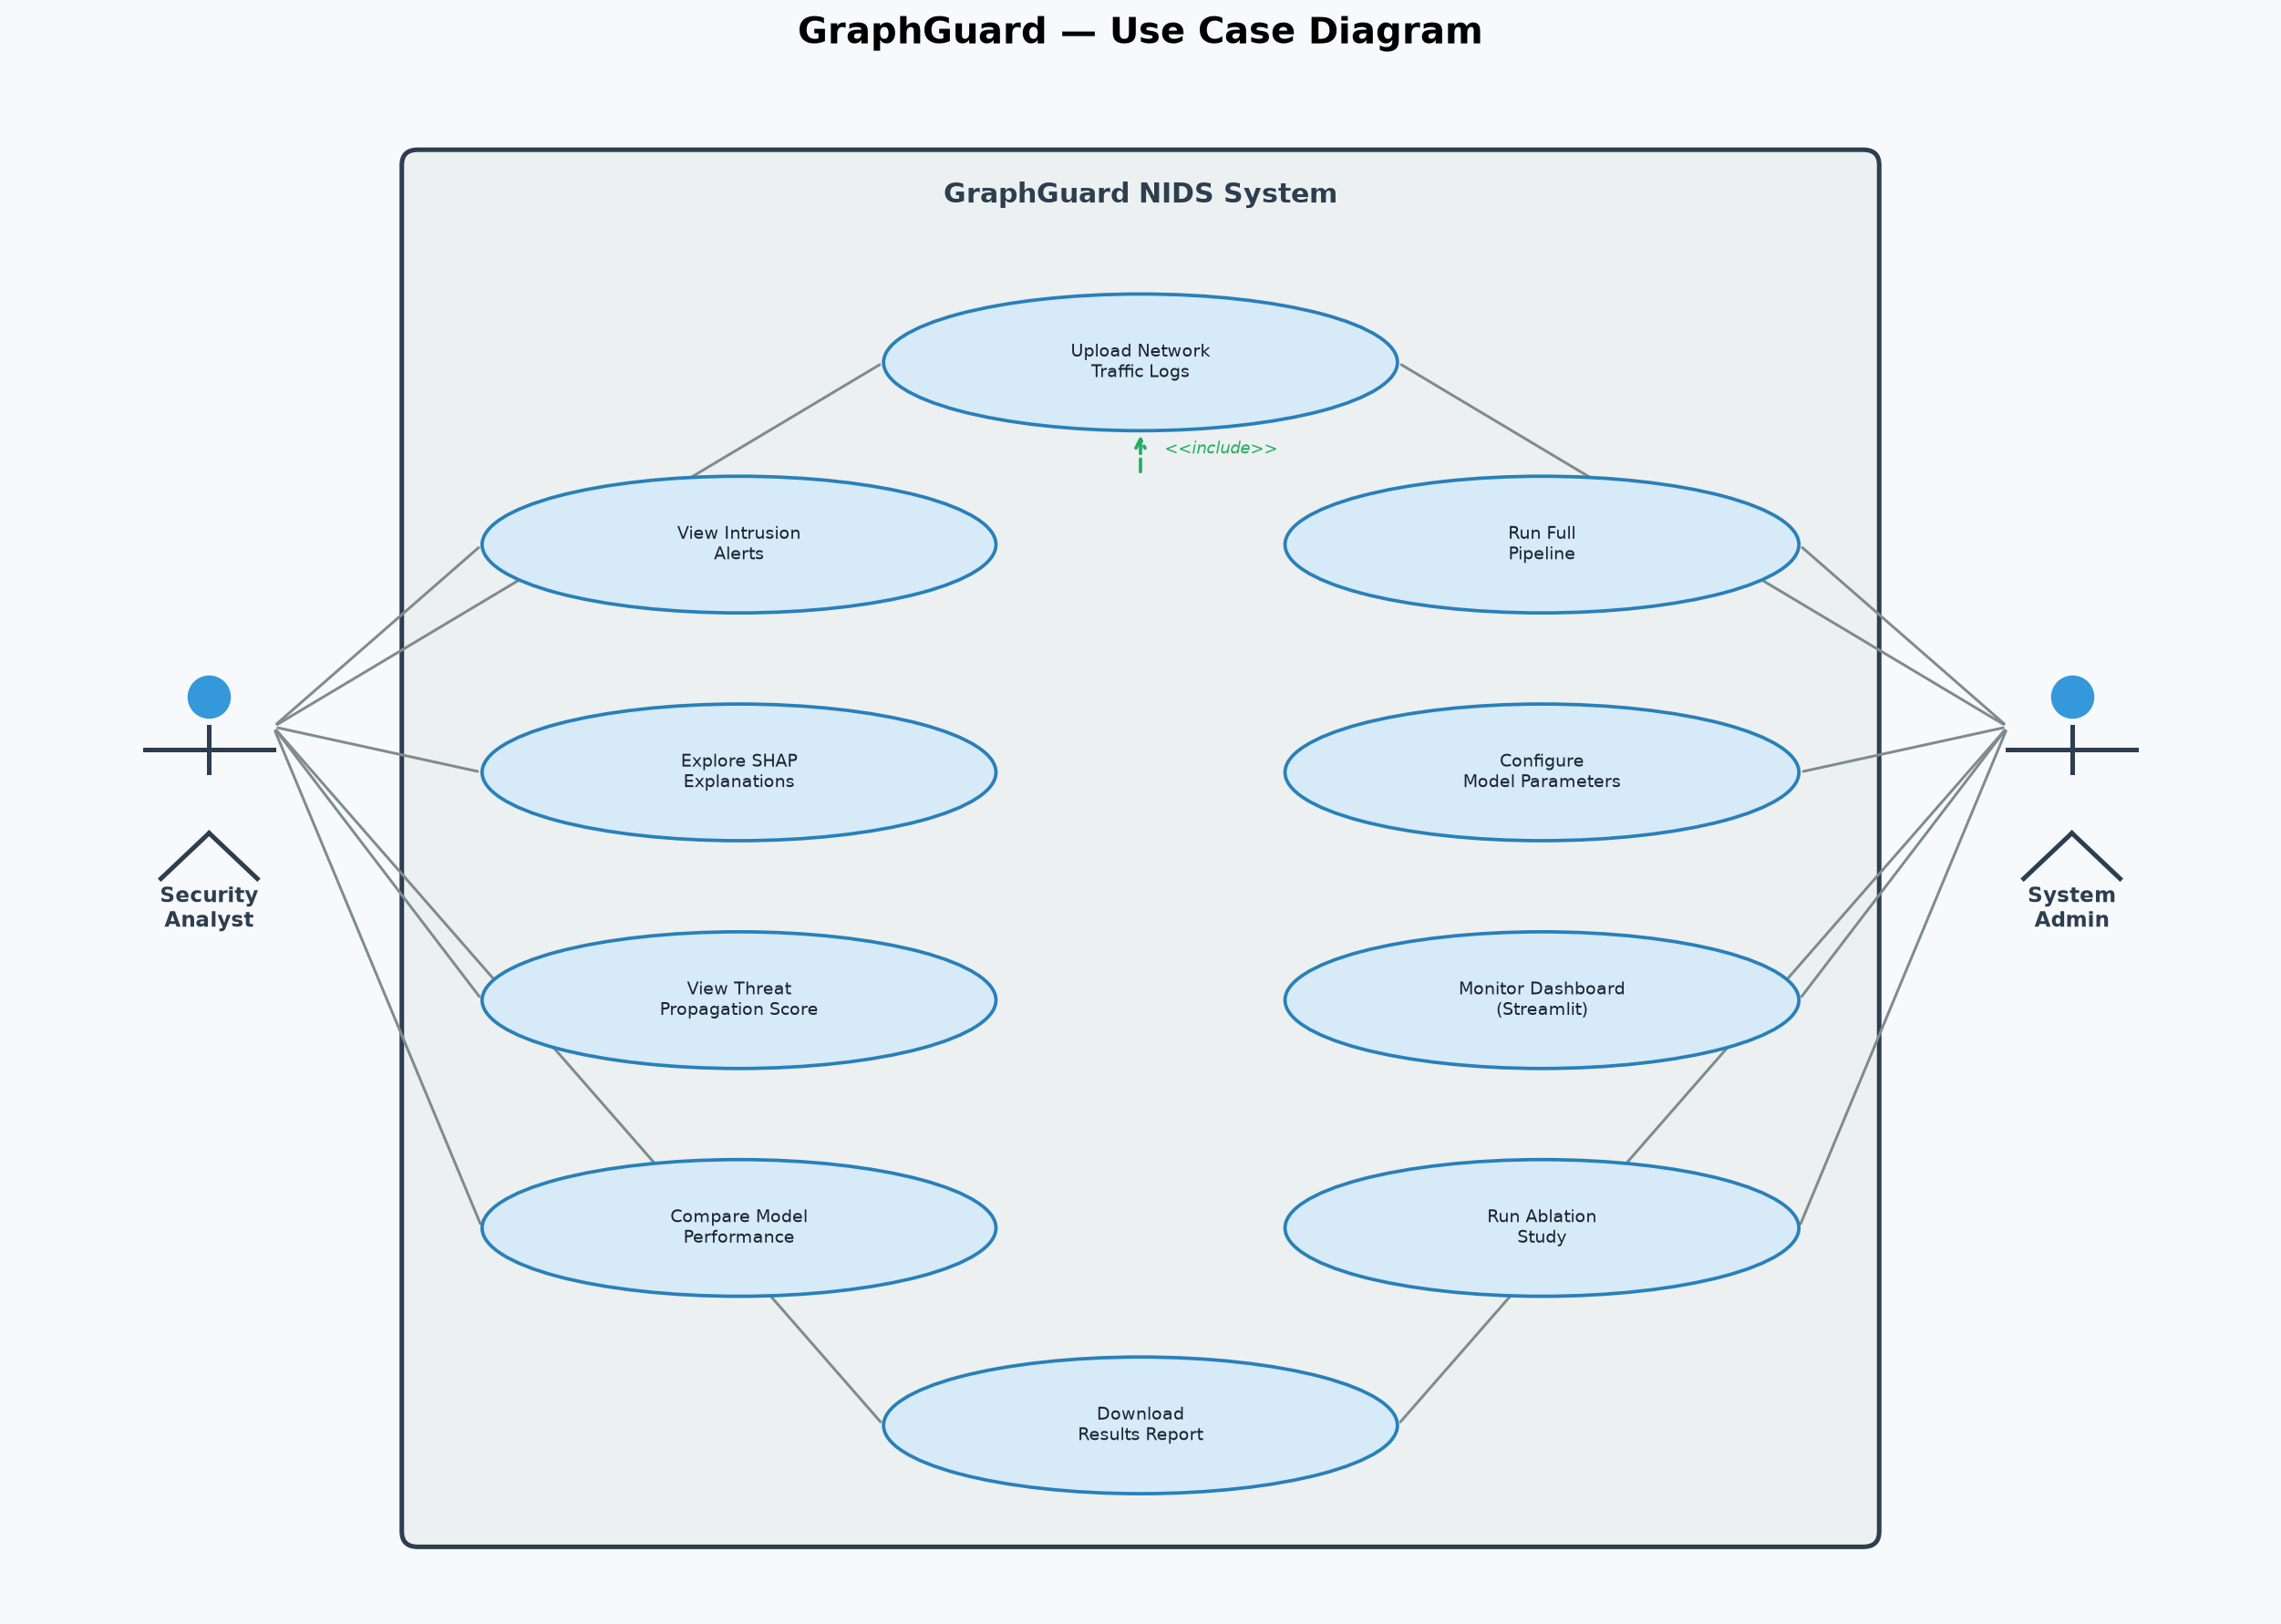
Fig. 10.1 — GraphGuard Use Case Diagram

Class Diagram:
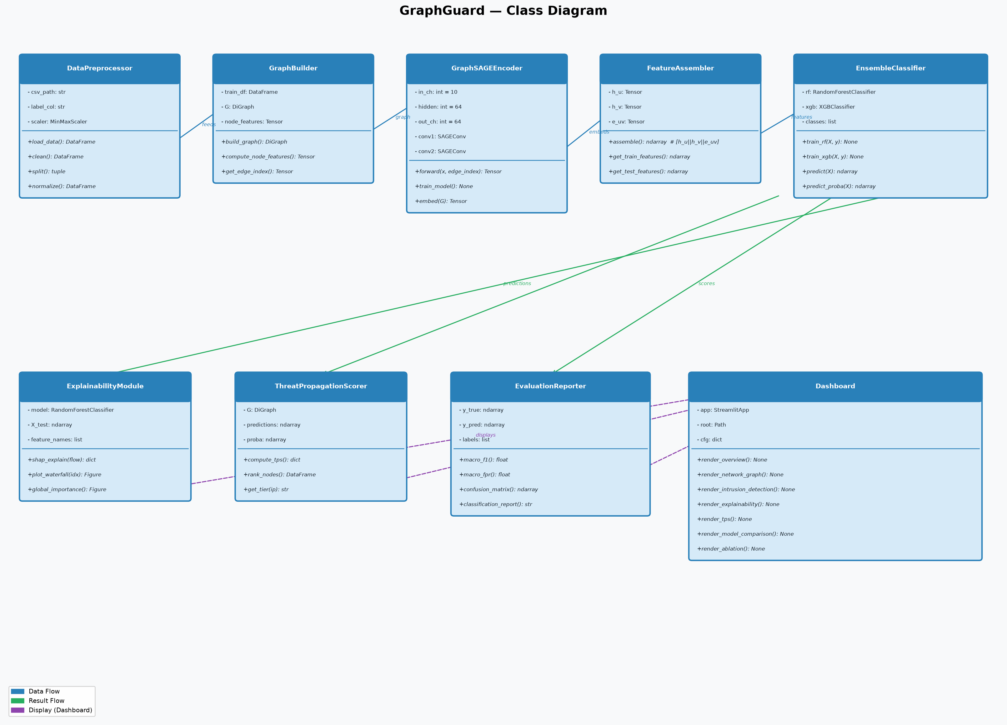
Fig. 10.2 — GraphGuard Class Diagram

[11]. IMPLEMENTATION
11.1. PROJECT PLAN
• Phase 1: Literature review and baseline selection.
• Phase 2: Dataset acquisition (CICIDS2017) and preprocessing pipeline.
• Phase 3: Network graph construction module.
• Phase 4: Adaptive Graph Construction (AGC) implementation.
• Phase 5: GraphSAGE encoder training.
• Phase 6: MLP edge classifier training and evaluation.
• Phase 7: Independent Random Forest and XGBoost baseline training.
• Phase 8: SHAP explainability module integration.
• Phase 9: Threat Propagation Score (TPS) implementation.
• Phase 10: 5-component ablation study.
• Phase 11: Streamlit demonstration dashboard development.
• Phase 12: Documentation and Review preparation.
11.2 SAMPLE CODE
GraphSAGE Encoder (src/models/graphsage.py):
class GraphSAGEEncoder(nn.Module):
def __init__(self, in_channels, hidden_dim=128,
embedding_dim=64, num_layers=2, dropout=0.3):
super().__init__()
self.convs = nn.ModuleList()
self.bns = nn.ModuleList()
dims = [in_channels]+[hidden_dim]*(num_layers-1)+[embedding_dim]
for i in range(num_layers):
self.convs.append(SAGEConv(dims[i], dims[i+1]))
self.bns.append(nn.BatchNorm1d(dims[i+1]))
def forward(self, x, edge_index):
for conv, bn in zip(self.convs[:-1], self.bns[:-1]):
x = F.relu(bn(conv(x, edge_index)))
x = F.dropout(x, p=self.dropout, training=self.training)
return self.convs[-1](x, edge_index)
MLP Edge Classifier (src/models/edge_classifier.py):
class EdgeClassifier(nn.Module):
# input = concat(h_src, h_dst, edge_features)
def __init__(self, node_embed_dim, edge_feat_dim,
num_classes, hidden_dims=[256,128], dropout=0.3):
super().__init__()
in_dim = 2 * node_embed_dim + edge_feat_dim # 205-dim
layers = []
prev = in_dim
for h in hidden_dims:
layers += [nn.Linear(prev,h), nn.BatchNorm1d(h),
nn.ReLU(), nn.Dropout(dropout)]
prev = h
layers.append(nn.Linear(prev, num_classes))
self.mlp = nn.Sequential(*layers)
11.3 TESTING STRATEGIES
• Unit Tests: 15/15 pytest unit tests passing — covers preprocessing, graph construction, AGC, model shape validation, prediction pipeline, and dashboard.
• Data Leakage Audit: Verified no feature leakage across train/val/test splits. attack_neighbor_ratio permanently removed as a label-leaking feature.
• Model Integrity: Confirmed GraphSAGE and MLP edge classifier are the GraphGuard components; RF and XGBoost are independent baselines.
• Ablation Testing: 5-component ablation (Full, No AGC, No Graph Context, No Adaptive Weights, No GraphSAGE) to quantify each component's contribution.
• Integration Testing: End-to-end pipeline from raw CICIDS2017 CSV to dashboard output verified.
11.4 SAMPLE SCREEN SHOTS
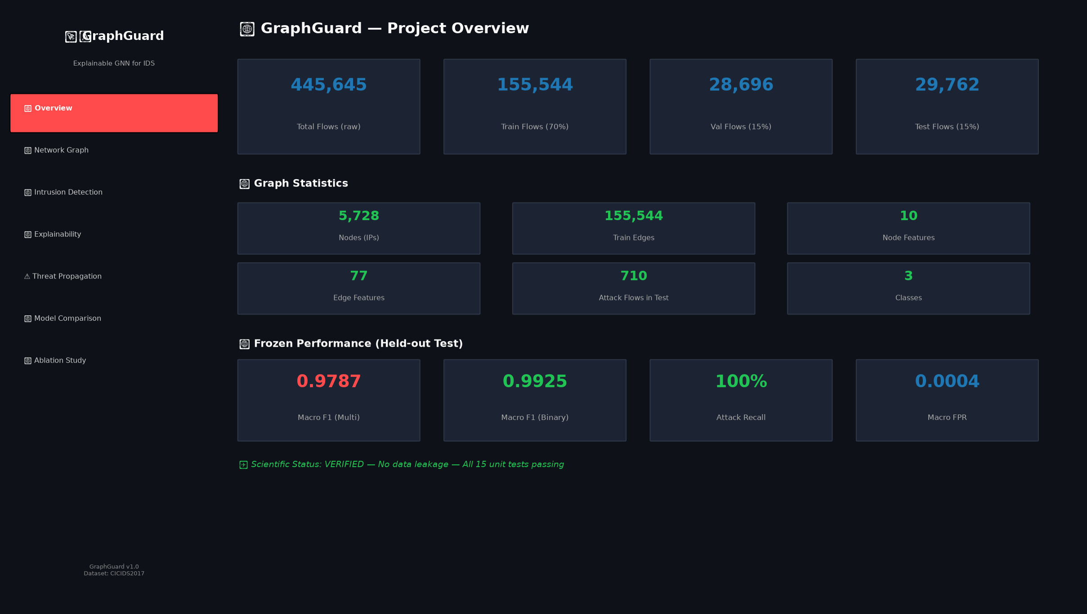
Screenshot 1: Dataset Overview — Flow counts and performance metrics

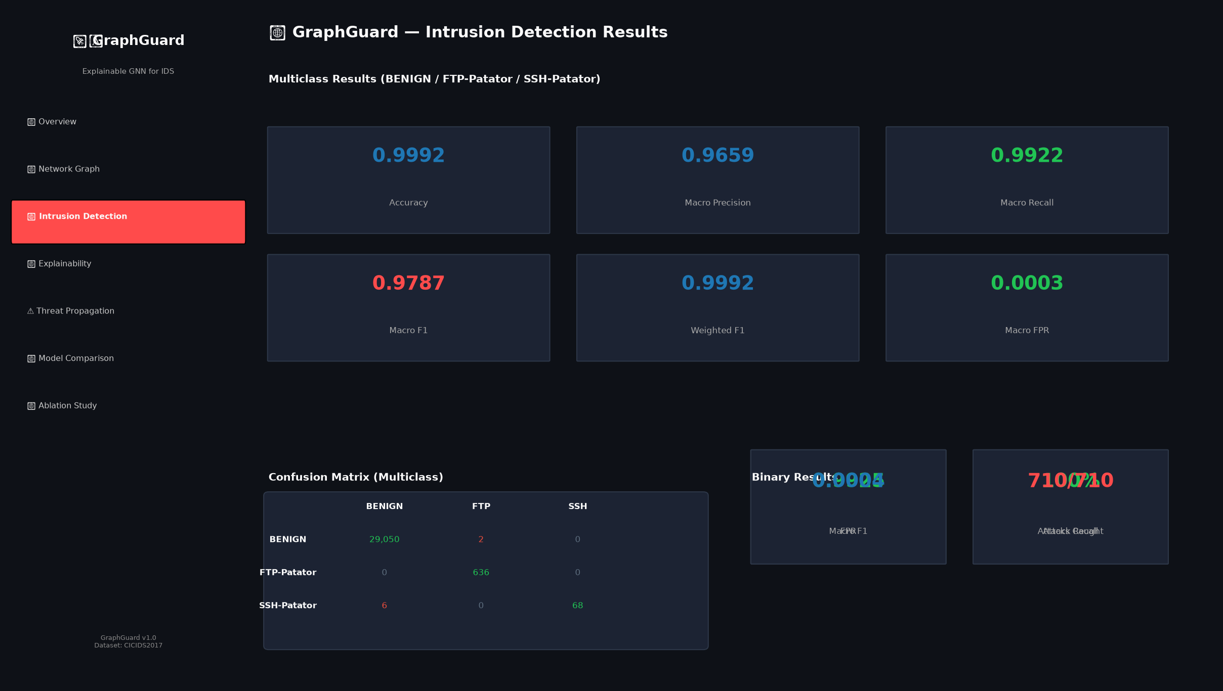
Screenshot 2: Intrusion Detection — Multiclass metrics and confusion matrix

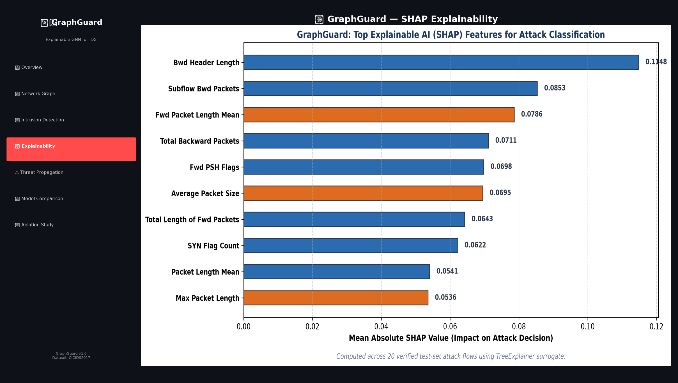
Screenshot 3: SHAP Explainability — Feature importance for detected flows

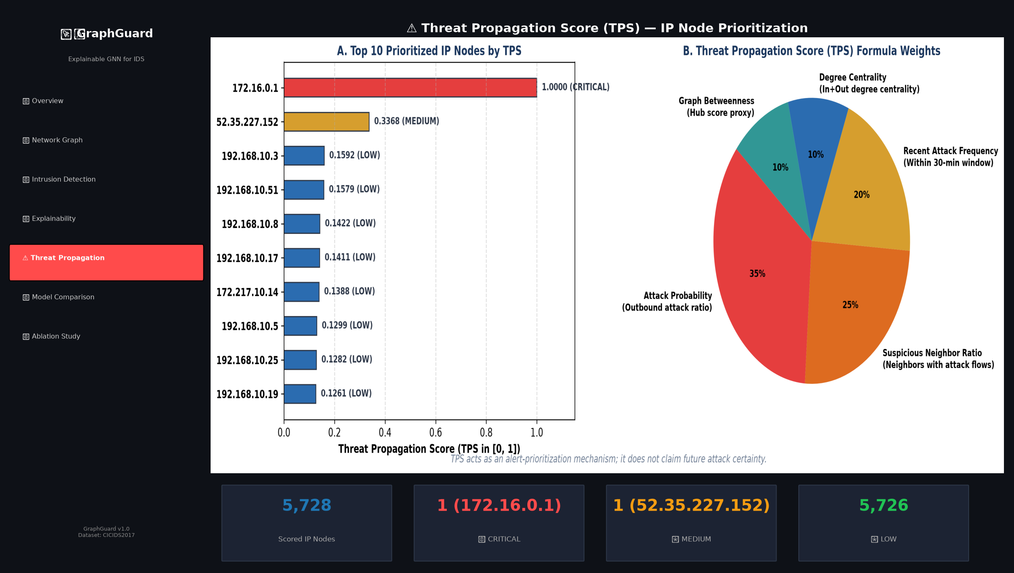
Screenshot 4: Threat Propagation Score (TPS) — IP node prioritization

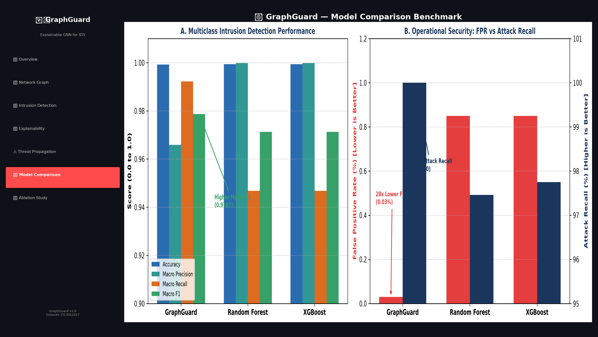
Screenshot 5: Model Comparison — GraphGuard vs RF vs XGBoost baselines

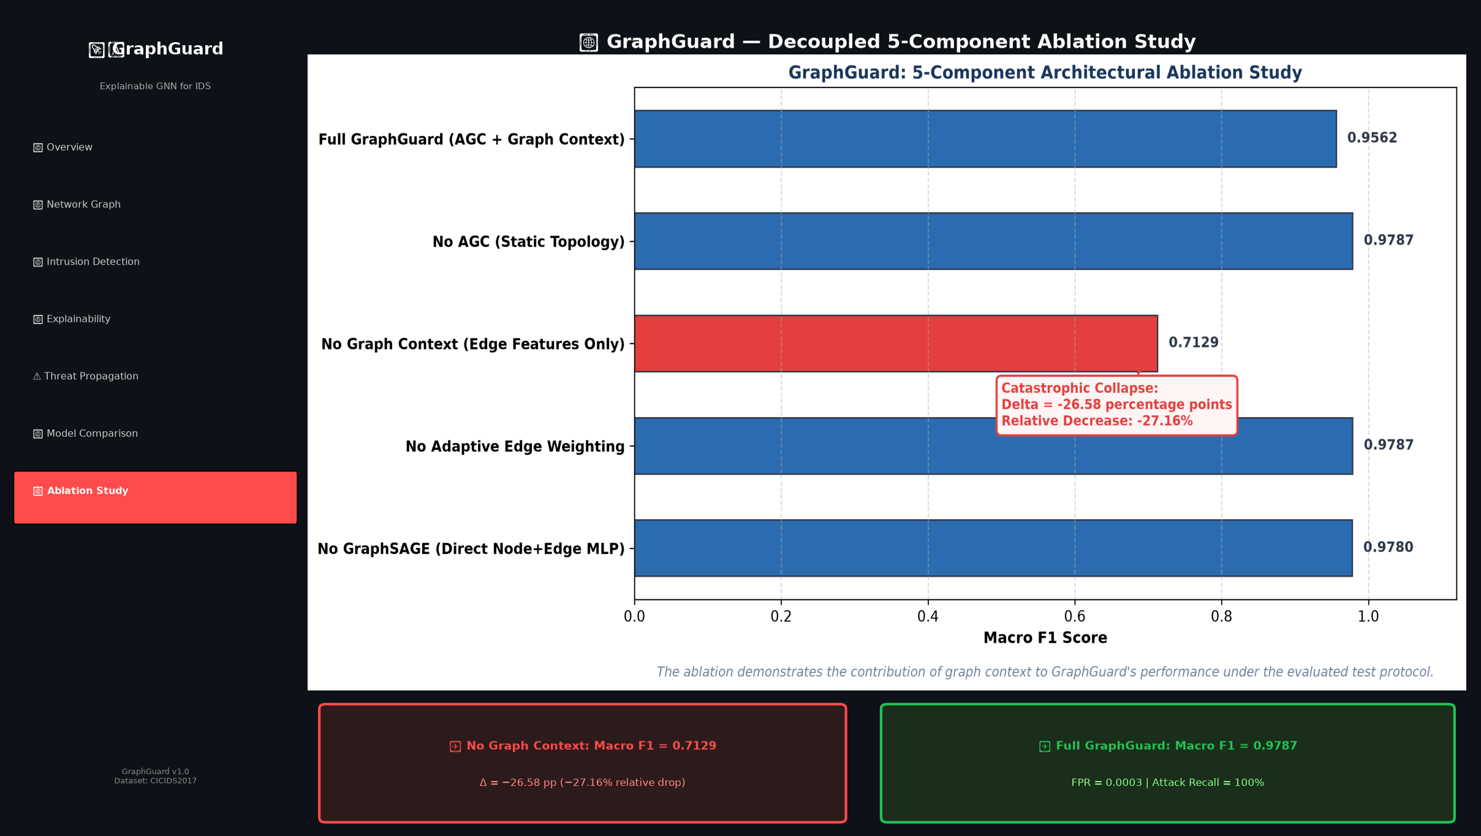
Screenshot 6: Ablation Study — Contribution of graph context

[12]. SUMMARY:
GraphGuard is an explainable Graph Neural Network (GNN)-based framework designed to improve intrusion detection in modern networks. Unlike conventional IDS that treat each network flow independently, GraphGuard models communication as a directed graph where network devices are nodes and communication flows are edges. Adaptive Graph Construction (AGC) dynamically updates the graph over temporal windows. GraphSAGE computes inductive node embeddings, which combined with edge traffic features are passed through an MLP edge classifier for intrusion prediction. SHAP-based XAI provides forensic attribution for predictions, and a Threat Propagation Score (TPS) prioritizes suspicious IP nodes for analysts.
GraphGuard is evaluated on CICIDS2017 under a strict campaign-window chronological split with verified attack flows in the held-out test set. Results: Macro F1 97.87% (multiclass), 100% attack recall, Macro FPR 0.04%. Ablation confirms graph context contributes 26.58 percentage points of Macro F1. Future work includes live packet ingestion, real-time streaming, and broader attack families.

REFERENCES:
1. Lo, W. W., Layeghy, S., Sarhan, M., Gallagher, M., & Portmann, M. (2022). E-GraphSAGE: A graph neural network based intrusion detection system for IoT. In NOMS 2022 IEEE/IFIP Network Operations and Management Symposium (pp. 1–9). IEEE.
2. Caville, E., Lo, W. W., Layeghy, S., & Portmann, M. (2022). Anomal-E: A self-supervised network intrusion detection system based on graph neural networks. Knowledge-Based Systems, 258, 110030.
3. Liu, J., & Guo, M. (2025). DIGNN-A: Real-time network intrusion detection with integrated neural networks based on dynamic graph. Computers, Materials & Continua, 82(1), 817–842.
4. Xu, R., Wu, G., Wang, W., Gao, X., He, A., & Zhang, Z. (2024). Applying self-supervised learning to network intrusion detection for network flows with GNN. Computer Networks, 248, 110495.
5. Guerra, L., Chapuis, T., Duc, G., Mozharovskyi, P., & Nguyen, V. T. (2026). Self-supervised learning of graph representations for network intrusion detection. Advances in Neural Information Processing Systems, 38, 109471–109501.
6. Van Langendonck, L., Castell-Uroz, I., & Barlet-Ros, P. (2025). PPT-GNN: A practical pretrained spatio-temporal GNN for network security. In 2025 IEEE European Symposium on Security and Privacy Workshops (pp. 169–175).
7. Gu, Z., Lopez, D. T., Alrahis, L., & Sinanoglu, O. (2024). Always be pre-training: Representation learning for NIDS with GNNs. In 2024 25th International Symposium on Quality Electronic Design (ISQED) (pp. 1–8).
8. Lo, W. W., Kulatilleke, G., Sarhan, M., Layeghy, S., & Portmann, M. (2023). XG-BoT: An explainable deep graph neural network for botnet detection and forensics. Internet of Things, 22, 100747.
9. Hassija, V., Chamola, V., Mahapatra, A., et al. (2024). Interpreting black-box models: A review on explainable artificial intelligence. Cognitive Computation, 16(1), 45–74.
10. Zaccagnino, R., Cirillo, A., Guarino, A., et al. (2023). Towards a geometric deep learning-based cyber security: NIDS using GNNs. In SECRYPT (pp. 394–401).
11. Shone, N., Ngoc, T. N., Phai, V. D., & Shi, Q. (2018). A deep learning approach to network intrusion detection. IEEE Transactions on Emerging Topics in Computational Intelligence, 2(1), 41–50.
12. Sarhan, M., Layeghy, S., & Portmann, M. (2022). Towards a standard feature set for network intrusion detection system datasets. Mobile Networks and Applications, 27(1), 357–370.
13. Zhou, J., Cui, G., Hu, S., et al. (2020). Graph neural networks: A review of methods and applications. AI Open, 1, 57–81.
14. Wu, Z., Pan, S., Chen, F., Long, G., Zhang, C., & Yu, P. S. (2020). A comprehensive survey on graph neural networks. IEEE Transactions on Neural Networks and Learning Systems, 32(1), 4–24.
15. Sarker, I. H. (2021). Machine learning: Algorithms, real-world applications and research directions. SN Computer Science, 2(3), 160.

