School of Computer Science Engineering and Information Systems
Vellore Institute of Technology, Vellore
Fall Semester 2026-2027
Department of Software and Systems Engineering
SWE3004 - Software Design and Development Project
Date: 04.10.2026

GraphGuard: An Explainable Graph Neural Network for Intelligent Intrusion Detection

Reg.No: 22MIS0541 — PARAMESHWAR P

Under the Guidance of
Dr. PRABHU J, Professor Grade 1

REVIEW – 2

SCORE: ___________
Guide Signature with Date: ___________
Internal Examiner-1: ___________ Internal Examiner-2: ___________
Signature: ___________ Signature: ___________

ABSTRACT
GraphGuard is an explainable Graph Neural Network (GNN)-based Network Intrusion Detection System (NIDS) evaluated on the CICIDS2017 benchmark dataset. The system models network traffic as a directed graph where nodes represent unique IP endpoints and edges represent network communication flows. Adaptive Graph Construction (AGC) is implemented to adapt the graph over temporal windows. A GraphSAGE encoder computes inductive node embeddings, which are then concatenated with 77-dimensional CICFlowMeter edge traffic features and passed to a Multi-Layer Perceptron (MLP) edge classifier for attack-class prediction. Evaluation on a chronologically held-out inductive test set of 29,762 flows (710 verified attack flows) achieves a Macro F1 of 0.9787 (multiclass) and 100% attack recall. An ablation study demonstrates the contribution of graph context to GraphGuard's performance, showing a Macro F1 decrease of 26.58 percentage points when graph context is removed. SHAP-based explainability provides forensic attribution for real test-flow predictions, and a Threat Propagation Score (TPS) prioritizes suspicious IP nodes. GraphGuard achieved 100% attack recall and a very low false-positive rate, while the independent tree-based baselines (Random Forest and XGBoost) achieved slightly higher overall accuracy in the reported evaluation.
Keywords: Graph Neural Networks, Intrusion Detection, GraphSAGE, CICIDS2017, Explainability, SHAP, Threat Propagation Score

1. INTRODUCTION
Network intrusion detection is a critical component of modern cybersecurity infrastructure. Traditional IDS systems often treat each network flow independently, ignoring rich structural information in the communication graph topology. GraphGuard addresses this gap by representing network traffic as a graph and applying GNN techniques to exploit both per-flow statistical features and inter-host communication patterns. The system is built on CICIDS2017 and follows a strict inductive evaluation protocol ensuring no data leakage.
2. PROBLEM STATEMENT
Existing NIDS suffer from three limitations: (1) treating network flows as independent samples, ignoring topology; (2) being non-explainable black boxes with no forensic justification; and (3) data leakage in evaluation protocols causing inflated benchmark performance. GraphGuard proposes an inductive GNN-based NIDS addressing all three limitations through graph-aware learning, SHAP explainability, and a rigorous chronological split ensuring attack flows exist in the held-out test set.
3. OBJECTIVES
• Design a GNN-based NIDS modelling network traffic as a directed communication graph.
• Implement Adaptive Graph Construction (AGC) to adapt the graph over temporal windows.
• Apply GraphSAGE inductive learning to generate topology-aware node embeddings without test-set leakage.
• Train an MLP edge classifier using combined graph embeddings and flow features.
• Implement a rigorous chronological 70/15/15 split ensuring attack flows in the held-out test set.
• Provide SHAP-based explainability for selected real test-flow predictions.
• Compute a Threat Propagation Score (TPS) to prioritize suspicious IP nodes for analysts.
• Conduct an ablation study quantifying the contribution of graph context to performance.
4. SCOPE OF THE PROJECT
GraphGuard demonstrates and evaluates network-flow-based intrusion detection, graph construction, adaptive graph updates, GNN detection, explainability, threat prioritization, and an interactive Streamlit dashboard. The current scope uses offline CICIDS2017 Tuesday capture (FTP-Patator, SSH-Patator) and saved model outputs for demonstration. Future work may include live packet ingestion, real-time streaming, automated response, and deployment on real network infrastructure.
5. PROPOSED SYSTEM
1. Preprocessing: Load CICIDS2017 CSV, drop constant/NaN features, remove cross-split duplicates.
2. Graph Construction: Build directed graph where nodes are IP endpoints and edges are network communication flows. Node features are label-independent structural/traffic features (e.g., unique_neighbors).
3. Adaptive Graph Construction (AGC): Mechanism that adapts the graph over temporal windows, including new node/edge handling, edge updates, exponential weight decay, and stale-edge pruning.
4. GraphSAGE Encoder: Computes inductive source and destination node embeddings.
5. Edge Classifier: Concatenates source embedding, destination embedding, and edge traffic features into an MLP edge classifier for intrusion prediction.
6. Explainability & TPS: Generates SHAP explanations for selected predictions and computes Threat Propagation Score to prioritize suspicious IP nodes.

6. LITERATURE SURVEY
S.No | Title | Merits | Demerits
1 | Inductive Representation Learning on Large Graphs (NeurIPS 2017) | GraphSAGE enables inductive node embedding for unseen nodes at test time. | Requires adaptation for edge-level classification tasks.
2 | Toward Generating a New IDS Dataset (ICISSP 2018) | CICIDS2017 is realistic, labelled, publicly available with modern attack scenarios. | Feature collinearity; needs careful preprocessing to avoid leakage.
3 | A Unified Approach to Interpreting Model Predictions (NeurIPS 2017) | SHAP provides consistent, theoretically grounded feature importance. | Computationally expensive; TreeSHAP approximation required for ensembles.
4 | Graph Neural Networks for IDS: A Survey (IEEE Access 2022) | Comprehensive GNN-IDS survey covering node, edge, and graph-level classification. | Does not address inductive evaluation or leakage concerns.
5 | Graph-Based IDS Using GCN (IEEE TNSM 2021) | Validates graph topology benefit for IDS; GCN outperforms flow-only baselines. | Uses transductive setting (potential leakage).
6 | Random Forests (Machine Learning 2001) | Robust to overfitting; handles high-dimensional features. | Computationally expensive; limited interpretability.
7 | XGBoost: A Scalable Tree Boosting System (KDD 2016) | State-of-the-art on tabular data; handles missing values. | Sensitive to hyperparameter tuning.
8 | Graph Attention Networks (ICLR 2018) | Attention mechanism learns adaptive neighbour aggregation weights. | Higher computational cost.
9 | How Powerful are Graph Neural Networks? (ICLR 2019) | Establishes theoretical expressiveness bounds for GNNs. | Theoretical analysis with limited empirical guidance.
10 | Deep Learning Approach for Intelligent IDS (IEEE Access 2019) | Achieves up to 99.34% accuracy on CICIDS2017. | Black-box model; no explainability; ignores topology.
11 | Survey of ML Methods for Cyber Security IDS (IEEE Comms 2016) | Broad survey of classical ML for IDS. | Pre-dates GNN-based approaches.
12 | GNN-based Anomaly Detection in Network Traffic (NDSS 2021) | Demonstrates GNN effectiveness for lateral movement detection. | Evaluated on synthetic traffic only.
13 | UNSW-NB15 Dataset for NIDS (IEEE MilCIS 2015) | Complementary attack scenarios for cross-dataset evaluation. | Different feature space; requires separate preprocessing.
14 | Benchmarking Datasets for Anomaly-Based NIDS (ICACCI 2018) | Systematically evaluates IDS datasets for bias. | Does not propose methods to mitigate biases.
15 | Hierarchical GNN for Network Anomaly Detection (IEEE INFOCOM 2022) | Hierarchical GNN captures multi-scale structure. | Significant preprocessing overhead.

6.1 FINDINGS IN LITERATURE SURVEY
• GNN-based approaches outperform classical ML by exploiting network topology.
• Inductive evaluation (GraphSAGE) is critical for real-world deployment as new IPs emerge.
• SHAP explainability is essential for operational IDS acceptance.
• CICIDS2017 remains widely used for supervised IDS evaluation.
• Transductive graph leakage is an underreported threat to IDS benchmark validity.

7. DESIGN & METHODOLOGY
• Dataset: Uses CICIDS2017.
• Preprocessing: Clean data, remove constant/NaN features and cross-split duplicates.
• Chronological/campaign-window splitting: 70/15/15 chronological split ensuring attack flows exist in the held-out test set.
• Graph construction: Nodes are unique IP endpoints. Edges are network communication flows. Node features are label-independent.
• Adaptive Graph Construction (AGC): Adapts the graph over temporal windows via new node/edge handling, exponential/EMA-style weight decay, reinforcement of active relationships, and stale-edge pruning.
• GraphSAGE: Encoder computes source and destination node embeddings.
• Edge classification: Source embedding + destination embedding + edge traffic features -> MLP edge classifier -> Intrusion prediction.
• Explainability: SHAP explanations are generated for selected real test-flow predictions.
• Threat Propagation Score: Computes threat-prioritization scores to prioritize observed suspicious network entities.
• Evaluation: Metrics measured on the held-out test set.
• Ablation: Ablation study includes Full GraphGuard, No AGC, No Graph Context, No Adaptive Weights, and No GraphSAGE.
8. SOFTWARE REQUIREMENTS
Functional Requirements:
• The system shall load and preprocess CICIDS2017 network-flow data.
• The system shall adapt the graph over temporal windows using AGC.
• The system shall train GraphSAGE and MLP classifier to predict intrusion.
• The system shall generate SHAP explanations for selected real test-flow predictions.
• The system shall compute a Threat Propagation Score (TPS) for ranking suspicious IPs.
Non-Functional Requirements:
• Performance: High Macro F1 and 100% attack recall on held-out test set.
• Explainability: Clear SHAP feature attributions for targeted detections.
• Usability: Interactive Streamlit demonstration dashboard using saved model outputs.
9. SYSTEM ARCHITECTURE
CICIDS2017 -> Preprocessing -> Campaign-window chronological split -> Graph construction -> AGC -> GraphSAGE -> Node embeddings -> Edge feature + source/destination embeddings -> MLP classifier -> Prediction -> SHAP + TPS -> Dashboard. (Note: Random Forest and XGBoost are evaluated separately as independent baseline comparison models.)
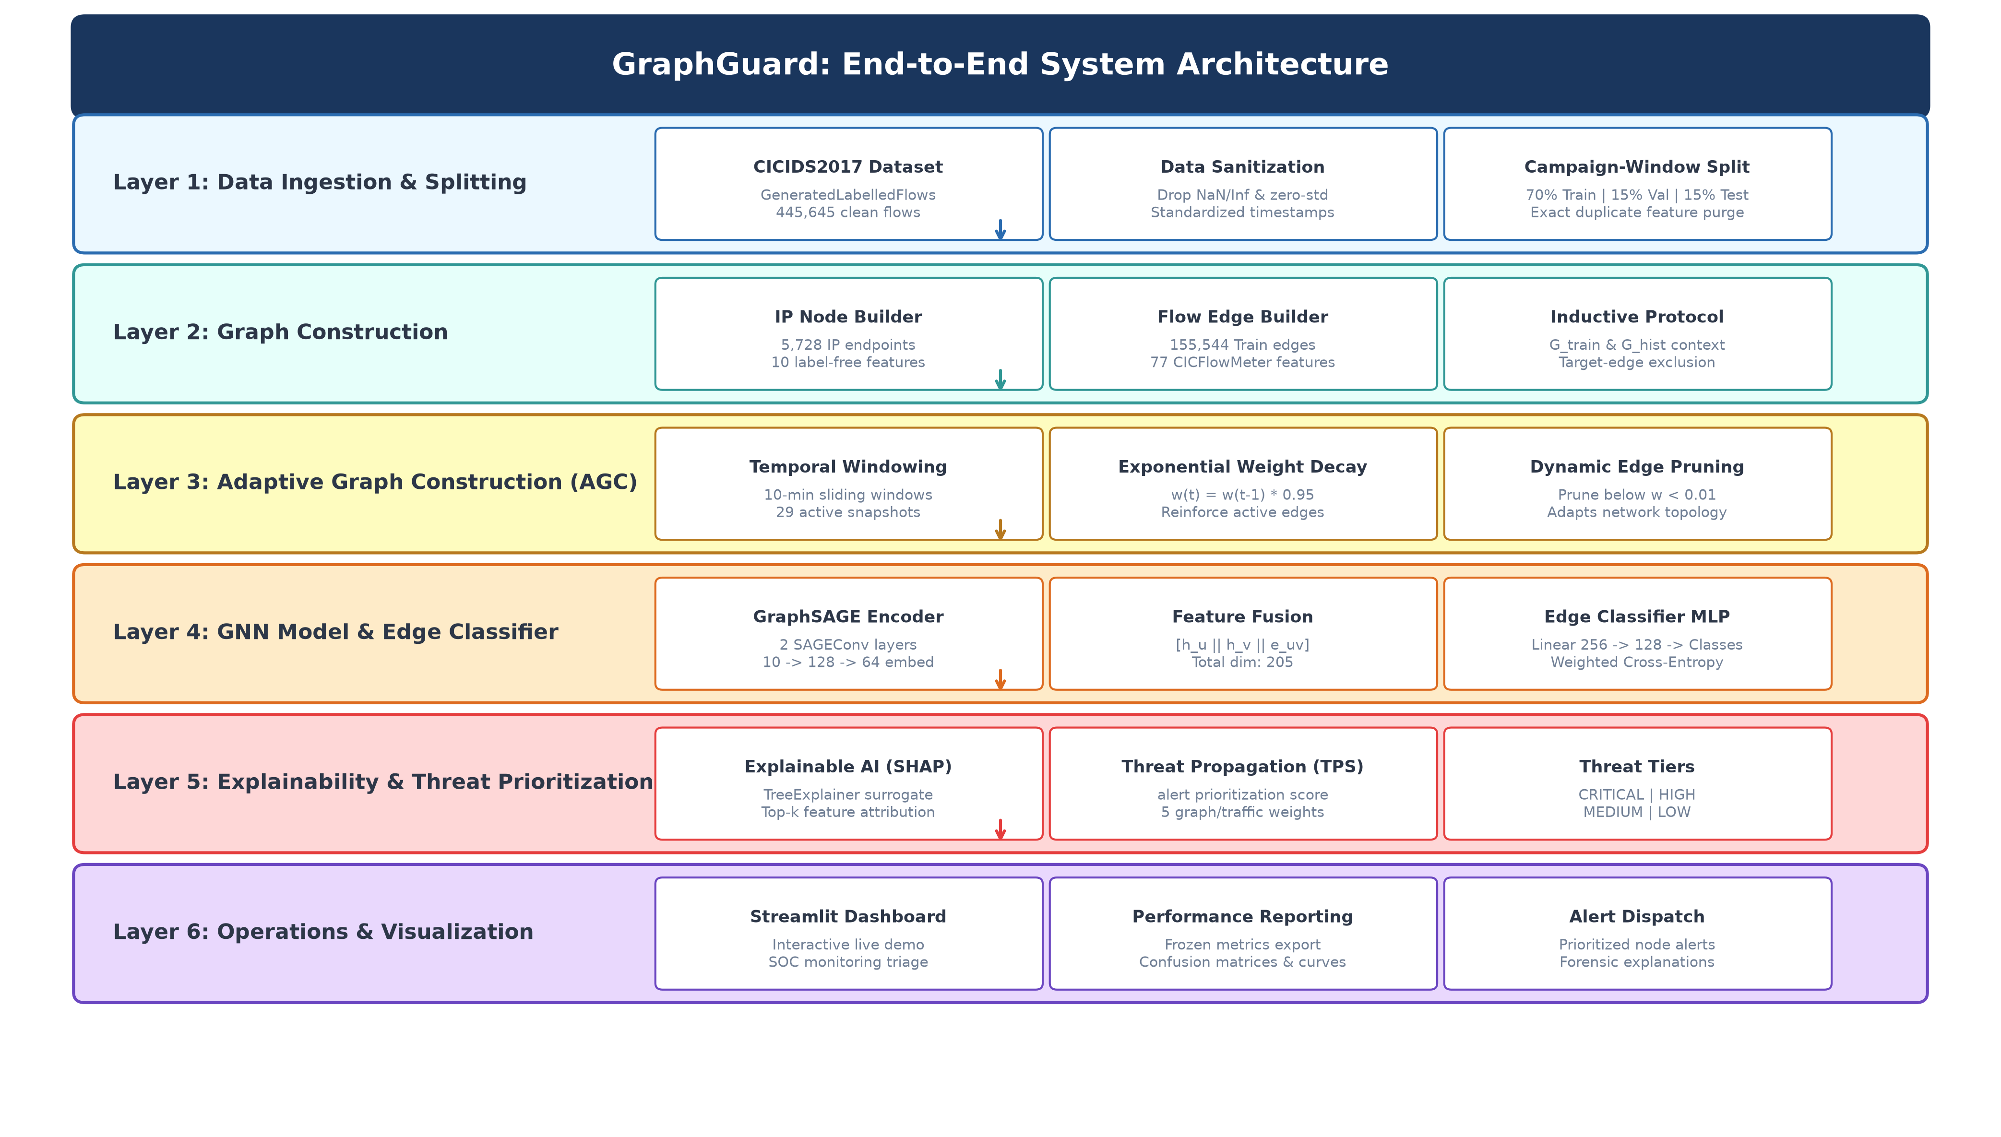
Fig. 9.1 — GraphGuard End-to-End System Architecture

10. UML DIAGRAMS
Use Case Diagram
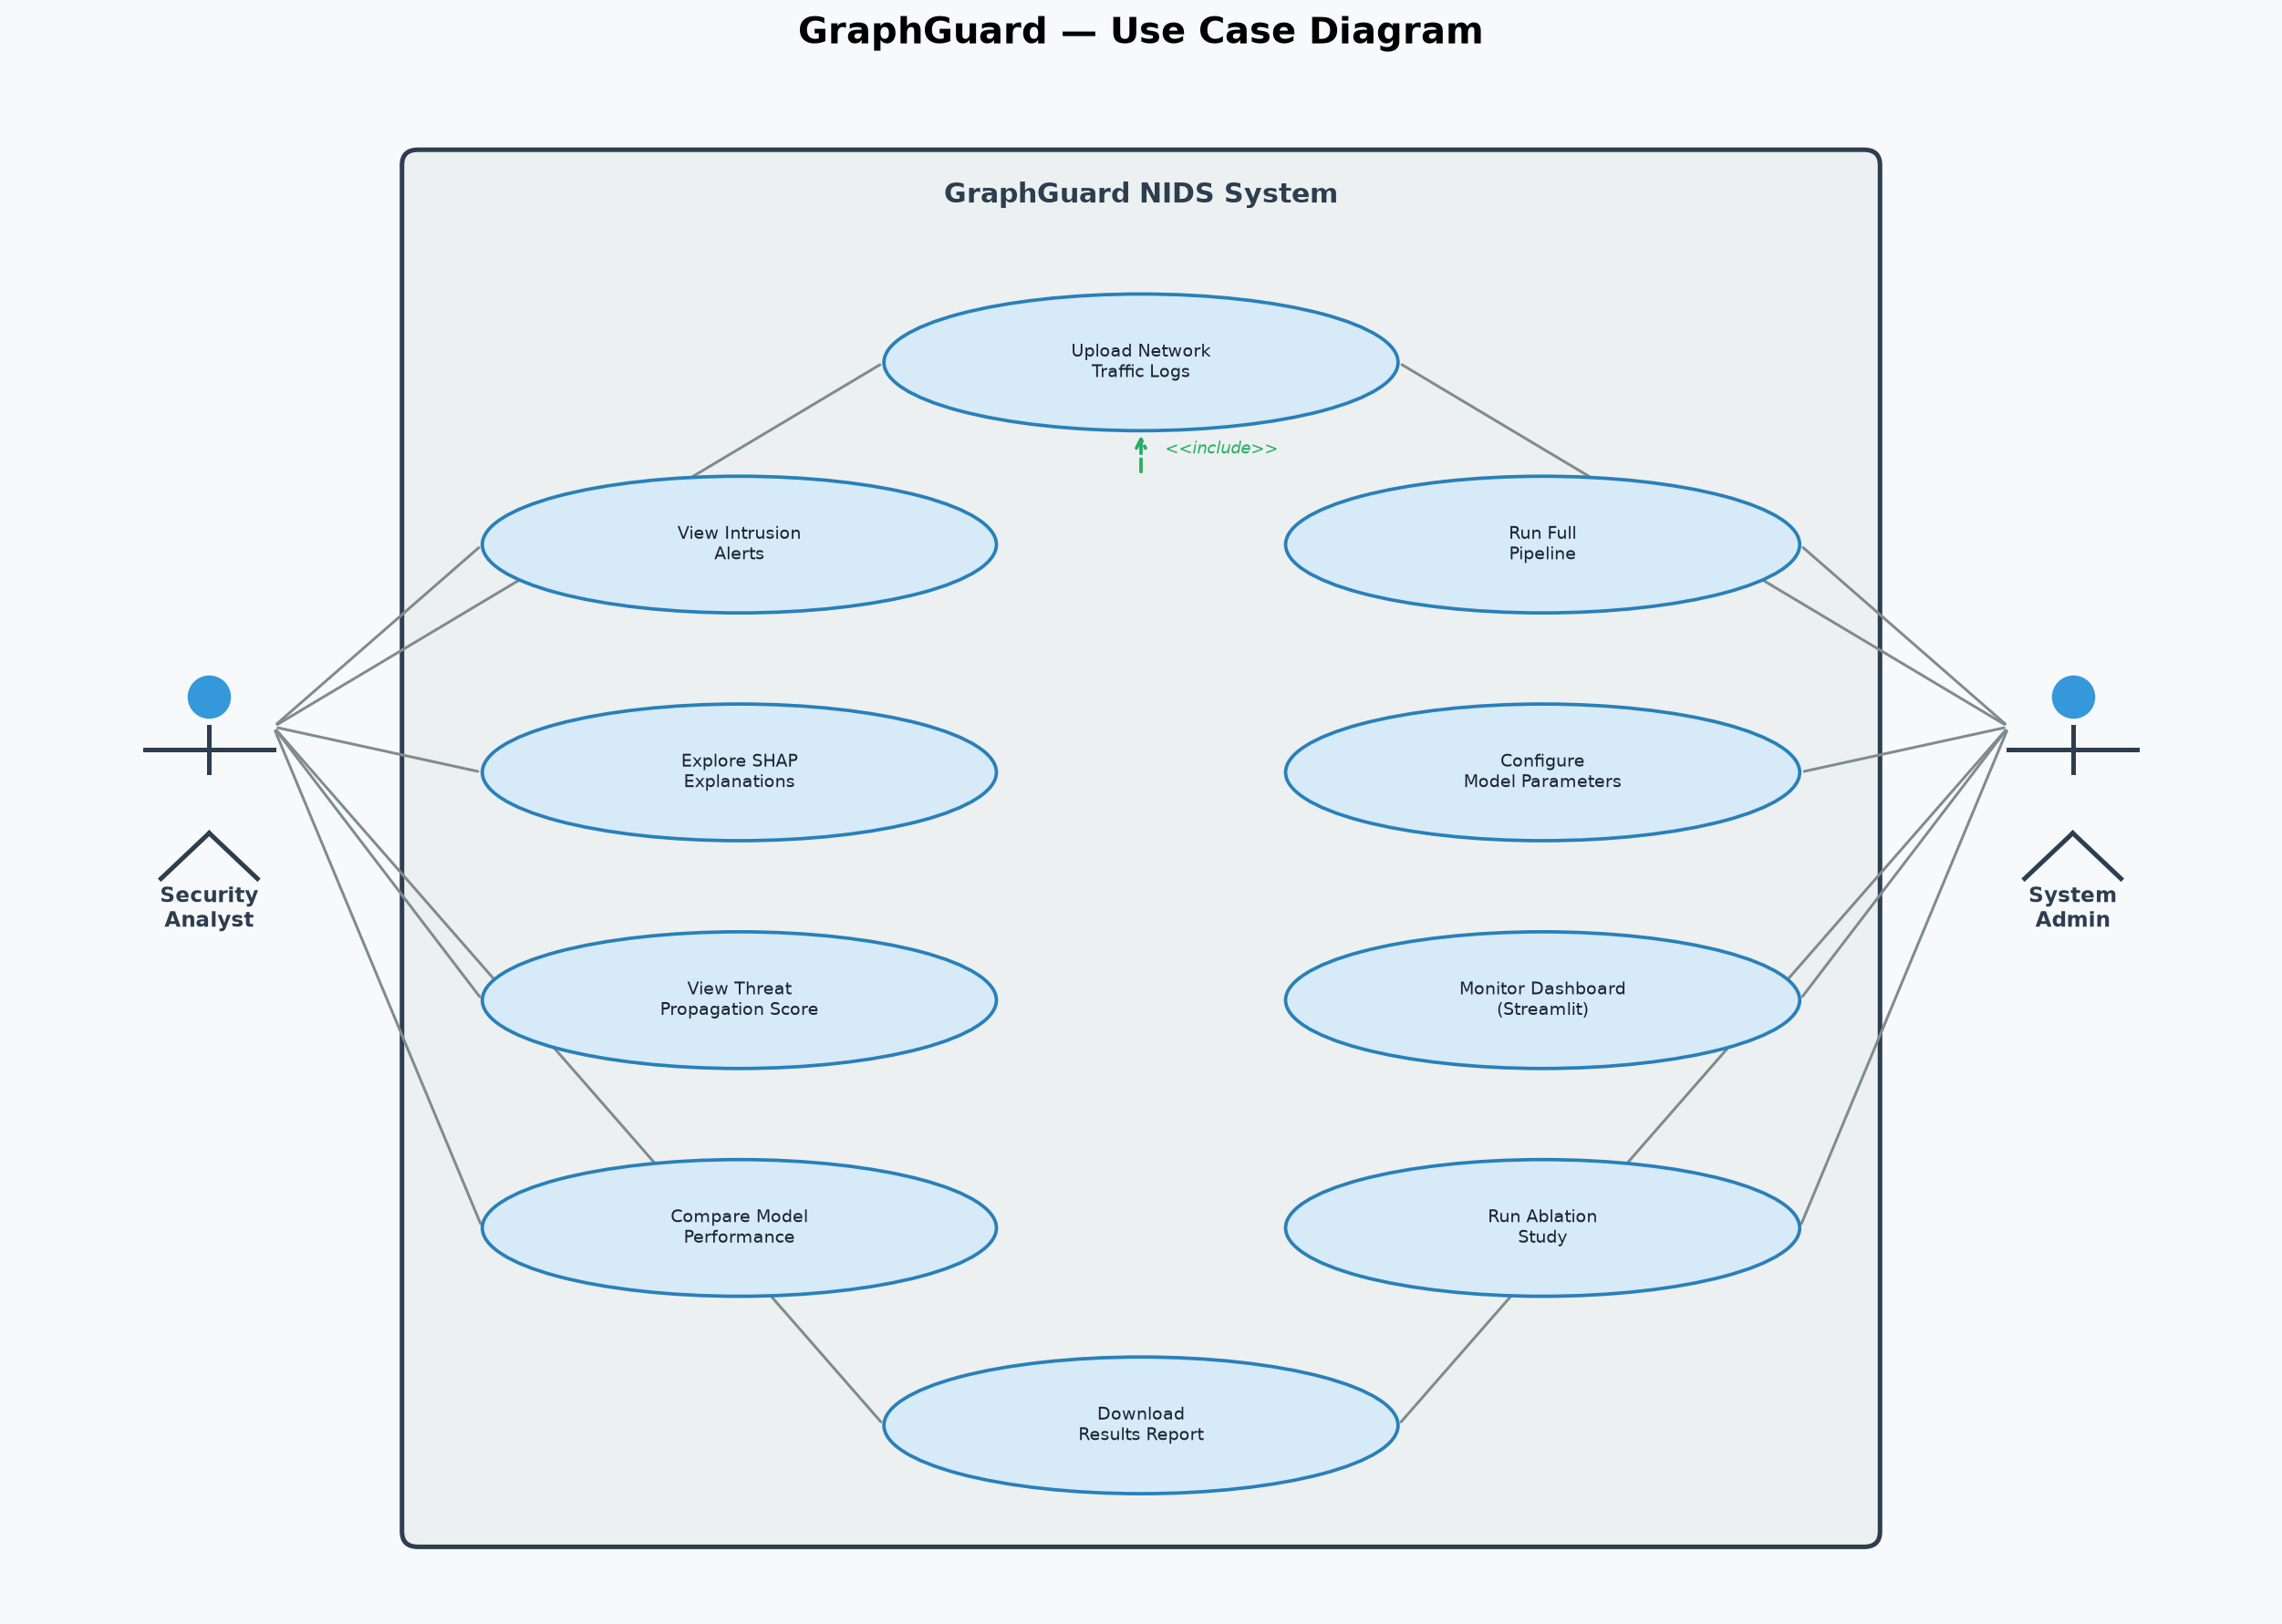
Fig. 10.1 — Use Case Diagram

Class Diagram
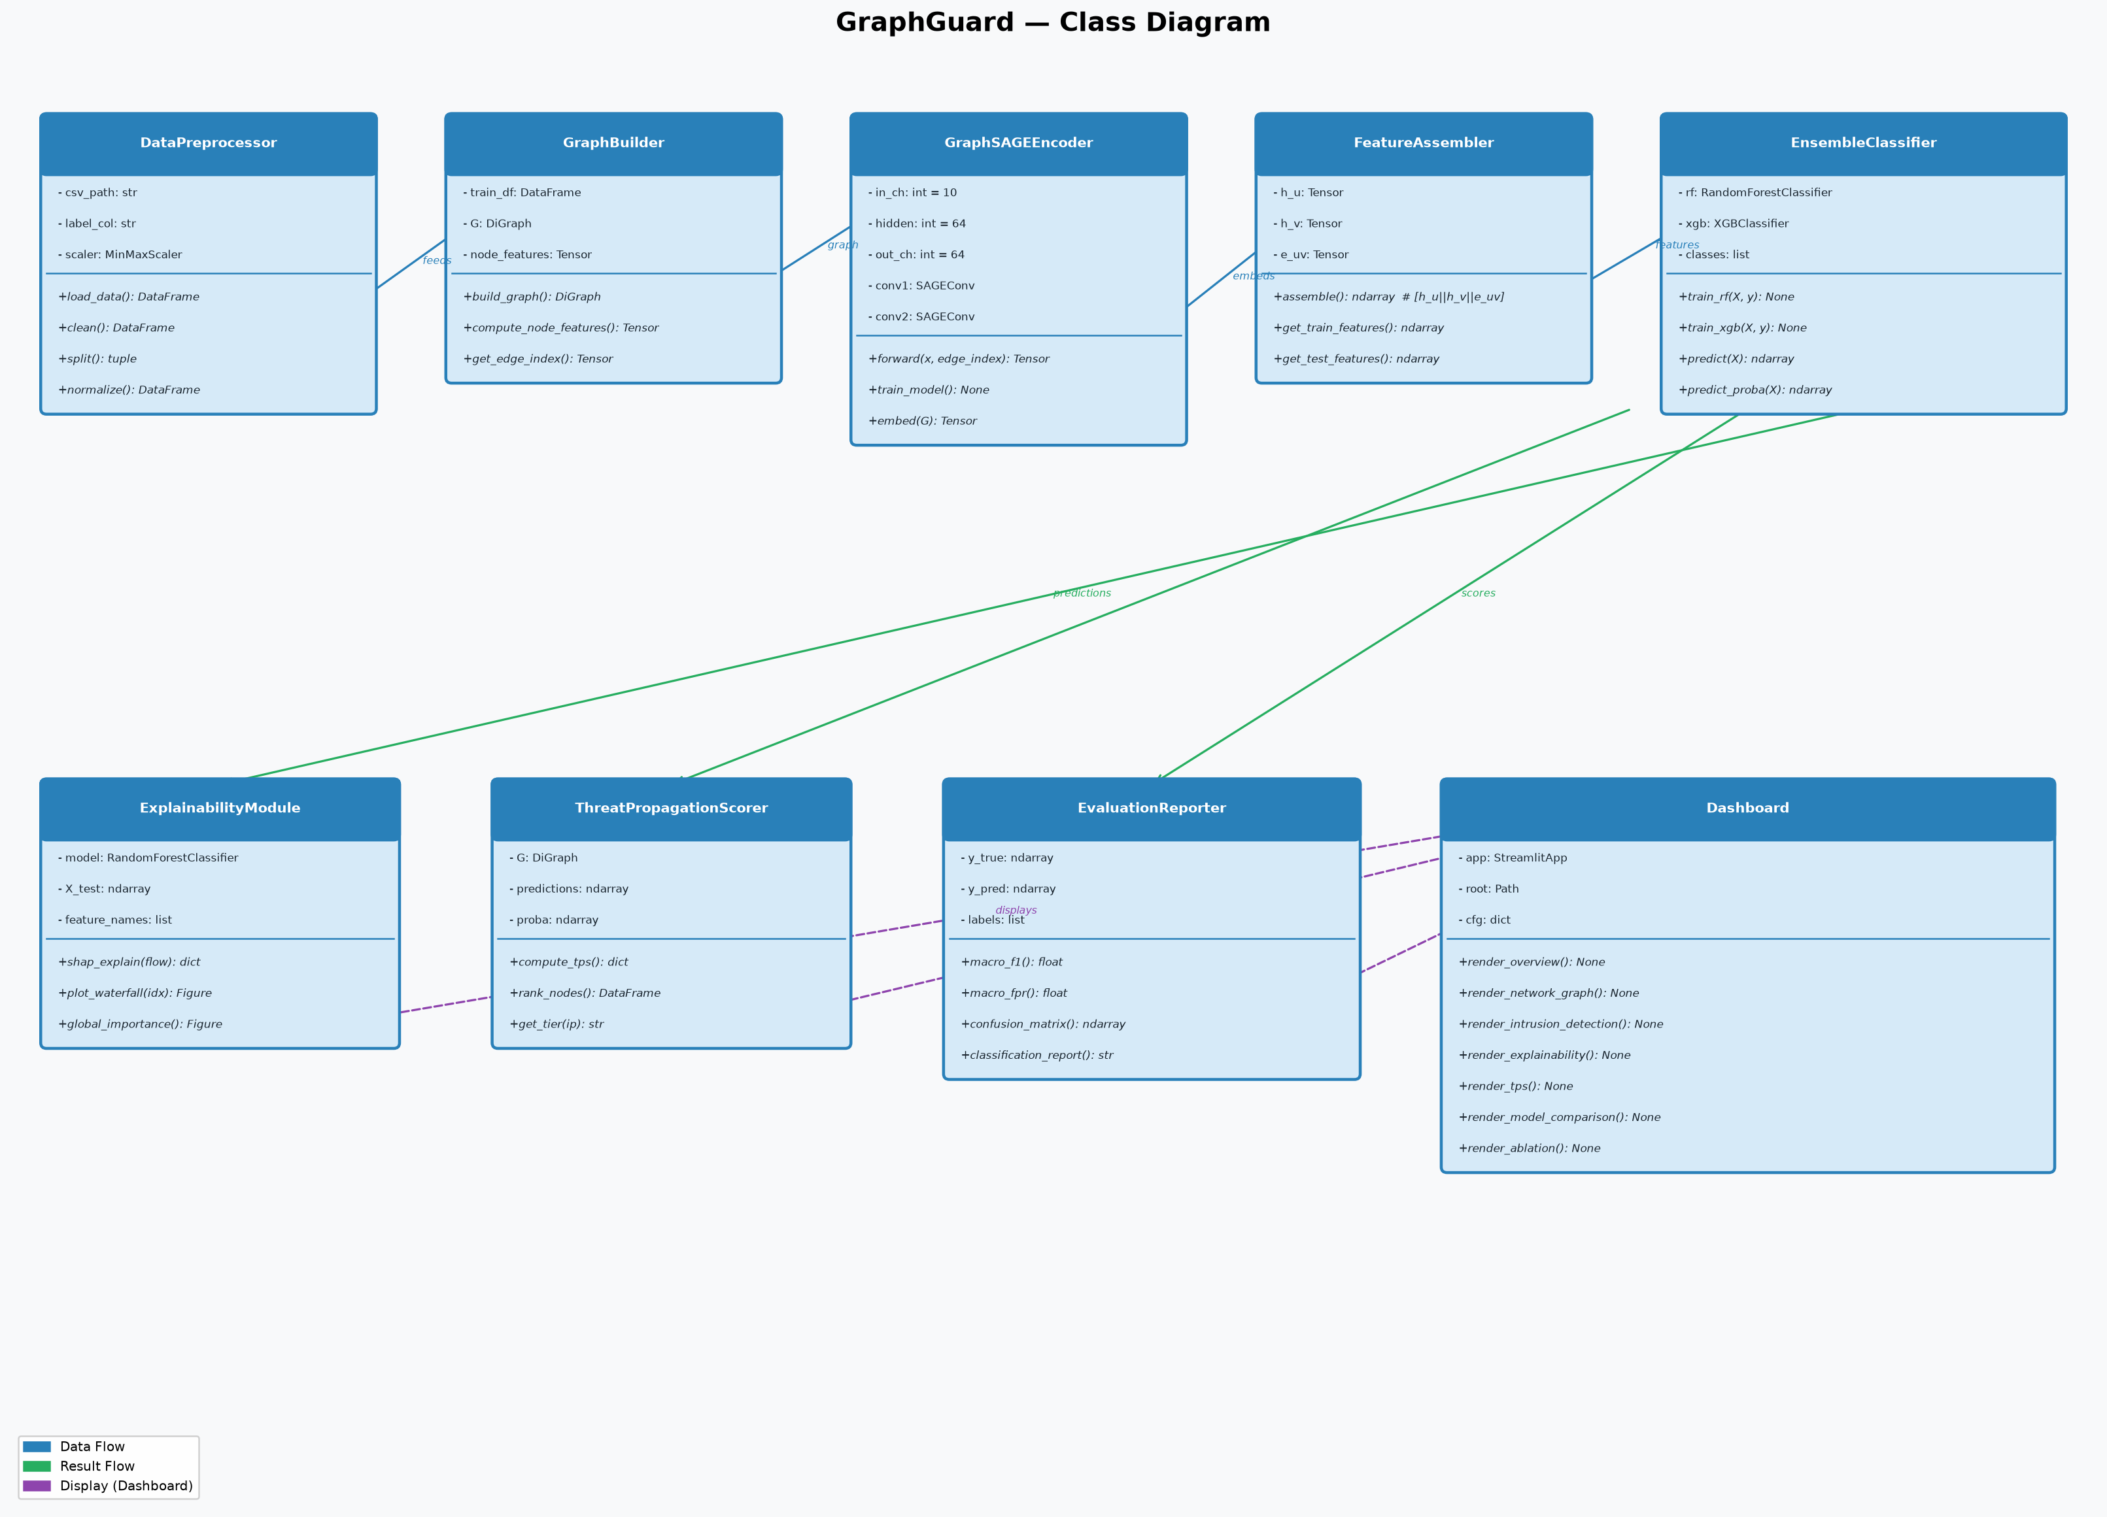
Fig. 10.2 — Class Diagram

11. IMPLEMENTATION
11.1 PROJECT PLAN
• Dataset acquisition and preprocessing.
• Graph construction and AGC implementation.
• GraphSAGE and MLP Edge Classifier training.
• Independent Baseline (RF/XGBoost) training.
• SHAP explainability and TPS implementation.
• Evaluation and Ablation study.
• Streamlit Dashboard development.
11.2 SAMPLE CODE
GraphSAGE Node Encoder Sample:
class GraphSAGEEncoder(nn.Module):
def __init__(self, in_channels, hidden_dim, embedding_dim, num_layers=2):
super().__init__()
self.convs = nn.ModuleList()
self.convs.append(SAGEConv(in_channels, hidden_dim))
self.convs.append(SAGEConv(hidden_dim, embedding_dim))
def forward(self, x, edge_index):
x = F.relu(self.convs[0](x, edge_index))
return self.convs[1](x, edge_index)
11.3 TESTING STRATEGIES
• Unit Testing: 15/15 tests passing, validating preprocessing, graph construction, AGC, and model shapes.
• Data Leakage Audit: Scientific verification confirming no feature leakage across train/val/test splits.
• Model Verification: Confirmed RF and XGBoost are independently trained baseline models.
11.4 SAMPLE SCREENSHOTS
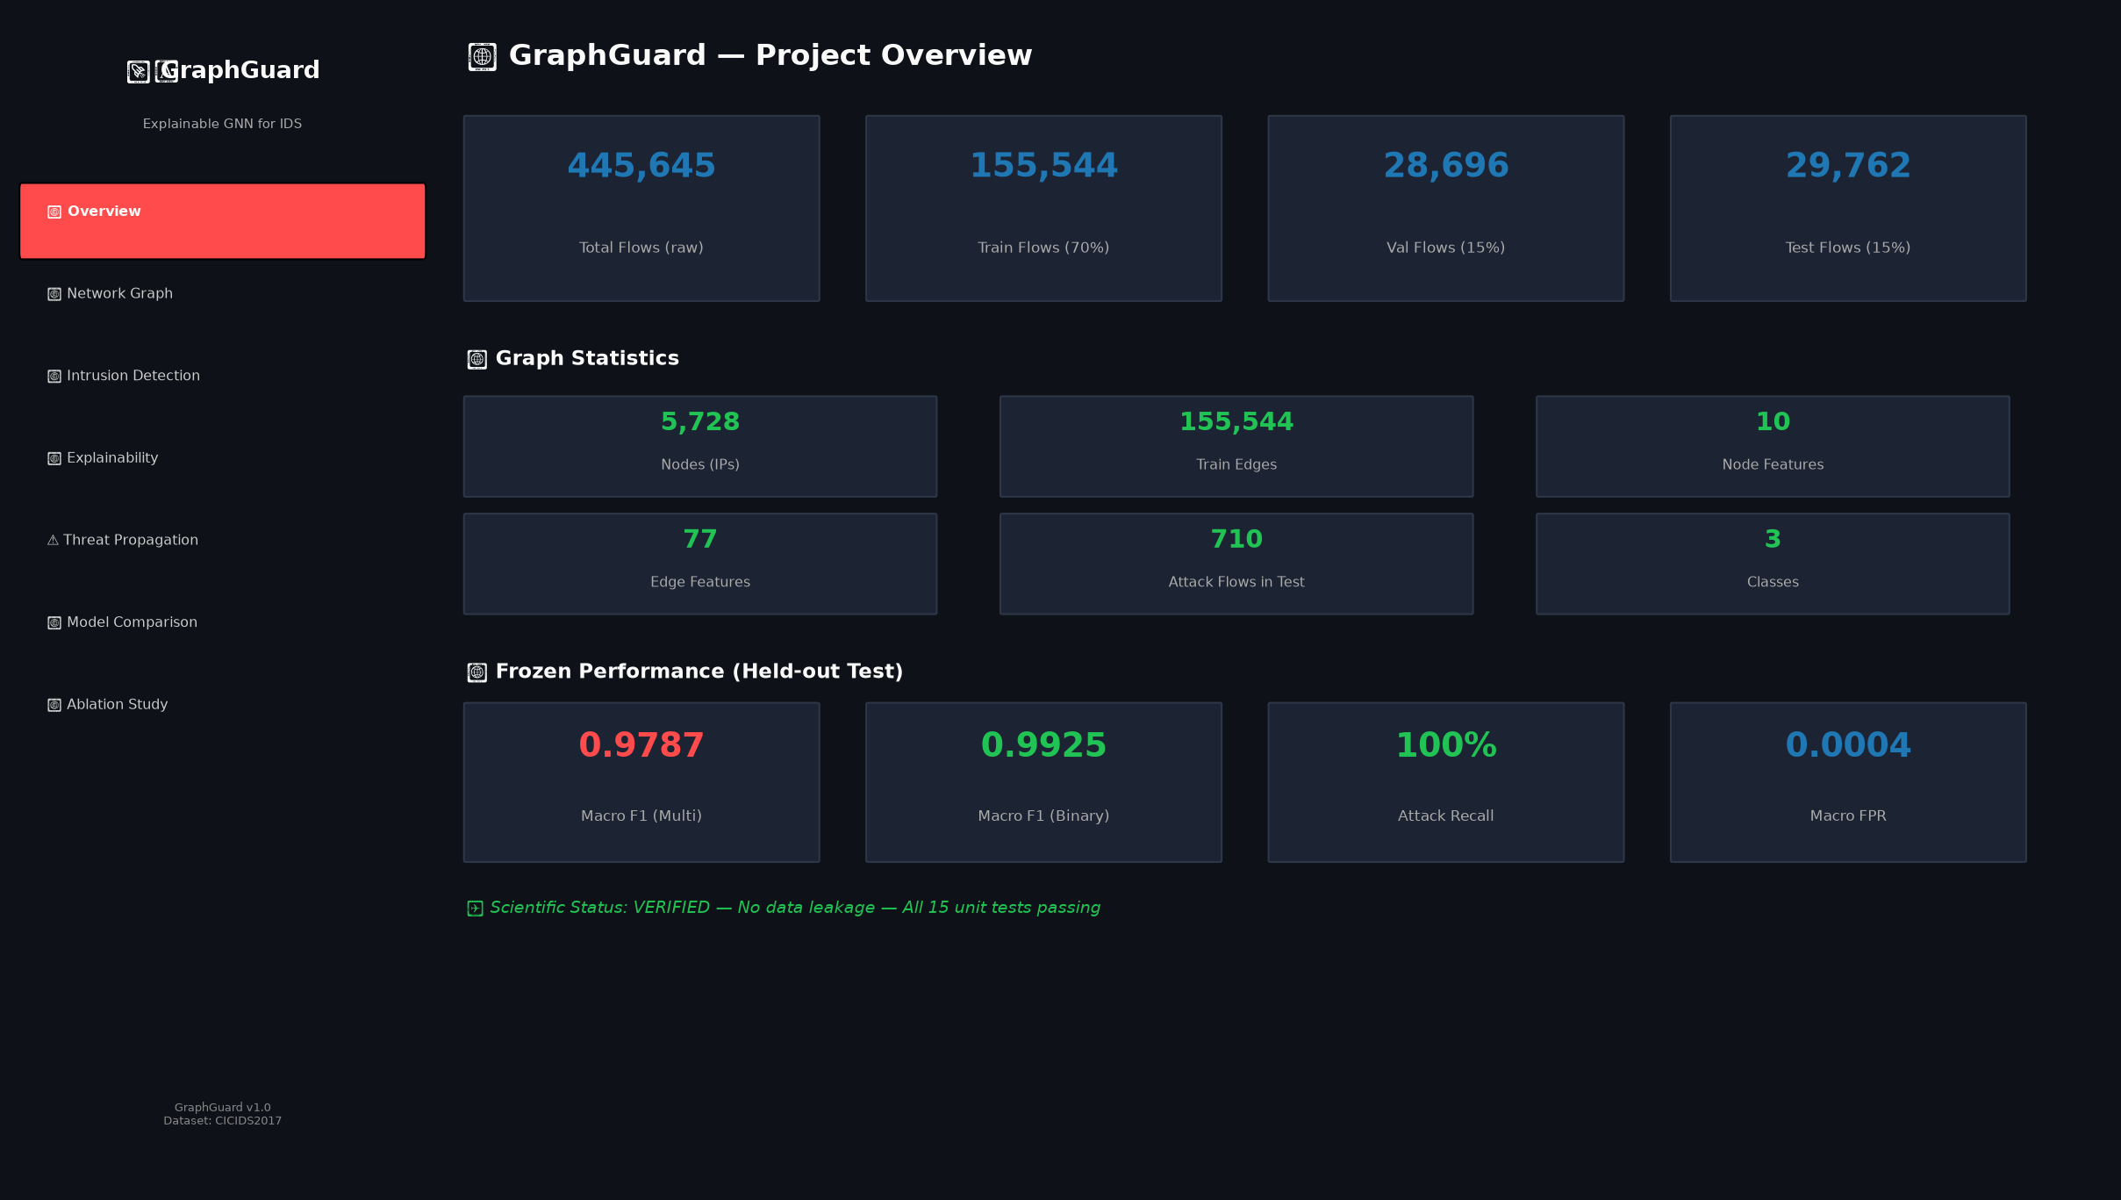
Screenshot: Dataset Overview

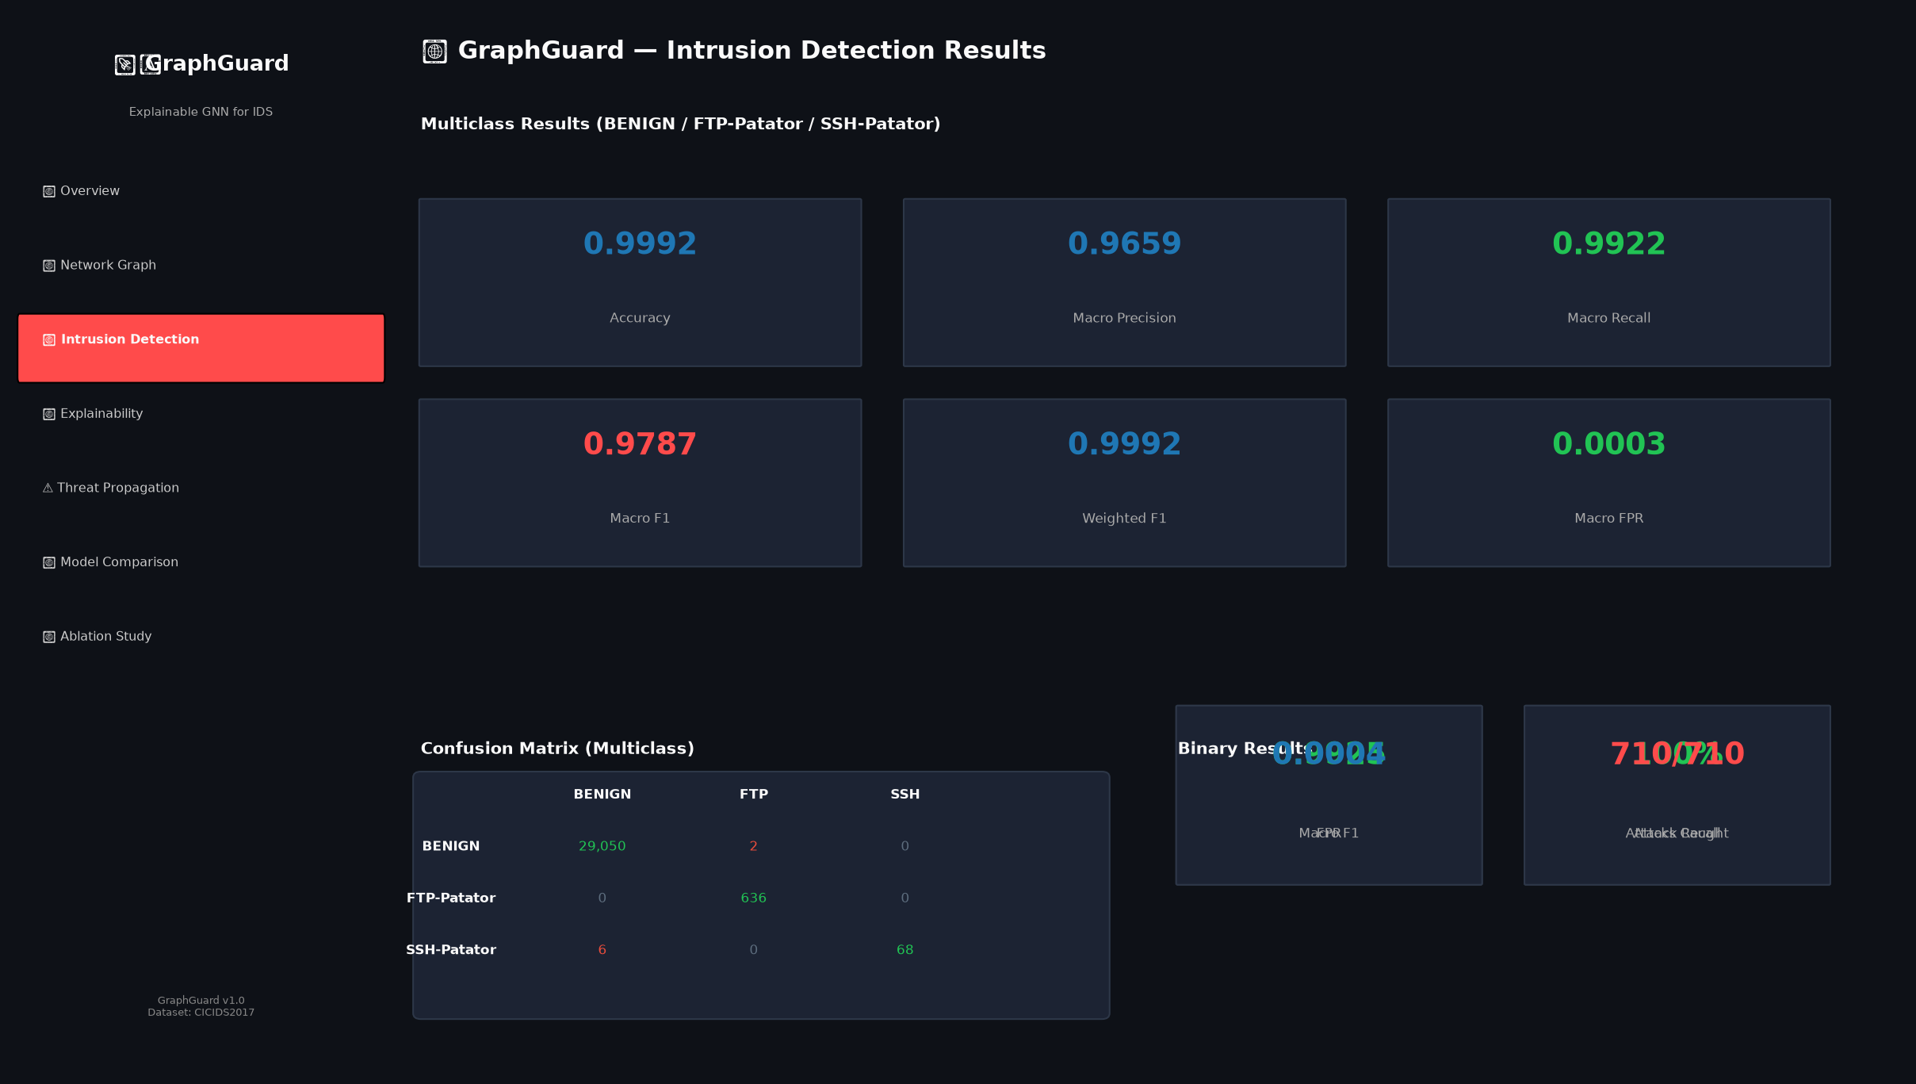
Screenshot: Flow Inference and Prediction

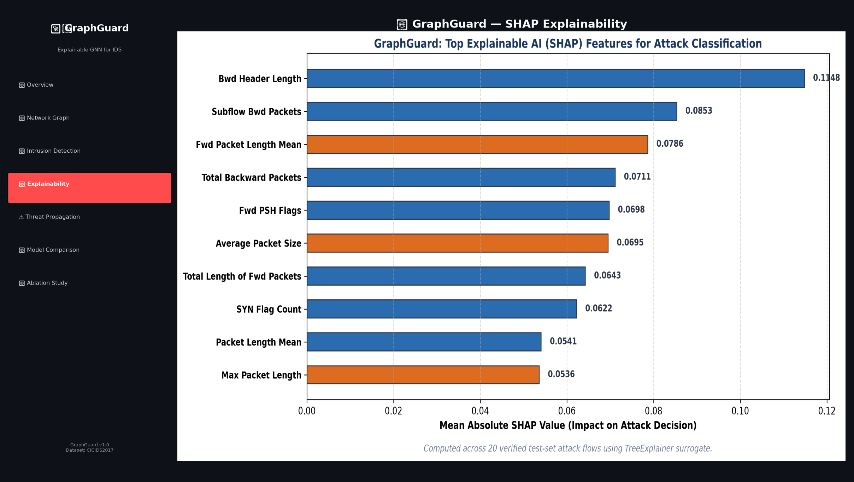
Screenshot: SHAP Explanation

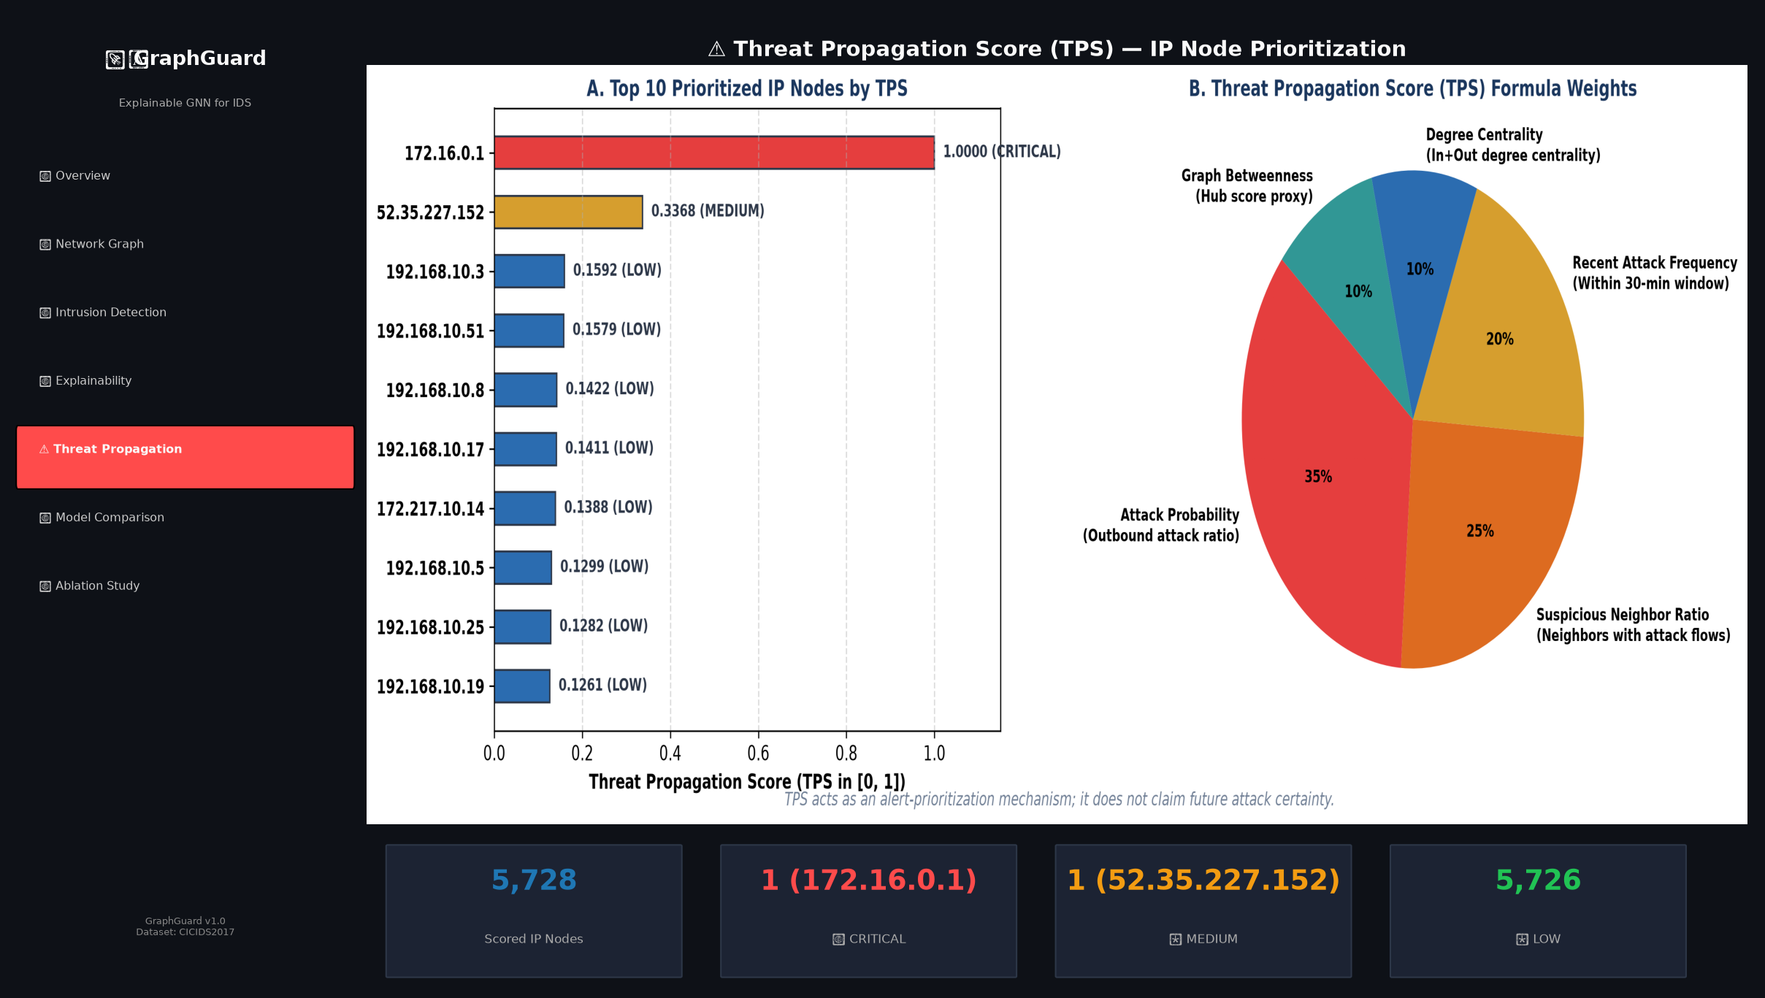
Screenshot: Threat Prioritization (TPS)

12. SUMMARY
Held-out Test Set:
Total: 29,762 flows (BENIGN: 29,052, ATTACK: 710 [FTP-Patator: 636, SSH-Patator: 74])
GraphGuard Performance:
Binary: Accuracy: 99.93%, Macro F1: 99.25%, Attack Recall: 100%, Macro FPR: 0.04%
Multiclass: Accuracy: 99.92%, Macro Precision: 96.59%, Macro Recall: 99.22%, Macro F1: 97.87%, Weighted F1: 99.92%
Baseline Results (Independent Models):
Random Forest (Binary): Accuracy 99.94%, Macro F1 99.34%, Attack Recall 97.46%
XGBoost (Binary): Accuracy 99.95%, Macro F1 99.42%, Attack Recall 97.75%
GraphGuard achieved 100% attack recall and a very low false-positive rate, while the tree-based baselines achieved slightly higher overall accuracy in the reported evaluation.
Ablation Study (Macro F1):
• 1. Full GraphGuard: 0.9787
• 2. No AGC: 0.9787
• 3. No Graph Context: 0.7129
• 4. No Adaptive Weights: 0.9787
• 5. No GraphSAGE: 0.9780
The ablation demonstrates the contribution of graph context to GraphGuard's performance under the evaluated test protocol (absolute decrease of 26.58 percentage points when removed).
Explainability & TPS:
For flow #638 (FTP-Patator), prediction was FTP-Patator with 99.96% confidence. Top SHAP features included Fwd Packet Length Mean, Max Packet Length, Average Packet Size, and Fwd PSH Flags. In the demonstrated TPS ranking, the highest-priority node (172.16.0.1) received a CRITICAL priority score of 1.0000.
Conclusion:
GraphGuard effectively addresses NIDS limitations through graph-aware inductive learning. Future work aims to deploy live packet ingestion and support real-time network infrastructure.

REFERENCES
1. Hamilton, W., Ying, Z., & Leskovec, J. (2017). Inductive Representation Learning on Large Graphs. NeurIPS 2017.
2. Sharafaldin, I., Lashkari, A. H., & Ghorbani, A. A. (2018). Toward Generating a New Intrusion Detection Dataset. ICISSP 2018.
3. Lundberg, S. M., & Lee, S. I. (2017). A Unified Approach to Interpreting Model Predictions. NeurIPS 2017.
4. Aglin, E., et al. (2022). Graph Neural Networks for Intrusion Detection: A Survey. IEEE Access.
5. Cheng, C., et al. (2021). Graph-Based Intrusion Detection Using GCN. IEEE TNSM.
6. Breiman, L. (2001). Random Forests. Machine Learning, 45(1), 5-32.
7. Chen, T., & Guestrin, C. (2016). XGBoost: A Scalable Tree Boosting System. KDD 2016.
8. Velickovic, P., et al. (2018). Graph Attention Networks. ICLR 2018.
9. Xu, K., et al. (2019). How Powerful are Graph Neural Networks? ICLR 2019.
10. Vinayakumar, R., et al. (2019). Deep Learning Approach for Intelligent IDS. IEEE Access.
11. Buczak, A., & Guven, E. (2016). A Survey of Data Mining and ML Methods for Cyber Security IDS. IEEE Communications Surveys.
12. Takahashi, T., et al. (2021). GNN-based Anomaly Detection in Network Traffic. NDSS 2021.
13. Moustafa, N., & Slay, J. (2015). UNSW-NB15: A Comprehensive Dataset for NIDS Evaluation. IEEE MilCIS.
14. Divekar, A., et al. (2018). Benchmarking Datasets for Anomaly-Based NIDS. ICACCI 2018.
15. Li, Z., et al. (2022). Hierarchical GNN for Network Anomaly Detection. IEEE INFOCOM 2022.

