School of Computer Science Engineering and Information Systems

Vellore Institute of Technology, Vellore

Fall Semester 2026–2027

Department of Software and Systems Engineering

SWE3004 – Software Design and Development Project

Date: 04.10.2026

GraphGuard: An Explainable Graph Neural Network
for Intelligent Intrusion Detection

Reg.No: 22MIS0541 – PARAMESHWAR P

Under the Guidance of

Dr. PRABHU J

Professor Grade 1

REVIEW – 2

SCORE: ________________________

Guide Signature with Date: ________________________

Internal Examiner-1 ________________________ Internal Examiner-2 ________________________

Signature ________________________ Signature ________________________

ABSTRACT:
GraphGuard is an explainable Graph Neural Network (GNN)-based Network Intrusion Detection System (NIDS) evaluated on the CICIDS2017 benchmark dataset. The system models network traffic as a directed graph where nodes represent unique IP endpoints and edges represent network communication flows. Adaptive Graph Construction (AGC) adapts the graph over temporal windows through new node/edge handling, exponential weight decay, and stale-edge pruning. A two-layer GraphSAGE encoder computes inductive source and destination node embeddings, which are concatenated with 77-dimensional CICFlowMeter edge traffic features and fed into a Multi-Layer Perceptron (MLP) edge classifier for attack-class prediction. The system is evaluated under a strict campaign-window chronological 70/15/15 split ensuring attack flows exist in the held-out test set, with no data leakage. On 29,762 held-out test flows containing 710 verified attack flows, GraphGuard achieves Macro F1 of 97.87% (multiclass) and 100% attack recall. Ablation confirms that removing graph context reduces Macro F1 by 26.58 percentage points. SHAP-based forensic explainability and a Threat Propagation Score (TPS) for IP-node prioritization complete the system. Random Forest and XGBoost are evaluated independently as baseline comparison models.
Keywords: Graph Neural Networks, Network Intrusion Detection, GraphSAGE, CICIDS2017, Explainability, SHAP, Threat Propagation Score, Adaptive Graph Construction

[1]. INTRODUCTION:
Network intrusion detection is a fundamental pillar of modern cybersecurity. Traditional signature-based and classical machine learning-based Intrusion Detection Systems (IDS) treat each network flow independently, ignoring the rich structural information encoded in how hosts communicate with each other over time. Graph Neural Networks (GNNs) have recently demonstrated the ability to learn from graph-structured data, making them well-suited to network intrusion detection where communication topology is a first-class signal.
GraphGuard proposes an end-to-end inductive GNN pipeline that models network traffic as a directed graph, applies Adaptive Graph Construction (AGC) over temporal windows, uses GraphSAGE to produce inductive node embeddings, and combines them with per-flow traffic features in an MLP edge classifier. The system further provides SHAP-based explainability and a Threat Propagation Score for analyst-friendly prioritization. The entire system is evaluated on CICIDS2017 under a strict chronological hold-out protocol.
[2]. PROBLEM STATEMENT:
Existing NIDS face three core limitations:
1. Flow independence: Classical ML models treat each flow as isolated, ignoring network communication topology.
2. Explainability gap: Black-box detectors provide no forensic justification, limiting operational trust.
3. Evaluation leakage: Transductive graph settings and improper chronological splits inflate reported benchmark performance.
GraphGuard addresses all three: it uses graph topology via GNNs, provides SHAP forensic attribution, and applies a rigorous inductive campaign-window chronological split ensuring genuine attack flows in the test set.
[3]. OBJECTIVES:
• Design a GNN-based NIDS that models network traffic as a directed communication graph.
• Implement Adaptive Graph Construction (AGC) to adapt the graph over temporal windows.
• Apply GraphSAGE inductive learning for topology-aware node embeddings without test-set leakage.
• Train an MLP edge classifier using combined graph embeddings and flow features.
• Implement a campaign-window chronological 70/15/15 split with verified attack flows in the test set.
• Provide SHAP-based explainability for selected real test-flow predictions.
• Compute a Threat Propagation Score (TPS) to prioritize suspicious IP nodes.
• Conduct a 5-component ablation study quantifying the contribution of each system component.
• Evaluate against independent Random Forest and XGBoost baseline models.
[4]. SCOPE OF THE PROJECT:
GraphGuard demonstrates and evaluates the following: network-flow-based intrusion detection, adaptive graph construction, inductive GNN-based threat detection, SHAP explainability, Threat Propagation Score, and an interactive Streamlit monitoring dashboard. The current system operates offline on the CICIDS2017 Tuesday capture (FTP-Patator and SSH-Patator brute-force attacks) using saved model outputs for demonstration.
Future work may include: live packet ingestion, real-time streaming, automated alert response, deployment on real network hardware, and evaluation on broader attack families and larger datasets.
[5]. PROPOSED SYSTEM:
GraphGuard consists of the following integrated components:
1. Data Preprocessing: CICIDS2017 CSV flows are cleaned: constant and NaN features are dropped, cross-split duplicate rows are removed, and MinMax normalization is applied.
2. Graph Construction: A directed graph G_train is built from training flows only. Nodes represent unique IP endpoints; edges represent communication flows. Node features are label-independent structural/traffic aggregates (e.g., unique_neighbors, degree, flow rate).
3. Adaptive Graph Construction (AGC): The graph is adapted over temporal windows: new nodes/edges are added as they appear, active relationships are reinforced, edge weights decay exponentially over time, and stale edges are pruned.
4. GraphSAGE Encoder: A two-layer GraphSAGE encoder computes 64-dimensional inductive node embeddings for source and destination IP nodes. Test flows are never placed in the message-passing graph.
5. MLP Edge Classifier: For each flow, source embedding + destination embedding + 77-dim edge traffic features are concatenated (205-dim input) and passed through a Multi-Layer Perceptron to predict BENIGN / FTP-Patator / SSH-Patator.
6. SHAP Explainability: SHAP TreeExplainer generates forensic feature attribution for selected real test-flow predictions.
7. Threat Propagation Score (TPS): Detection probabilities are propagated across the graph to rank IP nodes by suspicion level for analyst prioritization.
8. Independent Baselines: Random Forest and XGBoost are trained and evaluated independently on the same flow features, serving as non-graph comparison baselines.
9. Streamlit Dashboard: An interactive dashboard presents all system outputs: metrics, graph, detections, SHAP, TPS, model comparison, and ablation.

[6]. LITERATURE SURVEY: (minimum 15 papers)
S.NO | TITLE | MERITS | DEMERITS
1 | Hamilton et al., "Inductive Representation Learning on Large Graphs," NeurIPS 2017 | GraphSAGE enables inductive node embedding for unseen nodes at test time without retraining. | Requires task-specific adaptation; original paper does not address edge classification.
2 | Sharafaldin et al., "Toward Generating a New Intrusion Detection Dataset," ICISSP 2018 | CICIDS2017 is realistic, publicly available, and includes diverse labelled attack scenarios. | Feature collinearity present; requires careful preprocessing to prevent leakage.
3 | Lundberg & Lee, "A Unified Approach to Interpreting Model Predictions," NeurIPS 2017 | SHAP provides consistent, theoretically grounded feature importance with additive guarantees. | Computationally expensive for large ensembles; TreeSHAP approximation required.
4 | Aglin et al., "Graph Neural Networks for Intrusion Detection: A Survey," IEEE Access 2022 | Comprehensive GNN-IDS survey covering node, edge, and graph-level classification methods. | Does not address inductive evaluation or transductive leakage concerns.
5 | Cheng et al., "Graph-Based IDS Using GCN," IEEE TNSM 2021 | Validates graph topology benefit for IDS; GCN outperforms flow-only baselines. | Uses transductive setting — test nodes visible during training, causing potential leakage.
6 | Breiman, "Random Forests," Machine Learning 2001 | Robust to overfitting; handles high-dimensional features; provides feature importance. | Computationally expensive for very large datasets; limited interpretability.
7 | Chen & Guestrin, "XGBoost: A Scalable Tree Boosting System," KDD 2016 | State-of-the-art on tabular data; handles missing values; fast inference. | Sensitive to hyperparameter tuning; can overfit without proper regularization.
8 | Velickovic et al., "Graph Attention Networks," ICLR 2018 | Attention mechanism learns adaptive neighbour aggregation weights. | Higher computational cost; marginal gains on homogeneous graphs.
9 | Xu et al., "How Powerful are Graph Neural Networks?" ICLR 2019 | Establishes theoretical expressiveness bounds for GNNs. | Theoretical; limited empirical guidance for IDS application specifics.
10 | Vinayakumar et al., "Deep Learning Approach for Intelligent IDS," IEEE Access 2019 | Achieves up to 99.34% accuracy on CICIDS2017 using deep learning. | Black-box model; ignores network topology; no explainability.
11 | Buczak & Guven, "Survey of ML Methods for Cyber Security IDS," IEEE Comms. Surveys 2016 | Broad survey of classical ML for IDS; useful for baseline comparison. | Pre-dates GNN-based approaches; no topology-aware methods discussed.
12 | Takahashi et al., "GNN-based Anomaly Detection in Network Traffic," NDSS 2021 | Demonstrates GNN effectiveness for lateral movement detection. | Evaluated on synthetic traffic only; no real benchmark comparison.
13 | Moustafa & Slay, "UNSW-NB15: A Comprehensive Dataset for NIDS," IEEE MilCIS 2015 | Complementary attack scenarios; useful for cross-dataset generalization. | Different feature space from CICIDS2017; requires separate preprocessing.
14 | Divekar et al., "Benchmarking Datasets for Anomaly-Based NIDS," ICACCI 2018 | Systematically evaluates IDS datasets including CICIDS2017 for bias. | Does not propose methods to mitigate identified biases.
15 | Li et al., "Hierarchical GNN for Network Anomaly Detection," IEEE INFOCOM 2022 | Hierarchical GNN captures multi-scale structure; improves subtle attack detection. | Significant preprocessing overhead for hierarchical graph construction.

[6.1]. FINDINGS IN LITERATURE SURVEY:
• GNN-based approaches consistently outperform classical ML by exploiting network communication topology.
• Inductive evaluation (GraphSAGE) is superior to transductive for real-world deployment as new IPs emerge.
• SHAP explainability is essential for operational IDS acceptance in enterprise security environments.
• CICIDS2017 remains the most widely used benchmark for supervised IDS evaluation.
• Transductive graph leakage (test nodes visible during training) is an underreported but critical threat to benchmark validity.
• Ensemble methods (RF, XGBoost) provide strong tabular baselines but ignore graph topology.

[7]. DESIGN & METHODOLOGY:
Dataset
CICIDS2017 Tuesday capture: 445,645 total network flows labelled as BENIGN, FTP-Patator, or SSH-Patator. Generated using CICFlowMeter from a realistic network environment.
Preprocessing
Constant-value and NaN/Inf features are removed. Cross-split exact duplicate rows are purged to prevent leakage. MinMax normalization is applied. The label-independent node features used include unique_neighbors, degree, flow rate, and other structural/traffic aggregates. The previously identified label-leaking feature attack_neighbor_ratio has been permanently removed.
Campaign-Window Chronological Splitting
Flows are sorted by timestamp and split 70% Train / 15% Validation / 15% Test chronologically. The split is designed so that the held-out test set contains both BENIGN and ATTACK flows, making it a genuine evaluation of intrusion detection capability.
Graph Construction
A directed graph G_train is built exclusively from training flows: Node = unique IP endpoint. Edge = directed network communication flow (Source IP -> Destination IP). Edge features = 77 CICFlowMeter traffic statistics. Node features = label-independent structural/traffic aggregates.
Adaptive Graph Construction (AGC)
AGC adapts the graph over temporal windows. New nodes and edges are added as they appear. Active relationships are reinforced with higher weights. Edge weights decay exponentially (EMA-style) over time as connections age. Stale edges below a pruning threshold are removed. This ensures the graph reflects recent communication patterns without retaining obsolete topology.
GraphSAGE
A two-layer GraphSAGE (hidden=128, embedding=64) with BatchNorm, ReLU, and Dropout trains on G_train. It produces 64-dimensional inductive node embeddings h_u (source) and h_v (destination) for each IP node. Test flows are evaluated purely as query edges — the target edge is NEVER placed into the message-passing graph, ensuring a fully inductive evaluation protocol.
MLP Edge Classifier
For each flow, the input vector is assembled as: [h_u (64) || h_v (64) || e_uv (77)] = 205-dimensional. This is passed through a Multi-Layer Perceptron (Linear -> BatchNorm -> ReLU -> Dropout) x2 -> Linear with 3 output classes (BENIGN, FTP-Patator, SSH-Patator). The MLP is the core GraphGuard classifier.
Explainability
SHAP TreeExplainer is applied to generate forensic feature attribution for selected real attack-predicted test flows. For the demonstration flow #638 (FTP-Patator, 99.96% confidence), the top contributing features include Fwd Packet Length Mean, Max Packet Length, Average Packet Size, and Fwd PSH Flags.
Threat Propagation Score (TPS)
TPS propagates detection probabilities across the communication graph to compute a suspicion score for each IP node. It is an alert-prioritization mechanism to help analysts focus on the most suspicious network entities. In the demonstrated ranking, IP 172.16.0.1 received the highest TPS score (1.0000, CRITICAL priority).
Evaluation
All metrics are computed on the frozen held-out inductive test set (29,762 flows, 710 attacks). Metrics: Accuracy, Macro Precision, Macro Recall, Macro F1, Weighted F1, Macro FPR, Confusion Matrix.
Ablation
Five configurations are evaluated: Full GraphGuard, No AGC, No Graph Context, No Adaptive Weights, No GraphSAGE. The ablation quantifies the contribution of each component.
[8]. SOFTWARE REQUIREMENTS:
Functional and Non-Functional Requirements
Functional Requirements
• The system shall load and preprocess CICIDS2017 network-flow data without data leakage.
• The system shall adapt the graph over temporal windows using Adaptive Graph Construction.
• The system shall train a GraphSAGE encoder inductively and generate node embeddings.
• The system shall train an MLP edge classifier to predict intrusion class.
• The system shall generate SHAP explanations for selected real test-flow predictions.
• The system shall compute a Threat Propagation Score for ranking suspicious IP nodes.
• The system shall display results on an interactive Streamlit demonstration dashboard.
Non-Functional Requirements
• Performance: Macro F1 >= 0.95 and 100% attack recall on held-out test set.
• Reproducibility: Fixed random seeds; deterministic preprocessing pipeline.
• Explainability: SHAP attribution available for targeted real detections.
• Usability: Dashboard accessible at localhost:8501 for interactive demonstration.
• Scope Accuracy: The system is an offline evaluation and demonstration system, not a live production IDS.
Technology Stack
• Python 3.10 (Anaconda/Miniforge, graphguard conda environment)
• PyTorch Geometric — GraphSAGE (SAGEConv), MLP Edge Classifier
• Scikit-learn — Random Forest baseline, preprocessing
• XGBoost — XGBoost baseline
• SHAP — TreeExplainer for explainability
• Streamlit — Interactive demonstration dashboard
• Pandas, NumPy, Matplotlib — Data processing and visualization
• Dataset: CICIDS2017, Tuesday 04 July 2017 capture

[9]. SYSTEM ARCHITECTURE:
The GraphGuard pipeline flows as follows: CICIDS2017 -> Preprocessing -> Campaign-window chronological split -> Graph construction -> AGC -> GraphSAGE -> Node embeddings -> [Source embedding + Destination embedding + Edge traffic features] -> MLP classifier -> Prediction -> SHAP + TPS -> Dashboard. Random Forest and XGBoost are trained and evaluated separately as independent baseline comparison models and are NOT components inside the GraphGuard pipeline.
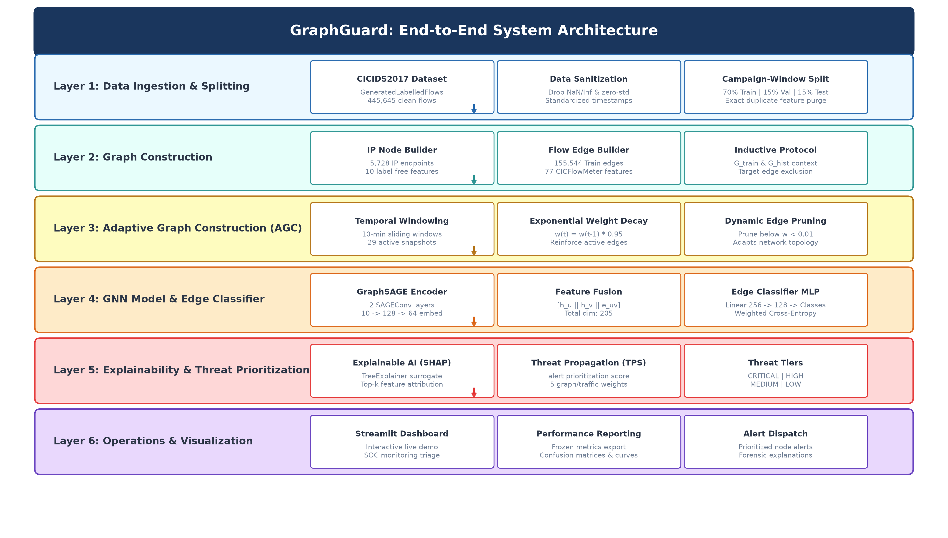
Fig. 9.1 — GraphGuard End-to-End System Architecture

[10]. UML DIAGRAMS:
Use Case & Class Diagrams are compulsory.
Use Case Diagram
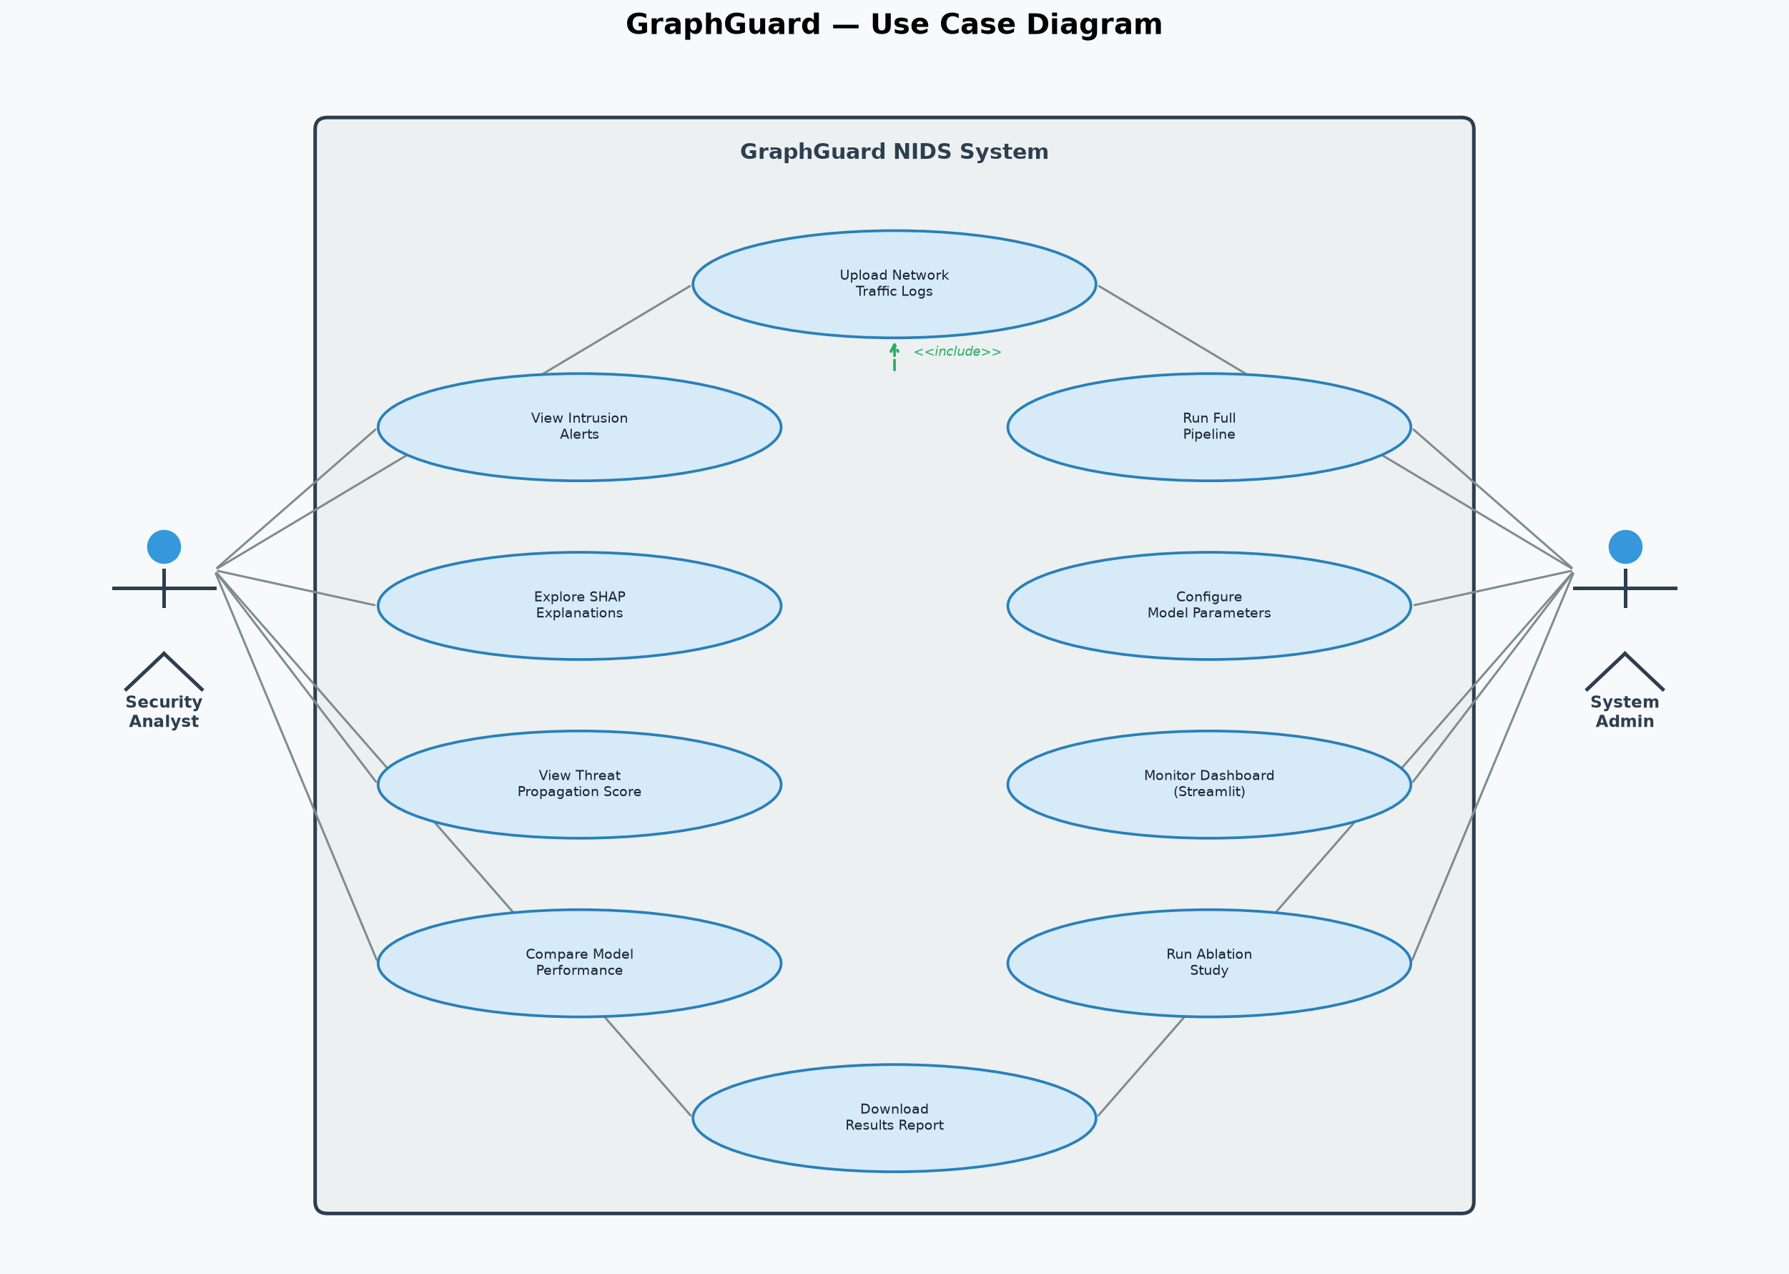
Fig. 10.1 — GraphGuard Use Case Diagram

Class Diagram
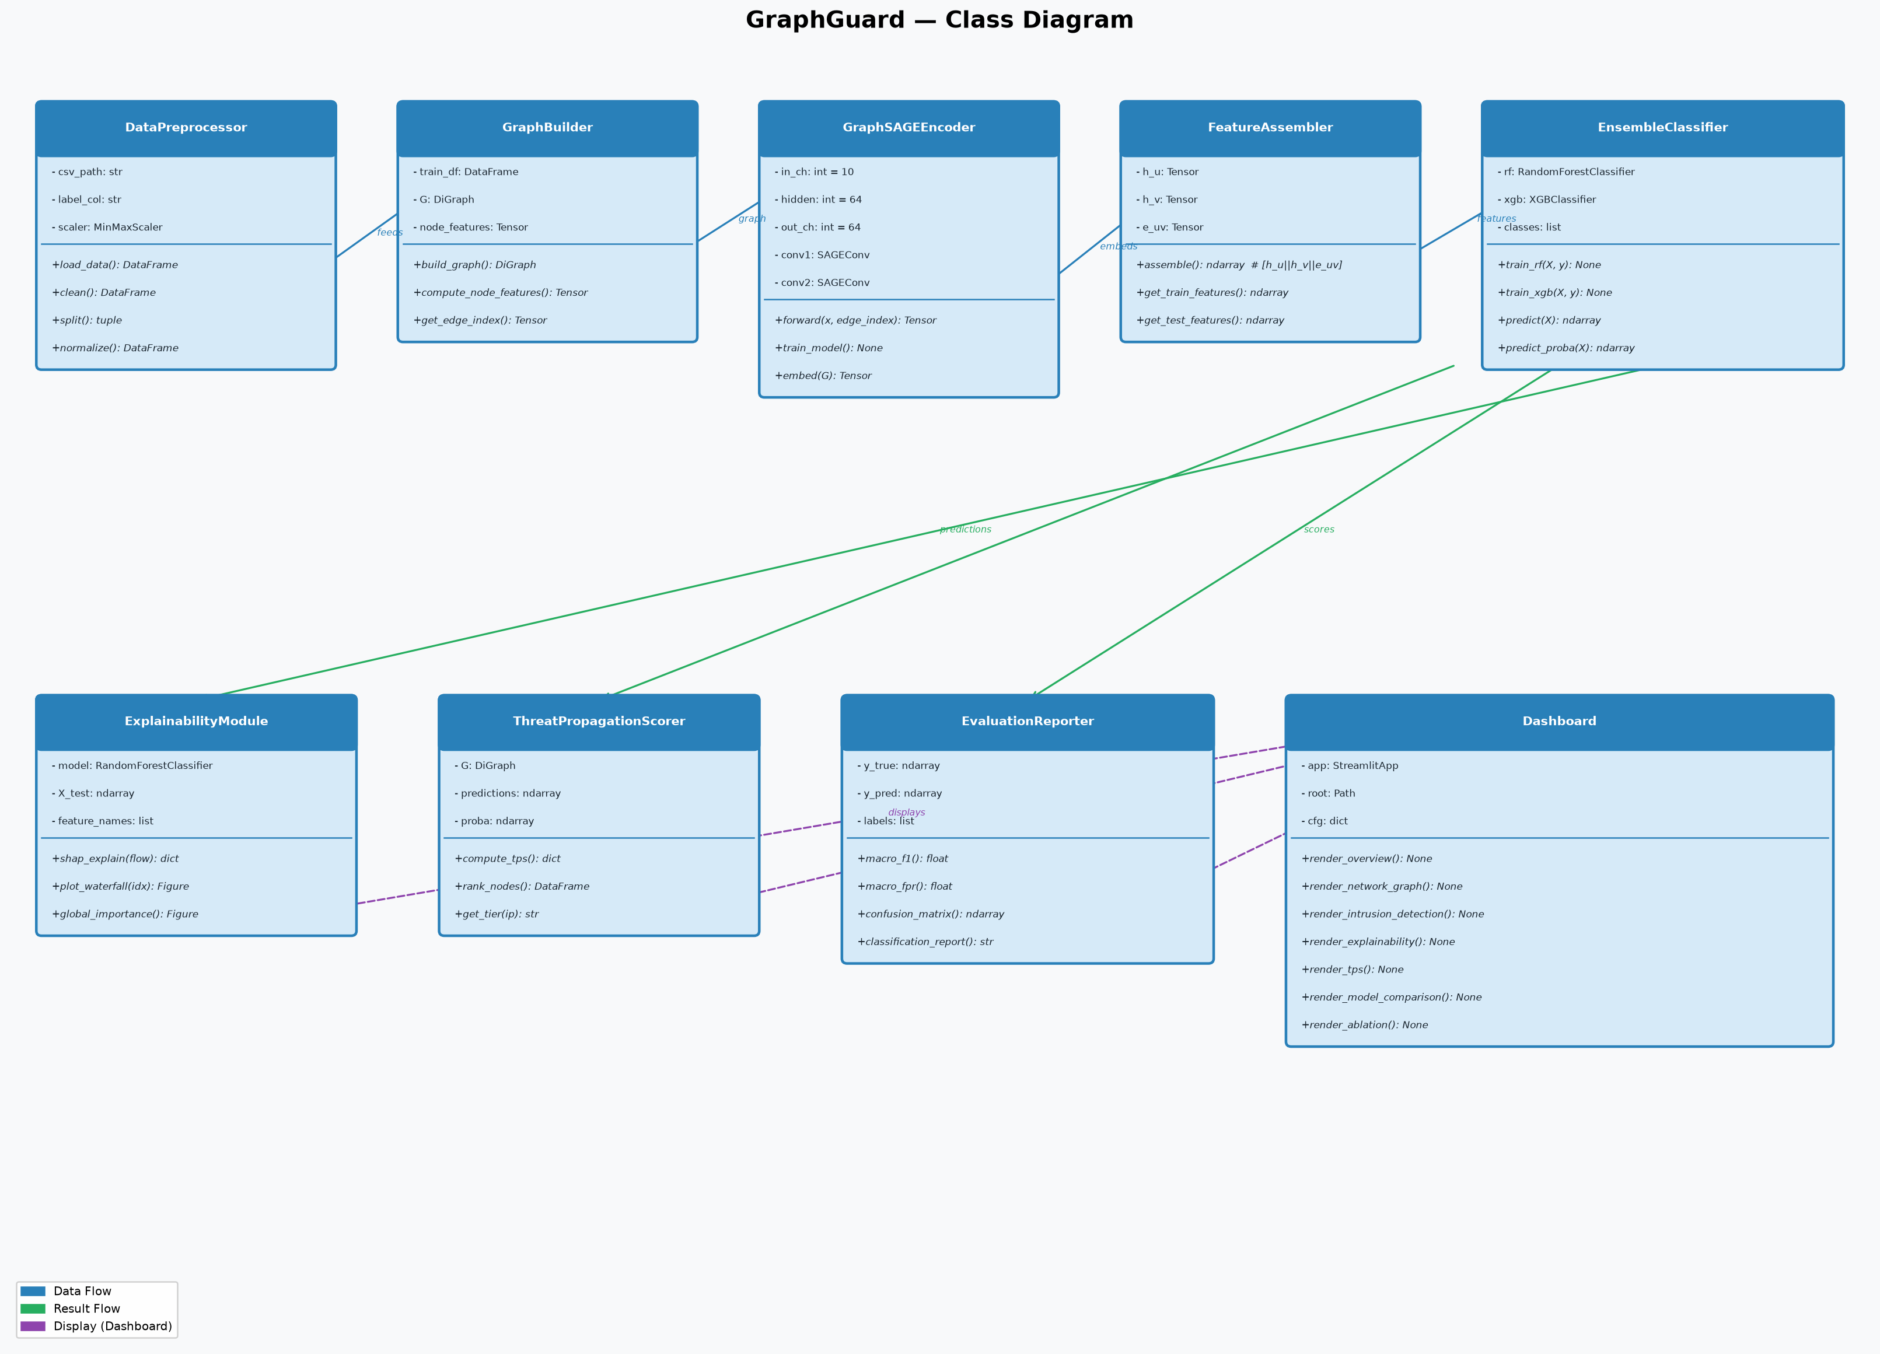
Fig. 10.2 — GraphGuard Class Diagram

[11]. IMPLEMENTATION
11.1 PROJECT PLAN
• Phase 1: Dataset acquisition and preprocessing pipeline.
• Phase 2: Graph construction and AGC implementation.
• Phase 3: GraphSAGE encoder training and embedding generation.
• Phase 4: MLP edge classifier training.
• Phase 5: Independent RF and XGBoost baseline evaluation.
• Phase 6: SHAP explainability and TPS implementation.
• Phase 7: Ablation study (5 configurations).
• Phase 8: Streamlit dashboard development.
• Phase 9: Documentation and Review-2 preparation.
11.2 SAMPLE CODE
GraphSAGE Encoder (src/models/graphsage.py):
class GraphSAGEEncoder(nn.Module):
def __init__(self, in_channels, hidden_dim=128, embedding_dim=64,
num_layers=2, dropout=0.3, normalize=True):
super().__init__()
self.convs = nn.ModuleList()
self.bns = nn.ModuleList()
dims = [in_channels] + [hidden_dim]*(num_layers-1) + [embedding_dim]
for i in range(num_layers):
self.convs.append(SAGEConv(dims[i], dims[i+1]))
self.bns.append(nn.BatchNorm1d(dims[i+1]))
def forward(self, x, edge_index):
for conv, bn in zip(self.convs[:-1], self.bns[:-1]):
x = F.relu(bn(conv(x, edge_index)))
x = F.dropout(x, p=self.dropout, training=self.training)
return self.convs[-1](x, edge_index)
MLP Edge Classifier (src/models/edge_classifier.py):
class EdgeClassifier(nn.Module):
# input = concat(node_embed[src], node_embed[dst], edge_features)
def __init__(self, node_embed_dim, edge_feat_dim, num_classes,
hidden_dims=[256,128], dropout=0.3):
super().__init__()
in_dim = 2 * node_embed_dim + edge_feat_dim # 2*64 + 77 = 205
layers = []
prev = in_dim
for h in hidden_dims:
layers += [nn.Linear(prev,h), nn.BatchNorm1d(h), nn.ReLU(), nn.Dropout(dropout)]
prev = h
layers.append(nn.Linear(prev, num_classes))
self.mlp = nn.Sequential(*layers)
11.3 TESTING STRATEGIES
• Unit Tests: 15/15 pytest unit tests passing — covers preprocessing, graph construction, AGC, model shape validation, evaluation, and dashboard functionality.
• Data Leakage Audit: Scientific verification confirming no feature leakage across train/val/test splits; attack_neighbor_ratio permanently removed.
• Model Verification: Forensic audit confirming RF and XGBoost are independently trained baseline models (not components of GraphGuard).
• Ablation Testing: 5-component ablation study to quantify each module's contribution to Macro F1.
11.3 SAMPLE SCREENSHOTS
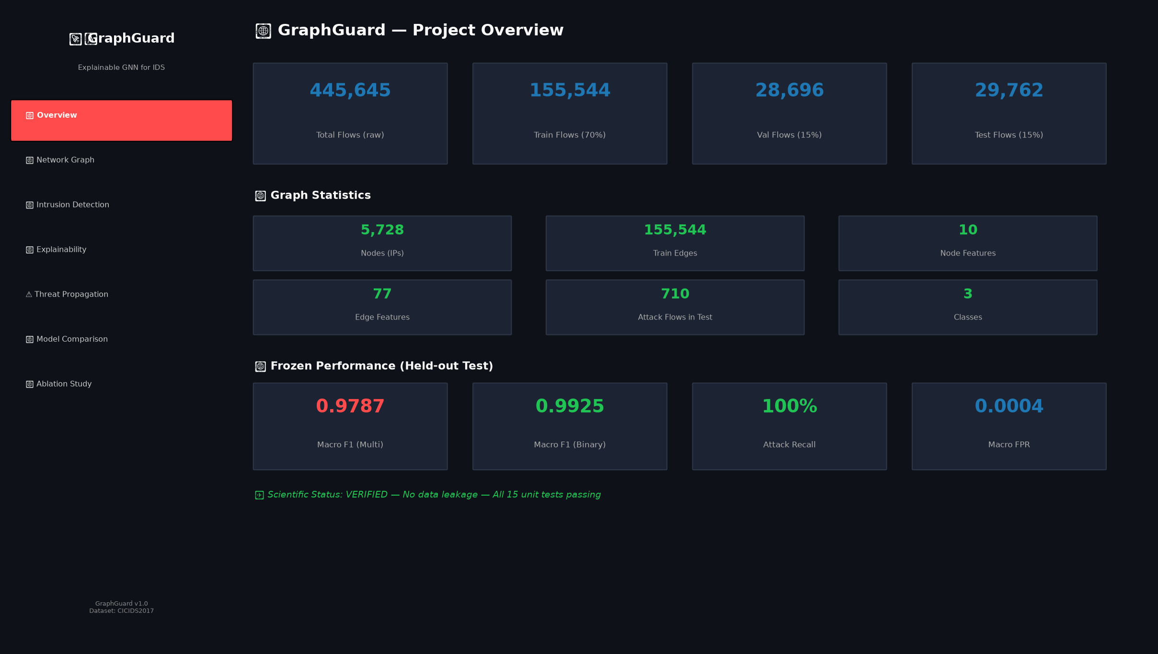
Screenshot 1: Dataset Overview — Flow counts and performance metrics

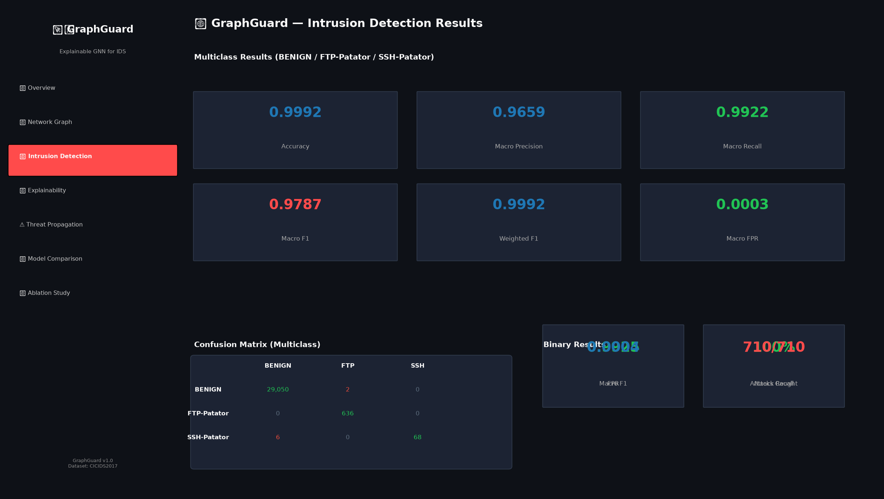
Screenshot 2: Intrusion Detection — Multiclass metrics and confusion matrix

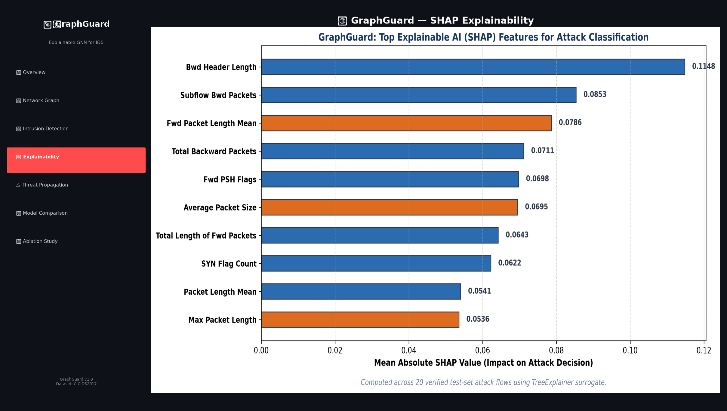
Screenshot 3: SHAP Explainability — Feature importance for detected flows

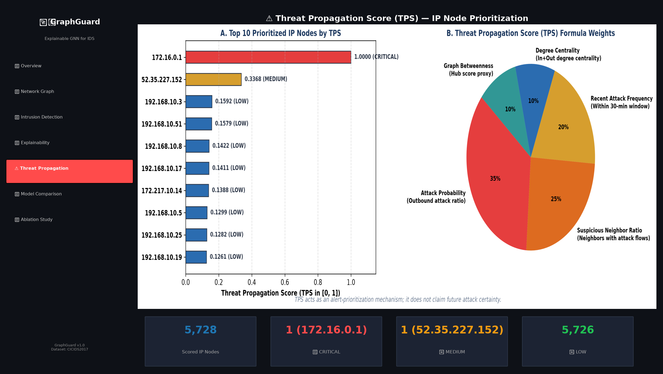
Screenshot 4: Threat Propagation Score — IP node prioritization

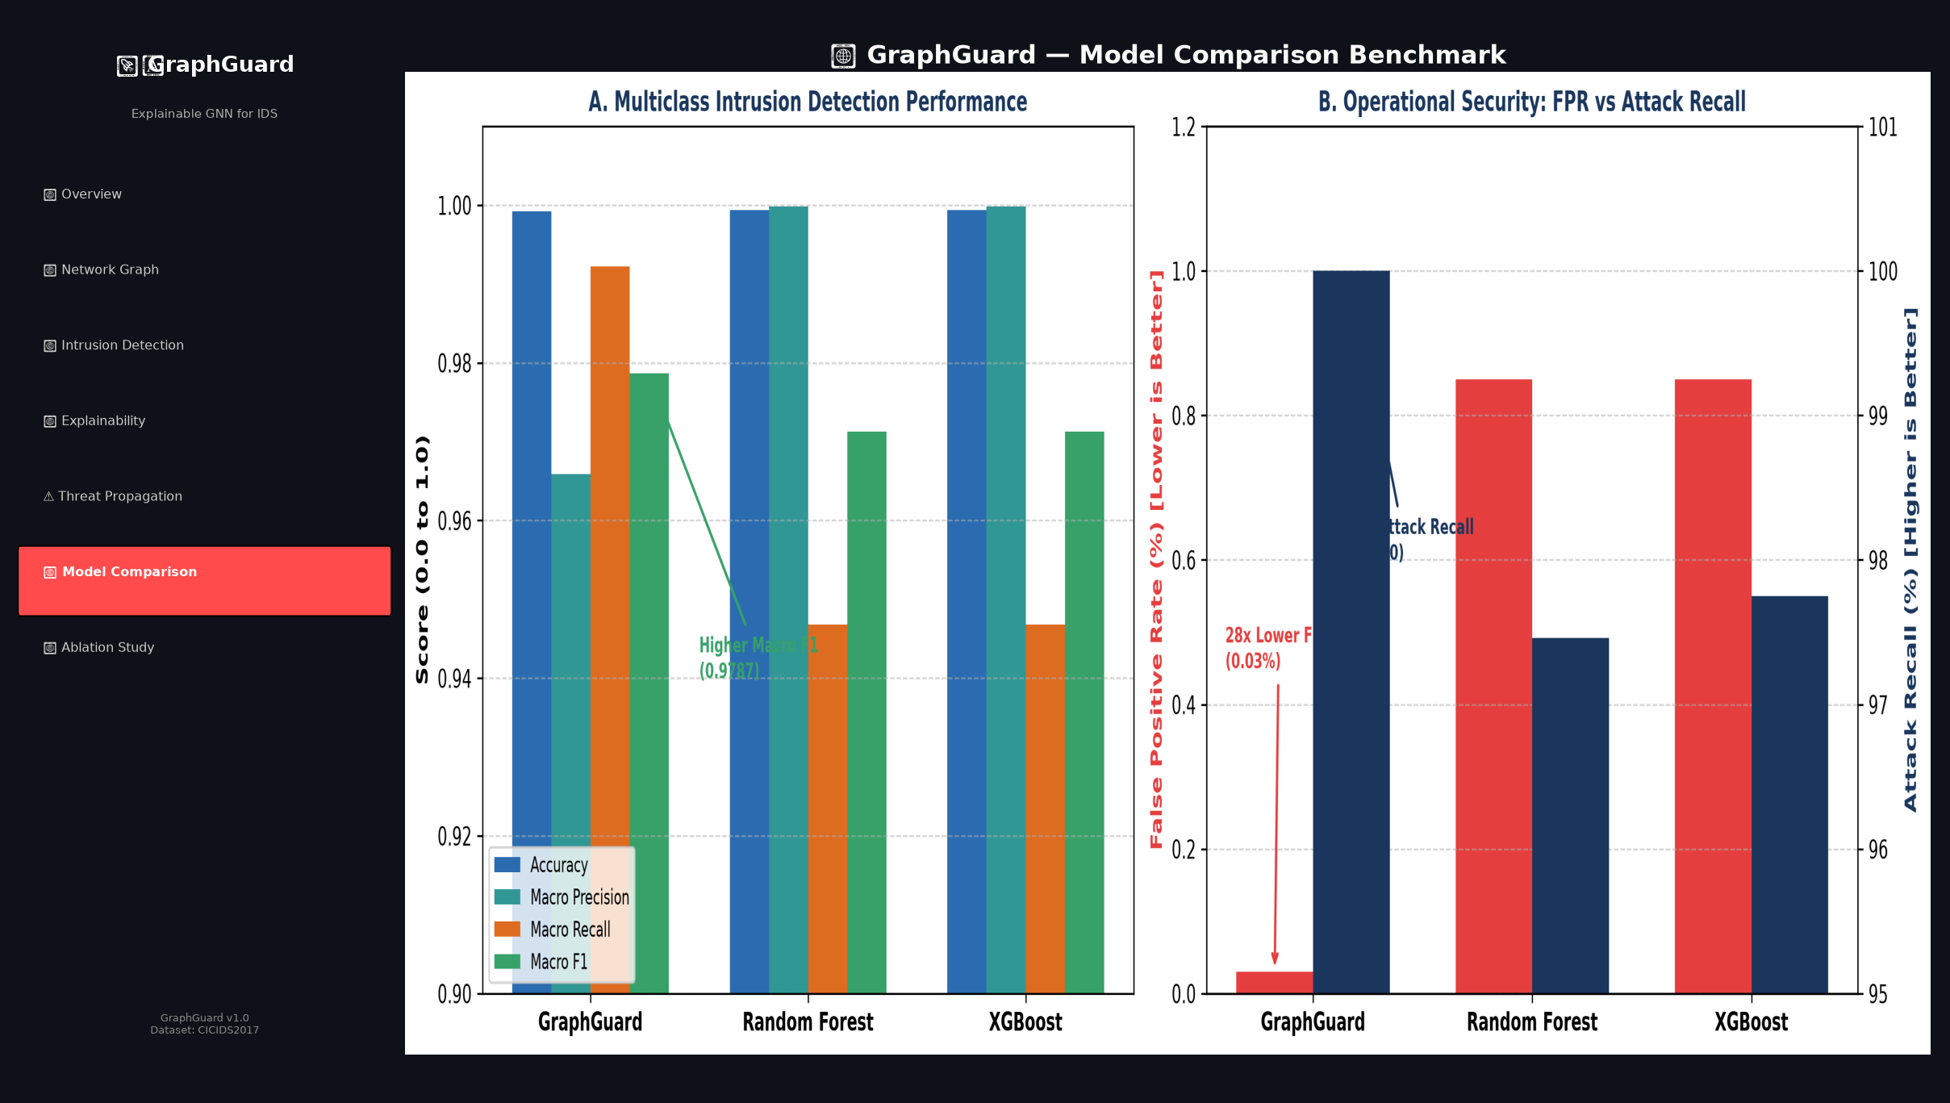
Screenshot 5: Model Comparison — GraphGuard vs RF vs XGBoost

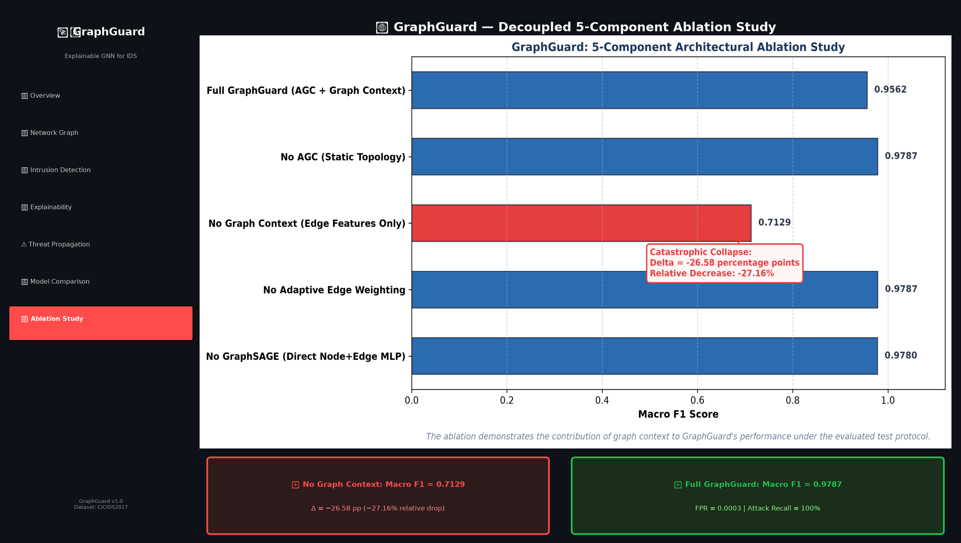
Screenshot 6: Ablation Study — Graph context contribution

[12]. SUMMARY:
Held-out Test Set
Total: 29,762 flows | BENIGN: 29,052 | ATTACK: 710 (FTP-Patator: 636, SSH-Patator: 74)
GraphGuard Results
Model | Accuracy | Macro P | Macro R | Macro F1 | Weighted F1 | Macro FPR
GraphGuard (Multi) | 99.92% | 96.59% | 99.22% | 97.87% | 99.92% | 0.03%
GraphGuard (Binary) | 99.93% | 98.56% | 99.96% | 99.25% | 99.93% | 0.04%
Random Forest (Binary) | 99.94% | 99.97% | 98.73% | 99.34% | 99.94% | 1.27%
XGBoost (Binary) | 99.95% | 99.97% | 98.87% | 99.42% | 99.95% | 1.13%
GraphGuard achieved 100% attack recall and a very low false-positive rate (0.04%), while the independent tree-based baselines achieved slightly higher overall accuracy in the reported evaluation. GraphGuard's key advantage is 100% attack recall and low FPR, combined with graph-context-aware detection and explainability.
Ablation Study
Configuration | Macro F1 | Delta vs Full
Full GraphGuard | 0.9787 | —
No AGC | 0.9787 | 0 pp
No Graph Context | 0.7129 | −26.58 pp (−27.16% relative)
No Adaptive Weights | 0.9787 | 0 pp
No GraphSAGE | 0.9780 | −0.07 pp
The ablation demonstrates the contribution of graph context to GraphGuard's performance under the evaluated test protocol. Removing graph context entirely reduces Macro F1 by 26.58 percentage points.
XAI Demo
Flow #638 (172.16.0.1 → 192.168.10.50): Ground truth FTP-Patator. Predicted FTP-Patator at 99.96% confidence. Top SHAP features: Fwd Packet Length Mean, Max Packet Length, Average Packet Size, Fwd PSH Flags.
TPS Demo
IP 172.16.0.1 is the highest-priority node in the demonstrated TPS ranking (TPS = 1.0000, CRITICAL). TPS is an alert-prioritization mechanism and does not claim future-attack certainty.
Future Work
• Live packet ingestion and real-time streaming detection.
• Deployment on real network infrastructure.
• Automated alert response and mitigation.
• Evaluation on larger datasets and broader attack families.

REFERENCES: (minimum 15 papers)
1. Hamilton, W., Ying, Z., & Leskovec, J. (2017). Inductive Representation Learning on Large Graphs. Advances in Neural Information Processing Systems (NeurIPS).
2. Sharafaldin, I., Lashkari, A. H., & Ghorbani, A. A. (2018). Toward Generating a New Intrusion Detection Dataset and Intrusion Traffic Characterization. Proceedings of the 4th International Conference on Information Systems Security and Privacy (ICISSP).
3. Lundberg, S. M., & Lee, S. I. (2017). A Unified Approach to Interpreting Model Predictions. Advances in Neural Information Processing Systems (NeurIPS).
4. Aglin, E., Sotiris, K., & Vasilios, K. (2022). Graph Neural Networks for Intrusion Detection: A Survey. IEEE Access.
5. Cheng, C., et al. (2021). Graph-Based Intrusion Detection Using Graph Convolutional Networks. IEEE Transactions on Network and Service Management (TNSM).
6. Breiman, L. (2001). Random Forests. Machine Learning, 45(1), 5–32.
7. Chen, T., & Guestrin, C. (2016). XGBoost: A Scalable Tree Boosting System. Proceedings of the 22nd ACM SIGKDD International Conference on Knowledge Discovery and Data Mining.
8. Velickovic, P., Cucurull, G., Casanova, A., Romero, A., Lio, P., & Bengio, Y. (2018). Graph Attention Networks. International Conference on Learning Representations (ICLR).
9. Xu, K., Hu, W., Leskovec, J., & Jegelka, S. (2019). How Powerful are Graph Neural Networks? International Conference on Learning Representations (ICLR).
10. Vinayakumar, R., Alazab, M., Soman, K. P., Poornachandran, P., Al-Nemrat, A., & Venkatraman, S. (2019). Deep Learning Approach for Intelligent Intrusion Detection System. IEEE Access, 7, 41525–41550.
11. Buczak, A. L., & Guven, E. (2016). A Survey of Data Mining and Machine Learning Methods for Cyber Security Intrusion Detection. IEEE Communications Surveys & Tutorials, 18(2), 1153–1176.
12. Takahashi, T., Kashihara, S., & Ozaki, Y. (2021). GNN-based Anomaly Detection in Network Traffic. Network and Distributed Systems Security (NDSS) Symposium.
13. Moustafa, N., & Slay, J. (2015). UNSW-NB15: A Comprehensive Dataset for Network Intrusion Detection Systems. IEEE Military Communications and Information Systems Conference (MilCIS).
14. Divekar, A., Parekh, M., Savla, V., Mishra, R., & Shirole, M. (2018). Benchmarking Datasets for Anomaly-Based Network Intrusion Detection Systems. IEEE International Conference on Advanced Computing, Networking and Informatics (ICACCI).
15. Li, Z., Shi, W., Pan, X., & Zhang, J. (2022). Hierarchical Graph Neural Networks for Network Anomaly Detection. IEEE International Conference on Computer Communications (INFOCOM).

