**3.1 Introduction**

An Arduino UNO is used for interfacing to various hardware components. The design will allow for the continuous monitoring of vehicle status, and provision of reports as requested. To enable this reporting, an Arduino UNO is interfaced with a GSM Modem and a GPS Receiver. The modem is used to send the location of the vehicle from a remote place. The GPS modem will continuously provide data showing the position of the vehicle. The GPS modem gives many parameters in its output, such as whether the vehicle is moving or is parked. This data will be sent to the user mobile upon demand. This vehicle theft detection system takes input from GPS and sends data through the GSM module to the desired mobile.

**3.2 Circuit Diagram**

Circuit Diagram of the hardware with the optional LCD Panel is shown in Fig 3.1. The interfaces of Arduino with both the modules is shown here.

Here Tx pin of GPS module is directly connected to digital pin number 10 of Arduino. By using Software Serial Library here, serial communications are allowed on pins 10 and 11, and made them Rx and Tx respectively. Rx pin of GPS Module is left open. By default, Pin 0 and 1 of Arduino are used for serial communication but by using the “SoftwareSerial” library, communication on other digital pins of the Arduino can be allowed. 12 Volt supply is used to power the GPS Module.

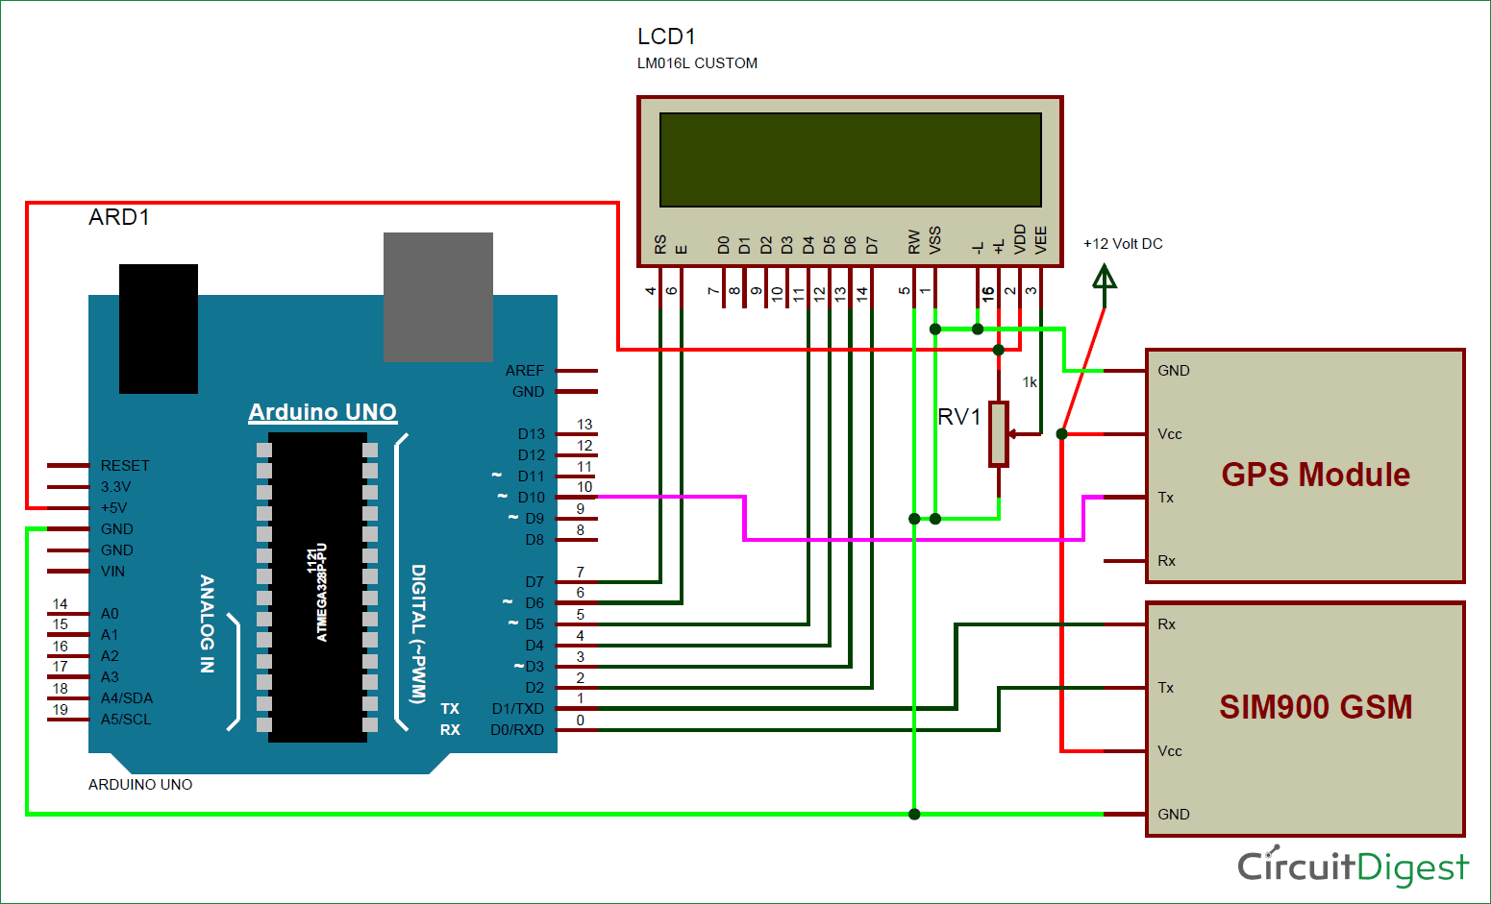

Fig 3.1: Circuit Diagram

Tx and Rx pins of GSM Module are directly connected to pin Rx and Tx of Arduino. GSM module is also powered by 12v supply. An optional LCD’s data pins D4, D5, D6 and D7 are connected to pin number 5, 4, 3, and 2 of Arduino. Command pin RS and EN of LCD are connected with pin number 2 and 3 of Arduino and RW pin is directly connected with ground. A Potentiometer is also used for setting contrast or brightness of LCD.

**3.3 Activity Diagram**

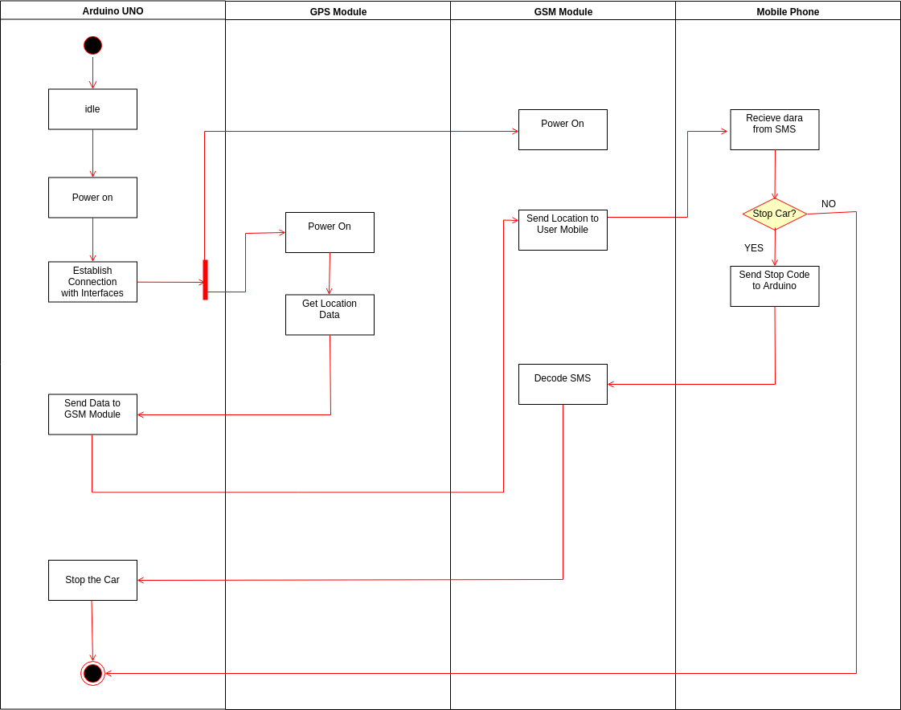Activity Diagram of the system is shown in Fig 3.2. The four main interfaces important for the working of this project are Arduino UNO, GPS Module, GSM Module, and a user with a Mobile Phone. The required result is carried out with the help of these interfaces.

Fig 3.2: Activity Diagram

The project starts by powering up the Arduino. The Arduino then establishes connections with the modules. Once the connection is established, it switches on the GSM and GPS Modules. The location data is then sent to the Arduino via GPS Module. This location data is then sent to the GPS Module which passes it to the user mobile phone through an SMS. The user then decides whether to stop the car or not. If no, the system stops there. If yes, user sends the stop code to the GSM module which decodes it and then sends it to the Arduino, which turns of the ignition of the car by executing the Stop command.

**3.4 Sequence Diagram**

The sequence diagram of this system is shown in Fig 3.3. This depicts the interaction between four main objects that are Arduino, GPS Module, GSM Module and the User Mobile Phone in a sequential order i.e. the order in which these interactions take place.

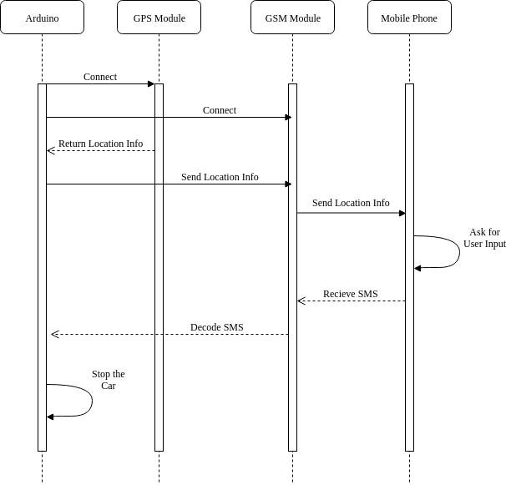

Fig 3.3: Sequence Diagram

The System starts and Arduino connects with GPS Module, then with the GSM Module. After these connections, the GPS Module returns the location information of the car to the Arduino. The Arduino then sends the location information to the GSM Module which contacts with the Mobile phone and sends that information to it. The phone asks for user input when provided, the SMS is sent to the system which is received by the GSM Module. The SMS is decoded at the Arduino and the car is stopped thereafter.

**3.5 Summary**

In this chapter, the design phase of the system was studied. The Circuit diagram showed the graphical representation of the electrical circuit. It used simple images of all the components that are Arduino, GSM Module, GPS Module and an LCD Panel, and interconnections of the circuit using standardized symbolic representations. Activity diagrams showed the workflows of stepwise activities and actions with the supported choice of whether the user wants to stop the vehicle or not. Sequence diagram depicted the objects and classes involved in the scenario and the sequence of messages exchanged between Arduino, GSM Module, GPS Module and the user mobile phone needed to carry out the functionality of stopping the vehicle in case of theft.