**4.1 Introduction**

Moving on to Implementation, this is the most critical stage of the system. After connecting the device with a power supply, it takes about 20-25 seconds for GSM Module to get the signal from the satellite. Once the connection is established, the GPS Module sends the location information to the mobile phone. All these details can be seen on the serial monitor if we connect the Arduino with a computer with Arduino IDE. After receiving message from the Vehicle Tracking System user can send message to the system to stop the vehicle. Thus, reaching the final stage. This system can be used as different versions of implementaion including personal use, bussiness use, security purposes or tracking use.

**4.2 Implementaion**

When the hardware is ready according to the given circuit diagram and after programming it, it can be installed in vehicle and power it up. The user just need to send a SMS, “Track Vehicle”, to the system that is placed in vehicle. Sent message is received by GSM module which is connected to the system and sends message data to Arduino. Arduino reads it and extract main message from the whole message. And then compare it with predefined message in Arduino. If any match occurs then Arduino reads coordinates by extracting $GPGGA String from GPS module data and send it to user by using GSM module. This message contains the coordinates of vehicle location.

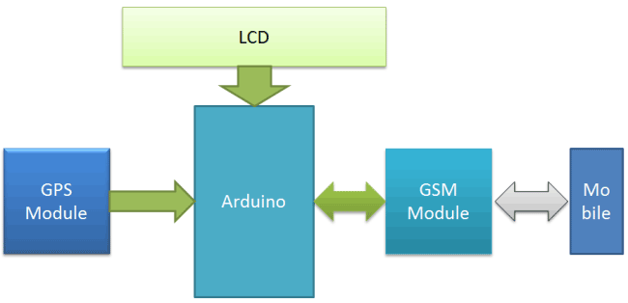

Fig 4.1: System Flow

As soon as the Arduino is powered up, a message will be sent to user using the GSM module regarding the starting of vehicle and to track the vehicle or not. According to user choice further decision will be made by Arduino. If the user chooses to track the vehicle GPS module will track the vehicle and will send the live coordinates of vehicle to the user with a message to stop the car at that coordinate. If the user chooses to stop the car then the Arduino will cut-off the power supply to engine and thus the car will stop there.

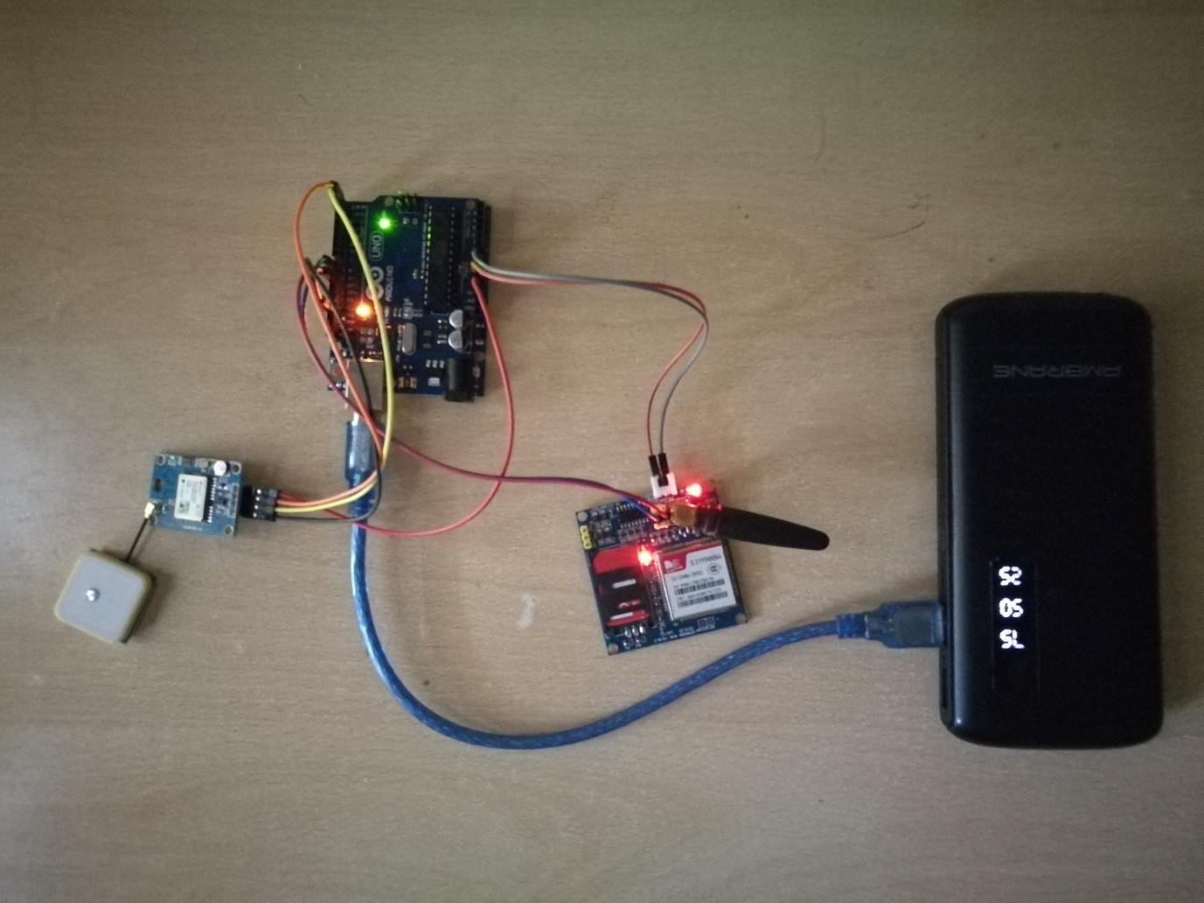Fig 4.2 shows the live working of the project. The Arduino is powered by a 5V Power Source that is coming from a power bank. GPS Modules and GSM Module are interfaced with Arduino by Jumper cables (male and female), while Arduino is connected to the power bank by a USB Cable.

Fig. 4.2: Live Project

Output of GPS module in the serial monitor is given in Fig 4.3. This data can be viewed by connecting the Arduino with a computer.

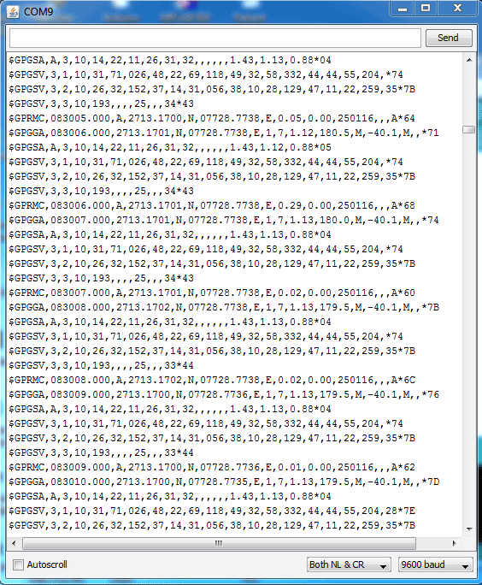

Fig 4.3

Below is the $GPGGA String description:

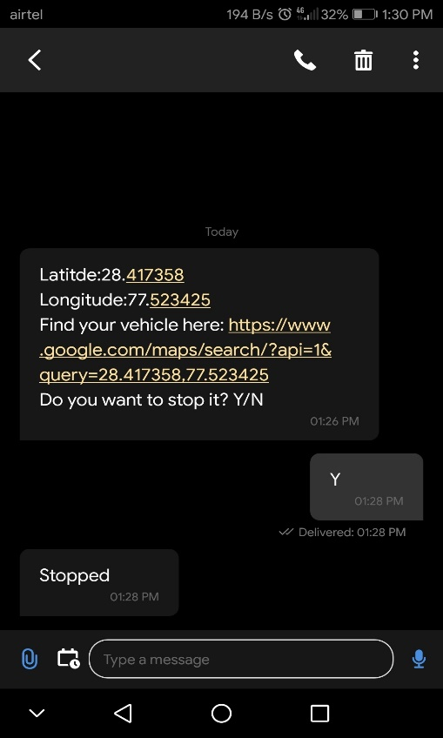$GPGGA,HHMMSS.SSS,latitude,N,longitude,E,FQ,NOS,HDP,altitude,M,height,M,,checksum data.

Fig 4.4

As shown in Fig 4.4, the conversation between Arduino and user will look like this. Arduino will send a live link to track vehicle via GSM module. This link can directly be open in Google Maps. If the user replies with “Y”, the Arduino sends the code and turns off the ignition of the car. If the user selects “N”, the system stops there until restarted again.

**4.3 Conclusion**

This system can be used for both personal and business purposes to improve safety and security, communication, and performance monitoring. Vehicle theft detection systems have become increasingly important in large cities and are more secured than many other systems. Nowadays, vehicle theft is rapidly increasing. With this technology however, vehicle theft can be better controlled. This technology can also help to advance transportation systems, and can be used in many organizations for security and tracking purposes. Also, the proposed system is more useful, as a result of the addition of different types of sensors which help to protect the owner and other users of the vehicle by reducing the possibility of collisions. In the event of an accident, the system will send the location to designated numbers so assistance can be provided as soon as possible. This will be particularly useful in instances where accidents occur in deserted places and midnights. In the future, this vehicle tracking and accident alert feature will play an important role in day-to-day life.

**4.4 Scope**

With location and positioning technology continuing to take over new heights including most advanced GPS tracking and a whole contingent of technologies like geo-fencing, Beacons, etc. it is can expected that future location trackers will become more powerful. GPS trackers these days are smaller and more power packed than what they were few years ago. GPS tracking devices are evolving and improving at a rapid space. Before you have the scope of getting familiar with the latest GPS technology advancements something new can take everyone for a surprise. Use the EEPROM to store the previous Navigating positions up to 256 locations and we can navigate up to N number of locations by increasing its memory. Also, reduce the size of the kit by using GPS+GSM on the same module. Accuracy can be increased up to 3m by increasing the cost of the GPS receivers. This project, with some modifications can be used for detection of bomb by connecting to the bomb detector. With the help of high sensitivity vibration sensors accidents can be detected. Whenever vehicle unexpectedly had an accident on the road with help of vibration sensor it is possible to detect the accident and send the location to the owner, hospital and police. This project can be used to assist the traffic. By keeping the kits in the entire vehicles and by knowing the locations of all the vehicles. If anybody steals some car, it is easy to can find the car around the globe. By keeping vehicle positioning vehicle on the vehicle.

**4.5 Summary**

This chapter gave detailed information about how to implement the idea of vehicle theft detection using Arduino, GPS and GSM modules. How the data will flow after interfacing Arduino with different components was well informed using system flow diagram. A photograph was also attached to show what the project would look like after the implementation. Screenshot of the output that would come on the Arduino IDE after running the project was also shown to demonstrate. And in the format in which messages would be sent to the owner of the vehicle are also attached with pictures. What would be the scope and extension of this project in near future was explained well with examples.