* 1. **Introduction**

Vehicle theft detection system enables the owner to observe and track the vehicle and find out about vehicle movement and past activities of automobile. This technology has proved useful in ensuring the security of vehicles. This hardware is fitted onto the vehicle in such a manner that persons who are in or outside of the vehicle cannot see it. Thus, it is used as a covert unit which continuously, sends location data to the monitoring unit. When a vehicle is stolen, the location data from the tracking system can be used to find the location, stop the engine and then inform the police for further action. When users make a request, the GPS coordinates of the vehicle are sent to a specified mobile. The user will be provided with the position of the vehicle in terms of latitude and longitude which can be viewed using Google Maps.

**1.2 Problem Statement**

There has been an increase in the usage of vehicle tracking and theft detection systems with advancement in technology. This implementation of the same enables the user to view its vehicle’s position on phone. The GPS, GSM/GPRS modules controlled by Arduino UNO are placed inside the vehicle. Thus, the vehicle’s location is determined whenever the user wants as shown in the figure 1.1[1]. Vehicle tracking and theft detection systems are very useful nowadays.



Fig 1.1

* 1. **Arduino UNO**

The Arduino UNO is an open-source microcontroller board based on the Microchip ATmega328P microcontroller and developed by Arduino.cc[2]. It is an open-source electronics platform based on easy-to-use hardware and software. Arduino boards are able to read inputs - light on a sensor, a finger on a button, or a Twitter message - and turn it into an output - activating a motor, turning on an LED, publishing something online. You can tell your board what to do by sending a set of instructions to the microcontroller on the board. To do so you use the Arduino programming language (based on Wiring), and the Arduino Software (IDE), based on Processing. A simple Arduino is shown in figure 1.2[3].

Over the years Arduino has been the brain of thousands of projects, from everyday objects to complex scientific instruments. A worldwide community of makers - students, hobbyists, artists, programmers, and professionals - has gathered around this open-source platform, their contributions have added up to an incredible amount of accessible knowledge that can be of great help to novices and experts alike.

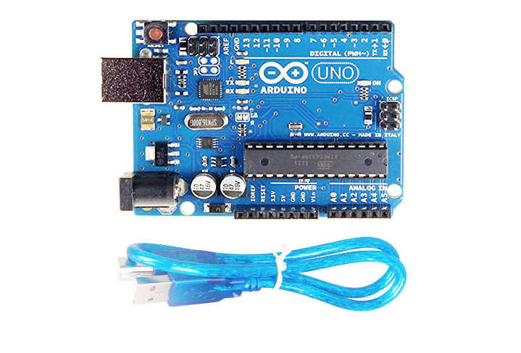

Fig 1.2

**1.3.1 Power**

The Arduino Uno can be powered via the USB connection or with an external power supply. The power source is selected automatically. The power pins are as follows:

* VIN. The input voltage to the Arduino board when it's using an external power source (as opposed to 5 volts from the USB connection or other regulated power source). You can supply voltage through this pin, or, if supplying voltage via the power jack, access it through this pin.
* 5V. The regulated power supply used to power the microcontroller and other components on the board. This can come either from VIN via an on-board regulator, or be supplied by USB or another regulated 5V supply.
* 3V3. A 3.3-volt supply generated by the on-board regulator. Maximum current draw is 50 mA.
* GND. Ground pins

**1.3.2 Input and Output**

Each of the 14 digital pins on the Uno can be used as an input or output, using pinMode(), digitalWrite(), and digitalRead()functions. In addition, some pins have specialized functions[4]:

* Serial: 0 (RX) and 1 (TX). Used to receive (RX) and transmit (TX) TTL serial data. These pins are connected to the corresponding pins of the ATmega8U2 USB-to-TTL Serial chip.
* External Interrupts: 2 and 3. These pins can be configured to trigger an interrupt on a low value, a rising or falling edge, or a change in value. See the attachInterrupt() function for details.
* PWM: 3, 5, 6, 9, 10, and 11. Provide 8-bit PWM output with the analogWrite() function.
* SPI: 10 (SS), 11 (MOSI), 12 (MISO), 13 (SCK). These pins support SPI communication using the SPI library.
* LED: 13. There is a built-in LED connected to digital pin 13. When the pin is HIGH value, the LED is on, when the pin is LOW, it's off.
* TWI: A4 or SDA pin and A5 or SCL pin. Support TWI communication using the Wire library.
* AREF. Reference voltage for the analog inputs. Used with analogReference().
* Reset. Bring this line LOW to reset the microcontroller. Typically used to add a reset button to shields which block the one on the board.

.

* 1. **GSM SIM900 Module**

SIM900 is an ultra compact and reliable wireless module. The SIM900A is a complete Dual-band GSM/GPRS solution in a SMT module which can be embedded in the customer applications[5].Featuring an industry-standard interface, the SIM900A delivers GSM/GPRS 900/1800MHz performance for voice, SMS, Data, and Fax in a small form factor and with low power consumption. The exapmle of commonly used GSM module is shown in figure 1.3[6]. With a tiny configuration of 24mmx24mmx3mm, SIM900A can fit in almost all the space requirements in user applications, especially for slim and compact demand of design.

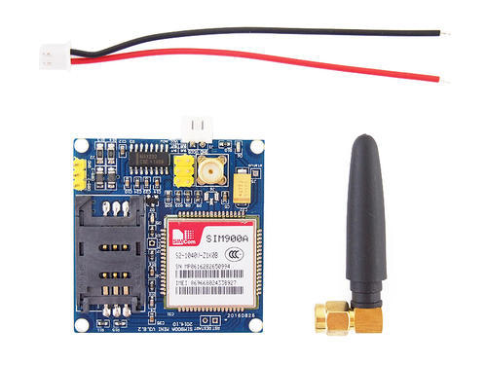

Fig 1.3

**1.4.1 Pin Description**

The SIM900A module has 6pins in which two pins for Vcc and Gnd and the rest are 3VR&3VT(3volt Rx & Tx) and 5VR,5VT(5volt Rx & Tx) and the connections are made as follows[7] :

* Vcc to 5V
* Gnd to Gnd
* 5VR digital pin 7
* 5VT digital pin 8

**1.5 GPS NEO6M Module**

Every single location in the entire globe can be specified in terms of geographical coordinates. The geographical coordinate is a system which specifies any given location on the earth surface as latitude and longitude. There are devices which can read the geographical coordinates of a place with the help of the signals received from a number of satellites orbiting the earth. The system of satellites which helps in the positioning of a place is called [Global Positioning System](http://www.engineersgarage.com/articles/global-positioning-system-gps) (GPS). The devices which can read the geographical coordinates of a place with the help of at least four GPS satellites are called GPS Receiver or simply GPS module. The NEO-6 module series is a family of stand-alone GPS receivers featuring the high performance u-blox 6 positioning engine[8]. These flexible and cost effective receivers offer numerous connectivity options in a miniature 16 x 12.2 x 2.4 mm package. Their compact architecture and power and memory options make NEO-6 modules ideal for battery operated mobile devices with very strict cost and space constraints. The 50-channel u-blox 6 positioning engine boasts a Time-To-First-Fix0(TTFF) of under 1 second. A GSM module is shown figure 1.4[9]. The dedicated acquisition engine, with 2 million correlators, is capable of massive parallel time/frequency space searches,enabling it to find satellites instantly. Innovative design and technology suppresses jamming sources and mitigates multipath effects, giving NEO-6 GPS receivers excellent navigation performance even in the most challenging environments.

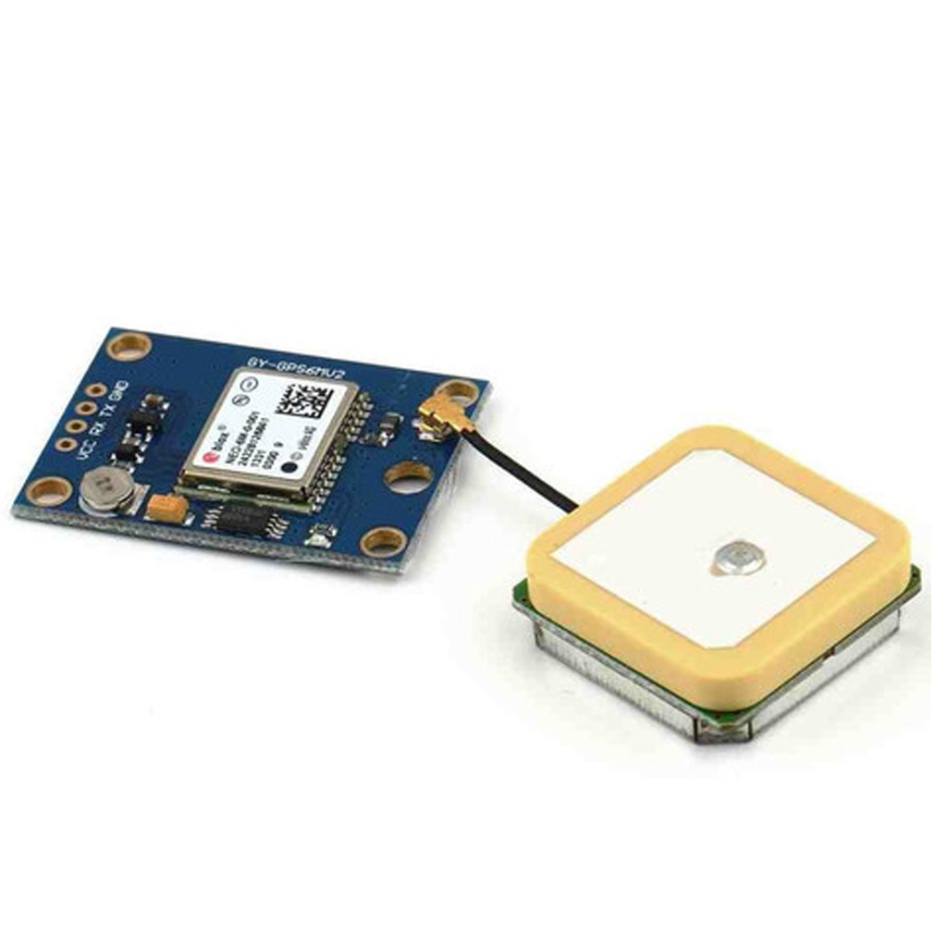

Fig 1.4

**1.5.1 Pin Description**

* VCC. Supply Voltage
* GND. Ground pin
* TX and RX. These 2 pins acts as an UART interface for communication[10]
  1. **Summary**

This chapter was about describing the basic problem brifely for which the solution has to be made. Arduino is explained as well as its pin description to know how to provide input and get output out of Arduino. Also, GSM module was illlustrated, configurations were defined and pin description was also described. The working of the GSM Module was thus depicted. GPS Module used for getting location data was described too. The pin configuration of GPS was defined so a user can know from where to give input and receive output, and which connections are to be made. The chapter provides the idea about how to use all these modules together by interfacing them with the Arduino UNO.