Replace

replace(‘’a’’,’’w’’)

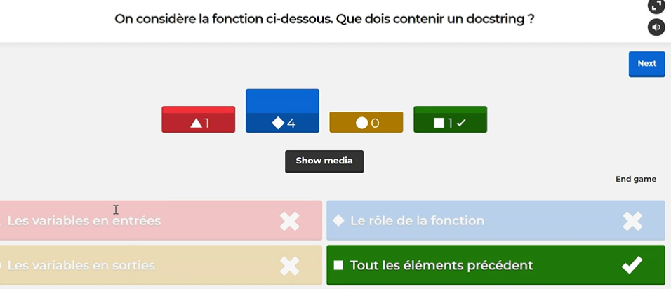

A docstring is a string literal that occurs as the first statement in a module, function, class, or method definition