Exercises: Objects & Composition
Problems for exercises and homework for the "JavaScript Advanced" course @ SoftUni. Submit your solutions in the SoftUni judge system at https://judge.softuni.bg/Contests/2759/Objects-and-Composition-Exercise.

Calorie Object
Write a function that composes an object by given properties. The input comes as an array of strings. Every even index of the array represents the name of the food. Every odd index is a number that is equal to the calories in 100 grams of the given product. Assign each value to its corresponding property, and finally print the object.
The input comes as an array of string elements.
The output should be printed on the console.

Examples
Input | Output
['Yoghurt', '48', 'Rise', '138', 'Apple', '52'] | { Yoghurt: 48, Rise: 138, Apple: 52 }
['Potato', '93', 'Skyr', '63', 'Cucumber', '18', 'Milk', '42'] | { Potato: 93, Skyr: 63, Cucumber: 18, Milk: 42 }

Construction Crew
Write a program that receives a worker object as a parameter and modifies its properties. Workers have the following structure:
{
weight: Number,
experience: Number,
levelOfHydrated: Number,
dizziness: Boolean
}
Weight is expressed in kilograms, experience in years and levelOfHydrated is in milliliters. If you receive a worker whose dizziness property is set to true it means he needs to intake some water to be able to work correctly. The required amount is 0.1ml per kilogram per year of experience. The required amount must be added to the existing amount (to the levelOfHydrated). Once the water is administered, change the dizziness property to false.
Workers who do not have dizziness should not be modified in any way. Return them as they were.

Input
Your function will receive a valid object as a parameter.

Output
Return the same object that was passed in, modified as necessary.

Examples
Input | Output
{ weight: 80,  experience: 1,  levelOfHydrated: 0,  dizziness: true } | { weight: 80,  experience: 1,  levelOfHydrated: 8,  dizziness: false }
{ weight: 120,  experience: 20,  levelOfHydrated: 200,  dizziness: true } | { weight: 120,  experience: 20,  levelOfHydrated: 440,  dizziness: false }
{ weight: 95,  experience: 3,  levelOfHydrated: 0,  dizziness: false } | { weight: 95,  experience: 3,  levelOfHydrated: 0,  dizziness: false }

Car Factory
Write a program that assembles a car by giving requirements out of existing components. The client will place an order in the form of an object describing the car. You need to determine which parts to use to fulfill the client’s order. You have the following parts in storage:
An engine has power (given in horsepower) and volume (given in cubic centimeters). Both of these values are numbers. When selecting an engine, pick the smallest possible that still meets the requirements.
Small engine: { power: 90, volume: 1800 }
Normal engine: { power: 120, volume: 2400 }
Monster engine: { power: 200, volume: 3500 }
A carriage has a type and color. Both of these values are strings. You have two types of carriages in storage and can paint them any color.
Hatchback: { type: 'hatchback', color: <as required> }
Coupe: { type: 'coupe', color: <as required> }
The wheels will be represented by an array of 4 numbers, each number represents the diameter of the wheel in inches. The size can only be an odd number. Round down any requirements you receive to the nearest odd number.

Input
You will receive an object as an argument to your function. The format will be as follows:
{ model: <model name>,
power: <minimum power>,
color: <color>,
carriage: <carriage type>,
wheelsize: <size> }

Output
Return the resulting car object as a result of your function. See the examples for details.

Examples
Input | Output
{ model: 'VW Golf II',  power: 90,  color: 'blue',  carriage: 'hatchback',  wheelsize: 14 } | { model: 'VW Golf II',  engine: { power: 90,  volume: 1800 },  carriage: { type: 'hatchback',  color: 'blue' },  wheels: [13, 13, 13, 13] }
{ model: 'Opel Vectra',  power: 110,  color: 'grey',  carriage: 'coupe',  wheelsize: 17 } | { model: 'Opel Vectra',  engine: { power: 120,  volume: 2400 },  carriage: { type: 'coupe',  color: 'grey' },  wheels: [17, 17, 17, 17] }

Heroic Inventory
In the era of heroes, every hero has his items that make him unique. Create a function that creates a register for the heroes, with their names, level, and items, if they have such. The register should accept data in a specified format, and return it presented in a specified format.

Input
The input comes as an array of strings. Each element holds data for a hero, in the following format:
"{heroName} / {heroLevel} / {item1}, {item2}, {item3}..."
You must store the data about every hero. The name is a string, a level is a number and the items are all strings.

Output
The output is a JSON representation of the data for all the heroes you’ve stored. The data must be an array of all the heroes. Check the examples for more info.

Examples
Input | Output
['Isacc / 25 / Apple, GravityGun',  'Derek / 12 / BarrelVest, DestructionSword',  'Hes / 1 / Desolator, Sentinel, Antara'] | [{"name":"Isacc","level":25,"items":["Apple","GravityGun"]},{"name":"Derek","level":12,"items":["BarrelVest","DestructionSword"]},{"name":"Hes","level":1,"items":["Desolator","Sentinel","Antara"]}]
['Jake / 1000 / Gauss, HolidayGrenade'] | [{"name":"Jake","level":1000,"items":["Gauss","HolidayGrenade"]}]

Hints
- We need an array that will hold our hero data. That is the first thing we create.
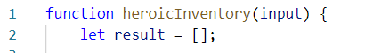
- Next, we need to loop over the whole input and process it. Let’s do that with a simple for loop.
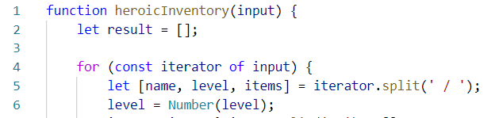
- Every element from the input holds data about a hero, however, the elements from the data we need are separated by some delimiter, so we just split each string with that delimiter.
- Next, we need to take the elements from the string array, which is a result of the string split, and by destructuring assignment syntax, we assign the array properties. Don’t forget to parse the number.

- However, here we remember there is something special about the items, so read the problem definition again, you will notice that there might be a case where the hero has no items; in that case, using destructuring is ok and when there are no items, our property items will be undefined and trying to spit it will throw an error. That is why we need to perform a simple check using the ternary operator.
- If there are any items in the input, the variable will be set to the split version of them. If not, it will just be set to an empty array.
- We have now extracted the needed data – we have stored the input name in a variable, we have parsed the given level to a number, and we have also split the items that the hero holds by their delimiter, which would result in a string array of elements. By definition, the items are strings, so we don’t need to process the array we’ve made anymore.
- Now what is left is to add that data into an object and add that object to the array.
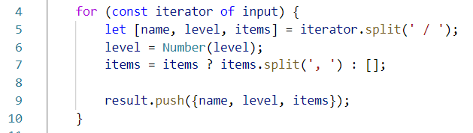
- Lastly, we need to turn the array of objects we have made, into a JSON string, which is done by the JSON.stringify() function
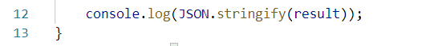

Lowest Prices in Cities
You will be given several towns, with products and their price. You need to find the lowest price for every product and the town it is sold at for that price.

Input
The input comes as an array of strings. Each element will hold data about a town, product, and its price at that town. The town and product will be strings, the price will be a number. The input will come in the following format:
{townName} | {productName} | {productPrice}

Output
As output, you must print each product with its lowest price and the town at which the product is sold at that price. If two towns share the same lowest price, print the one that was entered first.
The output, for every product, should be in the following format:
{productName} -> {productLowestPrice} ({townName})
The order of output in - order of entrance. See the examples for more info.

Examples
Input | Output
['Sample Town | Sample Product | 1000',  'Sample Town | Orange | 2',  'Sample Town | Peach | 1',  'Sofia | Orange | 3',  'Sofia | Peach | 2',  'New York | Sample Product | 1000.1',  'New York | Burger | 10'] | Sample Product -> 1000 (Sample Town)  Orange -> 2 (Sample Town)  Peach -> 1 (Sample Town)  Burger -> 10 (New York)

Store Catalogue
You have to create a sorted catalog of store products. You will be given the products’ names and prices. You need to order them in alphabetical order.

Input
The input comes as an array of strings. Each element holds info about a product in the following format:
"{productName} : {productPrice}"
The product’s name will be a string, which will always start with a capital letter, and the price will be a number. There will be NO duplicate product input. The comparison for alphabetical order is case-insensitive.

Output
As output, you must print all the products in a specified format. They must be ordered exactly as specified above. The products must be divided into groups, by the initial of their name. The group's initial should be printed, and after that, the products should be printed with 2 spaces before their names. For more info check the examples.

Examples
Input | Output |  | Input | Output
['Appricot : 20.4',  'Fridge : 1500',  'TV : 1499',  'Deodorant : 10',  'Boiler : 300',  'Apple : 1.25',  'Anti-Bug Spray : 15',  'T-Shirt : 10'] | A  Anti-Bug Spray: 15  Apple: 1.25  Appricot: 20.4  B  Boiler: 300  D  Deodorant: 10  F  Fridge: 1500  T  T-Shirt: 10  TV: 1499 |  | ['Banana : 2',  'Rubic's Cube : 5',  'Raspberry P : 4999',  'Rolex : 100000',  'Rollon : 10',  'Rali Car : 2000000',  'Pesho : 0.000001',  'Barrel : 10'] | B  Banana: 2  Barrel: 10  P  Pesho: 0.000001  R  Rali Car: 2000000  Raspberry P: 4999  Rolex: 100000  Rollon: 10  Rubic's Cube: 5

Towns to JSON
You're tasked to create and print a JSON from a text table. You will receive input as an array of strings, where each string represents a row of a table, with values on the row encompassed by pipes "|" and optionally spaces. The table will consist of exactly 3 columns "Town", "Latitude" and "Longitude". The Latitude and Longitude columns will always contain valid numbers. Check the examples to get a better understanding of your task.

Input
The input comes as an array of strings – the first string contains the table’s headings, each next string is a row from the table.

Output
- The output should be an array of objects wrapped in JSON.stringify().
- Latitude and Longitude must be parsed to numbers, and represented till the second digit after the decimal point!

Examples
Input | Output
['| Town | Latitude | Longitude |',  '| Sofia | 42.696552 | 23.32601 |',  '| Beijing | 39.913818 | 116.363625 |'] | [{"Town":"Sofia",  "Latitude":42.7,  "Longitude":23.32  },  {"Town":"Beijing",  "Latitude":39.91,  "Longitude":116.36  }]
['| Town | Latitude | Longitude |',  '| Veliko Turnovo | 43.0757 | 25.6172 |',  '| Monatevideo | 34.50 | 56.11 |'] | [{"Town":"Veliko Turnovo",  "Latitude":43.08,  "Longitude":25.62  },  {"Town":"Monatevideo",  "Latitude":34.5,  "Longitude":56.11  }]

Rectangle
Write a function that creates and returns a rectangle object. The rectangle needs to have a width (Number), height (Number), and color (String) properties, which are set via arguments during creation, and a calcArea() method, that calculates and returns the rectangle’s area.

Input
The function will receive three valid parameters – width (Number), height (Number), and color (String).

Output
Your function must return an object with all properties and methods as described. The calcArea() method of the object should return a number. The first letter in the color must be upperCase().

Examples
Input | Output
let rect = rectangle(4, 5, 'red');  console.log(rect.width);  console.log(rect.height);  console.log(rect.color);  console.log(rect.calcArea()); | 4  5  Red  20

Sorted List*
Create a function that returns a special object, which keeps a list of numbers, sorted in ascending order. It must support the following functionality:
- add(element) - adds a new element to the collection
- remove(index) - removes the element at position index
- get(index) - returns the value of the element at position index
- size - number of elements stored in the collection
The correct order of the elements must be kept at all times, regardless of which operation is called. Removing and retrieving elements shouldn’t work if the provided index points outside the length of the collection (either throw an error or do nothing). Note the size of the collection is not a function.

Input / Output
The initial function takes no arguments and must return an object.
All methods on the object that expect input will receive data as parameters. Methods that have validation will be tested with both valid and invalid data. Any result expected from a method should be returned as its result.

Examples
Input | Output
let list = createSortedList();  list.add(5);  list.add(6);  list.add(7);  console.log(list.get(1));  list.remove(1);  console.log(list.get(1)); | 6  7

Heroes
Create a function that returns an object with 2 methods (mage and fighter). This object should be able to create heroes (fighters and mages). Every hero has a state.
- Fighters have a name, health = 100, and stamina = 100 and every fighter can fight. When he fights his stamina decreases by 1 and the following message is printed on the console:
`${fighter's name} slashes at the foe!`
- Mages also have state (name, health = 100 and mana = 100). Every mage can cast spells. When a spell is cast the mage's mana decreases by 1 and the following message is printed on the console:
`${mage's name} cast ${spell}`

Note:
For more information check the examples below.
Input | Output
let create = solve();  const scorcher = create.mage("Scorcher");  scorcher.cast("fireball")  scorcher.cast("thunder")  scorcher.cast("light")  const scorcher2 = create.fighter("Scorcher 2");  scorcher2.fight()  console.log(scorcher2.stamina);  console.log(scorcher.mana); | Scorcher cast fireball  Scorcher cast thunder  Scorcher cast light  Scorcher 2 slashes at the foe!  99  97

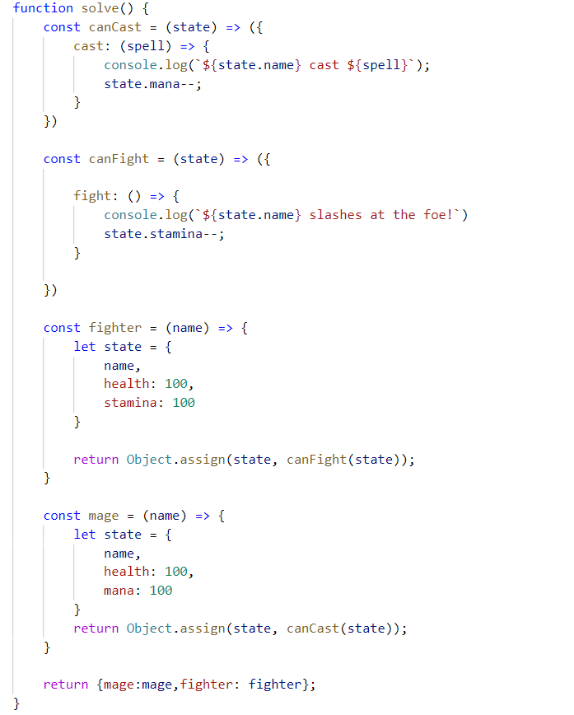

Jan's Notation *
Write a program that parses a series of instructions written in postfix notation and executes them (postfix means the operator is written after the operands). You will receive a series of instructions – if the instruction is a number, save it; otherwise, the instruction is an arithmetic operator(+-*/) and you must apply it to the most two most recently saved numbers. Discard these two numbers and in their place, save the result of the operation – this number is now eligible to be an operand in a subsequent operation. Keep going until all input instructions have been exhausted, or you encounter an error.
In the end, if you’re left with a single saved number, this is the result of the calculation and you must print it. If there are more numbers saved, then the user-supplied too many instructions and you must print "Error: too many operands!". If at any point during the calculation you don’t have two numbers saved, the user-supplied too few instructions and you must print "Error: not enough operands!". See the examples for more details.

Input
You will receive an array with numbers and strings – the numbers will be operands and must be saved; the strings will be arithmetic operators that must be applied to the operands.

Output
Print on the console on a single line the final result of the calculation or an error message, as instructed above.

Constraints
- The numbers (operands) will be integers
- The strings (operators) will always be one of +-*/
- The result of each operation will be in the range [-2⁵³…2⁵³-1] (MAX_SAFE_INTEGER will never be exceeded)

Examples
Input | Output | Explanation
[3,  4,  '+'] | 7 | The first instruction is a number, therefore we save it. The next one is also a number, we save it too.  The third instruction is a string, so it must be an operator – we remove the last two numbers we saved, and operate: 3+4=7. The result of this operation is then saved where the two operands used to be.  We’ve run out of instructions, so we check the saved values – we only have one, so this must be the final result. We print it on the console.
[5,  3,  4,  '*',  '-'] | -7 | We save in order 5, 3, and 4. The result of operation 3*4 is 12, which we save in place of 3 and 4.  Currently, we have 5 and 12 saved. The result of the operation 5-12 is -7, which we save in place of 5 and 12.  We have no more instructions and only one value saved, which we print.

Input | Output |  | Input | Output
[7,  33,  8,  '-'] | Error: too many operands! |  | [15,  '/'] | Error: not enough operands!

