Workshop: Movie Magic – Part 2
Your team at work is tasked with creating a website that will attract movie enthusiasts. The site is named "Movie Magic". Its purpose is to create an attractive and interactive platform for movie fans that offers a unique and enriching experience.

Main Task
If you have completed the previous task, good job! Now it's time to upgrade your app and implement a few new features. For instance, change the way you store data by using MongoDB and Mongoose, create and attach cast to each movie, make some relations between them, and include a few more pages.

Installing Dependencies
As you already know, you should install a bunch of new things so you could be able to continue with this part of the workshop.
Here's the list:
- MongoDB Download Center – You can check the Installation Instructions as well
- MongoDB Node.JS Driver
- Mongoose – Very useful Mongoose Documentation
- Robo 3T

Database Connection with ExpressJS
Your database.json file inside the config folder will be modified because you no longer will store the data in a JSON file. So, make sure that inside it the mongoose connection via MongoDB connection string is made and exported.
The index.js file should require the exported mongoose connection (database) before the server starts.

Model
If you follow the previous structure, you probably created ES6 class Model for each movie in this format:
- id – number
- title – string
- category– string
- genre – string
- director – string
- year – number
- imageURL – string
- rating – number
- description – string
Now it's time to refactor this ES6 class to a Mongoose Schema, so each Movie has the following structure:
- title – String, required
- category– String, required
- genre – String, required
- director – String, required
- year – Number, required, max and min value
- rating – Number, required, max and min value
- description – String, required, max length validation
- imageURL – String, required, http/https validation
- cast – a collection of ObjectIds, ref Cast Model
And create another model (Cast) in the following format:
- name – String, required
- age – Number, required, max and min value
- born – String, required
- name in movie – String, required
- cast image – String, required, http/https validation
- movie – ObjectId, ref Movie Model
Your model's folder should look like this:
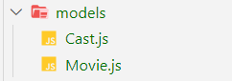

Database Persistence
All pages in the application should persist data to MongoDB & work with MongoDB.

Additional Pages
You should implement 2 new routes:
- /create/cast – should render the form for creating a cast form
- /attach/cast/:id – should render the cast page about attaching new cast to a movie,
and update the view on the /details/:id route that renders the movie details.
Use the provided resources to create the additional templates (and update the navigation accordingly) using Handlebars. Identify the dynamic parts and use appropriate syntax for interpolating and rendering the application context.

Add Cast Page View

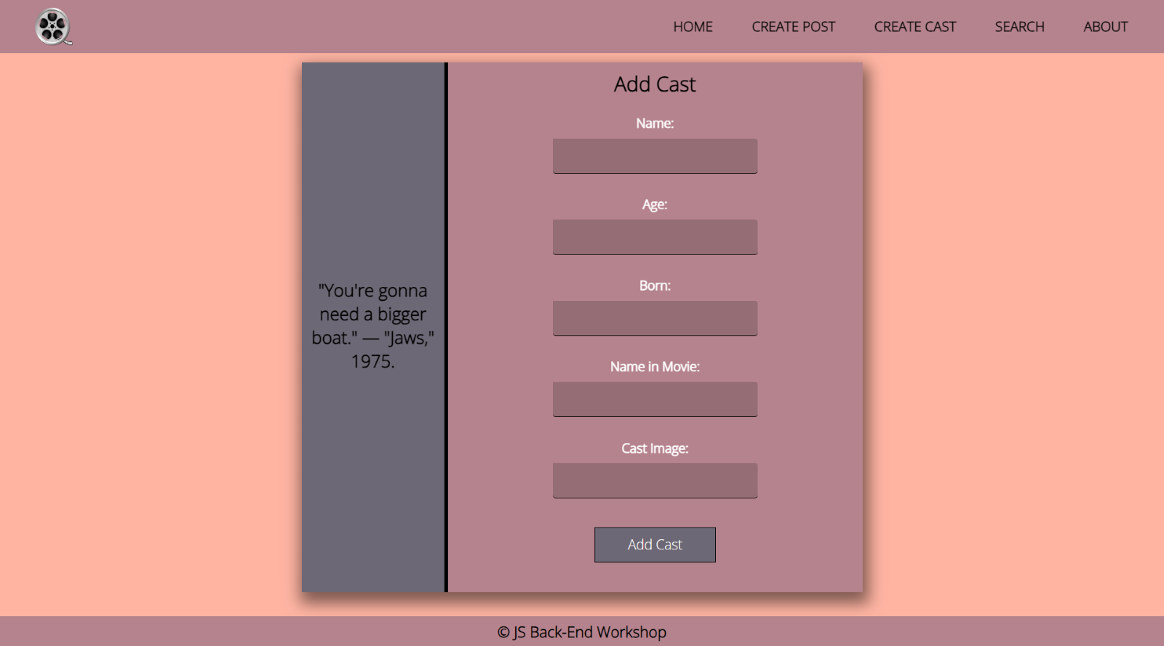Attach New Cast View
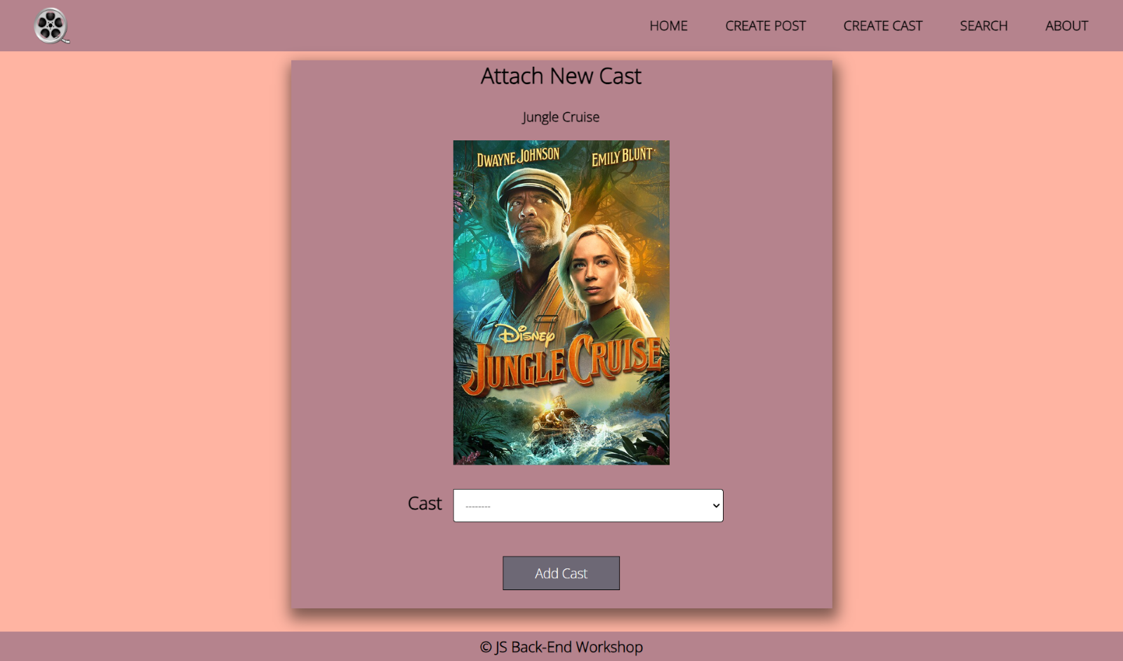

Updated Details Page View
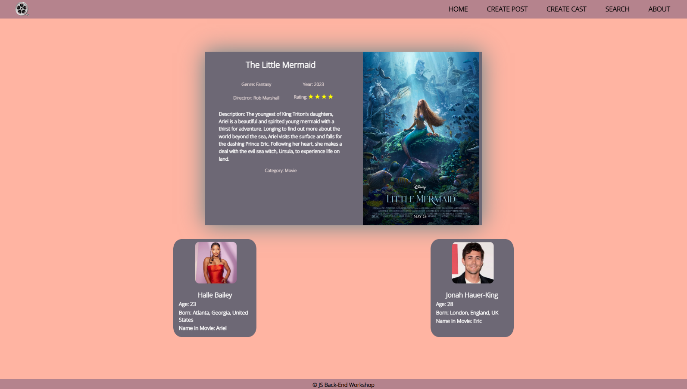
Good Luck! 😊

