Introduction to HTML and CSS - HTML Lab
Problems for exercises and homework for the "HTML and CSS" course @ SoftUni.

Topics Covered
- What is HTML?
- HTML Syntax
- Tags:
  - html, head, title, meta, body,
  - h1, h2, h3, h4, h5, h6, p, a, strong, em, ul, ol, li, dl, dt, dd, img, blockquote
  - main, aside, article, section, header, footer
  - details, summary, figure, caption

Resources
- HTML Element references on MDN:
  - https://developer.mozilla.org/en-US/docs/Web/HTML/Element
- HTML Basics
  - https://developer.mozilla.org/en-US/docs/Learn/Getting_started_with_the_web/HTML_basics
- Semantics:
  - https://developer.mozilla.org/en-US/docs/Glossary/Semantics
- W3 Validator:
  - https://validator.w3.org

Tasks

Simple HTML Document
Create an HTML Document and follow the requirements listed below to complete the task.
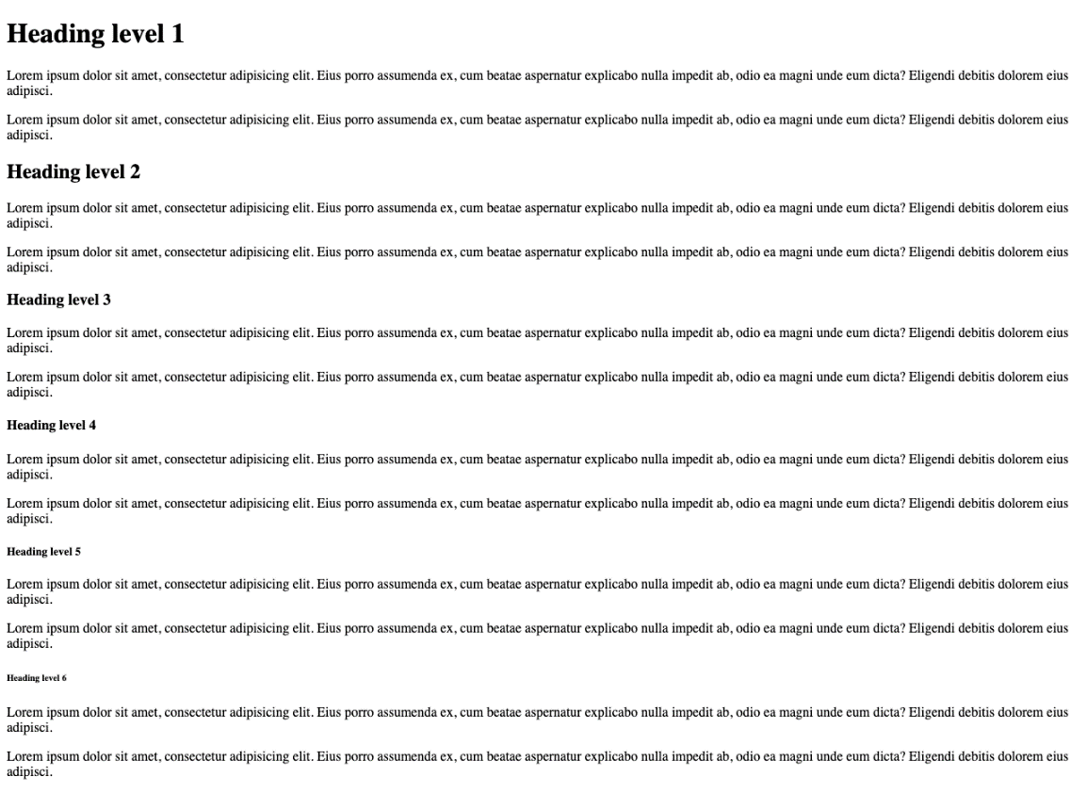

Requirements
- Use the copy provided in the text file.
- Create an HTML Document with html, head, title, body.
- Don't forget the Doctype declaration.
- Body needs to contain at 6 title – h1, h2, h3, h4, h5, h6.
- Body needs to contain at least 12 paragraphs.
- Place 2 paragraphs after each title.

Resources
- https://developer.mozilla.org/en-US/docs/Glossary/Doctype
- https://developer.mozilla.org/en-US/docs/Web/HTML/Element/html
- https://developer.mozilla.org/en-US/docs/Web/HTML/Element/head
- https://developer.mozilla.org/en-US/docs/Web/HTML/Element/title
- https://developer.mozilla.org/en-US/docs/Web/HTML/Element/body
- https://developer.mozilla.org/en-US/docs/Web/HTML/Element/Heading_Elements
- https://developer.mozilla.org/en-US/docs/Web/HTML/Element/p

Ordered & Unordered Lists
Create an HTML Document and follow the requirements listed below to complete the task.
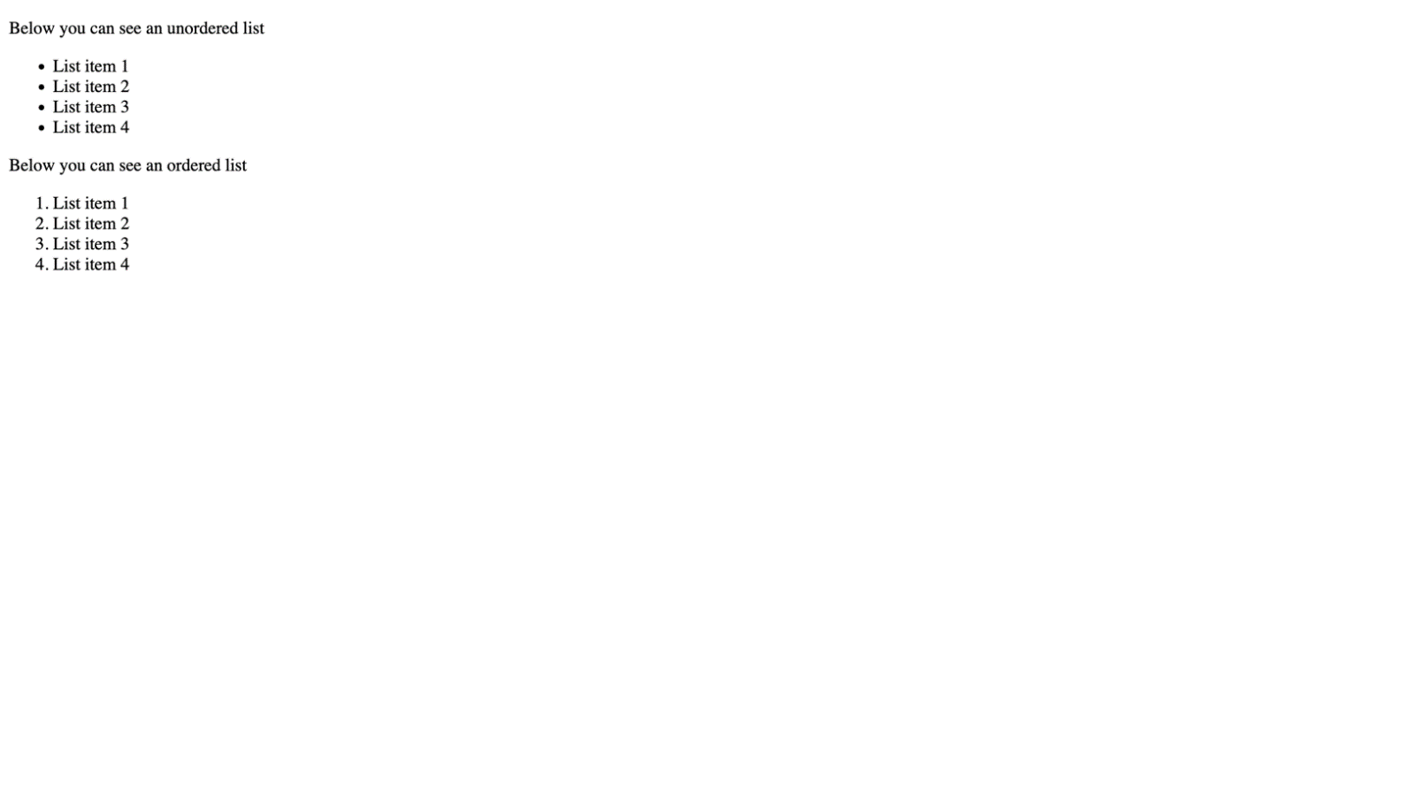

Requirements
- Use the copy provided in the text file.
- Body needs to contain 1 ul elements with 4 li elements each.
- Body needs to contain 1 ol element with 6 li elements each.

Resources
- https://developer.mozilla.org/en-US/docs/Web/HTML/Element/ul
- https://developer.mozilla.org/en-US/docs/Web/HTML/Element/ol
- https://developer.mozilla.org/en-US/docs/Web/HTML/Element/li

Nested Ordered & Unordered Lists
Create an HTML Document and follow the requirements listed below to complete the task.
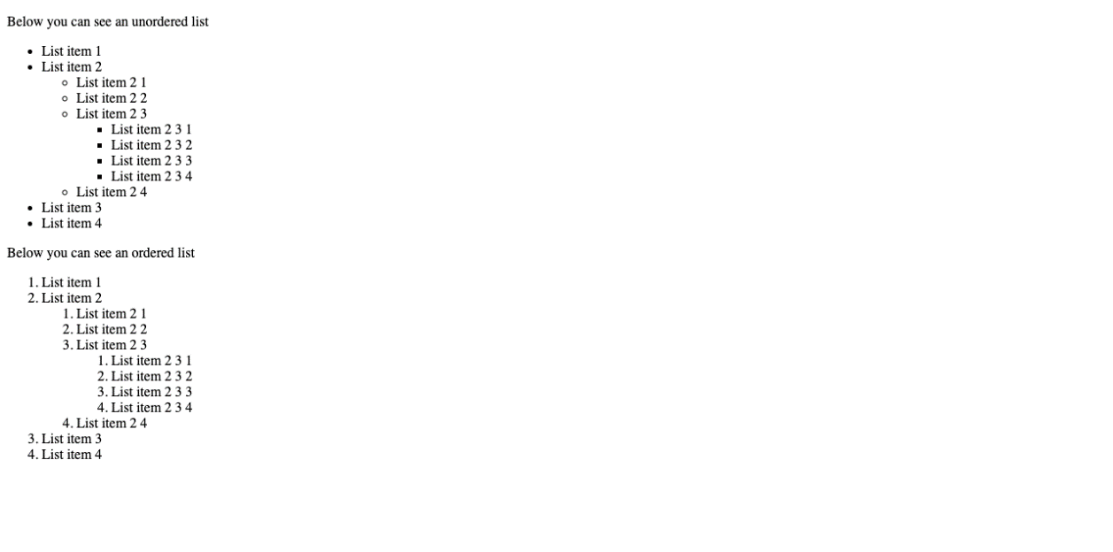

Requirements
- Use the copy provided in the text file.
- Body needs to contain 3 ul elements with 4 li elements each.
- ul elements should be nested in each other.
- The second li elements of the first-level ol should contain a ol.
- The third li elements of the second-level ol should contain a ol.

Resources
- https://developer.mozilla.org/en-US/docs/Web/HTML/Element/ul
- https://developer.mozilla.org/en-US/docs/Web/HTML/Element/ol
- https://developer.mozilla.org/en-US/docs/Web/HTML/Element/li

Definition List
Create an HTML Document and follow the requirements listed below to complete the task.
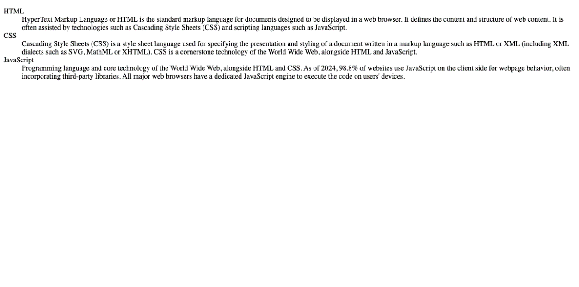

Requirements
- Use the copy provided in the text file.
- Body needs to contain 1 dl element, 3 dt elements and 3 dd elements.
- dt and dd elements should be inside the dl element.
- dd elements should follow a dl element.

Resources
- https://developer.mozilla.org/en-US/docs/Web/HTML/Element/dl
- https://developer.mozilla.org/en-US/docs/Web/HTML/Element/dt
- https://developer.mozilla.org/en-US/docs/Web/HTML/Element/dd

Marking Text – Links, Strong, Emphasis and more
Create an HTML Document and follow the requirements listed below to complete the task.
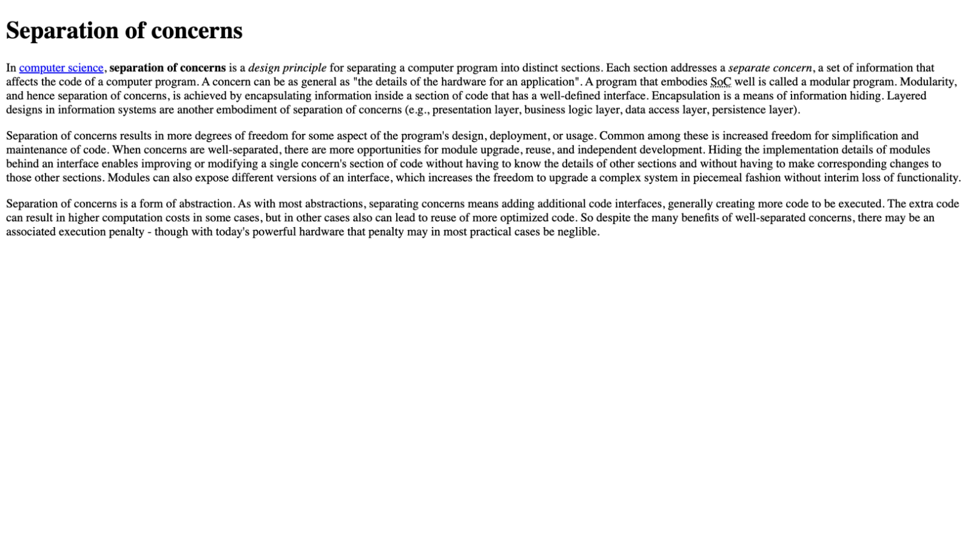

Requirements
- Use the copy provided in the file.
- Body element must contain:
  - 1 a element
  - 1 strong element
  - 1 em element
  - 1 abbr element

Resources
- https://developer.mozilla.org/en-US/docs/Web/HTML/Element/a
- https://developer.mozilla.org/en-US/docs/Web/HTML/Element/strong
- https://developer.mozilla.org/en-US/docs/Web/HTML/Element/em
- https://developer.mozilla.org/en-US/docs/Web/HTML/Element/cite
- https://developer.mozilla.org/en-US/docs/Web/HTML/Element/sup
- https://developer.mozilla.org/en-US/docs/Web/HTML/Element/abbr

Images
Create an HTML Document and follow the requirements listed below to complete the task.
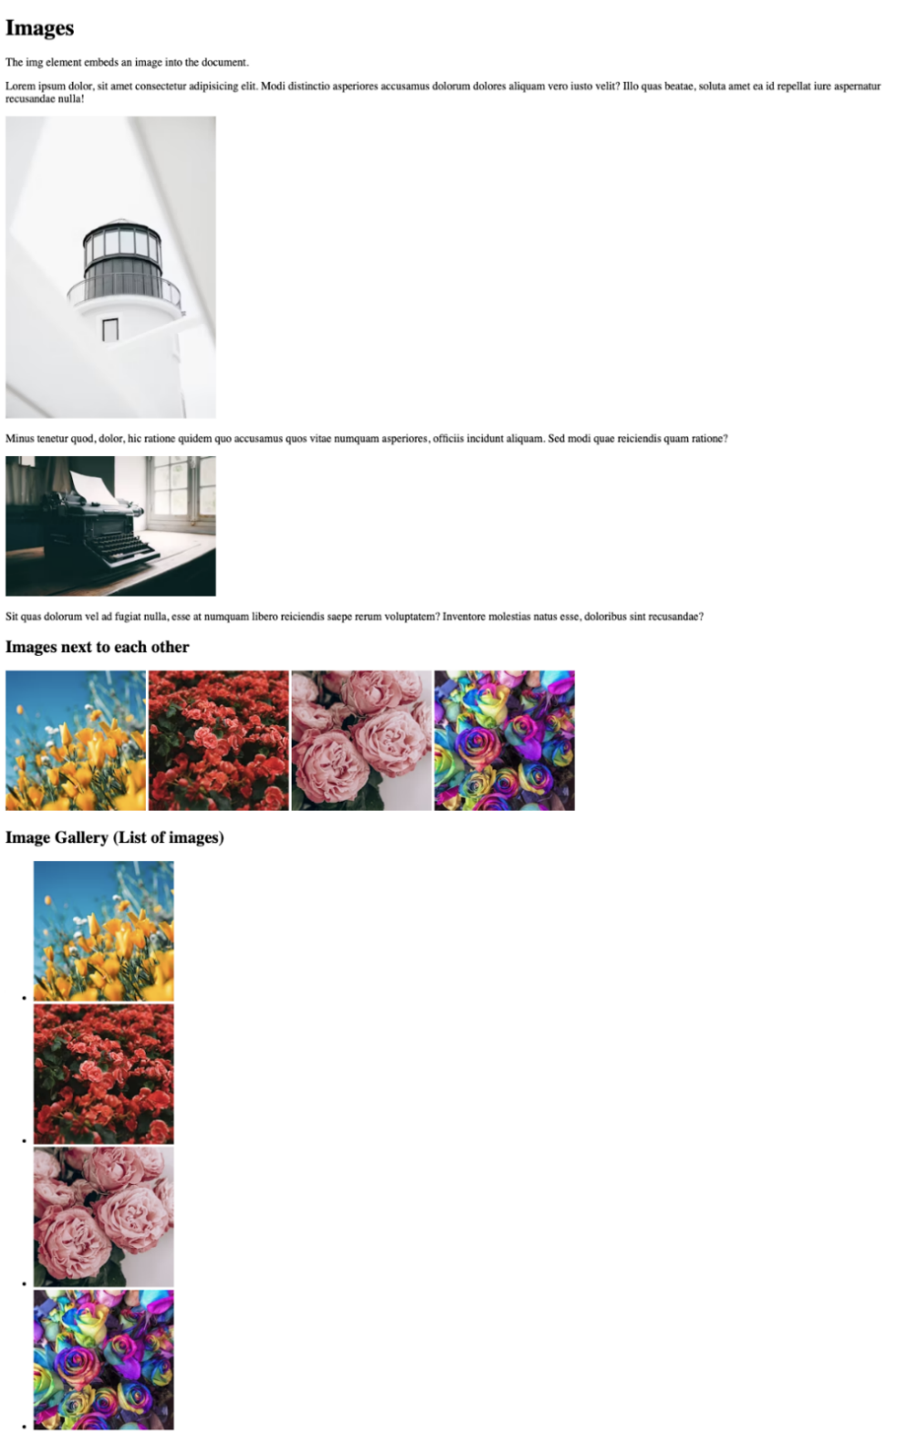

Requirements
- File Setup:
  - Create an HTML document named images.html
- HTML Requirements
  - Use img tag and get different images from unsplash.com
- Make sure you add one ul with li items and images inside

Resources
- https://developer.mozilla.org/en-US/docs/Web/HTML/Element/img

Semantic Tags – Header, Main, Footer
Create an HTML Document and follow the requirements listed below to complete the task.
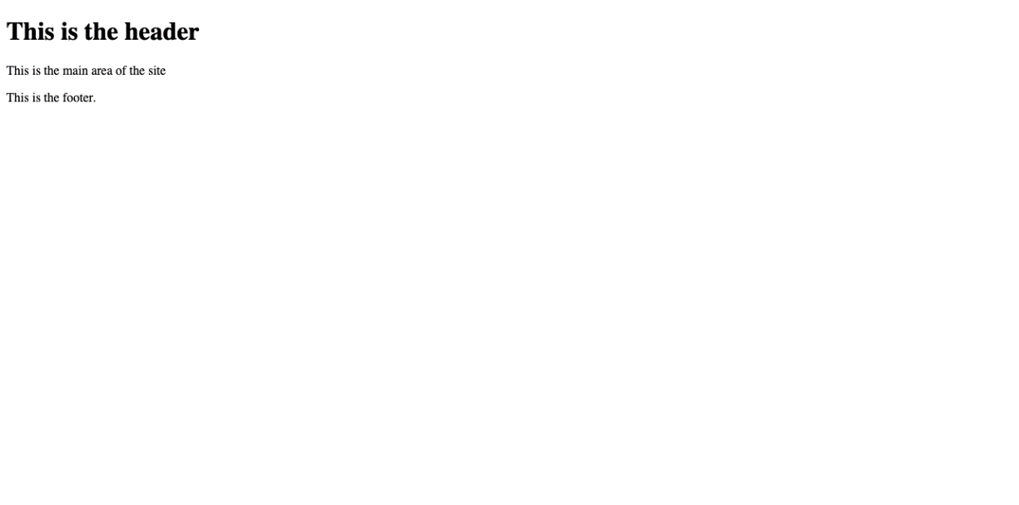

Requirements
- File Setup:
  - Create an HTML document named semantic-tags.html
- HTML Requirements
  - Create the simple document structure using the following tags:
    - header
    - main
    - footer

footerResources
- https://developer.mozilla.org/en-US/docs/Web/HTML/Element/header
- https://developer.mozilla.org/en-US/docs/Web/HTML/Element/footer
- https://developer.mozilla.org/en-US/docs/Web/HTML/Element/main

Semantic Tags – Article, Section
Create an HTML Document and follow the requirements listed below to complete the task.
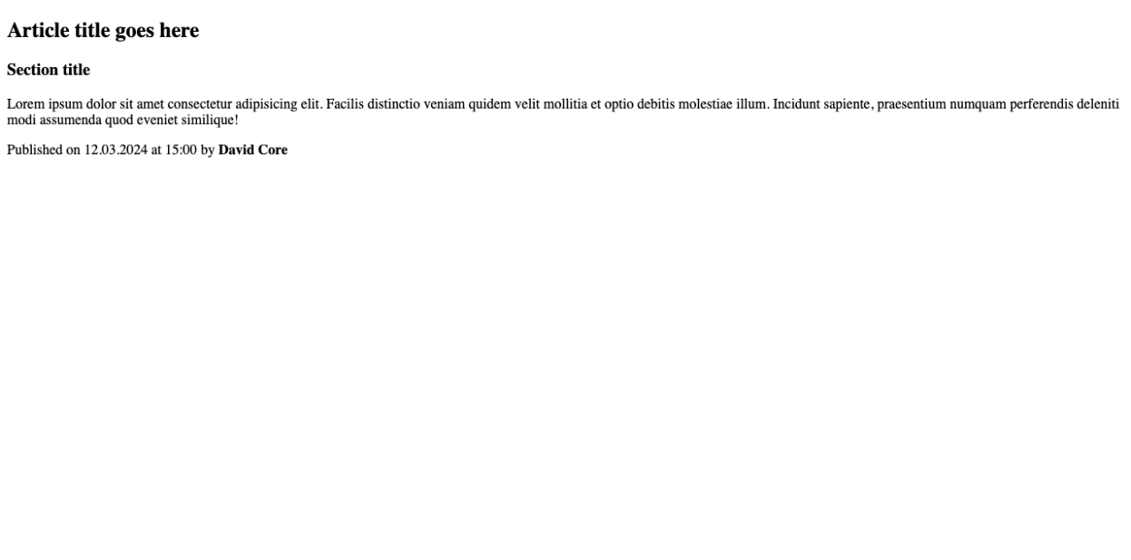

Requirements
- File Setup:
  - Create an HTML document named semantic-tags-part2.html
- HTML Requirements
  - Create the simple document structure using the following tags:
    - article
    - section

Resources
- https://developer.mozilla.org/en-US/docs/Web/HTML/Element/article
- https://developer.mozilla.org/en-US/docs/Web/HTML/Element/section

Semantic Tags – Details, Summary
Create an HTML Document and follow the requirements listed below to complete the task.


Requirements
- File Setup:
  - Create an HTML document named semantic-tags-part3.html
- HTML Requirements
  - Create the simple document structure using the following tags:
    - details
    - summary

Resources
- https://developer.mozilla.org/en-US/docs/Web/HTML/Element/details
- https://developer.mozilla.org/en-US/docs/Web/HTML/Element/summary

Semantic Tags – Figure, Figcaption
Create an HTML Document and follow the requirements listed below to complete the task.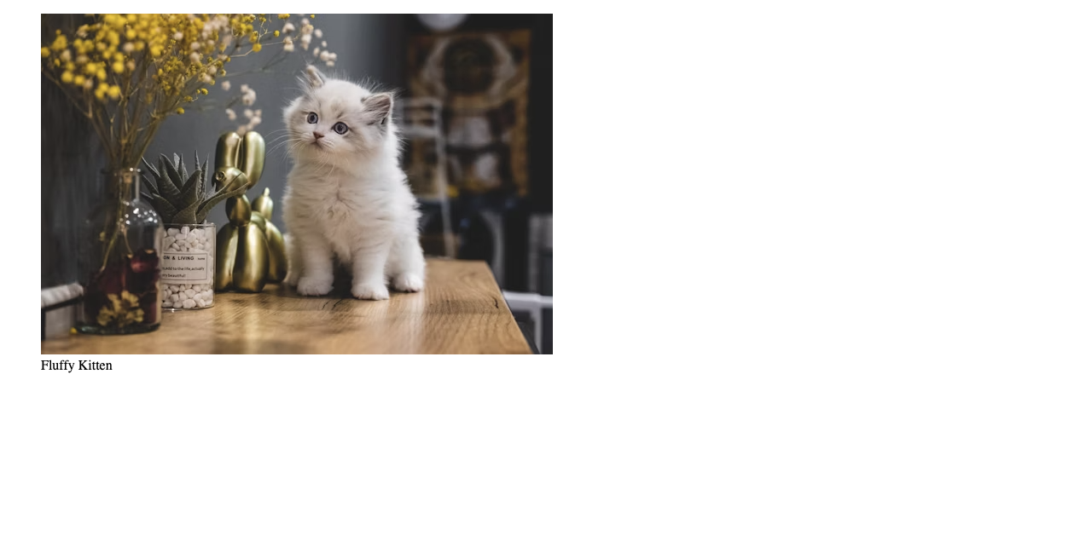

Requirements
- File Setup:
  - Create an HTML document named semantic-tags-part4.html
- HTML Requirements
  - Create the simple document structure using the following tags:
    - figure
    - figcaption

Resources
- https://developer.mozilla.org/en-US/docs/Web/HTML/Element/figure
- https://developer.mozilla.org/en-US/docs/Web/HTML/Element/figcaption

Semantic Tags – Nav
Create an HTML Document and follow the requirements listed below to complete the task.
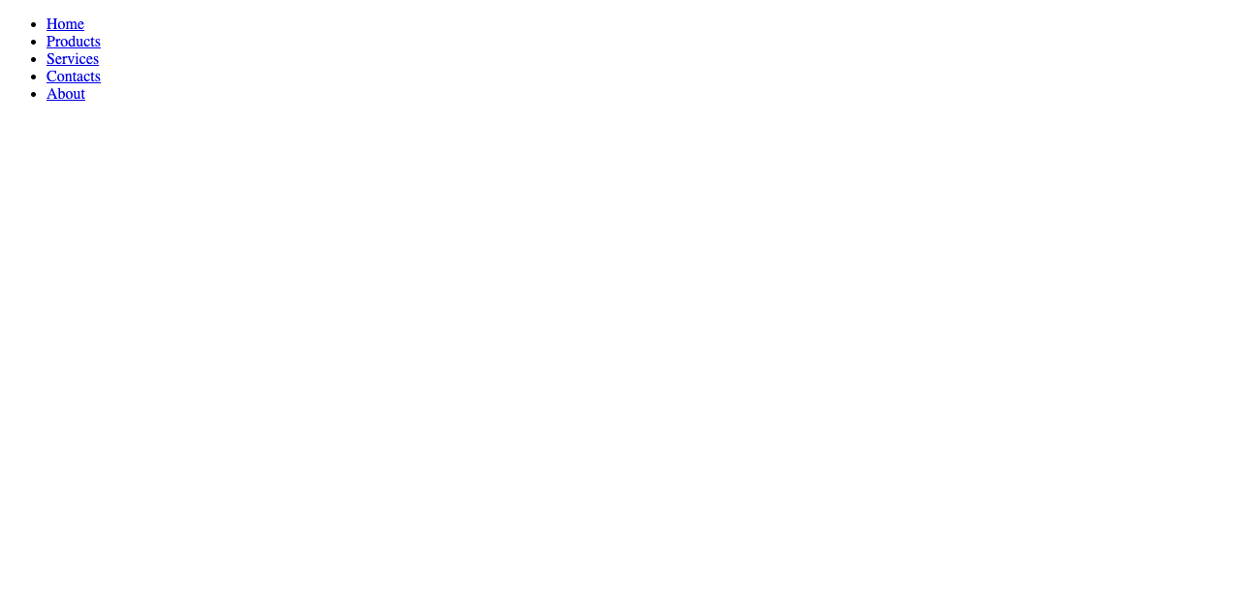

Requirements
- File Setup:
  - Create an HTML document named semantic-tags-nav.html
- HTML Requirements
  - Create the simple document structure using the following tags:
    - nav

Resources
- https://developer.mozilla.org/en-US/docs/Web/HTML/Element/nav

Semantic Tags – Time
Create an HTML Document and follow the requirements listed below to complete the task.
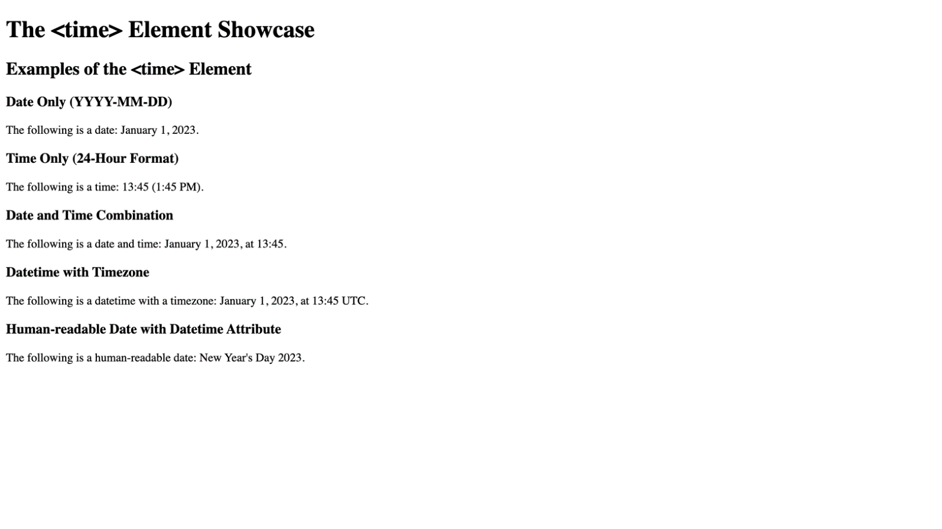

Requirements
- File Setup:
  - Create an HTML document named semantic-tags-time.html
- HTML Requirements
  - Create the simple document structure using the following tags:
    - time
- Display at least five different examples of the <time> element, including:
  - A date in the format "YYYY-MM-DD".
  - A time in the 24-hour format "HH:MM".
  - A date and time combination.
  - Each example should be accompanied by a brief description of what it represents, utilizing <p> elements for descriptions.

Resources
- https://developer.mozilla.org/en-US/docs/Web/HTML/Element/time

Semantic Tags – Blockquote
Create an HTML Document and follow the requirements listed below to complete the task.
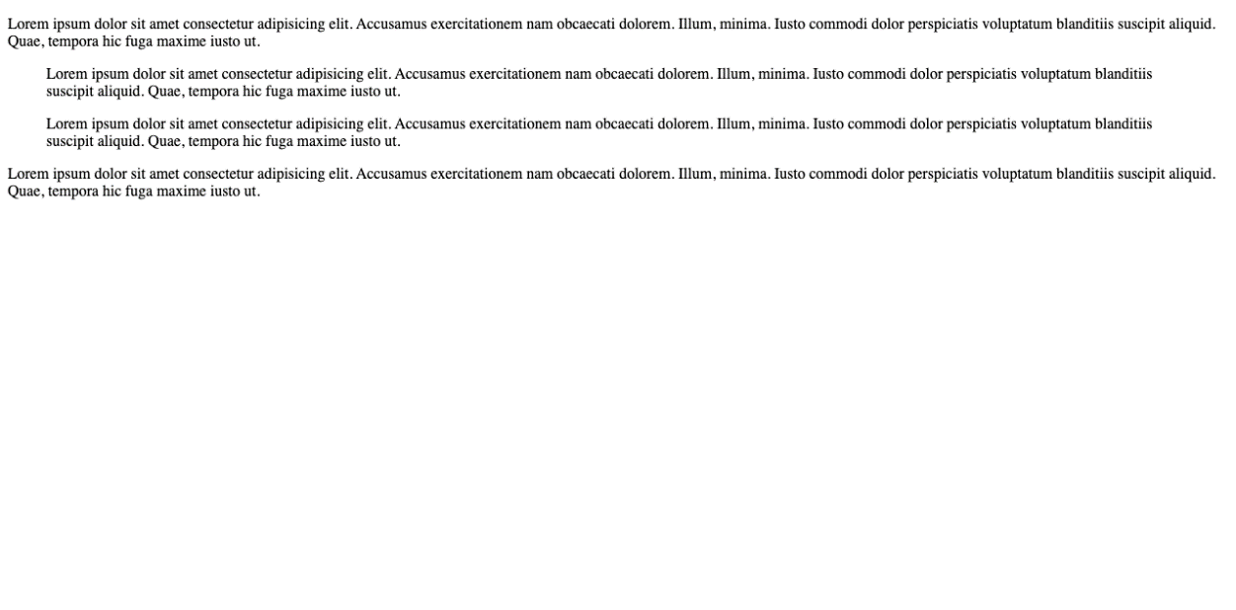

Requirements
- File Setup:
  - Create an HTML document named semantic-tags-blockquote.html
- HTML Requirements
  - Create the simple document structure using the following tags:
    - blockquote

Resources
- https://developer.mozilla.org/en-US/docs/Web/HTML/Element/blockquote

Wiki Article
Create an HTML Document and follow the requirements listed below to complete the task.
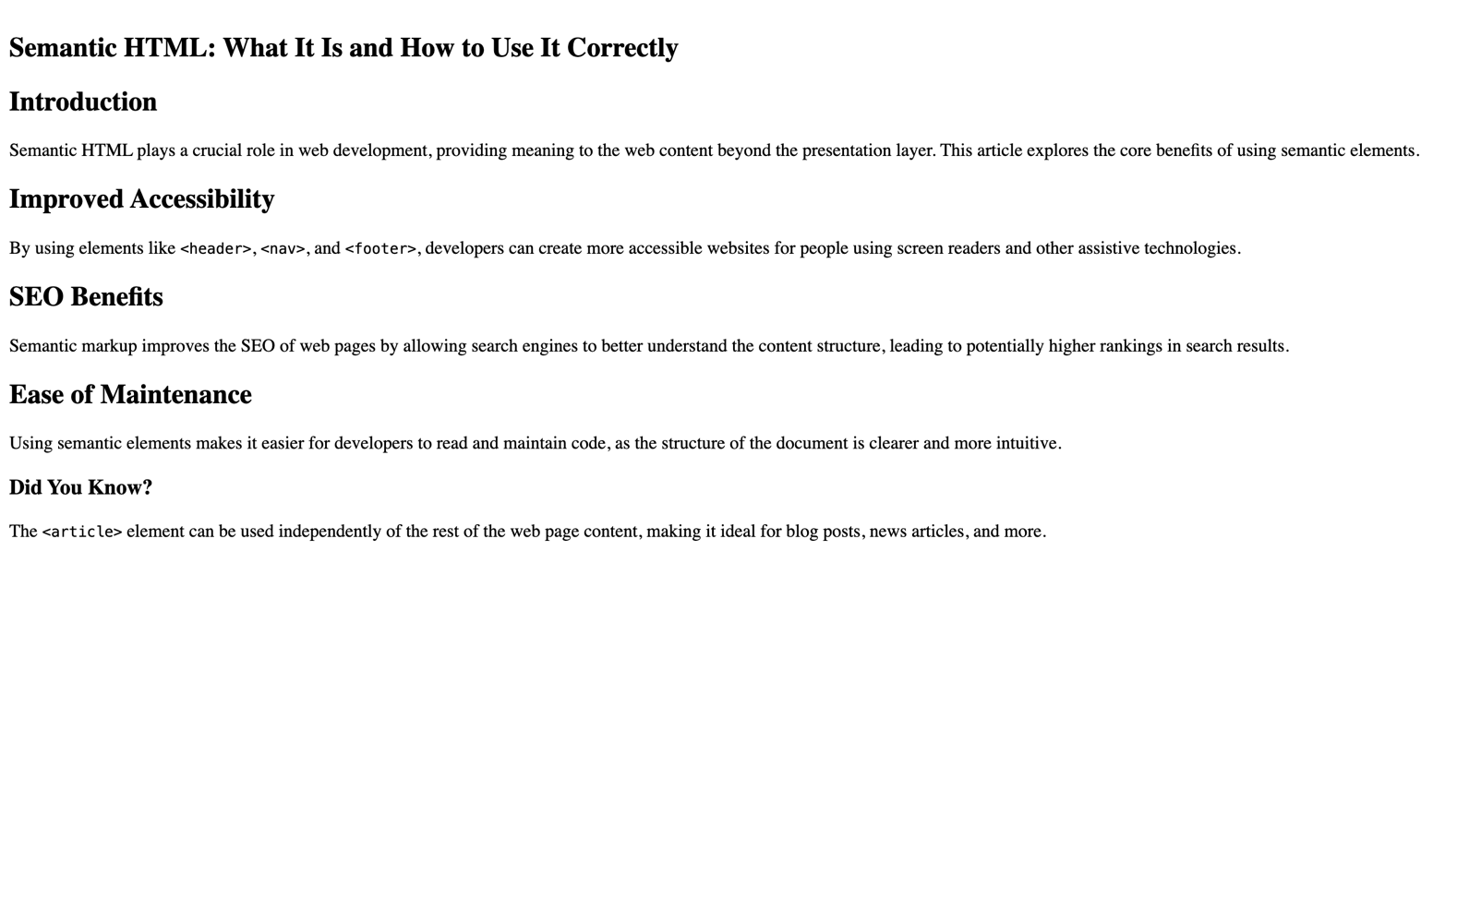
For full screenshot check the screenshot.png file in the folder for the task
Requirements:
- File Setup:
  - Create an HTML document named wiki-article.html

- HTML Requirements
  - Create the simple document structure using the following tags:
    - article
    - section
    - h2
    - p
  - Use the <article> tag to define the main content of your article.
  - Break your article into sections using the <section> tag, each with a heading <h2>
  - Ensure the main heading of your article is within an <h1> tag, placed inside the <article> tag.
  - Use <p> tags for paragraphs.

Resources
- https://developer.mozilla.org/en-US/docs/Web/HTML/Element/article
- https://developer.mozilla.org/en-US/docs/Web/HTML/Element/header
- https://developer.mozilla.org/en-US/docs/Web/HTML/Element/time
- https://developer.mozilla.org/en-US/docs/Web/HTML/Element/section
- https://developer.mozilla.org/en-US/docs/Web/HTML/Element/p
- https://developer.mozilla.org/en-US/docs/Web/HTML/Element/Heading_Elements

