Lab: Intro and Basic Syntax
Problems for in-class lab for the "C# Fundamentals" course @ SoftUni
You can check your solutions in Judge

Student Information
You will be given 3 lines of input – student name, age and average grade. Your task is to print all the info about the student in the following format: "Name: {student name}, Age: {student age}, Grade: {student grade}".

Examples
Input | Output
John  15  5.40 | Name: John, Age: 15, Grade: 5.40
Steve  16  2.50 | Name: Steve, Age: 16, Grade: 2.50
Marry  12  6.00 | Name: Marry, Age: 12, Grade: 6.00

Passed
Write a program, which takes as an input a grade and prints "Passed!" if the grade is equal or more than 3.00.

Input
The input comes as a single floating-point number.

Output
The output is either "Passed!" if the grade is equal or more than 3.00, otherwise you should print nothing.

Examples
Input | Output |  | Input | Output
5.32 | Passed! |  | 2.34 | (no output)

Solution
We need to take as an input a floating-point number from the console. We will use double.Parse() to convert string to double, which we receive from Console.ReadLine(). After that we compare the grade with 3.00 and prints the result only if the condition returns true.
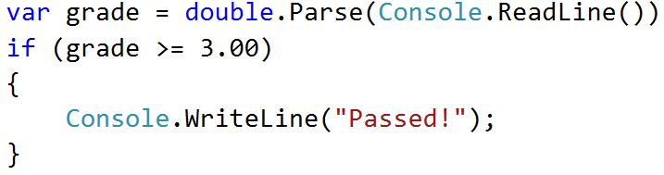

Passed or Failed
Modify the above program, so it will print "Failed!" if the grade is lower than 3.00.

Input
The input comes as a single double number.

Output
The output is either "Passed!" if the grade is more than 2.99, otherwise you should print "Failed!".

Examples
Input | Output |  | Input | Output
5.32 | Passed! |  | 2.36 | Failed!

Solution
Again, we need to take floating-point number from the console. After that print in the else statement the appropriate message.
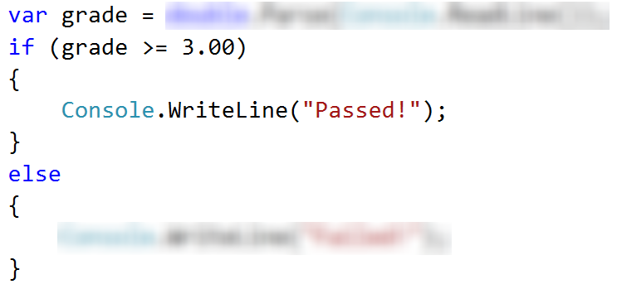

Back in 30 Minutes
Every time Stamat tries to pay his bills he sees on the cash desk the sign: "I will be back in 30 minutes". One day Stamat was sick of waiting and decided he needs a program, which prints the time after 30 minutes. That way he won’t have to wait on the desk and come at the appropriate time. He gave the assignment to you, so you have to do it.

Input
The input will be on two lines. On the first line, you will receive the hours and on the second you will receive the minutes.

Output
Print on the console the time after 30 minutes. The result should be in format hh:mm. The hours have one or two numbers and the minutes have always two numbers (with leading zero).

Constraints
- The hours will be between 0 and 23.
- The minutes will be between 0 and 59.

Examples
Input | Output |  | Input | Output |  | Input | Output |  | Input | Output |  | Input | Output
1  46 | 2:16 |  | 0  01 | 0:31 |  | 23  59 | 0:29 |  | 11  08 | 11:38 |  | 11  32 | 12:02

Hints
- Add 30 minutes to the initial minutes, which you receive from the console. If the minutes are more than 59 – increase the hours with 1 and decrease the minutes with 60. The same way check if the hours are more than 23. When you print check for leading zero.

Month Printer
Write a program, which takes an integer from the console and prints the corresponding month. If the number is more than 12 or less than 1 print "Error!".

Input
You will receive a single integer on a single line.

Output
If the number is within the boundaries print the corresponding month, otherwise print "Error!".

Examples
Input | Output |  | Input | Output
2 | February |  | 13 | Error!

Solution
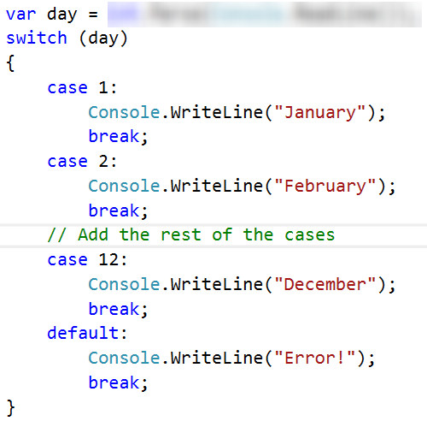

Foreign Languages
Write a program, which prints the language, that a given country speaks. You can receive only the following combinations: English is spoken in England and USA; Spanish is spoken in Spain, Argentina and Mexico; for the others, we should print "unknown".

Input
You will receive a single country name on a single line.

Output
Print the language, which the country speaks, or if it is unknown for your program, print "unknown".

Examples
Input | Output |  | Input | Output
USA | English |  | Germany | unknown

Hint
Think how you can merge multiple cases, in order to avoid writing more code than you need to.

Theatre Promotions
A theatre is doing a ticket sale, but they need a program to calculate the price of a single ticket. If the given age does not fit one of the categories, you should print "Error!". You can see the prices in the table below:
Day / Age | 0 <= age <= 18 | 18 < age <= 64 | 64 < age <= 122
Weekday | 12$ | 18$ | 12$
Weekend | 15$ | 20$ | 15$
Holiday | 5$ | 12$ | 10$

Input
The input comes in two lines. On the first line, you will receive the type of day. On the second – the age of the person.

Output
Print the price of the ticket according to the table, or "Error!" if the age is not in the table.

Constraints
- The age will be in the interval [-1000…1000].
- The type of day will always be valid.

Examples
Input | Output |  | Input | Output |  | Input | Output |  | Input | Output
Weekday  42 | 18$ |  | Holiday  -12 | Error! |  | Holiday  15 | 5$ |  | Weekend  122 | 15$

Solution

Step 1. Read the Input
We need to read two lines. First one will be the type of day. We will convert it to lower case letters with the method “ToLower()”. After that, we will read the age of the person and declare a variable – price, which we will use to set the price of the ticket.
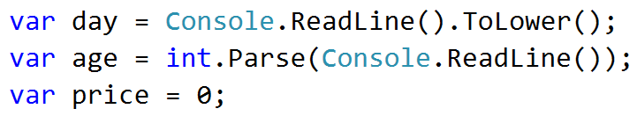
Step 2. Add If-else Statements for the Different Types of Day
For every type of day, we will need to add different cases to check the age of the person and set the price. Some of the age groups have equal prices for the same type of day. This means we can use logical operators to merge some of the conditions.
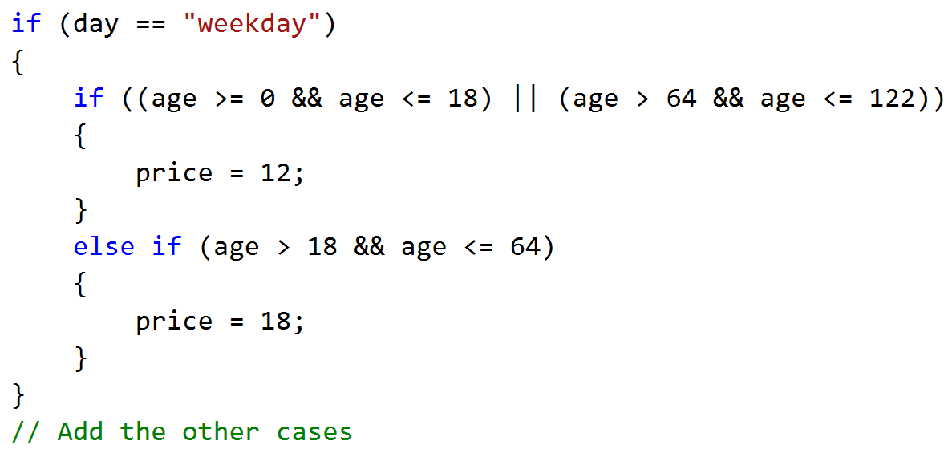
Think where and how you can use logical operators for the other cases.
Step 3. Print the Result
We can check if the price has a value different, than the initial one. If It it does, that means we got a valid combination of day and age and the price of the ticket is saved in the price variable. If the price has a value of 0, then none of the cases got hit, therefore we have to print the error message.
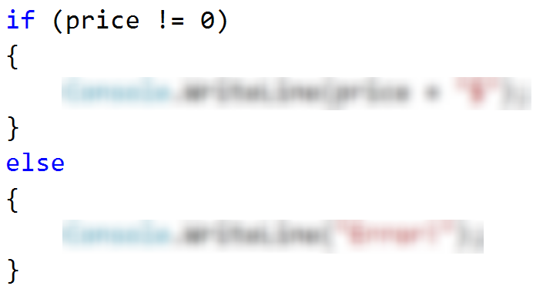

Divisible by 3
Write a program, which prints all the numbers from 1 to 100, which are divisible by 3. You have to use a single for loop. The program should not receive input.

Solution
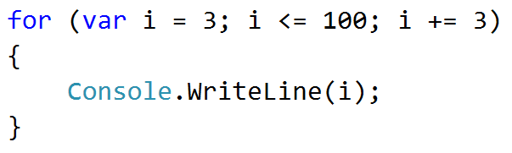

Sum of Odd Numbers
Write a program that prints the next n odd numbers (starting from 1) and on the last row prints the sum of them.

Input
On the first line, you will receive a number – n. This number shows how many odd numbers you should print.

Output
Print the next n odd numbers, starting from 1, separated by new lines. On the last line, print the sum of these numbers.

Constraints
- n will be in the interval [1…100]

Examples
Input | Output |  | Input | Output
5 | 1  3  5  7  9  Sum: 25 |  | 3 | 1  3  5  Sum: 9

Solution
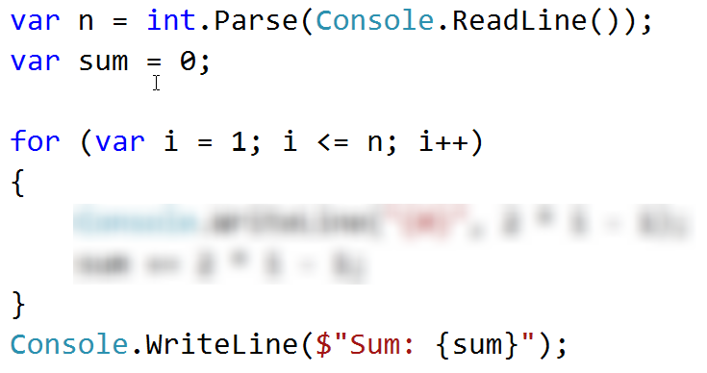

Multiplication Table
You will receive an integer as an input from the console. Print the 10 times table for this integer. See the examples below for more information.

Output
Print every row of the table in the following format:
{theInteger} X {times} = {product}

Constraints
- The integer will be in the interval [1…100]

Examples
Input | Output |  | Input | Output
5 | 5 X 1 = 5  5 X 2 = 10  5 X 3 = 15  5 X 4 = 20  5 X 5 = 25  5 X 6 = 30  5 X 7 = 35  5 X 8 = 40  5 X 9 = 45  5 X 10 = 50 |  | 2 | 2 X 1 = 2  2 X 2 = 4  2 X 3 = 6  2 X 4 = 8  2 X 5 = 10  2 X 6 = 12  2 X 7 = 14  2 X 8 = 16  2 X 9 = 18  2 X 10 = 20

Multiplication Table 2.0
Rewrite you program so it can receive the multiplier from the console. Print the table from the given multiplier to 10. If the given multiplier is more than 10 - print only one row with the integer, the given multiplier and the product. See the examples below for more information.

Output
Print every row of the table in the following format:
{theInteger} X {times} = {product}

Constraints
- The integer will be in the interval [1…100]

Examples
Input | Output |  | Input | Output |  | Input | Output
5  1 | 5 X 1 = 5  5 X 2 = 10  5 X 3 = 15  5 X 4 = 20  5 X 5 = 25  5 X 6 = 30  5 X 7 = 35  5 X 8 = 40  5 X 9 = 45  5 X 10 = 50 |  | 2  5 | 2 X 5 = 10  2 X 6 = 12  2 X 7 = 14  2 X 8 = 16  2 X 9 = 18  2 X 10 = 20 |  | 2  14 | 2 X 14 = 28

Even Number
Take as an input an even number and print its absolute value. If the number is odd, print "Please write an even number." and continue reading numbers.

Examples
Input | Output |  | Input | Output
1  3  6 | Please write an even number.  Please write an even number.  The number is: 6 |  | -6 | The number is: 6

Debug the Code: Holidays Between Two Dates
You are assigned to find and fix the bugs in an existing piece of code, using the Visual Studio debugger. You should trace the program execution to find the lines of code that produce incorrect or unexpected results.
You are given a program (existing source code) that aims to count the non-working days between two dates given in format day.month.year (e.g. between 1.05.2015 and 15.05.2015 there are 5 non-working days – Saturday and Sunday).

Examples
Input | Output | Comments
1.05.2016  15.05.2016 | 5 | There are 5 non-working days (Saturday / Sunday) in this period:  1-May-2016, 7-May-2016, 8-May-2016, 14-May-2016, 15-May-2016
1.5.2016  2.5.2016 | 1 | Only 1 non-working day in the specified period: 1.05.2016 (Sunday)
15.5.2020  10.5.2020 | 0 | The second date is before the first. No dates in the range.
22.2.2020  1.3.2020 | 4 | Two Saturdays and Sundays:  - 22.02.2020 and 23.02.2020  - 29.02.2020 and 1.03.2020
You can find the broken code in the judge system: Broken Code for Refactoring. It looks as follows:
HolidaysBetweenTwoDates.cs
using System;
using System.Globalization;

class HolidaysBetweenTwoDates
{
static void Main()
{
var startDate = DateTime.ParseExact(Console.ReadLine(),
"dd.m.yyyy", CultureInfo.InvariantCulture);
var endDate = DateTime.ParseExact(Console.ReadLine(),
"dd.m.yyyy", CultureInfo.InvariantCulture);
var holidaysCount = 0;
for (var date = startDate; date <= endDate; date.AddDays(1))
if (date.DayOfWeek == DayOfWeek.Saturday &&
date.DayOfWeek == DayOfWeek.Sunday) holidaysCount++;
Console.WriteLine(holidaysCount);
}
}

Hints
There are 4 mistakes in the code. You’ve got to use the debugger to find them and fix them. After you do that, submit your fixed code in the judge contest: https://judge.softuni.bg/Contests/Practice/Index/304#8.

