Lab: Methods
Problems for in-class lab for the "C# Fundamentals" course @ SoftUni
You can check your solutions in Judge

Declaring and Invoking Methods

Sign of Integer Numbers
Create a method that prints the sign of an integer number n:

Examples
Input | Output
2 | The number 2 is positive.
-5 | The number -5 is negative.
0 | The number 0 is zero.

Grades
Write a method that receives a grade between 2.00 and 6.00 and prints the corresponding grade in words
- 2.00 – 2.99 - "Fail"
- 3.00 – 3.49 - "Poor"
- 3.50 – 4.49 - "Good"
- 4.50 – 5.49 - "Very good"
- 5.50 – 6.00 - "Excellent"

Examples
Input | Output
3.33 | Poor
4.50 | Very good
2.99 | Fail

Hints
- Read the grade from the console and pass it to a method
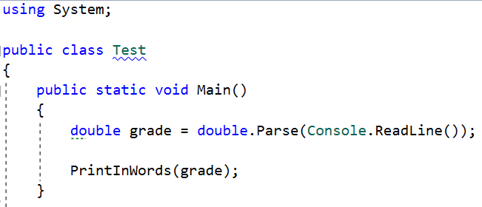
- Then create the method and make the if statements for each case
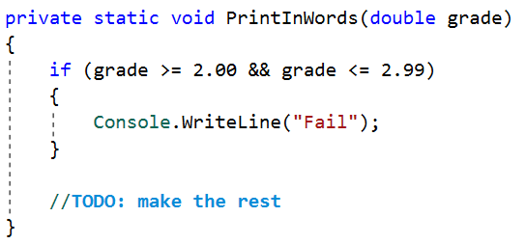

Calculations
Write a program that receives a string on the first line (add, multiply, subtract, divide) and on the next two lines receives two numbers. Create four methods (for each calculation) and invoke the right one depending on the command. The method should also print the result (needs to be void)

Example
Input | Output
subtract  5  4 | 1
divide  8  4 | 2

Hints
- Read the command on the first line and the two numbers, and then make an if/switch statement for each type of calculation
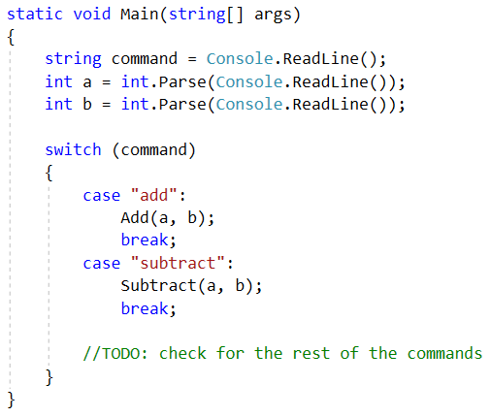
- Then create the four methods and print the result
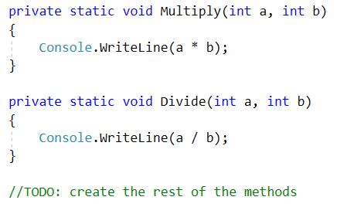

Printing Triangle
Create a method for printing triangles as shown below:

Examples
Input | Output
3 | 1  1 2  1 2 3  1 2  1
4 | 1  1 2  1 2 3  1 2 3 4  1 2 3  1 2  1

Hints
- After you read the input
- Start by creating a method for printing a single line from a given start to a given end. Choose a meaningful name for it, describing its purpose:
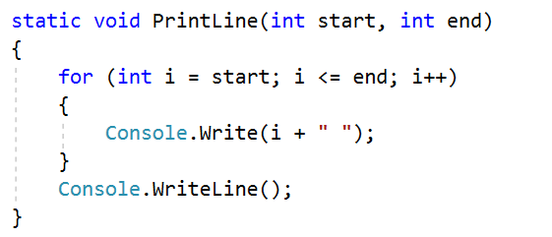
- Create another method for printing the whole triangle. Again choose a meaningful name for it, describing its purpose.
- Think how you can use the PrintLine() method to solve the problem
- After you spent some time thinking, you should have come to the conclusion that you will need two loops
- In the first loop you can print the first half of the triangle:
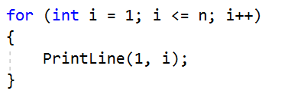
- In the second loop you can print the second half of the triangle:
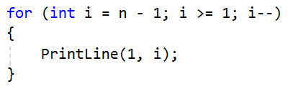

Orders
Write a method that calculates the total price of an order and prints it on the console. The method should receive one of the following products: coffee, coke, water, snacks; and a quantity of the product. The prices for a single piece of each product are:
- coffee – 1.50
- water – 1.00
- coke – 1.40
- snacks – 2.00
Print the result formatted to the second decimal place

Example
Input | Output
water  5 | 5.00
coffee  2 | 3.00

Hints
- Read the first two lines
- Create a method the pass the two variables in
- Print the result in the method

Returning Values and Overloading

Calculate Rectangle Area
Create a method that calculates and returns the area of a rectangle by given width and height:

Examples

Input | Output
3  4 | 12
6  2 | 12

Hints
- After reading the input
- Create a method, but this time instead of typing "static void" before its name, type "static double" as this will make it to return a value of type double:
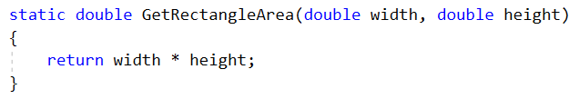
- Invoke the method in the main and save the return value in a new variable:
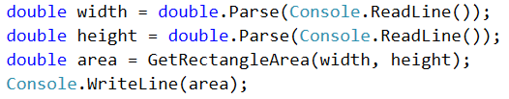

Repeat String
Write a method that receives a string and a repeat count n (integer). The method should return a new string (the old one repeated n times)

Example
Input | Output
abc  3 | abcabcabc
String  2 | StringString

Hints
- Firstly read the string and the repeat count n
- Then create the method and pass it the variables
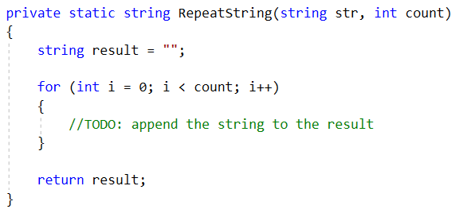
- In the main method, print the result

Math Power
Create a method that calculates and returns the value of a number raised to a given power:

Examples
Input | Output
2  8 | 256
3  4 | 81

Hints
- As usual, read the input
- Create a method which will have two parameters - the number and the power, and will return a result of type double:
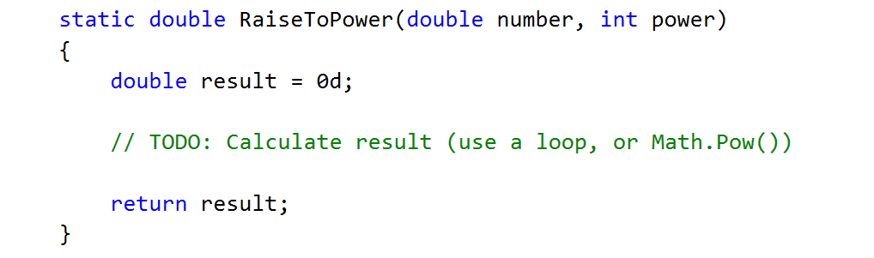
- Print the result

Greater of Two Values
Create a method GetMax() that returns the greater of two values (the values can be of type int, char or string)

Examples
Input | Output
int  2  16 | 16
char  a  z | z
string  aaa  bbb | bbb

Multiply Evens by Odds
Create a program that multiplies the sum of all even digits of a number by the sum of all odd digits of the same number:
- Create a method called GetMultipleOfEvenAndOdds()
- Create a method GetSumOfEvenDigits()
- Create GetSumOfOddDigits()
- You may need to use Math.Abs() for negative numbers

Examples
Input | Output | Comment
-12345 | 54 | Evens: 2 4  Odds: 1 3 5  Even sum: 6  Odd sum: 9  6 * 9 = 54
Math Operations
Write a method that receives two number and an operator, calculates the result and returns it. You will be given three lines of input. The first will be the first number, the second one will be the operator and the last one will be the second number. The possible operators are: / * + -
Print the result rounded up to the second decimal point.

Example
Input | Output
5  *  5 | 25
4  +  8 | 12

Hint
- Read the inputs and create a method that returns a double (the result of the operation)
