Databases Advanced Exam - 08 August 2020

Exam problems for the Databases Advanced - Entity Framework course @ SoftUni. Submit your solutions in the SoftUni judge system (delete all "bin"/"obj" and "packages" folders).
Your task is to create a database application, using Entity Framework Core, using the Code First approach. Design the domain models and methods for manipulating the data, as described below.

VaporStore
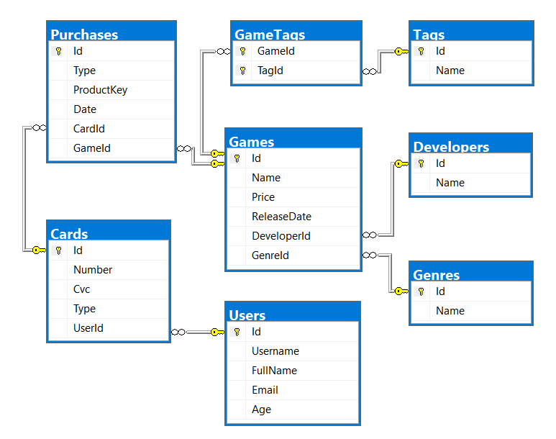

Project Skeleton Overview
You are given a project skeleton, which includes the following folders:
- Data – contains the VaporStoreDbContext class, Models folder which contains the entity classes and the Configuration class with connection string
- DataProcessor – contains the Serializer and Deserializer classes, which are used for importing and exporting data
- Datasets – contains the .json and .xml files for the import part
- ImportResults – contains the export results you make in the Deserializer class
- ExportResults – contains the import results you make in the Serializer class

Problem 1. Model Definition (50 pts)
Note: Foreign key navigation properties are required!
The application needs to store the following data:

Game
- Id – integer, Primary Key
- Name – text (required)
- Price – decimal (non-negative, minimum value: 0) (required)
- ReleaseDate – Date (required)
- DeveloperId – integer, foreign key (required)
- Developer – the game’s developer (required)
- GenreId – integer, foreign key (required)
- Genre – the game’s genre (required)
- Purchases - collection of type Purchase
- GameTags - collection of type GameTag. Each game must have at least one tag.

Developer
- Id – integer, Primary Key
- Name – text (required)
- Games - collection of type Game

Genre
- Id – integer, Primary Key
- Name – text (required)
- Games - collection of type Game

Tag
- Id – integer, Primary Key
- Name – text (required)
- GameTags - collection of type GameTag

GameTag
- GameId – integer, Primary Key, foreign key (required)
- Game – Game
- TagId – integer, Primary Key, foreign key (required)
- Tag – Tag

User
- Id – integer, Primary Key
- Username – text with length [3, 20] (required)
- FullName – text, which has two words, consisting of Latin letters. Both start with an upper letter and are followed by lower letters. The two words are separated by a single space (ex. "John Smith") (required)
- Email – text (required)
- Age – integer in the range [3, 103] (required)
- Cards – collection of type Card

Card
- Id – integer, Primary Key
- Number – text, which consists of 4 pairs of 4 digits, separated by spaces (ex. “1234 5678 9012 3456”) (required)
- Cvc – text, which consists of 3 digits (ex. “123”) (required)
- Type – enumeration of type CardType, with possible values (“Debit”, “Credit”) (required)
- UserId – integer, foreign key (required)
- User – the card’s user (required)
- Purchases – collection of type Purchase

Purchase
- Id – integer, Primary Key
- Type – enumeration of type PurchaseType, with possible values (“Retail”, “Digital”) (required)
- ProductKey – text, which consists of 3 pairs of 4 uppercase Latin letters and digits, separated by dashes (ex. “ABCD-EFGH-1J3L”) (required)
- Date – Date (required)
- CardId – integer, foreign key (required)
- Card – the purchase’s card (required)
- GameId – integer, foreign key (required)
- Game – the purchase’s game (required)

Problem 2. Data Import (30pts)
For the functionality of the application, you need to create several methods that manipulate the database. The project skeleton already provides you with these methods, inside the Deserializer class. Usage of Data Transfer Objects is optional.
Use the provided JSON and XML files to populate the database with data. Import all the information from those files into the database.
You are not allowed to modify the provided JSON and XML files.
If a record does not meet the requirements from the first section, print an error message:
Error message
Invalid Data

JSON Import (20 pts)

Import Games, Developers, Genres and Tags
Using the file games.json, import the data from that file into the database. Print information about each imported object in the format described below.

Constraints
- If any validation errors occur (such as if a Price is negative, a Name/ReleaseDate/Developer/Genre is missing, Tags are missing or empty), do not import any part of the entity and append an error message to the method output.
- Dates are always in the format “yyyy-MM-dd”. Do not forget to use CultureInfo.InvariantCulture!
- If a developer/genre/tag with that name doesn’t exist, create it.
- If a game is invalid, do not import its genre, developer or tags.

Example
games.json
[
{
"Price": 0,
"ReleaseDate": "2013-07-09",
"Developer": "Valid Dev",
"Genre": "Valid Genre",
"Tags": ["Valid Tag"]
},
{
"Name": "Invalid",
"Price": -5,
"ReleaseDate": "2013-07-09",
"Developer": "Valid Dev",
"Genre": "Valid Genre",
"Tags": ["Valid Tag"]
},
{
"Name": "Invalid",
"Price": 0,
"ReleaseDate": "2013-07-09",
"Genre": "Valid Genre",
"Tags": ["Valid Tag"]
},
{
"Name": "Invalid",
"Price": 0,
"ReleaseDate": "2013-07-09",
"Developer": "Valid Dev",
"Tags": ["Valid Tag"]
},
{
"Name": "Invalid",
"Price": 0,
"ReleaseDate": "2013-07-09",
"Developer": "Valid Dev",
"Genre": "Valid Genre",
"Tags": []
},
{
"Name": "Dota 2",
"Price": 0,
"ReleaseDate": "2013-07-09",
"Developer": "Valve",
"Genre": "Action",
"Tags": [
"Multi-player",
"Co-op",
"Steam Trading Cards",
"Steam Workshop",
"SteamVR Collectibles",
"In-App Purchases",
"Valve Anti-Cheat enabled"
]
},
...
]
Output
Invalid Data
Invalid Data
Invalid Data
Invalid Data
Invalid Data
Added Dota 2 (Action) with 7 tags
...
Upon successful import you should print "Added {gameName} ({gameGenre}) with {tagsCount} tags"!
Upon correct import logic, you should have imported 74 games, 66 developers, 12 genres and 25 tags.

Import Users and Cards
Using the file users.json, import the data from that file into the database. Print information about each imported object in the format described below.

Constraints
- If any validation errors occur (such as invalid full name, too short/long username, missing email, too low/high age, incorrect card number/CVC, no cards, etc.), do not import any part of the entity and append an error message to the method output.
- If any validation errors occur with card entity (such as invalid number/CVC, invalid Type) you should not import any part of the User entity holding this card and append an error message to the method output.

Example
users.json
[
{
"FullName": "",
"Username": "invalid",
"Email": "invalid@invalid.com",
"Age": 20,
"Cards": [
{
"Number": "1111 1111 1111 1111",
"CVC": "111",
"Type": "Debit"
}
]
},
{
"FullName": "Invalid Invalidman",
"Username": "",
"Email": "invalid@invalid.com",
"Age": 20,
"Cards": [
{
"Number": "1111 1111 1111 1111",
"CVC": "111",
"Type": "Debit"
}
]
},
{
"FullName": "Invalid Invalidman",
"Username": "invalid",
"Email": "",
"Age": 20,
"Cards": [
{
"Number": "1111 1111 1111 1111",
"CVC": "111",
"Type": "Debit"
}
]
},
{
"FullName": "Invalid Invalidman",
"Username": "invalid",
"Email": "invalid@invalid.com",
"Age": 2,
"Cards": [
{
"Number": "1111 1111 1111 1111",
"CVC": "111",
"Type": "Debit"
}
]
},
{
"FullName": "Invalid Invalidman",
"Username": "invalid",
"Email": "invalid@invalid.com",
"Age": 104,
"Cards": [
{
"Number": "1111 1111 1111 1111",
"CVC": "111",
"Type": "Debit"
}
]
},
{
"FullName": "Lorrie Silbert",
"Username": "lsilbert",
"Email": "lsilbert@yahoo.com",
"Age": 33,
"Cards": [
{
"Number": "1833 5024 0553 6211",
"CVC": "903",
"Type": "Debit"
},
{
"Number": "5625 0434 5999 6254",
"CVC": "570",
"Type": "Credit"
},
{
"Number": "4902 6975 5076 5316",
"CVC": "091",
"Type": "Debit"
}
]
},
{
"FullName": "Anita Ruthven",
"Username": "aruthven",
"Email": "aruthven@gmail.com",
"Age": 75,
"Cards": [
{
"Number": "5208 8381 5687 8508",
"CVC": "624",
"Type": "Debit"
}
]
},
...
]
Output
Invalid Data
Invalid Data
Invalid Data
Invalid Data
Invalid Data
Imported lsilbert with 3 cards
Imported aruthven with 1 cards
Upon successful import you should print "Imported {username} with {cardsCount} cards"!
Upon correct import logic, you should have imported 30 users and 61 cards.

XML Import (10 pts)

Import Purchases
Using the file purchases.xml, import the data from the file into the database. Print information about each imported object in the format described below.

Constraints
- If there are any validation errors, do not import any part of the entity and append an error message to the method output.
- Dates will always be in the format: “dd/MM/yyyy HH:mm”. Do not forget to use CultureInfo.InvariantCulture!

Example
purchases.xml
<Purchases>
<Purchase title="Dungeon Warfare 2">
<Type>Digital</Type>
<Key>ZTZ3-0D2S-G4TJ</Key>
<Card>1833 5024 0553 6211</Card>
<Date>07/12/2016 05:49</Date>
</Purchase>
<Purchase title="The Crew 2">
<Type>Retail</Type>
<Key>DCU0-S60G-NTQJ</Key>
<Card>5208 8381 5687 8508</Card>
<Date>22/01/2017 09:33</Date>
</Purchase>
<Purchase title="Slay the Spire">
<Type>Digital</Type>
<Key>KIJH-7JG6-0BHP</Key>
<Card>5208 8381 5687 8508</Card>
<Date>11/01/2018 19:46</Date>
</Purchase>
...
</Purchases>
Output
Imported Dungeon Warfare 2 for lsilbert
Imported The Crew 2 for aruthven
Imported Slay the Spire for aruthven
...
Upon successful import you should print "Imported {gameName} for {username}"!
Upon correct import logic, you should have imported 88 purchases.

Problem 3. Data Export (20 pts)
Use the provided methods in the Serializer class. Usage of Data Transfer Objects is optional.

JSON Export (10 pts)

Export All Games by Genres
The given method in the project skeleton receives an array of genre names. Export all games in those genres, which have any purchases. For each genre, export its id, genre name, games and total players (total purchase count). For each game, export its id, name, developer, tags (separated by ", ") and total player count (purchase count). Order the games by player count (descending), then by game id (ascending).
Order the genres by total player count (descending), then by genre id (ascending)

Example
Serializer.ExportGamesByGenres(context, new[] { "Nudity", "Violent" })
[
{
"Id": 4,
"Genre": "Violent",
"Games": [
{
"Id": 49,
"Title": "Warframe",
"Developer": "Digital Extremes",
"Tags": "Single-player, In-App Purchases, Steam Trading Cards, Co-op, Multi-player, Partial Controller Support",
"Players": 6
},
{
"Id": 22,
"Title": "Soul at Stake",
"Developer": "Chongming Studio",
"Tags": "Co-op, Multi-player, Online Multi-Player, Steam Cloud, Online Co-op",
"Players": 2
},
{
"Id": 40,
"Title": "Black Desert Online",
"Developer": "Pearl Abyss",
"Tags": "In-App Purchases, Steam Trading Cards, Online Multi-Player, Online Co-op, MMO, Partial Controller Support",
"Players": 1
},
{
"Id": 71,
"Title": "Dead by Daylight",
"Developer": "Behaviour Digital Inc.",
"Tags": "Steam Trading Cards, Co-op, Multi-player, Steam Achievements, Online Multi-Player, Full controller support, Steam Cloud, Online Co-op",
"Players": 1
}
],
"TotalPlayers": 10
}
...
]

XML Export (10 pts)

Export User Purchases by Type
Use the method provided in the project skeleton, which receives a purchase type as a string. Export all users who have any purchases. For each user, export their username, purchases for that purchase type and total money spent for that purchase type. For each purchase, export its card number, CVC, date in the format "yyyy-MM-dd HH:mm" (make sure you use CultureInfo.InvariantCulture) and the game. For each game, export its title (name), genre and price. Order the users by total spent (descending), then by username (ascending). For each user, order the purchases by date (ascending). Do not export users, who don’t have any purchases.
Note: All prices must be in decimal without any formatting!

Example
Serializer.ExportUserPurchasesByType(context, "Digital")
<Users>
<User username="mgraveson">
<Purchases>
<Purchase>
<Card>7991 7779 5123 9211</Card>
<Cvc>340</Cvc>
<Date>2017-08-31 17:09</Date>
<Game title="Counter-Strike: Global Offensive">
<Genre>Action</Genre>
<Price>12.49</Price>
</Game>
</Purchase>
<Purchase>
<Card>7790 7962 4262 5606</Card>
<Cvc>966</Cvc>
<Date>2018-02-28 08:38</Date>
<Game title="Tom Clancy's Ghost Recon Wildlands">
<Genre>Action</Genre>
<Price>59.99</Price>
</Game>
</Purchase>
</Purchases>
<TotalSpent>72.48</TotalSpent>
</User>
<User username="vsjollema">
<Purchases>
<Purchase>
<Card>8608 6806 8238 3092</Card>
<Cvc>081</Cvc>
<Date>2017-10-01 01:14</Date>
<Game title="Garry's Mod">
<Genre>Indie</Genre>
<Price>9.99</Price>
</Game>
</Purchase>
<Purchase>
<Card>4846 1275 4235 3039</Card>
<Cvc>268</Cvc>
<Date>2017-11-12 03:51</Date>
<Game title="Total War: WARHAMMER II">
<Genre>Action</Genre>
<Price>59.99</Price>
</Game>
</Purchase>
</Purchases>
<TotalSpent>69.98</TotalSpent>
</User>
...
</Users>

