02. Build Dreams
You are given an unresponsive website (HTML + CSS + images). Your task is to make the site responsive.
The site layout should change according to the browser viewport / screen size.
You need to implement 1 layout: width <= 600p. The figures below represent this layout:
- width <= 600px (mobile)
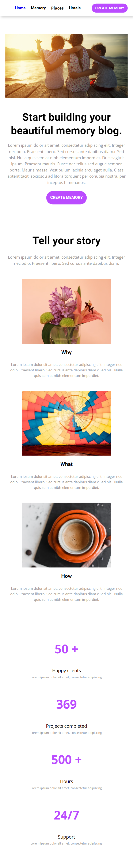

Output
The output should be valid HTML5 + CSS3 + images that implement the above responsive site.

Constraints
- You should write styles only in responsive.css file.
- The site should open correctly in the latest version of Chrome

