CreateArt
Create a Web page (HTML5 + CSS3 + images) that looks and behaves like the screenshot below:
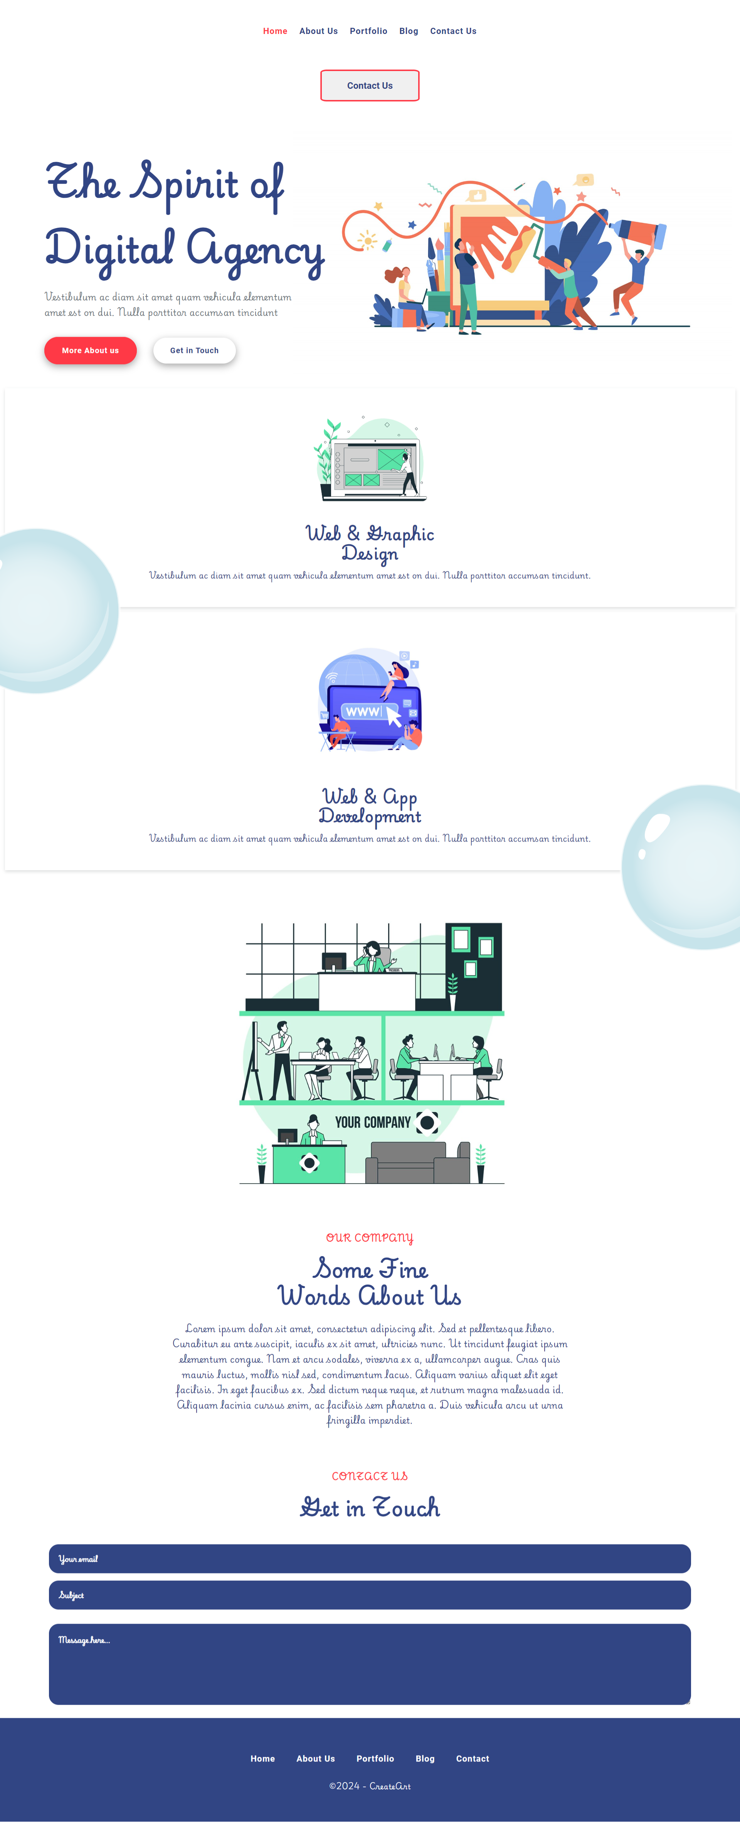
You are given the above screenshots + all required images.

Output
The output should be valid HTML5 + CSS3 + images that implement the above web page.

Constraints
- Use font 'Playwrite PE' for the text and font 'Roboto' for the buttons – (https://fonts.googleapis.com/css2?family=Playwrite+PE:wght@100..400&display=swap)
(https://fonts.googleapis.com/css2?family=Roboto:ital,wght@0,100;0,300;0,400;0,500;0,700;0,900;1,100;1,300;1,400;1,500;1,700;1,900&display=swap)
- The site should open correctly in the latest version of Chrome

