Responsive Web Design – Lab
Problems for exercises and homework for the "HTML and CSS" course @ SoftUni.

Topics Covered
Responsive web design (RWD) is a web design approach to make web pages render well on all screen sizes and resolutions while ensuring good usability. It is the way to design for a multi-device web. In this article, we'll help you understand some techniques that can be used to master it.

Resources
- Responsive design
  - https://developer.mozilla.org/en-US/docs/Learn/CSS/CSS_layout/Responsive_Design
- Beginner's guide to media queries
  - https://developer.mozilla.org/en-US/docs/Learn/CSS/CSS_layout/Media_queries

Media Types

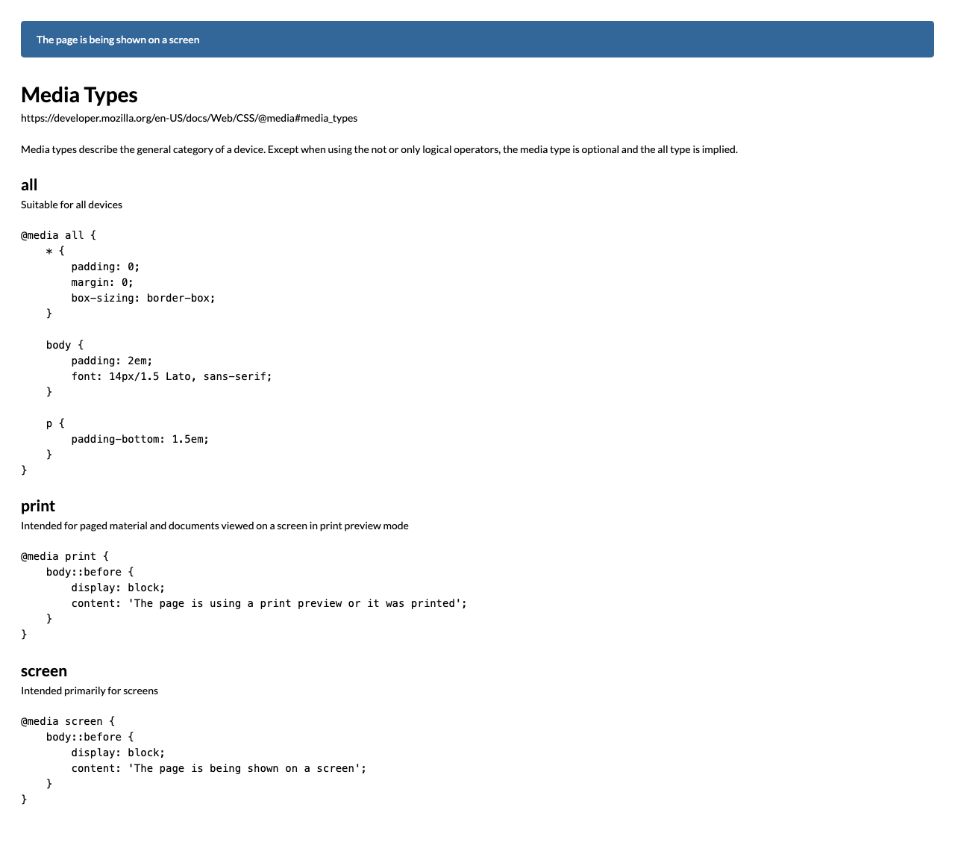
For full screenshot check the screenshot.png file in the folder for the task
Objective:
Create a webpage that looks like the screenshot above.

Requirements:
- File Setup:
  - Create an HTML document named media-types.html
  - Create a CSS file named media-types.css
- Element creation
  - Add title of the page in an <h1> element
  - Add <h2> elements and p elements for each <h2> as shown on the screenshot
- Styling
  - Add the standard reset styling – padding, margin, box-sizing
  - Add the following styles the body element:
    - Padding – 2em
    - Font – 14px/1.5 Lato, sans-serif
  - Add padding-bottom of 1.5em to all paragraphs
  - Add the following styles to the body’s ::before pseudo element
    - Background-color - #369
    - Color - #fff
    - Padding – 1em 1.5em
    - Margin-bottom – 2em
    - Border-radius – 0.3em
  - Add the media queries outlined in the text and screenshot

Media Features

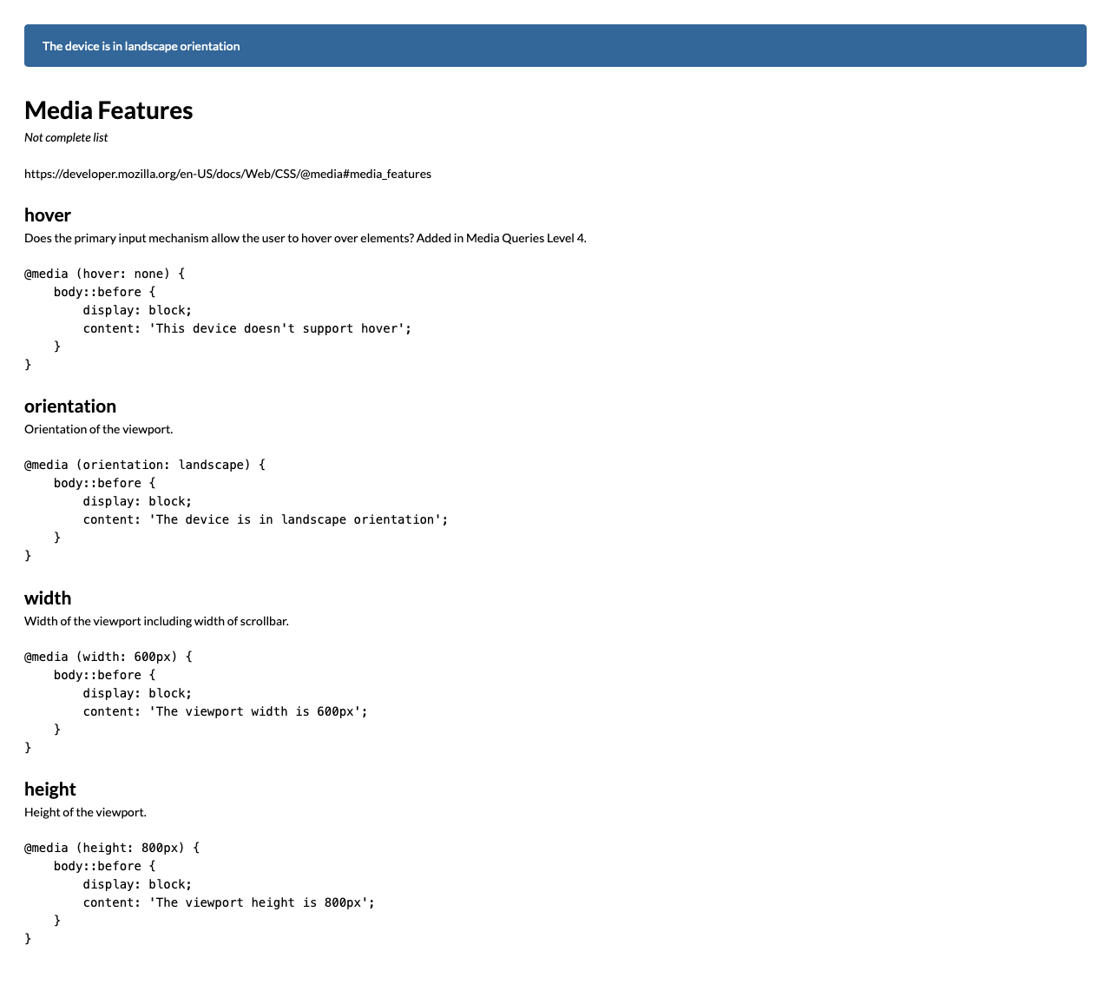
For full screenshot check the screenshot.png file in the folder for the task
Objective:
Create a webpage that looks like the screenshot above.

Requirements:
- File Setup:
  - Create an HTML document named media-features.html
  - Create a CSS file named media-features.css
- Element creation
  - Add title of the page in an <h1> element
  - Add <h2> elements and p elements for each <h2> as shown on the screenshot
- Styling
  - Copy styling from Task 1
  - Add the media queries outlined in the text and screenshot

Logical Operators

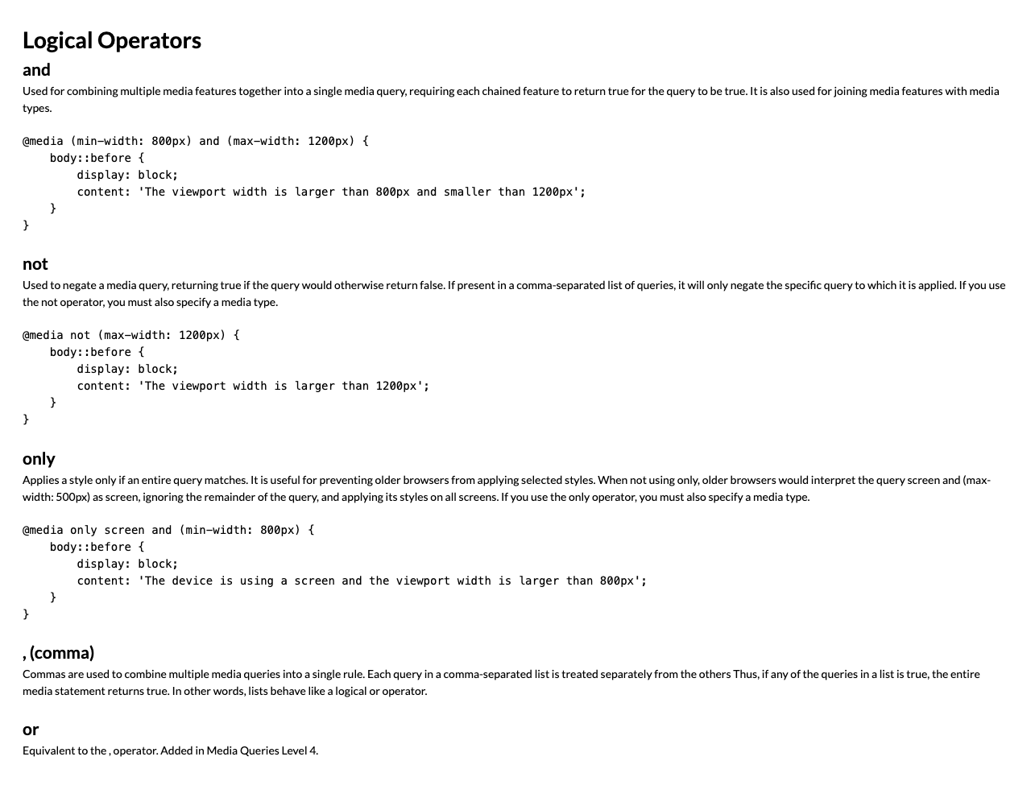
For full screenshot check the screenshot.png file in the folder for the task
Objective:
Create a webpage that looks like the screenshot above.

Requirements:
- File Setup:
  - Create an HTML document named logical-operators.html
  - Create a CSS file named logical-operators.css
- Element creation
  - Add title of the page in an <h1> element
  - Add <h2> elements and p elements for each <h2> as shown on the screenshot
- Styling
  - Copy styling from Task 1
  - Add the media queries outlined in the text and screenshot

Media Feature - width

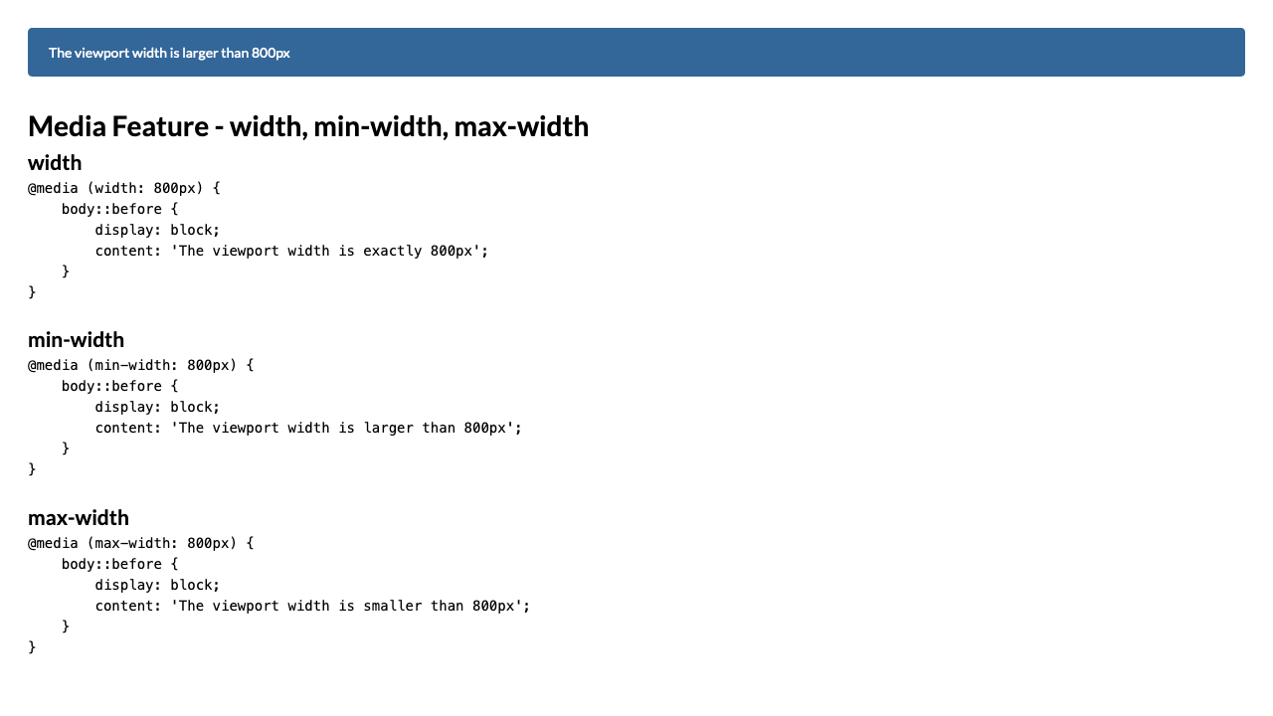
For full screenshot check the screenshot.png file in the folder for the task
Objective:
Create a webpage that looks like the screenshot above.

Requirements:
- File Setup:
  - Create an HTML document named media-feature-width.html
  - Create a CSS file named media-feature-width.css
- Element creation
  - Add title of the page in an <h1> element
  - Add <h2> elements and p elements for each <h2> as shown on the screenshot
- Styling
  - Copy styling from Task 1
  - Add the media queries outlined in the text and screenshot

Media Feature - hover

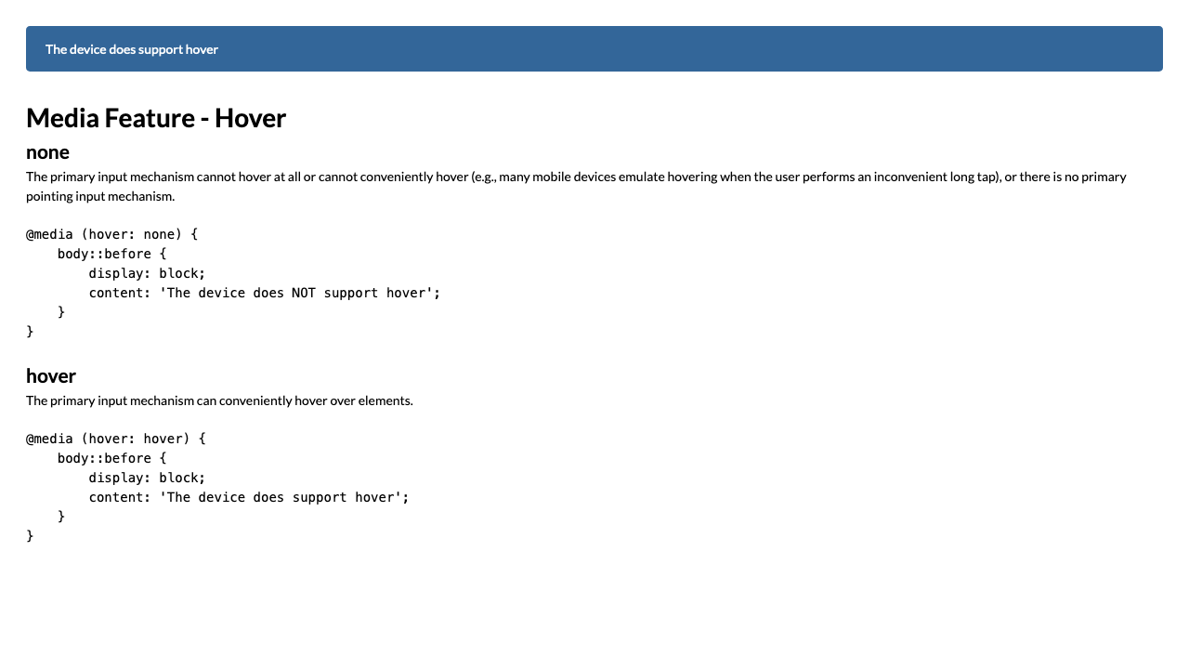
For full screenshot check the screenshot.png file in the folder for the task
Objective:
Create a webpage that looks like the screenshot above.

Requirements:
- File Setup:
  - Create an HTML document named media-feature-hover.html
  - Create a CSS file named media-feature-hover.css
- Element creation
  - Add title of the page in an <h1> element
  - Add <h2> elements and p elements for each <h2> as shown on the screenshot
- Styling
  - Copy styling from Task 1
  - Add the media queries outlined in the text and screenshot

Complex Queries

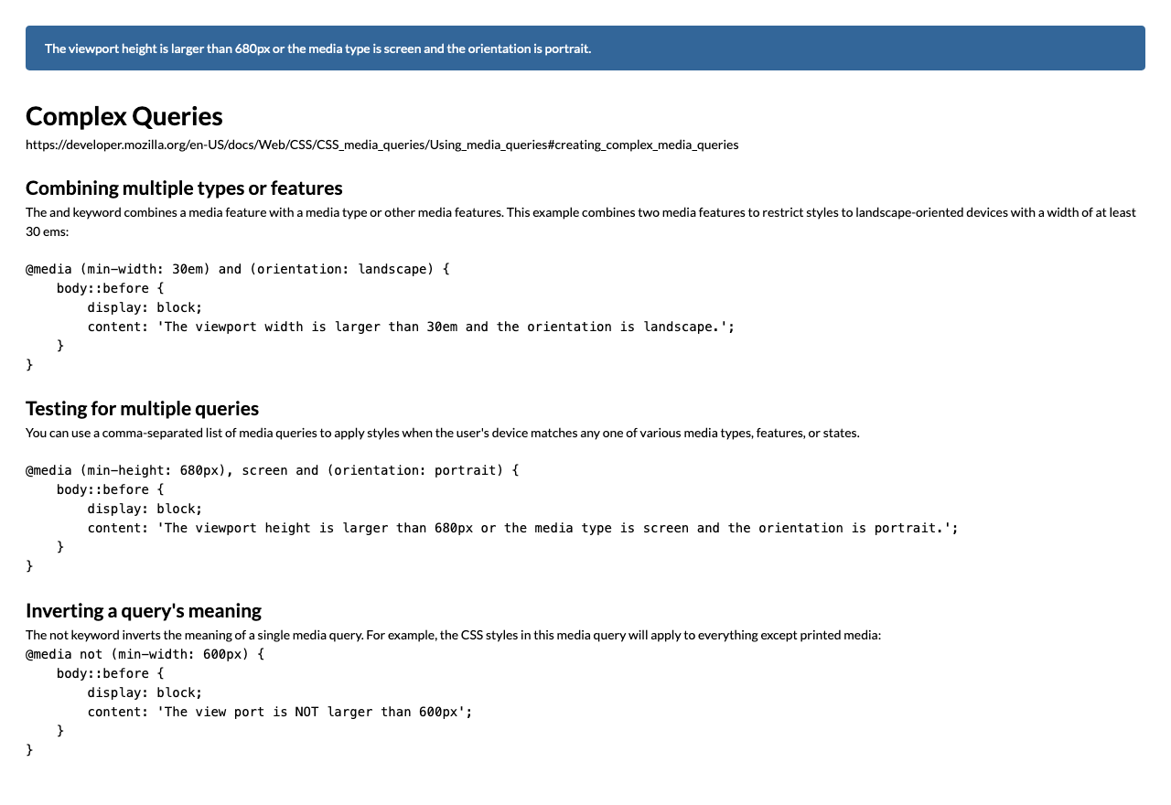
For full screenshot check the screenshot.png file in the folder for the task
Objective:
Create a webpage that looks like the screenshot above.

Requirements:
- File Setup:
  - Create an HTML document named complex-queries.html
  - Create a CSS file named complex-queries.css
- Element creation
  - Add title of the page in an <h1> element
  - Add <h2> elements and p elements for each <h2> as shown on the screenshot
- Styling
  - Copy styling from Task 1
  - Add the media queries outlined in the text and screenshot

