JS Advanced Retake Exam

Problem 1. Service
Environment Specifics
Please, be aware that every JS environment may behave differently when executing code. Certain things that work in the browser are not supported in Node.js, which is the environment used by Judge.
The following actions are NOT supported:
- .forEach() with NodeList (returned by querySelector() and querySelectorAll())
- .forEach() with HTMLCollection (returned by getElementsByClassName() and element.children)
- Using the spread-operator (...) to convert a NodeList into an array
- append() in Judge (use only appendChild())
- replaceWith() in Judge
- replaceAll() in Judge
- closest() in Judge
- replaceChildren()
- Always turn the collection into a JS array (forEach, forOf, et.)
If you want to perform these operations, you may use Array.from() to first convert the collection into an array.
Use the provided skeleton to solve this problem.
Note: You can't and you have no permission to change directly the given HTML code (index.html file).
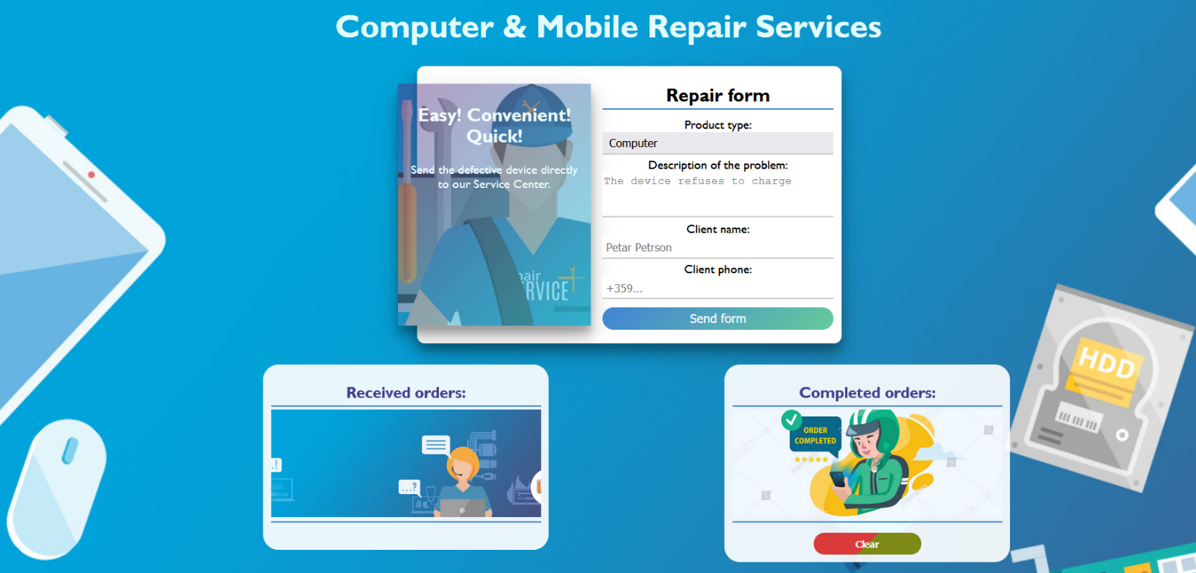

Your Task
Write the missing JavaScript code to make the Service work as expected:
- All fields (description, client name, and client phone) are filled with the correct input
  - Description, client name, and client phone are non-empty strings. If any of them are empty, the program should not do anything.
  - Note that the possible values for the Product type are two - Phone and Computer. To see which drop-down menu option is selected, read its parent's properties: value.
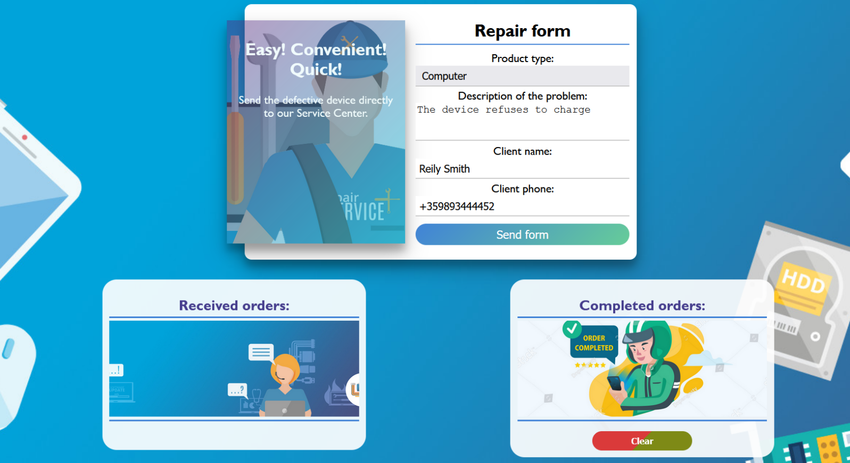
- Getting the information from the repair form

- When you click the ["Send form"] button, the information from the input fields must be added to the section with the id "received-orders" and then clear input fields.
- The HTML structure looks like this:

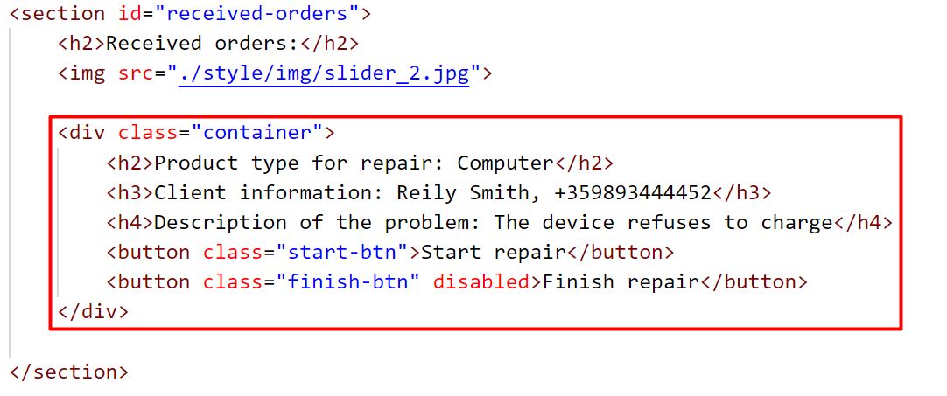

Note: When an order is successfully added, the button ["Finish repair"] must be disabled, as the order cannot be completed if it has not started (Once the button is disabled, its color will turn gray).

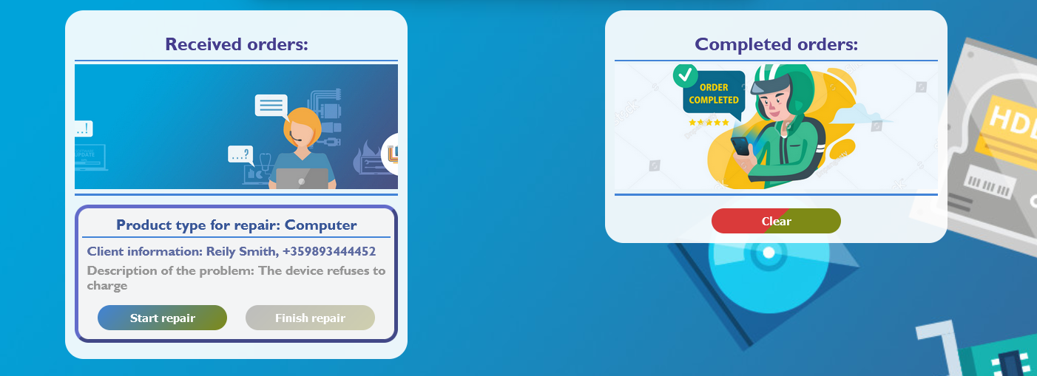
- When the ["Start repair"] button is clicked, repair on the device begins. Since the process has already started, the worker will not be allowed to restart it, so the ["Start repair"] button must be disabled. (Once the button is disabled, its color will turn gray).
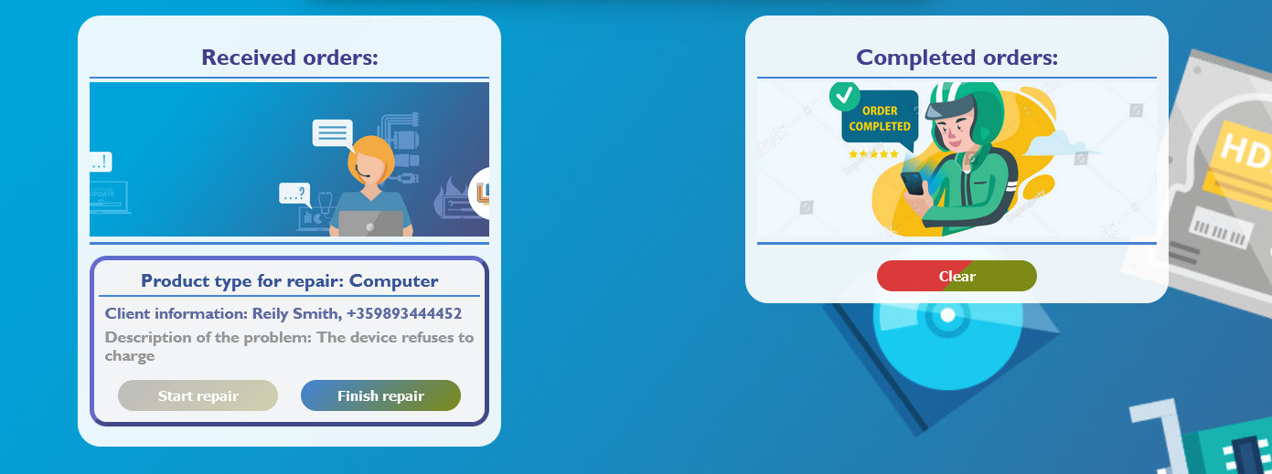
- Button ["Finish repair"] must become activated.

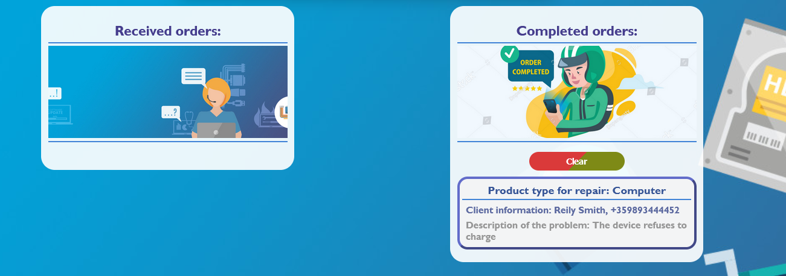
- When the ["Finish repair"] button is clicked, repair on the device is complete. Therefore, you need to move the current device in the section with the id "completed-orders".

- The HTML structure looks like this:

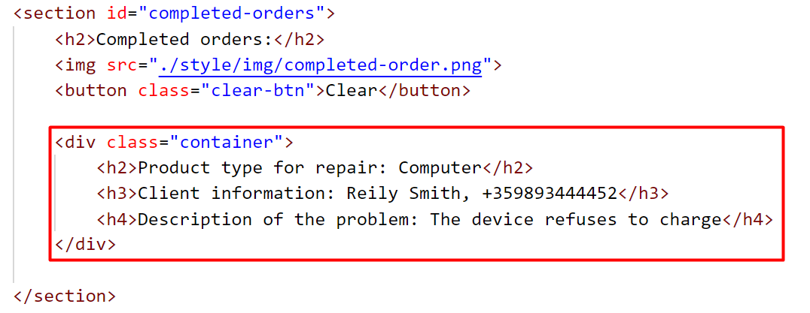
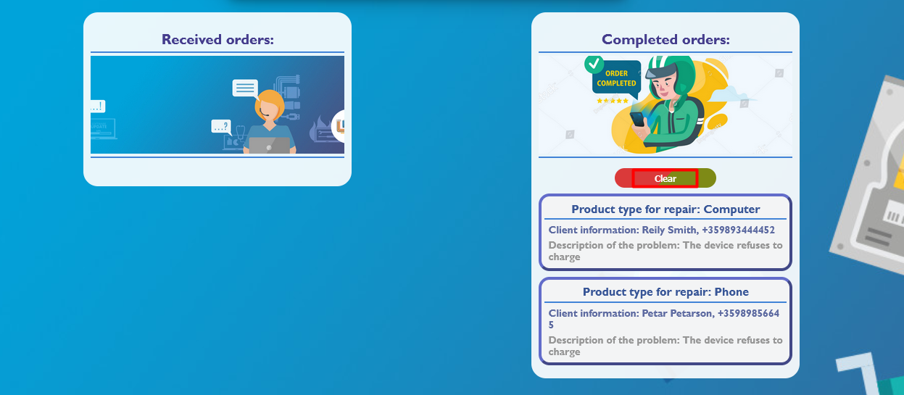
- When you click the ["Clear"] button, you must remove all added div elements with class "container" from the section Completed orders.

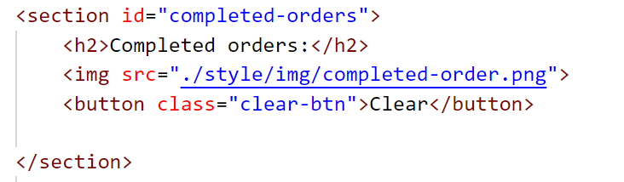
- The HTML structure looks like this:
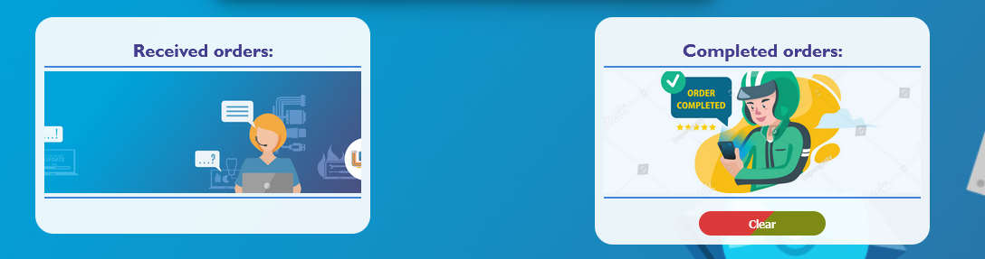

Submission
Submit only your solve() function.
GOOD LUCK…

