Lab: Unit Testing
Problems for exercises and homework for the "C# OOP" course @ SoftUni".

Part I: Unit Testing Basics

Test Axe
Load provided solution in Visual Studio. Add new project Tests
Create a class AxeTests
Create the following tests:
- Test if weapon loses durability after each attack
- Test attacking with a broken weapon

Solution
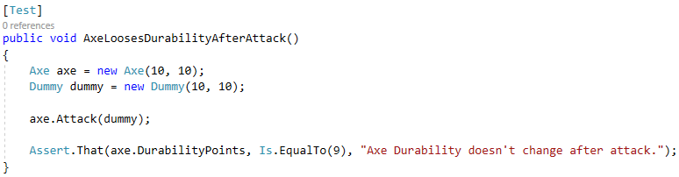

Test Dummy
Create a class DummyTests
Create the following tests:
- Dummy loses health if attacked
- Dead Dummy throws exception if attacked
- Dead Dummy can give XP
- Alive Dummy can't give XP

Hints
Follow the logic of the previous problem

Refactor Tests
Refactor the tests for Axe and Dummy classes
Make sure that:
- Names of test methods are descriptive
- You use appropriate assertions (assert equals vs assert true)
- You use assertion messages
- There are no magic numbers
- There is no code duplication (Don’t Repeat Yourself)

Hints
Extract constants and private fields for Axe class
Create a method that executes before each test
Make use of constants and private fields, as well as add assertion messages
Follow the same logic for other test methods and TestDummy class

Part II: Dependencies and Mocking
(Work on this part in the second unit-testing lecture – Mocking and test driven development)

Fake Axe and Dummy
Test if hero gains XP when target dies
To do this, you need to:
- Make Hero class testable (use Dependency Injection)
- Introduce Interfaces for Axe and Dummy
  - Interface Weapon
  - Interface Target
Create fake Weapon and fake Dummy for the test

Hints
Create IWeapon and ITarget interface. Modify implementation methods to make use of interfaces. Modify both Axe and Dummy classes.
Use Dependency Injection for Hero class
Create HeroTests class and test gaining XP functionality by faking Weapon and Target classes

Mocking
Include Moq in the project dependencies, then:
- Mock fakes from previous problem Hints
Go to HeroTests and refactor the code, making use of Moq

