Lab: Multidimensional Arrays
Problems for exercises and homework for the "CSharp Advanced" course @ Software University.
You can check your solutions here: https://judge.softuni.bg/Contests/1452/Multidimensional-Arrays-Lab

Sum Matrix Elements
Write program that reads a matrix from the console and print:
- Count of rows
- Count of columns
- Sum of all matrix elements
On first line you will get matrix sizes in format [rows, columns]

Examples
Input | Output
3, 6  7, 1, 3, 3, 2, 1  1, 3, 9, 8, 5, 6  4, 6, 7, 9, 1, 0 | 3  6  76
2, 4  10, 11, 12, 13  14, 15, 16, 17 | 2  4  108

Hints
- On next [rows] lines you will get elements for each column separated with coma and whitespace
- Try to use only foreach for printing

Sum Matrix Columns
Write program that read a matrix from console and print the sum for each column. On first line you will get matrix rows. On the next rows lines, you will get elements for each column separated with a space.

Examples
Input | Output
3, 6  7 1 3 3 2 1  1 3 9 8 5 6  4 6 7 9 1 0 | 12  10  19  20  8  7
3, 3  1 2 3  4 5 6  7 8 9 | 12  15  18

Hints
- Read matrix sizes.
- On the next row lines read the columns.
- Traverse the matrix and sum all elements in each column.
- Print the sum and continue with the other columns.

Primary Diagonal
Write a program that finds the sum of matrix primary diagonal.
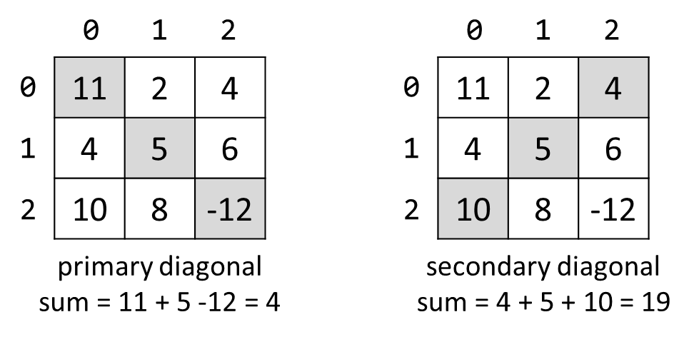

Input
- On the first line, you are given the integer N – the size of the square matrix
- The next N lines holds the values for every row – N numbers separated by a space

Examples
Input | Output
3  11 2 4  4 5 6  10 8 -12 | 4
3  1 2 3  4 5 6  7 8 9 | 15

Symbol in Matrix
Write a program that reads N, number representing rows and cols of a matrix. On the next N lines, you will receive rows of the matrix. Each row consists of ASCII characters. After that, you will receive a symbol. Find the first occurrence of that symbol in the matrix and print its position in the format: "({row}, {col})". If there is no such symbol print an error message
"{symbol} does not occur in the matrix "

Examples
Input | Output
3  ABC  DEF  X!@  ! | (2, 1)
4  asdd  xczc  qwee  qefw  4 | 4 does not occur in the matrix

Square with Maximum Sum
Write a program that read a matrix from console. Then find biggest sum of 2x2 submatrix and print it to console.
On first line you will get matrix sizes in format rows, columns.
One next rows lines you will get elements for each column separated with coma.
Print biggest top-left square, which you find and sum of its elements.

Examples
Input | Output
3, 6  7, 1, 3, 3, 2, 1  1, 3, 9, 8, 5, 6  4, 6, 7, 9, 1, 0 | 9 8  7 9  33
2, 4  10, 11, 12, 13  14, 15, 16, 17 | 12 13  16 17  58

Hints
- Think about IndexOutOfRangeException()
- If you find more than one max square, print the top-left one

Jagged-Array Modification
Write a program that reads a matrix from the console. On the first line you will get matrix rows. On next rows lines you will get elements for each column separated with space. You will be receiving commands in the following format:
- Add {row} {col} {value} – Increase the number at the given coordinates with the value.
- Subtract {row} {col} {value} – Decrease the number at the given coordinates by the value.
Coordinates might be invalid. In this case you should print "Invalid coordinates". When you receive "END" you should print the matrix and stop the program.

Examples
Input | Output
3  1 2 3  4 5 6  7 8 9  Add 0 0 5  Subtract 1 1 2  END | 6 2 3  4 3 6  7 8 9
4  1 2 3 4  5 6 7 8  8 7 6 5  4 3 2 1  Add 4 4 100  Add 3 3 100  Subtract -1 -1 42  Subtract 0 0 42  END | Invalid coordinates  Invalid coordinates  -41 2 3 4  5 6 7 8  8 7 6 5  4 3 2 101

Pascal Triangle
The triangle may be constructed in the following manner: In row 0 (the topmost row), there is a unique nonzero entry 1. Each entry of each subsequent row is constructed by adding the number above and to the left with the number above and to the right, treating blank entries as 0. For example, the initial number in the first (or any other) row is 1 (the sum of 0 and 1), whereas the numbers 1 and 3 in the third row are added to produce the number 4 in the fourth row.
If you want more info about it: https://en.wikipedia.org/wiki/Pascal's_triangle
Print each row elements separated with whitespace.

Examples
Input | Output
4 | 1  1 1  1 2 1  1 3 3 1
13 | 1  1 1  1 2 1  1 3 3 1  1 4 6 4 1  1 5 10 10 5 1  1 6 15 20 15 6 1  1 7 21 35 35 21 7 1  1 8 28 56 70 56 28 8 1  1 9 36 84 126 126 84 36 9 1  1 10 45 120 210 252 210 120 45 10 1  1 11 55 165 330 462 462 330 165 55 11 1  1 12 66 220 495 792 924 792 495 220 66 12 1

Hints
- The input number n will be 1 <= n <= 60
- Think about proper type for elements in array
- Don’t be scary to use more and more arrays

