Working with Forms - Lab
Problems for exercises and homework for the "HTML and CSS" course @ SoftUni.

Topics Covered
- Web forms are a very powerful tool for interacting with users — most commonly they are used for collecting data from users or allowing them to control a user interface.

Resources
- Web form building blocks
  - https://developer.mozilla.org/en-US/docs/Learn/Forms

Form Element

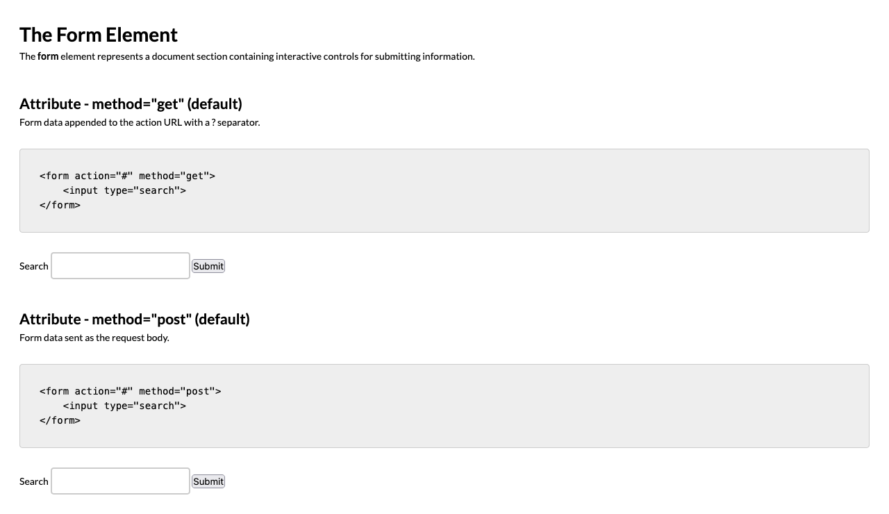
For full screenshot check the screenshot.png file in the folder for the task
Objective:
Create a webpage that looks like the screenshot above.

Requirements:
- File Setup:
  - Create an HTML document named form-element.html
  - Create a CSS file named form-element.css
- Element creation
  - Add title of the page in an <h1> element
  - Add <h2> elements and p elements for each <h2> as shown on the screenshot
- Styling
  - Add the standard reset styling – padding, margin, box-sizing
  - Add the following styles to the HTML element
    - Font – 14px/1.5 Lato, sans-serif
  - Inherit the font styling on these elements – body, input, textarea, select, option
  - Add padding of 2 em to the body element
  - Add margin-top of 2em to all h2 elements
  - Add the following styles to the code elements:
    - Display – block
    - Padding – 2em 2em 0.5em 2em
    - Border-radius – 0.3em
    - Margin – 2em 0
    - Border – 1px solid #ccc
    - Overlow – auto
  - Add the following styles to the input elements:
    - Display – inline-block
    - Padding – 0.5em 0.8em
    - Border – 2px solid #ccc
    - Outline – none
  - Add the following styles to the input when focused:
    - Border-color – #090

Text input

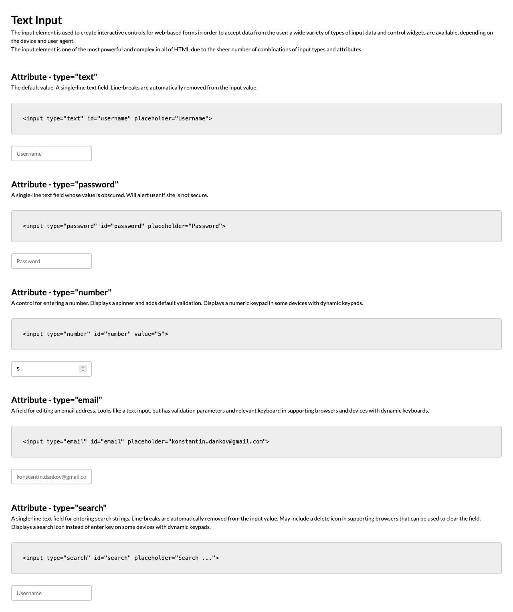
For full screenshot check the screenshot.png file in the folder for the task
Objective:
Create a webpage that looks like the screenshot above.

Requirements:
- File Setup:
  - Create an HTML document named text-input.html
  - Create a CSS file named text-input.css
- Element creation
  - Add title of the page in an <h1> element
  - Add <h2> elements and p elements for each <h2> as shown on the screenshot
- Styling
  - Copy the styling from Task 1

Textarea

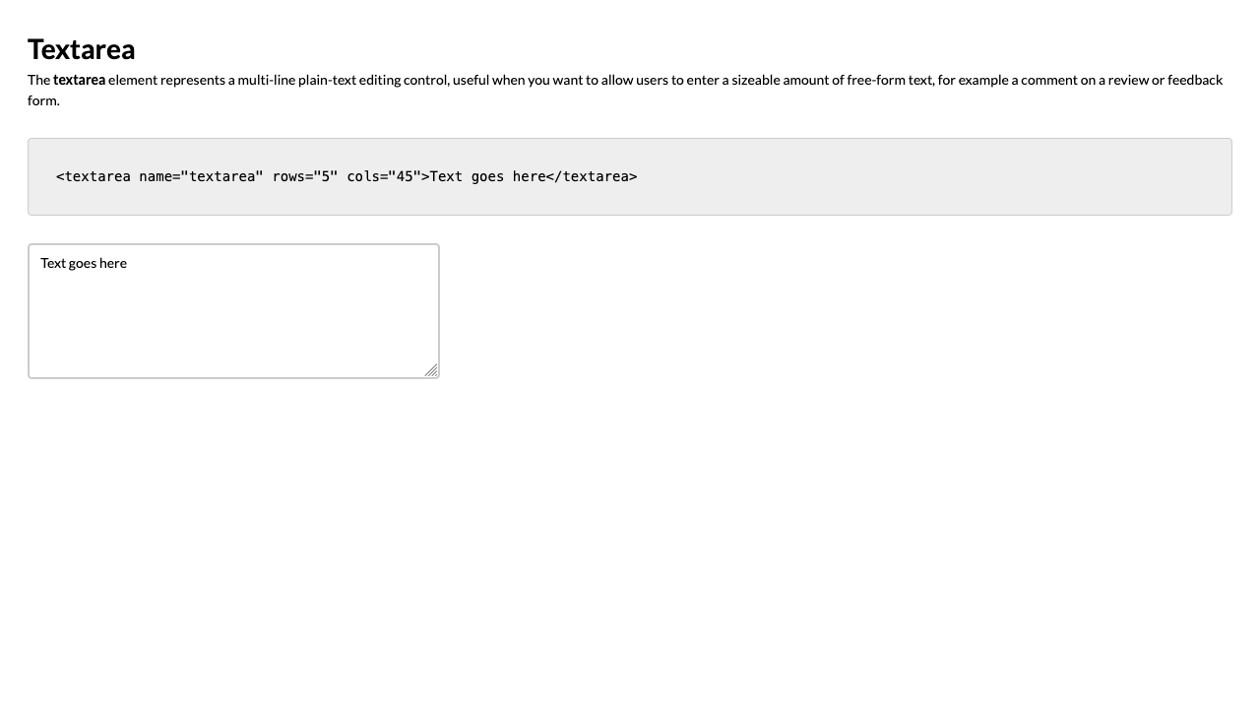
For full screenshot check the screenshot.png file in the folder for the task
Objective:
Create a webpage that looks like the screenshot above.

Requirements:
- File Setup:
  - Create an HTML document named media-types.html
  - Create a CSS file named media-types.css
- Element creation
  - Add title of the page in an <h1> element
  - Add <h2> elements and p elements for each <h2> as shown on the screenshot
- Styling
  - Copy the styling from Task 1
  - Make sure the textarea has the same styling as the input elements

Radio

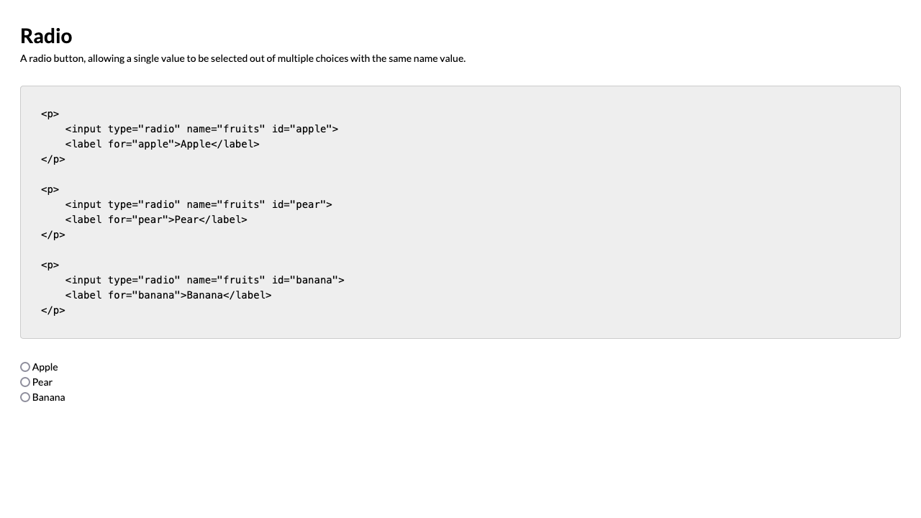
For full screenshot check the screenshot.png file in the folder for the task
Objective:
Create a webpage that looks like the screenshot above.

Requirements:
- File Setup:
  - Create an HTML document named radio.html
  - Create a CSS file named radio.css
- Element creation
  - Add title of the page in an <h1> element
  - Add <h2> elements and p elements for each <h2> as shown on the screenshot
- Styling
  - Copy the styling from Task 1

Checkbox

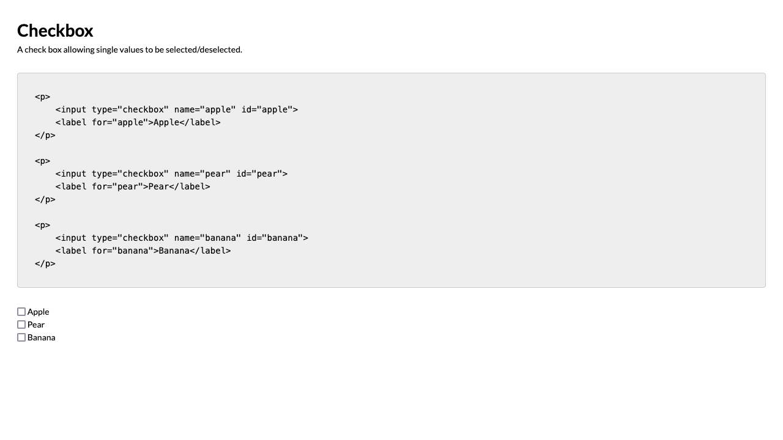
For full screenshot check the screenshot.png file in the folder for the task
Objective:
Create a webpage that looks like the screenshot above.

Requirements:
- File Setup:
  - Create an HTML document named media-types.html
  - Create a CSS file named media-types.css
- Element creation
  - Add title of the page in an <h1> element
  - Add <h2> elements and p elements for each <h2> as shown on the screenshot
- Styling
  - Copy the styling from Task 1

Select

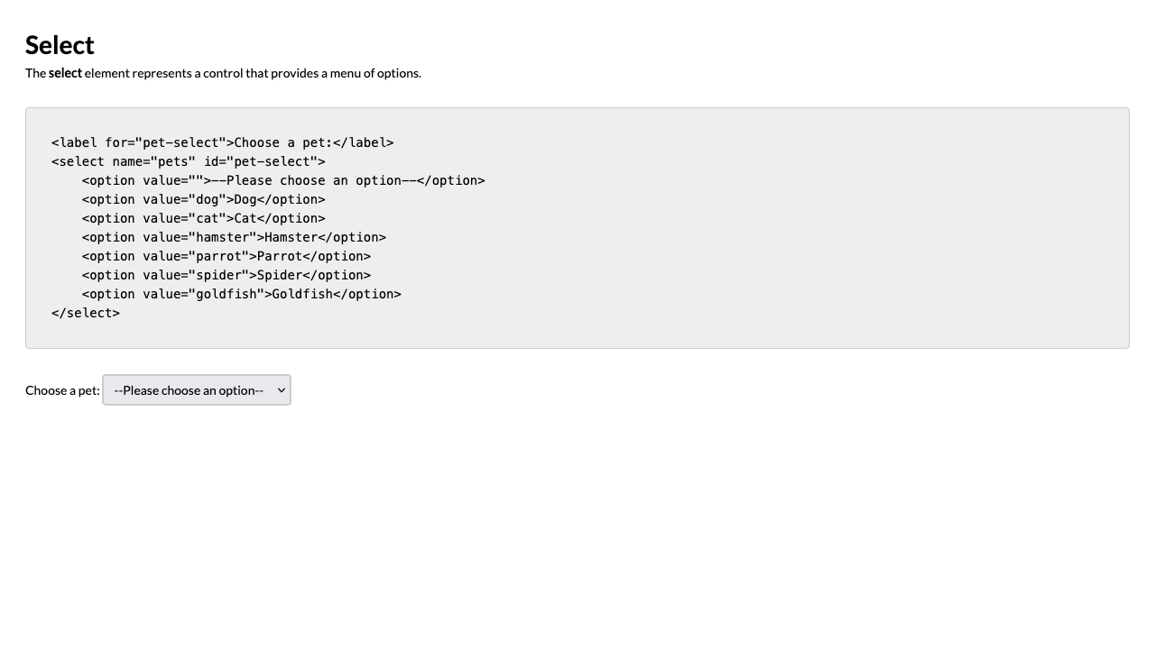
For full screenshot check the screenshot.png file in the folder for the task
Objective:
Create a webpage that looks like the screenshot above.

Requirements:
- File Setup:
  - Create an HTML document named select.html
  - Create a CSS file named select.css
- Element creation
  - Add title of the page in an <h1> element
  - Add <h2> elements and p elements for each <h2> as shown on the screenshot
- Styling
  - Copy the styling from Task 1
  - Add the following styles to the select elements:
    - Display – inline-block
    - Padding – 0.5em 0.8em
    - Border – 2px solid #ccc
    - Border-radius – 0.3em

Multiselect

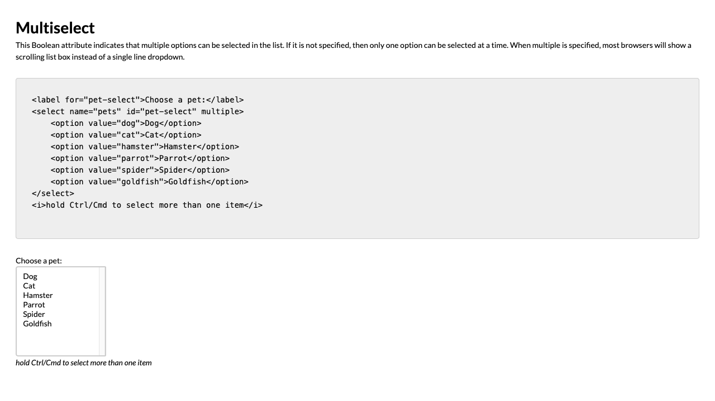
For full screenshot check the screenshot.png file in the folder for the task
Objective:
Create a webpage that looks like the screenshot above.

Requirements:
- File Setup:
  - Create an HTML document named media-types.html
  - Create a CSS file named media-types.css
- Element creation
  - Add title of the page in an <h1> element
  - Add <h2> elements and p elements for each <h2> as shown on the screenshot
- Styling
  - Copy the styling from Task 6
  - Add the following styles to the select elements who have the multiple attribute:
    - Display – block
    - Min-width – 20ch
    - Min-height – 20ch

Fieldset

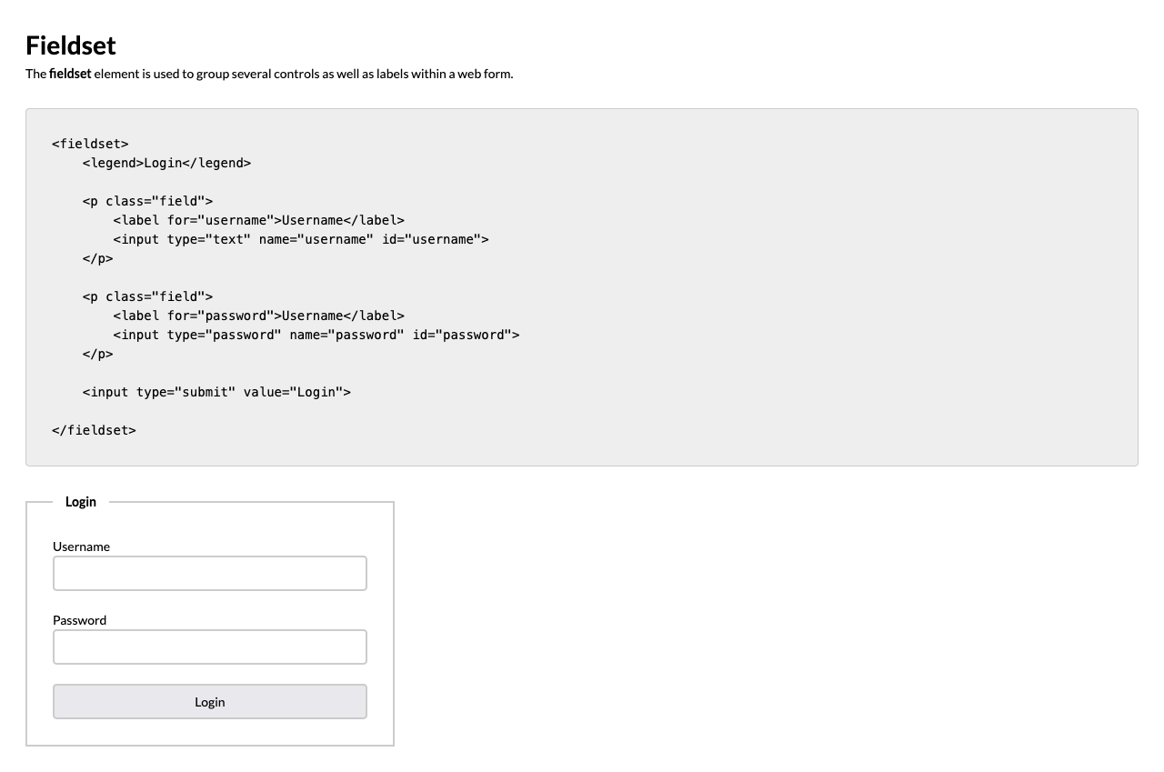
For full screenshot check the screenshot.png file in the folder for the task
Objective:
Create a webpage that looks like the screenshot above.

Requirements:
- File Setup:
  - Create an HTML document named media-types.html
  - Create a CSS file named media-types.css
- Element creation
  - Add title of the page in an <h1> element
  - Add <h2> elements and p elements for each <h2> as shown on the screenshot
  - Add a fieldset element with a legend element as shown in the screenshot
  - Add label elements and input elements and surround each pair with a paragraph with a class of “field”
- Styling
  - Copy the styling from Task 1
  - Add the following styles to the fieldset elements:
    - Padding – 2em
    - Border – 2px solid #ccc
    - Max-width – 50ch
  - Add the following styles to the legend elements that are inside of a fieldset:
    - Padding – 0 1em
    - Font-weight – bold
  - Add font-weight – bold to all labels inside of the fieldset
  - Add the following styles to all input elements inside of the fieldset:
    - Display – block
    - Width – 100%
  - Add padding-bottom of 1.5em to all elements with a class of field

