Database Basics MS SQL Exam – 10.08.2022
Submit your solutions in the SoftUni Judge system at Judge

100 National Tourist Sites of Bulgaria

100 Tourist Sites of Bulgaria is a Bulgarian national movement established in 1966 to promote tourism among Bulgaria's most significant cultural, historic, and natural landmarks. You are given the task to create a database in which you will store information about the sites and the tourists who are visiting them.

Section 1. DDL (30 pts)
You have been given the following E/R Diagram.
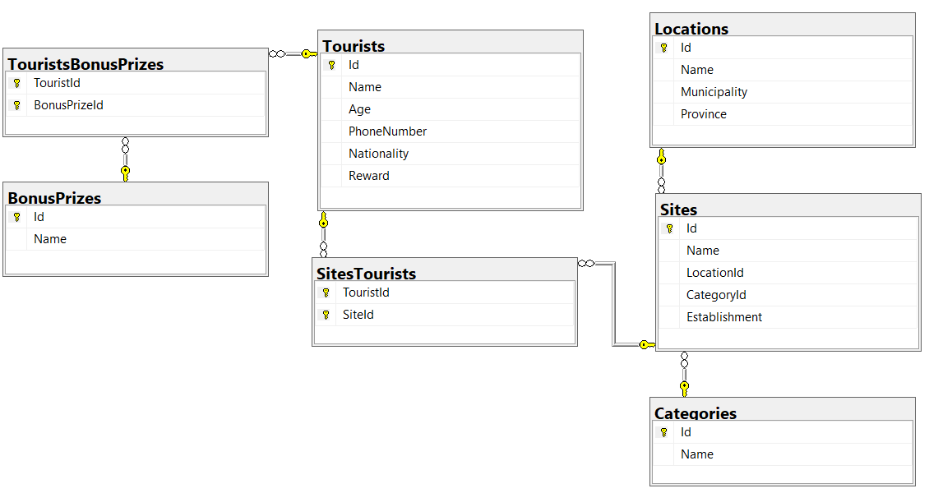

Create a database called NationalTouristSitesOfBulgaria. You need to create 7 tables:
- Categories – contains information about the different categories of the tourist sites;
- Locations – contains information about the locations of the tourist sites;
- Sites – contains information about the tourist sites;
- Tourists – contains information about the tourists, who are visiting the tourist sites;
- SitesTourists – a many to many mapping table between the sites and the tourists;
- BonusPrizes – contains information about the bonus prizes, which are given to an annual raffle;
- TouristsBonusPrizes – a many to many mapping table between the tourists and the bonus prizes.

NOTE: Keep in mind that Judge doesn't accept "ALTER" statement and square brackets naming (when the names are not keywords).
NOTE: Use VARCHAR for strings, not NVARCHAR.

You have been tasked to create the tables in the database by the following models:

Categories
Column Name | Data Type | Constraints
Id | Integer from 0 to 2,147,483,647 | PK, Unique table identification, Identity
Name | String up to 50 symbols | Null is not allowed

Locations
Column Name | Data Type | Constraints
Id | Integer from 0 to 2,147,483,647 | PK, Unique table identification, Identity
Name | String up to 50 symbols | Null is not allowed
Municipality | String up to 50 symbols | Null is allowed
Province | String up to 50 symbols | Null is allowed

Sites
Column Name | Data Type | Constraints
Id | Integer from 0 to 2,147,483,647 | PK, Unique table identification, Identity
Name | String up to 100 symbols | Null is not allowed
LocationId | Integer from 0 to 2,147,483,647 | Relationship with table Locations, Null is not allowed
CategoryId | Integer from 0 to 2,147,483,647 | Relationship with table Categories, Null is not allowed
Establishment | String up to 15 symbols | Null is allowed

Tourists
Column Name | Data Type | Constraints
Id | Integer from 0 to 2,147,483,647 | PK, Unique table identification, Identity
Name | String up to 50 symbols | Null is not allowed
Age | Integer from 0 to 2,147,483,647 | In range between 0 (inclusive) and 120 (inclusive).  Null is not allowed
PhoneNumber | String up to 20 symbols | Null is not allowed
Nationality | String up to 30 symbols | Null is not allowed
Reward | String up to 20 symbols | Null is allowed

SitesTourists
Column Name | Data Type | Constraints
TouristId | Integer from 0 to 2,147,483,647 | PK, Unique table identification, Relationship with table Tourists  Null is not allowed
SiteId | Integer from 0 to 2,147,483,647 | PK, Unique table identification, Relationship with table Sites.  Null is not allowed

BonusPrizes
Column Name | Data Type | Constraints
Id | Integer from 0 to 2,147,483,647 | PK, Unique table identification, Identity
Name | String up to 50 symbols | Null is not allowed

TouristsBonusPrizes
Column Name | Data Type | Constraints
TouristId | Integer from 0 to 2,147,483,647 | PK, Unique table identification, Relationship with table Tourists  Null is not allowed
BonusPrizeId | Integer from 0 to 2,147,483,647 | PK, Unique table identification, Relationship with table BonusPrizes  Null is not allowed

Database design
Submit all of your created statements to Judge (only creation of tables).

Section 2. DML (10 pts)
Before you start you have to import "01. DDL_Dataset.sql ". If you have created the structure correctly the data should be successfully inserted.
In this section, you have to do some data manipulations:

Insert
Let's insert some sample data into the database. Write a query to add the following records into the corresponding tables. All Ids should be auto-generated.
Tourists
Name | Age | PhoneNumber | Nationality | Reward
Borislava Kazakova | 52 | +359896354244 | Bulgaria | NULL
Peter Bosh | 48 | +447911844141 | UK | NULL
Martin Smith | 29 | +353863818592 | Ireland | Bronze badge
Svilen Dobrev | 49 | +359986584786 | Bulgaria | Silver badge
Kremena Popova | 38 | +359893298604 | Bulgaria | NULL

Sites
Name | LocationId | CategoryId | Establishment
Ustra fortress | 90 | 7 | X
Karlanovo Pyramids | 65 | 7 | NULL
The Tomb of Tsar Sevt | 63 | 8 | V BC
Sinite Kamani Natural Park | 17 | 1 | NULL
St. Petka of Bulgaria – Rupite | 92 | 6 | 1994

Update
For some of the tourist sites there are no clear records when they were established, so you need to update the column 'Establishment' for those records by putting the text '(not defined)'.

Delete
For this year's raffle it was decided to remove the Sleeping bag from the bonus prizes.

Section 3. Querying (40 pts)
You need to start with a fresh dataset, so recreate your DB and import the sample data again (01. DDL_Dataset.sql). DO NOT CHANGE OR INCLUDE DATA FROM DELETE, INSERT AND UPDATE TASKS!!!

Tourists
Extract information about all the Tourists – name, age, phone number and nationality. Order the result by nationality (ascending), then by age (descending), and then by tourist name (ascending).

Example
Name | Age | PhoneNumber | Nationality
Danny Kane | 39 | +32487454880 | Belgium
Krasen Krasenov | 62 | +359897653265 | Bulgaria
Pavel Mateev | 51 | +359879632123 | Bulgaria
Kameliya Dimitrova | 42 | +359898645326 | Bulgaria
Dobroslav Mihalev | 39 | +359889632200 | Bulgaria
Mariya Petrova | 37 | +359887564235 | Bulgaria
… | … | … | …

Sites with Their Location and Category
Select all sites and find their location and category. Select the name of the tourist site, name of the location, establishment year/ century and name of the category. Order the result by name of the category (descending), then by name of the location (ascending) and then by name of the site itself (ascending).

Example
Site | Location | Establishment | Category
Clock Tower – Botevgrad | Botevgrad | 1866 | Spare time in the city
Clock Tower of Etropole | Etropole | 1710 | Spare time in the city
House of Humour and Satire Museum – Gabrovo | Gabrovo | 1972 | Spare time in the city
Museum of Education – Gabrovo | Gabrovo | 1974 | Spare time in the city
Antique Theater – Plovdiv | Plovdiv | II | Spare time in the city
Salt Museum – Pomorie | Pomorie | 2002 | Spare time in the city
… | … | …

Count of Sites in Sofia Province
Extract all locations which are in Sofia province. Find the count of sites in every location. Select the name of the province, name of the municipality, name of the location and count of the tourist sites in it. Order the result by count of tourist sites (descending) and then by name of the location (ascending).

Example
Province | Municipality | Location | CountOfSites
Sofia | Sofia | Sofia | 11
Sofia | Etropole | Etropole | 3
Sofia | Botevgrad | Botevgrad | 1
Sofia | Koprivshtitsa | Koprivshtitsa | 1
Sofia | Svoge | Osenovlag village | 1
Sofia | Samokov | Samokov | 1

Tourist Sites established BC
Extract information about the tourist sites, which have a location name that does NOT start with the letters 'B', 'M' or 'D' and which are established Before Christ (BC). Select the site name, location name, municipality, province and establishment. Order the result by name of the site (ascending).
NOTE: If the establishment century is Before Christ (BC), it will always be in the following format: 'RomanNumeral BC'.

Example
Site | Location | Municipality | Province | Establishment
Asen's Fortress | Asenovgrad | Asenovgrad | Plovdiv | V BC
National archaeological reserve Kabile | Yambol | Yambol | Yambol | II BC
Perperikon – Medieval Archaeological Complex | Rhodope Mountain | NULL | NULL | V BC
Shumen Fortress Historical-Archaeological Preserve | Shumen | Shumen | Shumen | I BC
Starosel – Thracian Temple Complex | Starosel village | Hisarya | Plovdiv | V BC
Thracian Tomb of Kazanlak | Kazanlak | Karlovo | Plovdiv | IV BC

Tourists with their Bonus Prizes
Extract information about the tourists, along with their bonus prizes. If there is no data for the bonus prize put '(no bonus prize)'. Select tourist's name, age, phone number, nationality and bonus prize. Order the result by the name of the tourist (ascending).
NOTE: There will never be a tourist with more than one prize.

Example
Name | Age | PhoneNumber | Nationality | Reward
Alonzo Conti | 36 | +393336258996 | Italy | (no bonus prize)
Brus Brown | 42 | +447459881347 | UK | (no bonus prize)
Claudia Reuss | 54 | +4930774615846 | Germany | Sleeping bag
Cosimo Ajello | 51 | +393521112654 | Italy | (no bonus prize)
Cyrek Gryzbowski | 64 | +48503435735 | Poland | (no bonus prize)
Danny Kane | 39 | +32487454880 | Belgium | Water filter jug
… | … | … | … | …

Tourists visiting History and Archaeology sites
Extract all tourists, who have visited sites from category 'History and archaeology'. Select their last name, nationality, age and phone number. Order the result by their last name (ascending).
NOTE: The name of the tourists will always be in the following format: 'FirstName LastName'.

Example
LastName | Nationality | Age | PhoneNumber
Bauer | Germany | 49 | +496913265224
Becker | Germany | 36 | +491711234567
Bianchi | Italy | 51 | +393125965845
Brown | UK | 42 | +447459881347
Conti | Italy | 36 | +393336258996
Dimitrova | Bulgaria | 42 | +359898645326
… | … | … | …

Section 4. Programmability (20 pts)

Tourists Count on a Tourist Site
Create a user-defined function named udf_GetTouristsCountOnATouristSite (@Site) which receives a tourist site and returns the count of tourists, who have visited it.

Examples
Query
SELECT dbo.udf_GetTouristsCountOnATouristSite ('Regional History Museum – Vratsa')
Output
6
Query
SELECT dbo.udf_GetTouristsCountOnATouristSite ('Samuil’s Fortress')
Output
8

Query
SELECT dbo.udf_GetTouristsCountOnATouristSite ('Gorge of Erma River')
Output
7

Annual Reward Lottery
A reward scheme has been developed to encourage collection of as many stamps as possible. Depending on the number of stamps collected, participants may receive bronze, silver or gold badges.
Create a stored procedure, named usp_AnnualRewardLottery(@TouristName). Update the reward of the given tourist according to the count of the sites he have visited:
- >= 100 receives 'Gold badge'
- >= 50 receives 'Silver badge'
- >= 25 receives 'Bronze badge'
Extract the name of the tourist and the reward he has.

Example
Query
EXEC usp_AnnualRewardLottery 'Gerhild Lutgard'

Result
Name | Reward
Gerhild Lutgard | Gold badge

Example
Query
EXEC usp_AnnualRewardLottery 'Teodor Petrov'

Result
Name | Reward
Teodor Petrov | Silver badge

Example
Query
EXEC usp_AnnualRewardLottery 'Zac Walsh'

Result
Name | Reward
Zac Walsh | Bronze badge

Example
Query
EXEC usp_AnnualRewardLottery 'Brus Brown'

Result
Name | Reward
Brus Brown | NULL

