Containers and Clouds Exam
Problems for the exam for the DevOps for Developers module @ SoftUni.

Django App with Docker
You are provided with a simple Python Web app, based on the Django framework in the resources.
The given Dockerfile is empty and you should write it by yourself to build the Python image like this:
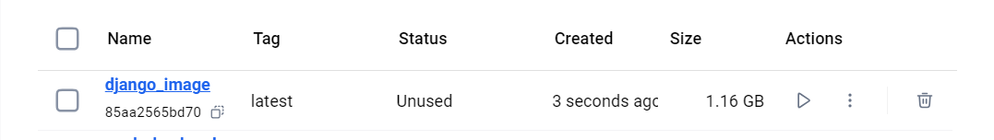
Next, you should build a Docker image from the provided Dockerfile.
You should also run the app in a container as the one shown below (with the same name and ports):
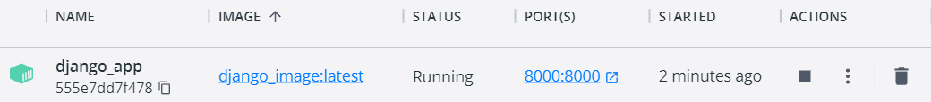
NOTE: Use Python 3.12 or earlier (3.6–3.12 supported) in your Dockerfile to avoid startup errors.
NOTE: You can find the needed CMD command below:
CMD ["python", "manage.py", "runserver", "0.0.0.0:8000"]

Requirements
Provide the Dockerfile, as well as a screenshoot of the running Python Web app and a list of the docker commands used in the CLI in a text file.
Place all of the files in a folder named {username}-task-1, where username is your SoftUni username.

Deploy an ASP.NET Core MVC app to Azure via Terraform
You are provided with a .NET application that consists of two projects – one for the web application and one for the SQL Server database.
Your task is to deploy the app to Azure via Terraform. Deploy the app using four Terraform configuration files – main.tf, variables.tf, values.tfvars, outputs.tf.

Requirements
Provide the Terraform configuration files, the public URL of the deployed application, and a screenshot of the application's main page, accessed via the URL.
Place all of the files in a folder named {username}-task-2.

Set up App Monitoring
Set up monitoring for the deployed .NET app in Azure. You should follow the steps and instructions below.

Set up Prometheus and Blackbox Exporter (pts.)
Set the following configurations in the prometheus-exam.yml file:
- Scrape the target every 15 seconds
- Metrics should be accessed on /probe

Set up AlertManager (pts.)
Set the following configurations in the alertmanager-exam.yml file:
- Set the timeout for alert resolution for 1 minute
- Specify the webhook_receiver (use the web.hook website)
- Specify that the alerts are sent to the webhook_receiver
- Configure the alerting rules
Don't forget to change the configurations in the prometheus-exam.yml file

Requirements
Provide the alertmanager-exam.yml, alert-rules-exam.yml and prometheus-exam.yml configuration files. In addition provide the following screenshots:
- Prometheus Targets page (Status -> Target)
- Prometheus Alerts page
- Received alert in webhook.site
Place all of the files and screenshots in a folder named {username}-task-3.

Submission
Add all of the folders in an archive (.zip, .rar, .7z) and upload it to the SULS system.

