Database Basics MS SQL Regular Exam – 15 Oct 2023
Exam problems for the "Database Basics" course @ SoftUni.
Submit your solutions in the SoftUni Judge system at Judge.

Tourist Agency

Section 1. DDL (30 pts)
You have been given the E/R Diagram of the TouristAgency database.
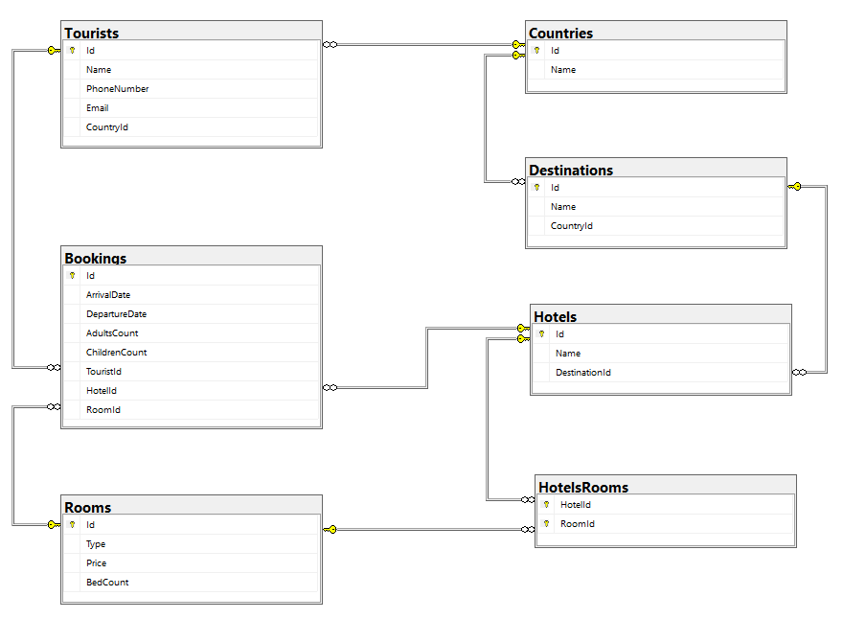
Create a database called TouristAgency. You need to create 7 tables:
- Countries – contains information about the countries, in which the destinations and hotels are located, each tourist will also has a country;
- Destinations – contains information about the holiday destinations(areas, resorts, etc.);
- Rooms – contains information about the rooms (type of room, count of beds);
- Hotels – contains information about each hotel;
- Tourists – containts information about each tourist, that has booked a room in a hotel;
- Bookings – contains information about each booking;
- HotelsRooms – mapping table between hotels and rooms;

NOTE: Keep in mind that Judge doesn't accept "ALTER" statement and square brackets naming (when the names are not keywords).
NOTE: Please keep in mind that in case you have to work with a date, you have to use the exact same data type, described in the models tables. If you don't use the correct type, the Judge system won't accept your submission as correct.

You have been tasked to create the tables in the database by the following models:

Countries
Column Name | Data Type | Constraints
Id | Integer from 0 to 2,147,483,647 | PK, Unique table identification, Identity
Name | String up to 50 symbols, Unicode | Null is not allowed

Destinations
Column Name | Data Type | Constraints
Id | Integer from 0 to 2,147,483,647 | PK, Unique table identification, Identity
Name | String up to 50 symbols | Null is not allowed
CountryId | Integer from 0 to 2,147,483,647 | Relationship with table Countries, Null is not allowed

Rooms
Column Name | Data Type | Constraints
Id | Integer from 0 to 2,147,483,647 | PK, Unique table identification, Identity
Type | String up to 40 symbols | Null is not allowed
Price | Decimal, up to 18 digits, 2 of which after the decimal point | Null is not allowed
BedCount | Integer from 0 to 2,147,483,647 | In range between 0 (exclusive) and 10 (inclusive).  Null is not allowed

Hotels
Column Name | Data Type | Constraints
Id | Integer from 0 to 2,147,483,647 | PK, Unique table identification, Identity
Name | String up to 50 symbols | Null is not allowed
DestinationId | Integer from 0 to 2,147,483,647 | Relationship with table Destinations, Null is not allowed

Tourists
Column Name | Data Type | Constraints
Id | Integer from 0 to 2,147,483,647 | PK, Unique table identification, Identity
Name | String up to 80 symbols, Unicode | Null is not allowed
PhoneNumber | String up to 20 symbols | Null is not allowed
Email | String up to 80 symbols | Null is allowed
CountryId | Integer from 0 to 2,147,483,647 | Relationship with table Countries, Null is not allowed

Bookings
Column Name | Data Type | Constraints
Id | Integer from 0 to 2,147,483,647 | PK, Unique table identification, Identity
ArrivalDate | DateTime2 | Null is not allowed
DepartureDate | DateTime2 | Null is not allowed
AdultsCount | Integer from 0 to 2,147,483,647 | In range between 1 (inclusive) and 10 (inclusive).  Null is not allowed
ChildrenCount | Integer from 0 to 2,147,483,647 | In range between 0 (inclusive) and 9 (inclusive).  Null is not allowed
TouristId | Integer from 0 to 2,147,483,647 | Relationship with table Tourists, Null is not allowed
HotelId | Integer from 0 to 2,147,483,647 | Relationship with table Hotels, Null is not allowed
RoomId | Integer from 0 to 2,147,483,647 | Relationship with table Rooms, Null is not allowed

HotelsRooms
Column Name | Data Type | Constraints
HotelId | Integer from 0 to 2,147,483,647 | PK, Unique table identification, Relationship with table Hotels, Null is not allowed
RoomId | Integer from 0 to 2,147,483,647 | PK, Unique table identification, Relationship with table Rooms, Null is not allowed

Database design
Submit all of yours CREATE statements to Judge (only the creation of tables).

Section 2. DML (10 pts)
Before you start, you have to import "Dataset.sql ". If you have created the structure correctly, the data should be successfully inserted.
In this section, you have to do some data manipulations:

Insert
Let's insert some sample data into the database. Write a query to add the following records into the corresponding tables. All IDs (Primary Keys) should be auto-generated.

Tourists
Name | PhoneNumber | Email | CountryId
John Rivers | 653-551-1555 | john.rivers@example.com | 6
Adeline Aglaé | 122-654-8726 | adeline.aglae@example.com | 2
Sergio Ramirez | 233-465-2876 | s.ramirez@example.com | 3
Johan Müller | 322-876-9826 | j.muller@example.com | 7
Eden Smith | 551-874-2234 | eden.smith@example.com | 6

Bookings
ArrivalDate | DepartureDate | AdultsCount | ChildrenCount | TouristId | HotelId | RoomId
2024-03-01 | 2024-03-11 | 1 | 0 | 21 | 3 | 5
2023-12-28 | 2024-01-06 | 2 | 1 | 22 | 13 | 3
2023-11-15 | 2023-11-20 | 1 | 2 | 23 | 19 | 7
2023-12-05 | 2023-12-09 | 4 | 0 | 24 | 6 | 4
2024-05-01 | 2024-05-07 | 6 | 0 | 25 | 14 | 6

Update
We've decided to change the departure date of the bookings that are scheduled to arrive in December 2023. The updated departure date for these bookings should be set to one day later than their original departure date.
We need to update the email addresses of tourists, whose names contain "MA". The new value of their email addresses should be set to NULL.

Delete
In table Tourists, delete every tourist, whose Name contains family name "Smith". Keep in mind that there could be foreign key constraint conflicts.

Section 3. Querying (40 pts)
You need to start with a fresh dataset, so recreate your DB and import the sample data again ("Dataset.sql").

Bookings by Price of Room and Arrival Date
Select all bookings, ordered by price of room (descending), then by arrival date (ascending). The arrival date should be formatted in the 'yyyy-MM-dd' format in the query results.
Required columns:
- ArrivalDate
- AdultsCount
- ChildrenCount

Example
ArrivalDate | AdultsCount | ChildrenCount
2023-10-05 | 3 | 1
2023-11-19 | 4 | 2
2023-12-10 | 5 | 1
2023-10-01 | 2 | 0
… | … | …

Hotels by Count of Bookings
Select all hotels with "VIP Apartment" available. Order results by the count of bookings (count of all bookings for the specific hotel, not only for VIP apartment) made for every hotel (descending).
Required columns:
- Id
- Name

Example
Id | Name
5 | Saint Ouen Marche Aux Puces
11 | Silken Al-Andalaus Palace
20 | Kivotos
3 | Antica Panada
... | ...

Tourists without Bookings
Select all tourists that haven’t booked a hotel yet. Order them by name (ascending).
Required columns:
- Id
- Name
- PhoneNumber

Example
Id | Name | PhoneNumber
19 | Ahmet Yilmaz | 777-777-7707
14 | Friedrich Weber | 434-444-4414
... | ... | ...

First 10 Bookings
Select the first 10 bookings that will arrive before 2023-12-31. You will need to select the bookings in hotels with odd-numbered IDs. Sort the results in ascending order, first by CountryName, and then by ArrivalDate.
Required columns:
- HotelName
- DestinationName
- CountryName

Example
HotelName | DestinationName | CountryName
Royal Promenade des Anglais | Nice | France
Saint Ouen Marche Aux Puces | Paris | France
Saint Ouen Marche Aux Puces | Paris | France
… | … | …

Tourists booked in Hotels
Select all of the tourists that have a name, not ending in "EZ", and display the names of the hotels, that they have booked a room in. Order by the price of the room (descending).
Required columns:
- HotelName
- RoomPrice

Example
HotelName | RoomPrice
Kivotos | 600.00
Silken Al-Andalaus Palace | 280.50
Liebesbier Urban Art & Smart Hotel | 280.50
Anklamer Hof | 250.00
Silken Al-Andalaus Palace | 250.00
Silken Al-Andalaus Palace | 250.00
… | …

Hotels Revenue

In this task, you will write an SQL query to calculate the total price of all bookings for each hotel based on the room price and the number of nights guests have stayed. The result should list the hotel names and their corresponding revenue.
- Foreach Booking you should join data for the Hotel and the Room, using the Id references;
- NightsCount – you will need the ArrivalDate and DepartureDate for a DATEDIFF function;

Calculate the TotalRevenue by summing the price of each booking, using Price of the Room that is referenced to the specific Booking and multiply it by the NightsCount.

Group all the bookings by HotelName using the reference to the Hotel.

Order the results by TotalRevenue in descending order.
Required columns:
- HotelName
- TotalRevenue

Example
HotelName | HotelRevenue
Bonvecchiati | 10521.50
Kivotos | 6530.00
Cavo Tagoo | 3666.75
… | …

Section 4. Programmability (20 pts)

Rooms with Tourists
Create a user-defined function, named udf_RoomsWithTourists(@name) that receives a room's type.
The function should return the total number of tourists that the specific room type has been booked for (adults + children).
Hint: A Double Room could be booked for: 2 adults + 0 children, 1 adult + 1 children, 1 adult + 0 children.

Example
Query
SELECT dbo.udf_RoomsWithTourists('Double Room')
Output
17

Search for Tourists from a Specific Country
Create a stored procedure, named usp_SearchByCountry(@country) that receives a country name. The procedure must print full information about all tourists that have an booked a room and have origin from the given country: Name, PhoneNumber, Email and CountOfBookings (the count of all bookings made). Order them by Name (ascending) and CountOfBookings (decending).

Example
Query
EXEC usp_SearchByCountry 'Greece'
Output
Name | PhoneNumber | Email | CountOfBookings
Maria Papadopoulou | 333-303-3333 | maria.papadopoulou@example.com | 3
Nikos Papadopoulos | 303-323-3333 | nikos.papadopoulos@example.com | 3

