Lab: Iterators and Comparators
Problems for the "C# Advanced" course @ Software University
You can check your solutions in Judge

Library
Note: Put your classes in the namespace IteratorsAndComparators. Also your Visual Studio project should be named “IteratorsAndComparators”, as well as your assembly name (it is inherited from the Visual Studio project name).
Create a class Book, which should have the following public properties:
- string Title
- int Year
- List<string> Authors
Authors can be zero (anonymous), one or many. A Book should have only one constructor.
Create a class Library, which should store a collection of books and implement the IEnumerable<Book> interface.
- List<Book> books
A Library could be initialized without books or with any number of books and should have only one constructor.

Examples
StartUp.cs
public static void Main()
{
Book bookOne = new Book("Animal Farm", 2003, "George Orwell");
Book bookTwo = new Book("The Documents in the Case", 2002,
"Dorothy Sayers", "Robert Eustace");
Book bookThree = new Book("The Documents in the Case", 1930);

Library libraryOne = new Library();
Library libraryTwo = new Library(bookOne, bookTwo, bookThree);
}

Solution
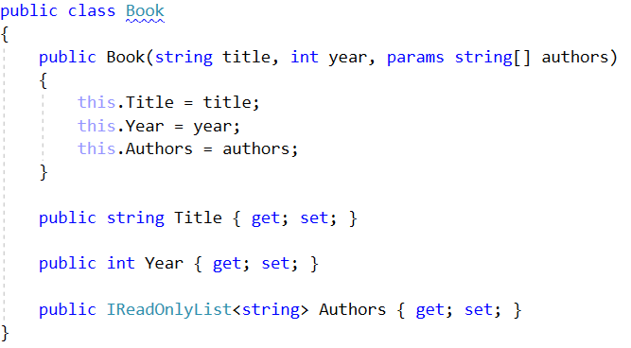
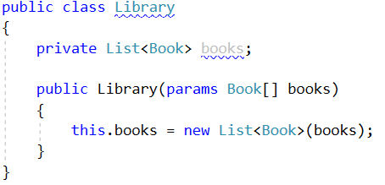

Library Iterator
Note: Put your classes in the namespace IteratorsAndComparators.
Extend your solution from the previous task. Inside the Library, create a nested class LibraryIterator, which should implement the IEnumerator<Book> interface. Try to implement the bodies of the inherited methods by yourself. You will need two more members:
- List<Book> books
- int currentIndex
Now you should be able to iterate through a Library in the Main method.

Examples
StartUp.cs
public static void Main()
{
Book bookOne = new Book("Animal Farm", 2003, "George Orwell");
Book bookTwo = new Book("The Documents in the Case", 2002,
"Dorothy Sayers", "Robert Eustace");
Book bookThree = new Book("The Documents in the Case", 1930);

Library libraryOne = new Library();
Library libraryTwo = new Library(bookOne, bookTwo, bookThree);

foreach (var book in libraryTwo)
{
Console.WriteLine(book.Title);
}
}
This is the expected output from the above code:
Output
Animal Farm
The Documents in the Case
The Documents in the Case

Solution
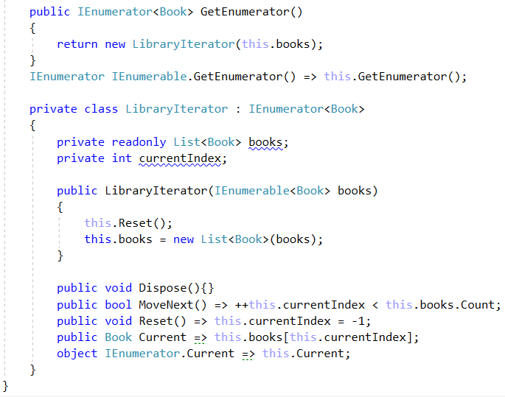

Comparable Book
NOTE: You need the namespace IteratorsAndComparators.
Extend your solution from the previous task. Implement the IComparable<Book> interface in the existing class Book. The comparison between the two books should happen in the following order:
- First, sort them in ascending chronological order (by year).
- If two books are published in the same year, sort them alphabetically.
Override the ToString() method in your Book class, so it returns a string in the format:
- "{title} - {year}"
Change your Library class, so that it stores the books in the correct order.

Examples
StartUp.cs
public static void Main()
{
Book bookOne = new Book("Animal Farm", 2003, "George Orwell");
Book bookTwo = new Book("The Documents in the Case", 2002, "Dorothy Sayers", "Robert Eustace");
Book bookThree = new Book("The Documents in the Case", 1930);

Library libraryOne = new Library();
Library libraryTwo = new Library(bookOne, bookTwo, bookThree);

foreach (var book in libraryTwo)
{
Console.WriteLine(book);
}
}

Examples
Output
The Documents in the Case - 1930
The Documents in the Case - 2002
Animal Farm - 2003

Solution
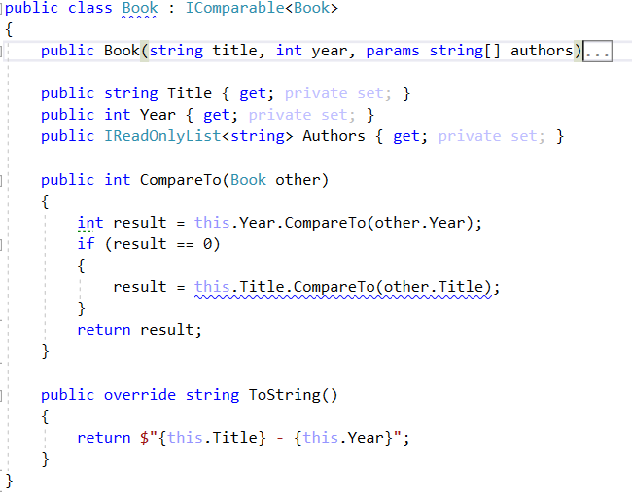

Book Comparator
NOTE: You need the namespace IteratorsAndComparators.
Extend your solution from the prevoius task. Create a class BookComparator, which should implement the IComparer<Book> interface and thus include the following method:
- int Compare(Book, Book)
BookComparator must compare two books by:
- Book title - alphabetical order
- Year of publishing a book - from the newest to the oldest
Modify your Library class once again to implement the new sorting.

Examples
Startup.cs
public static void Main()
{
Book bookOne = new Book("Animal Farm", 2003, "George Orwell");
Book bookTwo = new Book("The Documents in the Case", 2002, "Dorothy Sayers", "Robert Eustace");
Book bookThree = new Book("The Documents in the Case", 1930);

Library library = new Library(bookOne, bookTwo, bookThree);
}

Output
Animal Farm - 2003
The Documents in the Case - 2002
The Documents in the Case - 1930

Solution
