Exercise: Inheritance
Problems for exercise and homework for the "C# OOP" course @ SoftUni".
You can check your solutions here: https://judge.softuni.bg/Contests/1500/Inheritance-Exercise
Use the provided skeleton for each of the exercises.

Person
You are asked to model an application for storing data about people. You should be able to have a person and a child. The child derives from the person. Your task is to model the application.
- Person – represents the base class by which all of the others are implemented.
- Child - represents a class, which derives from Person.

Note
Your class’s names MUST be the same as the names shown above!!!
Sample Main()
static void Main()
{
string name = Console.ReadLine();
int age = int.Parse(Console.ReadLine());

Child child = new Child(name, age);
Console.WriteLine(child);
}
Create a new empty class and name it Person. Set its access modifier to public so it can be instantiated from any project. Every person has a name, and an age.
Sample Code
public class Person
{
// 1. Add Fields

// 2. Add Constructor

// 3. Add Properties

// 4. Add Methods
}
- Define a field for each property the class should have (e.g. Name, Age)
- Define the Name and Age properties of a Person.

Step 1 – Define a Constructor
Define a constructor that accepts name and age.
Sample Code
public Person(string name, int age)
{
this.Name = name;
this.Age = age;
}

Step 2 – Override ToString()
As you probably already know, all classes in C# inherit the Object class and therefore have all its public members (ToString(), Equals() and GetHashCode() methods). ToString() serves to return information about an instance as string. Let's override (change) its behavior for our Person class.
Sample Code
public override string ToString()
{
StringBuilder stringBuilder = new StringBuilder();
stringBuilder.Append(String.Format("Name: {0}, Age: {1}",
this.Name,
this.Age));

return stringBuilder.ToString();
}
And voila! If everything is correct, we can now create Person objects and display information about them.

Step 3 – Create a Child
Create a Child class that inherits Person and has the same constructor definition. However, do not copy the code from the Person class - reuse the Person class' constructor.
Sample Code
public Child(string name, int age)
: base(name, age)
{
}
There is no need to rewrite the Name and Age properties since Child inherits Person and by default has them.

Examples
Input | Output
Pesho  12 | Name: Pesho, Age: 12

Zoo
NOTE: You need a public class StartUp.
Create a project Zoo. It needs to contain the following classes:
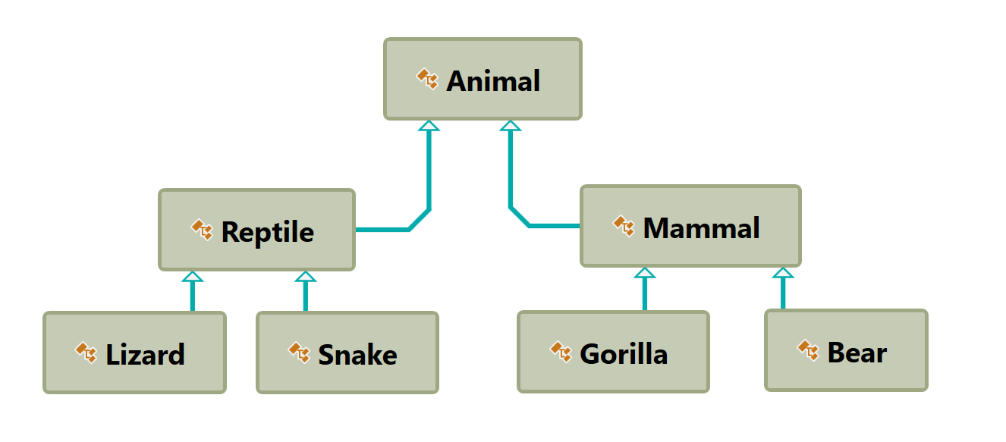
Follow the diagram and create all of the classes. Each of them, except the Animal class, should inherit from another class. Every class should have:
- A constructor, which accepts one parameter: name.
- Property Name - string.
Zip your solution without the bin and obj folders and upload it in Judge.

Players and Monsters
NOTE: You need a public class StartUp.
Your task is to create the following game hierarchy:
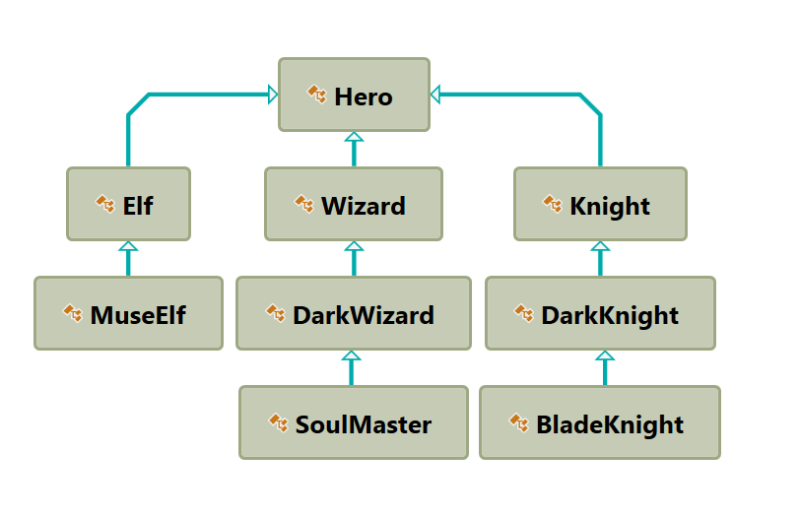
Create a class Hero. It should contain the following members:
- A constructor, which accepts:
  - username – string
  - level – int
- The following properties:
  - Username - string
  - Level – int
- ToString() method
Hint: Override ToString() of the base class in the following way:
public override string ToString()
{
return $"Type: {this.GetType().Name} Username: {this.Username} Level: {this.Level}";
}

Need for Speed
NOTE: You need a public class StartUp. Create the following hierarchy with the following classes: 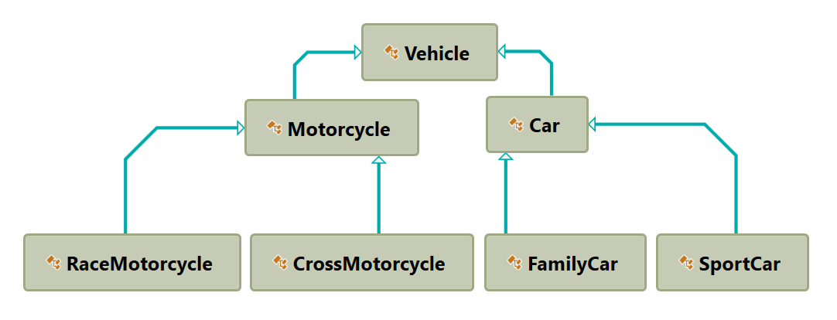

Create a base class Vehicle. It should contain the following members:
- A constructor that accepts the following parameters: int horsePower, double fuel
- DefaultFuelConsumption – double
- FuelConsumption – virtual double
  - Per kilometer.
- Fuel – double
- HorsePower – int
- virtual void Drive(double kilometers)
  - The Drive method should have a functionality to reduce the Fuel based on the travelled kilometers.
The default fuel consumption for Vehicle is 1.25. Some of the classes have different default fuel consumption values:
- SportCar – DefaultFuelConsumption = 10
- RaceMotorcycle – DefaultFuelConsumption = 8
- Car – DefaultFuelConsumption = 3
Zip your solution without the bin and obj folders and upload it in Judge.

Restaurant
NOTE: You need a public class StartUp. Create a Restaurant project with the following classes and hierarchy:
There are Food and Beverages in the restaurant and they are all products.
The Product class must have the following members:
- A constructor with the following parameters: string name, decimal price
- Name – string
- Price – decimal
Beverage and Food classes are products.
The Beverage class must have the following members:
- A constructor with the following parameters: string name, decimal price, double milliliters
  - Reuse the constructor of the inherited class
- Name – string
- Price – double
- Milliliters – double
HotBeverage and ColdBeverage are beverages and they accept the following parameters upon initialization: string name, decimal price, double milliliters. Reuse the constructor of the inherited class.
Coffee and Tea are hot beverages.
The Coffee class must have the following additional members:
- Caffeine – double
The Coffee class must have the following default values:
- Milliliters = 50
- Price = 3.50
The Food class must have the following members:
- A constructor with the following parameters: string name, decimal price, double grams
- Name – string
- Price – decimal
- Grams – double
MainDish, Dessert and Starter are food. They all accept the following parameters upon initialization: string name, decimal price, double grams. Reuse the base class constructor.
Dessert must accept one more parameter in its constructor: double calories, and has a property:
- Calories
Make Fish, Soup and Cake inherit the proper classes.
The Cake class must have the following default values:
- Grams = 250
- Calories = 1000
- Price = 5
A Fish must have the following default values:
- Grams = 22
Zip your solution without the bin and obj folders and upload it in Judge.

Animals
NOTE: You need a public class StartUp.
Create a hierarchy of Animals. Your program should have three different animals – Dog, Frog and Cat. Deeper in the hierarchy you should have two additional classes – Kitten and Tomcat. Kittens are female and Tomcats are male. All types of animals should be able to produce some kind of sound - ProduceSound(). For example, the dog should be able to bark. Your task is to model the hierarchy and test its functionality. Create an animal of each kind and make them all produce sound.
You will be given some lines of input. Each two lines will represent an animal. On the first line will be the type of animal and on the second – the name, the age and the gender. When the command "Beast!" is given, stop the input and print all the animals in the format shown below.

Output
- Print the information for each animal on three lines. On the first line, print: "{AnimalType}"
- On the second line print: "{Name} {Age} {Gender}"
- On the third line print the sounds it produces: "{ProduceSound()}"

Constraints
- Each Animal should have a name, an age and a gender
- All input values should not be blank (e.g. name, age and so on…)
- If you receive an input for the gender of a Tomcat or a Kitten, ignore it but create the animal
- If the input is invalid for one of the properties, throw an exception with message: "Invalid input!"
- Each animal should have the functionality to ProduceSound()
- Here is the type of sound each animal should produce:
  - Dog: "Woof!"
  - Cat: "Meow meow"
  - Frog: "Ribbit"
  - Kittens: "Meow"
  - Tomcat: "MEOW"

Examples
Input | Output
Cat  Tom 12 Male  Dog  Sharo 132 Male  Beast! | Cat  Tom 12 Male  Meow meow  Dog  Sharo 132 Male  Woof!
Frog  Kermit 12 Male  Beast! | Frog  Kermit 12 Male  Ribbit
Frog  Sashko -2 Male  Frog  Sashko 2 Male  Beast! | Invalid input!  Frog  Sashko 2 Male  Ribbit

