JS Advanced Retake Exam

Problem 1. Dish Manager
Environment Specifics
Please, be aware that every JS environment may behave differently when executing code. Certain things that work in the browser are not supported in Node.js, which is the environment used by Judge.
The following actions are NOT supported:
- .forEach() with NodeList (returned by querySelector() and querySelectorAll())
- .forEach() with HTMLCollection (returned by getElementsByClassName() and element.children)
- Using the spread-operator (...) to convert a NodeList into an array
- append() in Judge (use only appendChild())
- replaceWith() in Judge
- replaceChildren() in Judge
- replaceAll() in Judge
- closest() in Judge
If you want to perform these operations, you may use Array.from() to first convert the collection into an array.
Use the provided skeleton to solve this problem.
Note: You can't and you have no permission to change directly the given HTML code (index.html file).
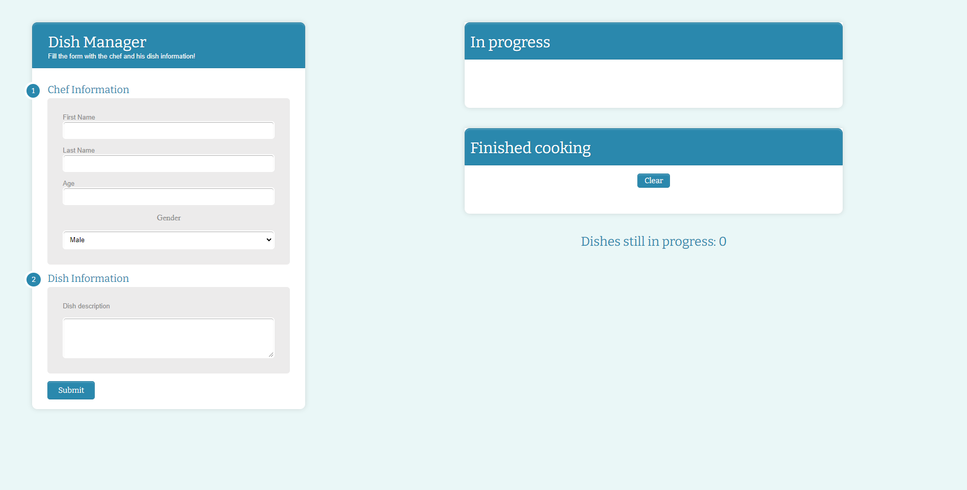

Your Task
Write the missing JavaScript code to make the Dish Manager work as expected:
All fields (First Name, Last Name, Age and Dish description) are filled with the correct input
  - First Name, Last Name, Age and Dish description are non-empty strings. If any of them are empty, the program should not do anything.

- Getting the information from the form

When you click the ["Submit"] button, the information from the input fields must be added to the ul with the id "in-progress" and then clear input fields. Also the counter with id "progress-count" should be increased by 1.
The HTML structure looks like this:

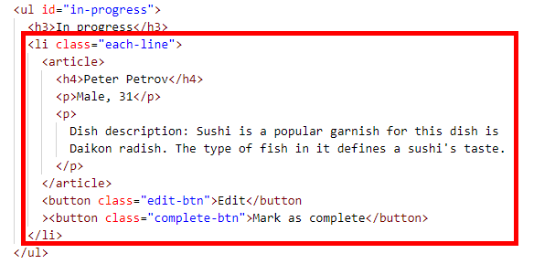

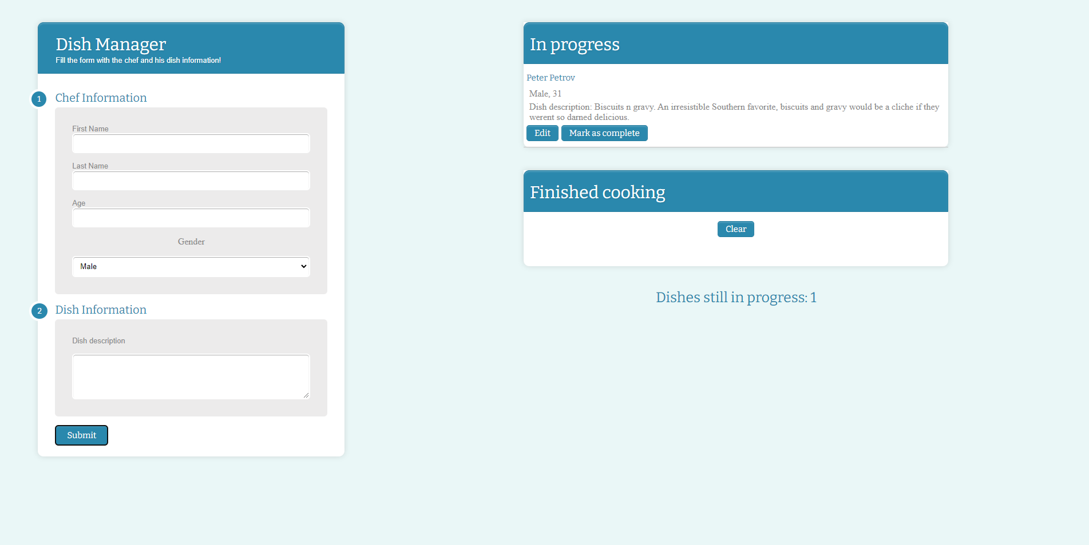

Edit information for posts
When the ["Edit"] button is clicked, the information from the post must be sent to the input’s fields and the record should be deleted from the ul "in-progress". Also the counter with id "progress-count" should be decreased by 1.
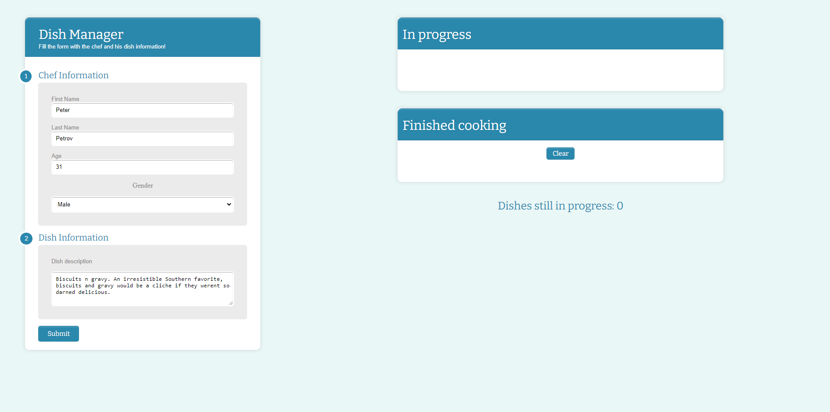
After editing the information make a new record to the ul with updated information and increase the counter.
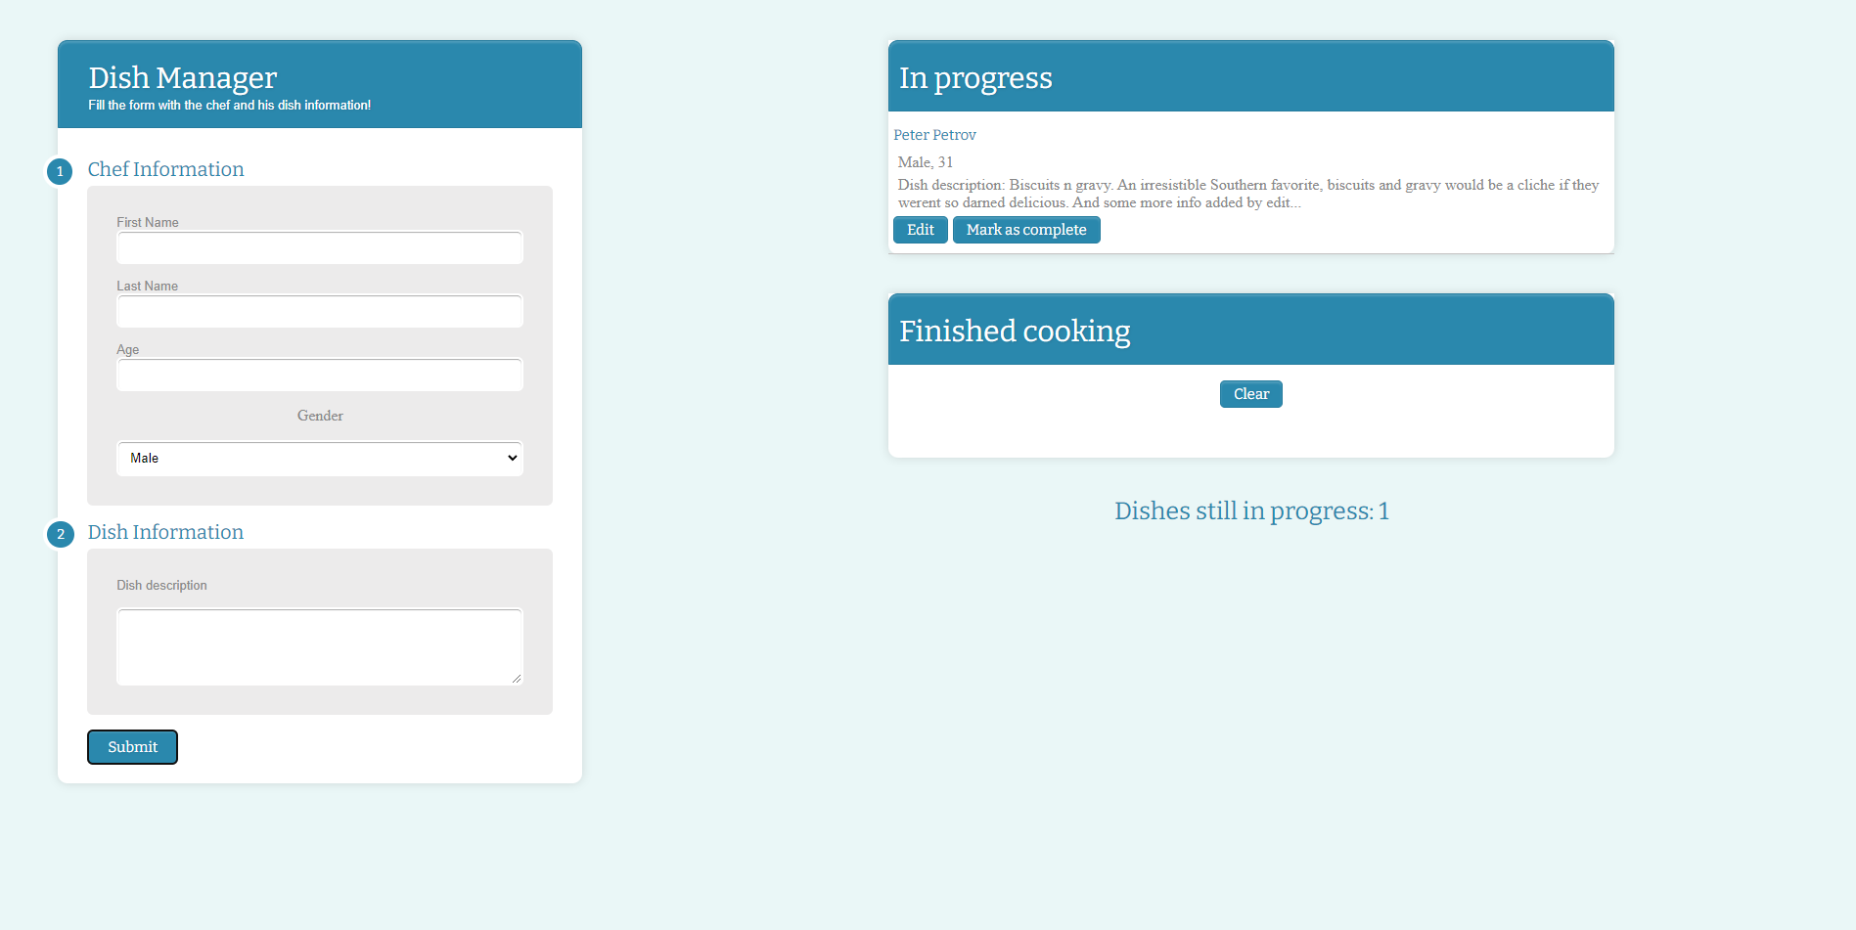

Complete posts
When you click the ["Mark as complete"] button, the record must be deleted from the ul with id
"in-progress" , appended to the ul with the id "finished" and the counter with id "progress-count" should be decreased by 1.
The buttons [“Edit”] and [“Mark as complete”] should be removed from the li element.
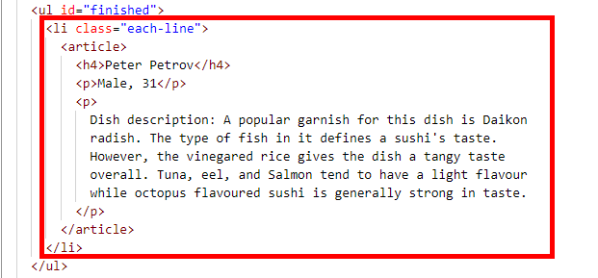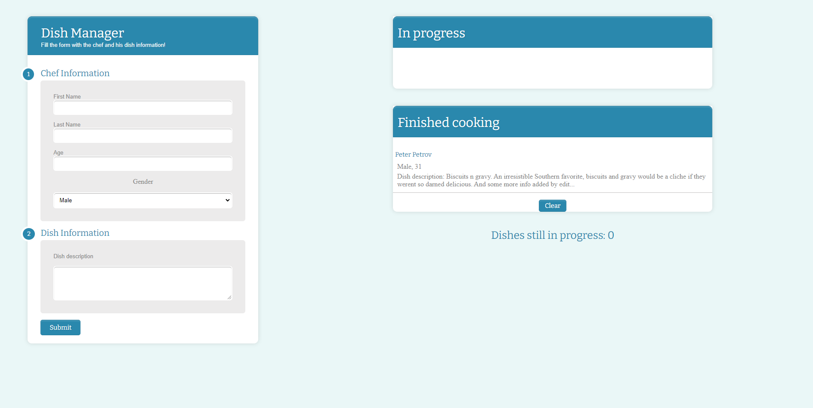

Clear posts
When you click the ["Clear"] button, the record for all posts must be deleted from the ul with the id "finished".

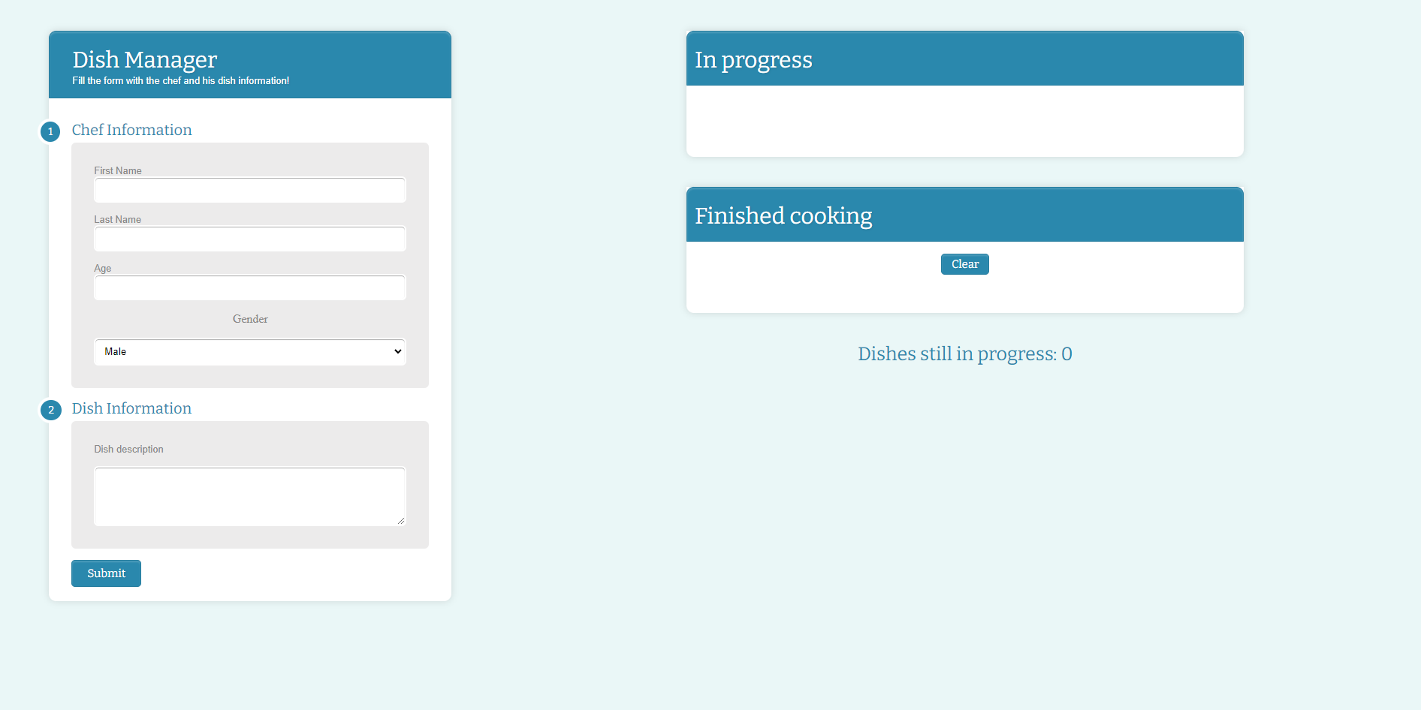

Submission
Submit only your solve() function.
GOOD LUCK…

